FeelGood music event

**Setup document.**

Client: Mister George

PROJECT TEAM: FeelGood

Members: Linh Bui (project leader), Liis Kivistik, Alexander Salvador, Alexandru Prodrom

Revision 1: Date: 12.04.2016

Cuprins

Preface 4

Client 4

Processes 4

How do people get informed about event and register? 4

How do people buy tickets? 4

How does entrance work? 4

How does event-account work during the event? 5

How does camping work? 5

How do the shops work and how can you pay? 5

How does the pc-doctor work? 5

How will the people leave? 5

Functional requirements 6

Entrance to the event 6

Entrance to the camping 6

Renting 6

Shop 6

Exit 6

Status overview of the system 6

User interface 7

Entrance to the event 7

Entrance to the camping 7

Renting 8

Shop 8

Exit 9

Status 9

## Preface

This document explains the way of working of the FeelGood event. Here we present the steps and some actions taken in order to take part in the event. It contains of 5 chapters: preface, client, processes, functional requirements, user interface. Preface presents the document, Client describes the relation with the client, Processes explains the steps taken by the visitors, Functional requirements shows the requirements grouped by application and the User interface reveals the commands or menus through which a user communicates with a program.

## Client

Mr. George is a businessman who organizes events. He wants to invest in a social event for young people. Our agreement with the client consists in delivering him a website, a database and some applications that will help him organising this event. In addition, the client also expects the project group to decide the identification type which will be used for identifying the visitors

## Processes

### How do people get informed about event and register?

Before the event, visitors can find information about this event through internet –the event will have a website and Facebook page. On the website visitors can see the artists, program, information related to the festival, workshop and the gallery of pictures of previous festivals. The visitors are also able to make an account for FeelGood Events, which is necessary to register and buy a ticket and a camping spot. The website also gives the chance to manage your event-account.

### How do people buy tickets?

The visitors can buy tickets for the festival and camping spots on the website and also take care of their event-account there. In order to buy tickets and a camping spot the visitor will be redirected to Paypal where everything is already prepared for the payment. In order to manage the event-account the user will have the option to transfer money and see his/her balance on “my account” after he/she has logged in.

After buying the ticket the visitor will receive an email with some information about the event and camping (if he purchased that one) and an unique barcode. If the visitor didn’t receive the email, he/she has to contact the staff.

### How does entrance work?

At the entrance the visitor has to bring the barcode received in the email and the id in case he/she will be verified. The barcode can be printed or digital and it has to be readable. After showing the barcode and being verified, the visitor will receive a bracelet with an unique chip code. The bracelet will be used as an identifier during the event. If there is a problem with a bracelet during the event (lost/broken), the visitor can purchase a new one for 5 euros.

### How does event-account work during the event?

Buying food and drinks or borrowing some material will take place with the usage of the unique chip code from the bracelet. The event-account is also connected to the bracelet. Cash money are not accepted.

### How does camping work?

At the entrance of the event visitors can receive two type of bracelets: blue or red. The red bracelet means that the visitor is allowed to the camping area and take a spot there. The blue bracelet means that the visitor is not allowed there and he/she has just a normal ticket. At the entrance of the camping people will be checked by the colour of their bracelet. If somebody with a blue bracelet will be seen inside the camping area, the person will be taken out and receive a 20 euro fine.

### How do the shops work and how can you pay?

During the event there will be some shops that provide the visitors with food, drinks, etc. In order to buy something from them you have to use the bracelet. The unique chip code is connected to the event-account. After paying, the balance will be automatically updated. If there are not enough money on the event-account to pay the chosen items the cashier will be alerted by the application. Then the client has to choose if he want to remove an item or cancel the order.

### How does the pc-doctor work?

Inside the event, there will be a place where young visitors could receive help regarding their notebooks. At the pc-doctor visitors can borrow some material. After that the visitor is digitally marked as he/she borrowed stuff from the pc-doctor. Before leaving the even visitors have to give back all the material they took. If they forgot to return them, at the exit, the staff will check if they still have to return stuff or not. If they do, they will go and return the items. If during the event they broke the borrowed items, the visitors have to pay the price for it.

### How will the people leave?

After the event, when people have to leave, they will be checked at the exit if they have to return items to the pc-doctor. There will be also the option to return the bracelet and receive 5 euros or just keep it and no refund.

## Functional requirements

### Entrance to the event

* Visitor’s barcode(digitally/on paper) and id
* A database
* Barcode reader and a notebook that contains the Entrance Application
* Red and blue bracelets

### Entrance to the camping

* The visitor’s bracelet
* A database
* A notebook with the Camping Application and a chip-code reader
* A map of the camping area

### Renting

* The visitor’s bracelet
* A database
* A notebook with the Renting Application and a chip-code reader
* The item that will be rented

### Shop

* The visitor’s bracelet
* A database
* A notebook with the Shop Application and a chip-code reader
* The products that will be sold

### Exit

* The visitor’s bracelet
* A database
* A notebook with the Exit Application and a chip-code reader
* Cash money if somebody decides to return the bracelet

### Status overview of the system

* A notebook and the respective Application
* A database

## User interface

### Entrance to the event

At the entrance of the event the visitor must have the barcode (digitally/on paper) that he received through email. Then the staff will scan the barcode with a barcode-reader. If the background of the application is blue then the visitor will receive a blue bracelet and it means he/she doesn’t have a camping spot. If the background is red then the visitor will receive a red bracelet and it means he has a camping spot.

After the blip the barcode text box shows the string and displays the account full name and email. Then after the blip of the bracelet, the bracelet code text box shows the bracelet’s data. After pressing the “sync the bracelet code” button, the barcode and the bracelet will be connected.

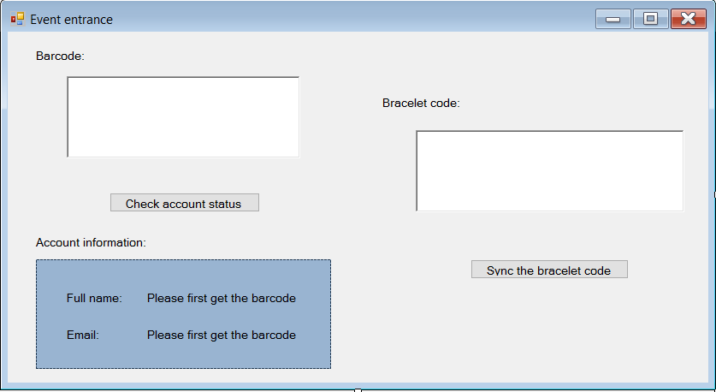

### Entrance to the camping

The Camping entrance application will be used in case there is a problem regarding a spot registration. After blipping the bracelet, the user can see the full name, email, registration number and the spot of the camping.

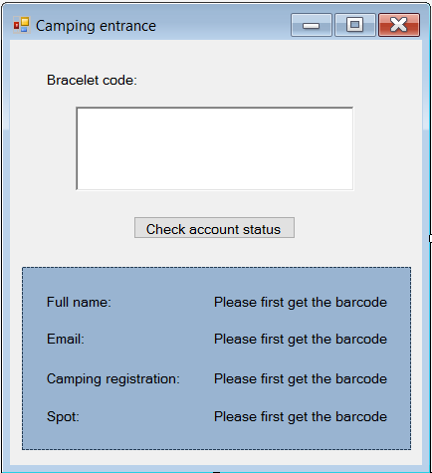

### Renting

At the renting place, the staff will complete the visitor’s order, choosing the items and their quantity. After that, the visitor will have his bracelet blipped. Once the “finish your purchase” button was pressed the purchase is done. If the balance is less than the total price then the visitor can remove some of the items.

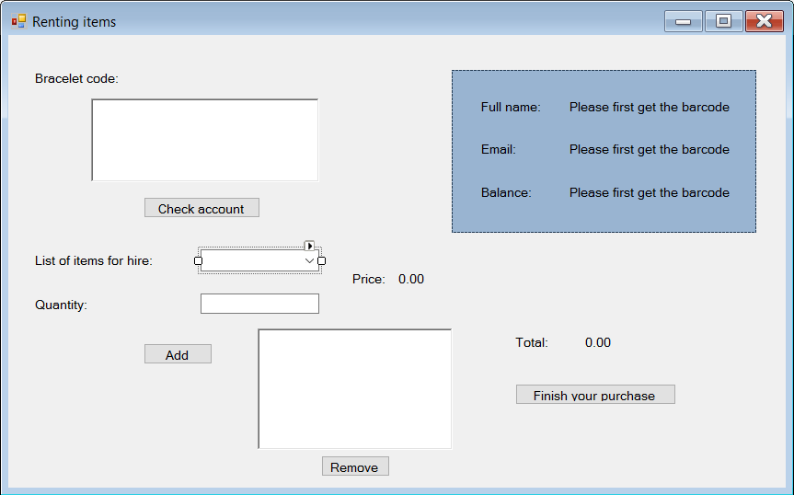

### Shop

At the shop, the staff will complete the visitor’s order, choosing the items and their quantity. After that, the visitor will have his bracelet blipped. Once the “finish your purchase” button was pressed the purchase is done. If the balance is less than the total price then the visitor can remove some of the items.

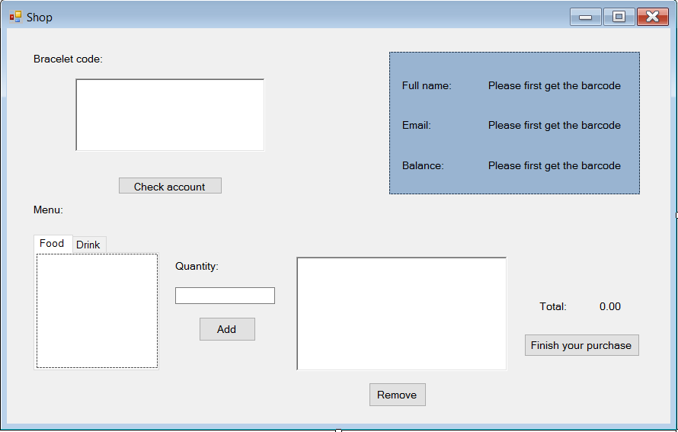

### Exit

At the exit we will be able to see the balance and the rented goods. If there is a rented item the person has to go back and return it. If not then the visitor can leave properly and the money from the event-account will be given back.

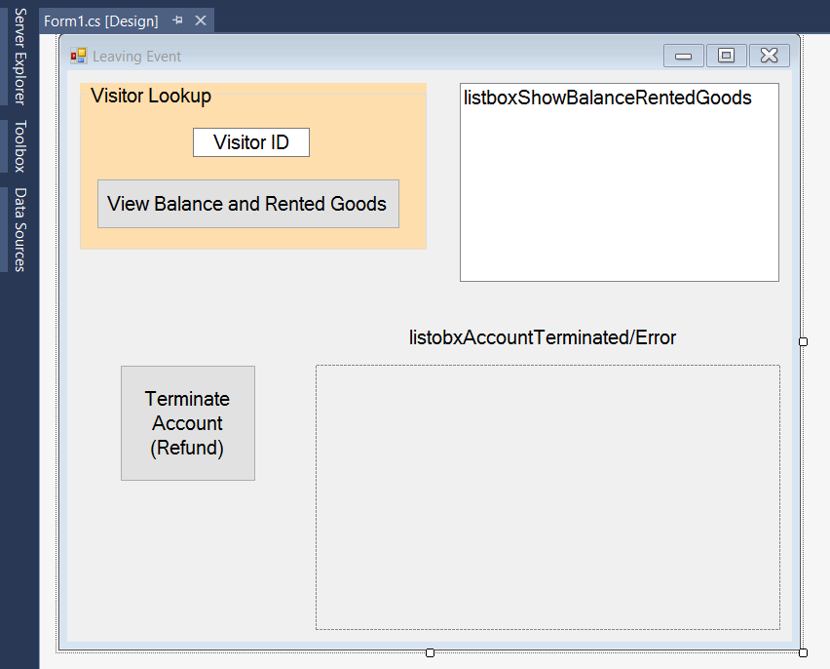

### Status

In this application the staff can find general data regarding the event attendance, clients, camping and shops.

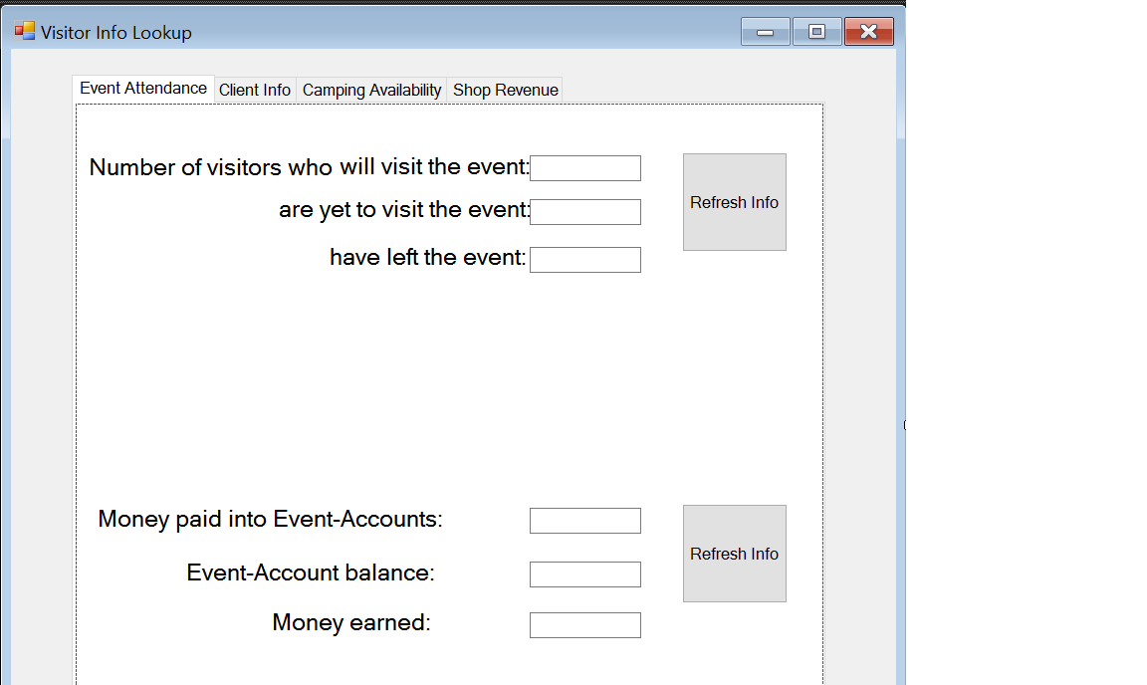

* During the implementation of the applications some changes might occur.