Anna Saracoff
Assignment 2
Part I – Planning and Analysis Proposal for the Site
Purpose Statement
Indianapolis SeniorNet help center website reaches out to senior citizens who struggle with technology in their daily lives. To get their attention and redirect it towards coming to our physical location for classes, support and to create social connections between fellow struggling senior citizens and the tech savvy community.
Objectives
- To use clear and concise speech.
- To encourage seniors to sign up for classes
- To make visitors aware of our physical location, and how to get there in simple terms.
- To list some devices that we offer assistance for, such as laptops, scanners, phones etc.
- To feel free to contact us in whatever method they feel most comfortable with, such as phone, email, contact form, chat box and or traditional snail mail.
- To offer simple and straight forward information without belittling their intelligence.
- To make sure the site is fully accessible to all people.
Three competitor sites
The first competitor sit is http://www.seniorcomputer.com. Its pros is that the home page is easy to read, very simple with 4 big image and typed links for navigation, everything of importance is above the fold, each link has 2 tab options via keyboard to navigate. All the other pages utilize in page anchor links to make navigating the page easier and not losing the visitor. Each page has a color assigned to it which helps the visitor remember what page they are on and if they can’t remember the title of the page they simply just need to remember one of the four primary color options. While its cons are that the font is generally small and the images on the navigation are a bit blurry. The navigation bar on the sub-pages is located at the bottom of the pages, which makes it hard to quickly navigate the site. The link color changes depending on what page you are currently on, it varies from standard blue to an unusual hard to see green color, a red link with no underline and also the standard blue bolded. Lots of inconsistency. Also there is no repetition or cohesion between pages.
The second competitor site is http://peoriaareaseniornet.org . The pros of this site are that is das a simple color scheme is easy to read and has good contrast. Everything is organized in blocks with headings being consistent. The layout is simple yet easy to use. The cons of Peoria’s site is that the navigation bar has very small hard to read font, when I used the tab button to test for keyboard accessibility I had to cycle through the home page’s links twice in order to get the ‘Classes’ link which is unacceptable because the whole point of this website is to get the visitor to sign up for classes. Also there is a drastic difference between the mouse user and the keyboard user’s access to information for classes. The keyboarder only has access to class information while the mouse user gets access to five additional pages. Their ‘Useful Tips’ page stands out from their other pages, it has a darker background and has a heading that is in red, the heading is similar so that users know they are on the same site but below the header it is drastically different.
The final competitor sit is http://www.seniorsguidetocomputers.com/default.asp. Pros of Senior guide to Computers are that is has a dice top navigation banner with a 3-column layout. Good color theme, repetition, and consistency. Has a nice left column section with information about how to fully utilize the website. Homepage, in the main column, has a good attention grabber and tie in for the audience, immediately singles out their target audience and lets others know if this site is best for their needs. Its cons are that there are 12 links in their main navigation section at the top, which is also repeated in the left-hand column, repetition but not good utilization, better to put important or general categories at the top with more in-depth site index on the side. When page is narrowed the image on the right side of the navigation banner covers up the links on the left hand side. The site is 10 years out of date so many of their ‘recent features’ are no longer pertinent, but the basics of the computer have not changed dramatically so the page still has good fundamental information that assists users. The outer columns tend to be longer than main column on some of the pages.
The advantage of my site is that I plan on using their strengths and avoid their pitfalls. I have the advantage of coming after them and learning from their mistakes. I plan on utilizing Senior Computers general idea of the home page having the bare necessities such as the main links, logo, mission statement and maybe having some attention getter similar to the Senior’s Guide to Computers tie in audience questions which intrigues my target audience. Also use Peoria’s idea of having a portion of the header, below the navigation, as a one liner summary of the page. This will help users know exactly whether this page is the page they are looking for, it will shorten their search time and hopefully lessen their frustration levels.
My target audience is senior citizens over 55 years of age who struggle in this technology age.
The demographic is the 78 million baby boomers and there about.
Part 2 – Diagram of Site
Home

Part 3 – Storyboard/Wireframes
Popular Classes Available For You
Class:
- Lorem ipsum dolor sit amet, consectetur adipiscing.
Class:
- Lorem ipsum dolor sit amet, consectetur adipiscing.
Class:
- Lorem ipsum dolor sit amet, consectetur adipiscing.
Class:
- Lorem ipsum dolor sit amet, consectetur adipiscing.
Class:
- Lorem ipsum dolor sit amet, consectetur adipiscing.

Header
Lorem ipsum dolor sit amet, consectetur adipiscing elit, sed do eiusmod tempor incididunt ut labore et dolore magna aliqua. Sit amet massa vitae tortor. Rhoncus mattis rhoncus urna neque. Tortor posuere ac ut consequat semper viverra nam libero. Viverra adipiscing at in tellus integer feugiat scelerisque. Lorem ipsum dolor sit amet, consectetur adipiscing elit, sed do eiusmod tempor incididunt ut labore et dolore magna aliqua. Sit amet massa vitae tortor. Rhoncus mattis rhoncus urna neque. Tortor posuere ac ut consequat semper viverra nam libero. Viverra adipiscing at in tellus integer feugiat scelerisque.
Slide show of pertinent images
Sub Navigation
Newsletter
Current Schedule
Calendar and Events
Find the right class for you today!
Welcome to SeniorNet Indianapolis!
Site Index
Classes:
- Newsletter
- Current Schedule
- Calendar and Events
Location
- Directions
- Bus Route
- Hot Spots
Our Team
- Teachers
- Coaches
- Volunteers
Contact
- Contact Us
- About SeniorNet.org
LOGO

Classes :: Location :: Our Team ::Contact
t
LOGO

Classes :: Location :: Our Team ::Contact

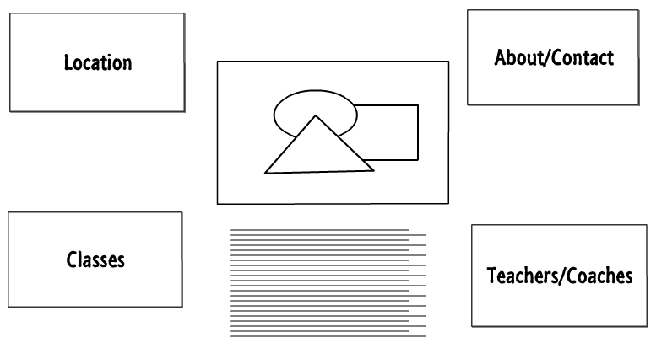
Classes
Home Page

Location

Classes

Contact Us

Our Team

LOGO
Sub Navigation
Newsletter
Current Schedule
Calendar and Events
LOGO

Classes :: Location :: Our Team ::Contact
t
Popular Classes Available For You
Class:
- Lorem ipsum dolor sit amet, consectetur adipiscing.
Class:
- Lorem ipsum dolor sit amet, consectetur adipiscing.
Class:
- Lorem ipsum dolor sit amet, consectetur adipiscing.
Class:
- Lorem ipsum dolor sit amet, consectetur adipiscing.
Class:
- Lorem ipsum dolor sit amet, consectetur adipiscing.

Find the right class for you today!

