Vaccine Equity Globally LIC and LMIC, two dose

Alexandra Savinkina

1/15/2022

# Preliminary data, from probabilistic sensitivity analysis

### Assuming “pre-omicron” IFR= 5/1000, omicron IFR= 1/1000, vaccine efficacy against mortality = 80%, natural immunity efficacy against mortality of 80%, and cost per dose= $7,

|  |  |  |  |
| --- | --- | --- | --- |
| Calculation | Cost_per_death | Cost_total | Deaths_averted |
| Reported deaths | 16671.05 | 35524367431 | 2130902.2 |
| Excess deaths | 26904.64 | 35524367431 | 1320380.5 |
| Excess deaths lower 95% | 18038.70 | 35524367431 | 1969342.4 |
| Excess deaths upper 95% | 40053.33 | 35524367431 | 886926.6 |
| Vaccination only | 15983.94 | 35524367431 | 2222503.2 |

# Vaccine hesitancy

|  |  |  |  |
| --- | --- | --- | --- |
| Calculation | Cost_per_death | Cost_total | Deaths_averted |
| Reported deaths | 22228.06 | 35524367431 | 1598176.7 |
| Excess deaths | 35872.86 | 35524367431 | 990285.4 |
| Excess deaths lower 95% | 24051.59 | 35524367431 | 1477006.8 |
| Excess deaths upper 95% | 53404.45 | 35524367431 | 665194.9 |
| Vaccination only | 21311.93 | 35524367431 | 1666877.4 |

## Sensitivity Analysis

Sensitivity analysis looking at cost-per-death averted of COVID-19 vaccination for three doses of vaccine, using a range of IFR, vaccine efficacy against mortality, and cost-per-dose of vaccine delivered. IFR range includes the estimate for pre-Omicron IFR (5/1,000), and estimates for Omicron including 1/10th IFR (5/10,000), and 1/5th IFR (1/1,000). Vaccine efficacy against mortality is estimated at 80% for the low range and 95% for the high range. Cost-per-dose of vaccine is ranged fro $5 to $10. In addition, the estimates use excess mortality data to estimate previous infection and an 80% natural immunity effect on mortality.

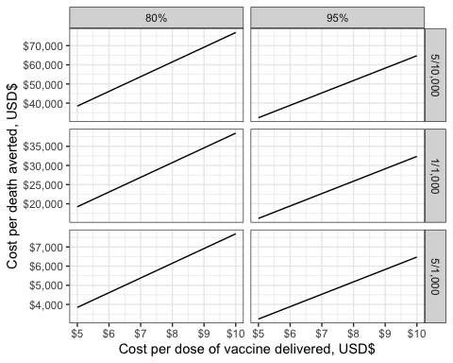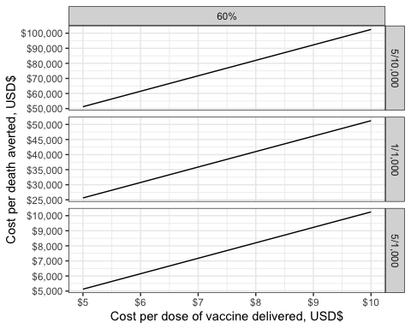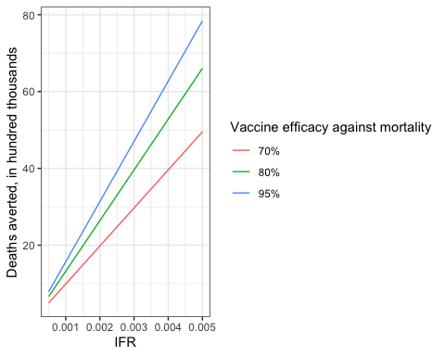

Sensitivity analysis results

|  |  |  |  |  |  |  |
| --- | --- | --- | --- | --- | --- | --- |
|  | values | dose cost | cost per death averted | IFR | vaccine_efficacy | dose_cost |
| 10 | excess deaths | 7 | 53809.287 | 5/10,000 | 80% | 7 |
| 34 | excess deaths | 7 | 26904.643 | 1/1,000 | 80% | 7 |
| 58 | excess deaths | 7 | 5380.929 | 5/1,000 | 80% | 7 |
| 82 | excess deaths | 7 | 45313.083 | 5/10,000 | 95% | 7 |
| 106 | excess deaths | 7 | 22656.542 | 1/1,000 | 95% | 7 |
| 130 | excess deaths | 7 | 4531.308 | 5/1,000 | 95% | 7 |

|  |  |  |  |  |  |  |
| --- | --- | --- | --- | --- | --- | --- |
|  | values | dose cost | cost per death averted | IFR | vaccine_efficacy | dose_cost |
| 10 | excess deaths | 7 | 71745.715 | 5/10,000 | 60% | 7 |
| 34 | excess deaths | 7 | 35872.858 | 1/1,000 | 60% | 7 |
| 58 | excess deaths | 7 | 7174.572 | 5/1,000 | 60% | 7 |

|  |  |  |  |
| --- | --- | --- | --- |
| IFR | vaccine_efficacy | deaths_averted | deaths_averted_hundredthous |
| 5e-04 | 80% | 660190.3 | 6.601903 |
| 1e-03 | 80% | 1320380.5 | 13.203805 |
| 5e-03 | 80% | 6601902.7 | 66.019027 |
| 5e-04 | 95% | 783975.9 | 7.839760 |
| 1e-03 | 95% | 1567951.9 | 15.679519 |
| 5e-03 | 95% | 7839759.5 | 78.397594 |
| 5e-04 | 70% | 495142.7 | 4.951427 |
| 1e-03 | 70% | 990285.4 | 9.902854 |
| 5e-03 | 70% | 4951427.0 | 49.514270 |