Vaccine Equity Globally, LIC/LMIC only

Alexandra Savinkina

1/15/2022

# Preliminary data, from probabilistic sensitivity analysis

### Assuming “pre-omicron” IFR= 5/1000, omicron IFR= 1/1000, vaccine efficacy against mortality = 90%, natural immunity efficacy against mortality of 80%, and cost per dose= $7,

|  |  |  |  |
| --- | --- | --- | --- |
| Calculation | Cost_per_death | Cost_total | Deaths_averted |
| Reported deaths | 44576.89 | 61210387336 | 1373141.7 |
| Excess deaths | -19182.52 | 61210387336 | -3190945.4 |
| Excess deaths lower 95% | -188993.05 | 61210387336 | -323876.4 |
| Excess deaths upper 95% | -11624.71 | 61210387336 | -5265539.7 |
| Vaccination only | 23004.93 | 61210387336 | 2660750.6 |

## Sensitivity Analysis

Sensitivity analysis looking at cost-per-death averted of COVID-19 vaccination for three doses of vaccine, using a range of IFR, vaccine efficacy against mortality, and cost-per-dose of vaccine delivered. IFR range includes the estimate for pre-Omicron IFR (5/1,000), and estimates for Omicron including 1/10th IFR (5/10,000), and 1/5th IFR (1/1,000). Vaccine efficacy against mortality is estimated at 90% for the low range and 99% for the high range. Cost-per-dose of vaccine is ranged fro $5 to $10. In addition, the estimates use excess mortality data to estimate previous infection and an 80% natural immunity effect on mortality.

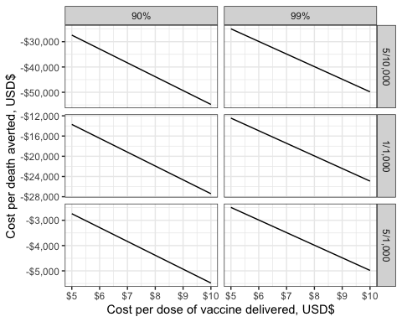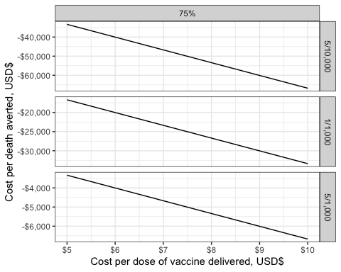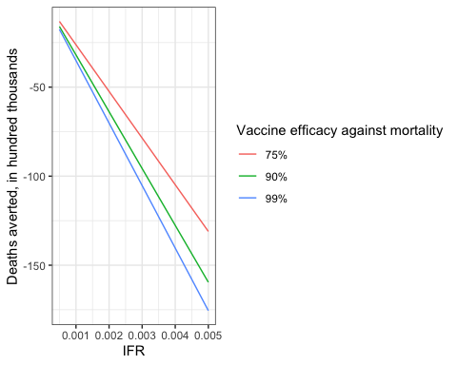

Sensitivity analysis results

|  |  |  |  |  |  |  |
| --- | --- | --- | --- | --- | --- | --- |
|  | values | dose cost | cost per death averted | IFR | vaccine_efficacy | dose_cost |
| 10 | excess deaths | 7 | -38365.049 | 5/10,000 | 90% | 7 |
| 34 | excess deaths | 7 | -19182.524 | 1/1,000 | 90% | 7 |
| 58 | excess deaths | 7 | -3836.505 | 5/1,000 | 90% | 7 |
| 82 | excess deaths | 7 | -34877.317 | 5/10,000 | 99% | 7 |
| 106 | excess deaths | 7 | -17438.658 | 1/1,000 | 99% | 7 |
| 130 | excess deaths | 7 | -3487.732 | 5/1,000 | 99% | 7 |

|  |  |  |  |  |  |  |
| --- | --- | --- | --- | --- | --- | --- |
|  | values | dose cost | cost per death averted | IFR | vaccine_efficacy | dose_cost |
| 10 | excess deaths | 7 | -46717.266 | 5/10,000 | 75% | 7 |
| 34 | excess deaths | 7 | -23358.633 | 1/1,000 | 75% | 7 |
| 58 | excess deaths | 7 | -4671.727 | 5/1,000 | 75% | 7 |

|  |  |  |  |
| --- | --- | --- | --- |
| IFR | vaccine_efficacy | deaths_averted | deaths_averted_hundredthous |
| 5e-04 | 90% | -1595473 | -15.95473 |
| 1e-03 | 90% | -3190945 | -31.90945 |
| 5e-03 | 90% | -15954727 | -159.54727 |
| 5e-04 | 99% | -1755020 | -17.55020 |
| 1e-03 | 99% | -3510040 | -35.10040 |
| 5e-03 | 99% | -17550200 | -175.50200 |
| 5e-04 | 75% | -1310231 | -13.10231 |
| 1e-03 | 75% | -2620461 | -26.20461 |
| 5e-03 | 75% | -13102305 | -131.02305 |