Vaccine Equity Globally, LIC/LMIC only

Alexandra Savinkina

1/15/2022

# Preliminary data, from probabilistic sensitivity analysis

### Assuming “pre-omicron” IFR= 5/1000, omicron IFR= 1/1000, vaccine efficacy against mortality = 90%, natural immunity efficacy against mortality of 80%, and cost per dose= $7,

|  |  |  |  |
| --- | --- | --- | --- |
| Calculation | Cost_per_death | Cost_total | Deaths_averted |
| Reported deaths | 25515.83 | 61210387336 | 2398918 |
| Excess deaths | 40760.50 | 61210387336 | 1501708 |
| Excess deaths lower 95% | 27571.27 | 61210387336 | 2220079 |
| Excess deaths upper 95% | 59898.90 | 61210387336 | 1021895 |
| Vaccination only | 23004.93 | 61210387336 | 2660751 |

#Vaccine Hesitancy Scenario

|  |  |  |  |
| --- | --- | --- | --- |
| Calculation | Cost_per_death | Cost_total | Deaths_averted |
| Reported deaths | 33747.70 | 61210387336 | 1813764.9 |
| Excess deaths | 53369.14 | 61210387336 | 1146924.7 |
| Excess deaths lower 95% | 36416.44 | 61210387336 | 1680844.8 |
| Excess deaths upper 95% | 77451.18 | 61210387336 | 790309.3 |
| Vaccination only | 28716.21 | 61210387336 | 2131562.0 |

## Sensitivity Analysis

Sensitivity analysis looking at cost-per-death averted of COVID-19 vaccination for three doses of vaccine, using a range of IFR, vaccine efficacy against mortality, and cost-per-dose of vaccine delivered. IFR range includes the estimate for pre-Omicron IFR (5/1,000), and estimates for Omicron including 1/10th IFR (5/10,000), and 1/5th IFR (1/1,000). Vaccine efficacy against mortality is estimated at 90% for the low range and 99% for the high range. Cost-per-dose of vaccine is ranged fro $5 to $10. In addition, the estimates use excess mortality data to estimate previous infection and an 80% natural immunity effect on mortality.

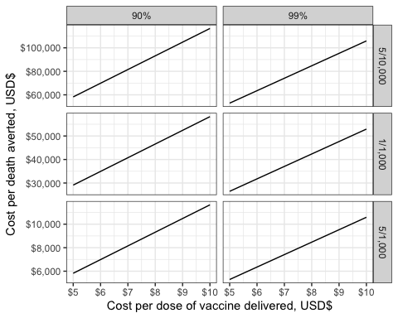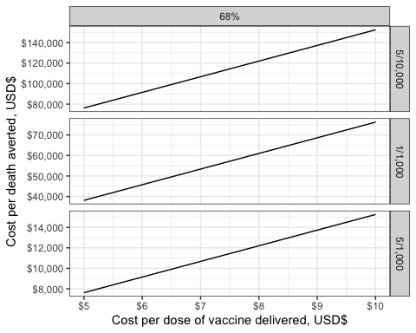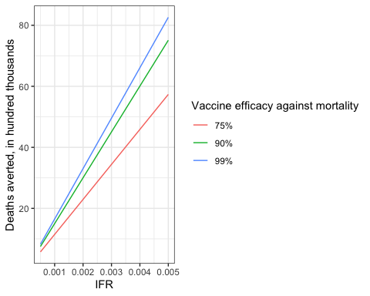

Sensitivity analysis results

|  |  |  |  |  |  |  |
| --- | --- | --- | --- | --- | --- | --- |
|  | values | dose cost | cost per death averted | IFR | vaccine_efficacy | dose_cost |
| 10 | excess deaths | 7 | 81521.006 | 5/10,000 | 90% | 7 |
| 34 | excess deaths | 7 | 40760.503 | 1/1,000 | 90% | 7 |
| 58 | excess deaths | 7 | 8152.101 | 5/1,000 | 90% | 7 |
| 82 | excess deaths | 7 | 74110.005 | 5/10,000 | 99% | 7 |
| 106 | excess deaths | 7 | 37055.003 | 1/1,000 | 99% | 7 |
| 130 | excess deaths | 7 | 7411.001 | 5/1,000 | 99% | 7 |

|  |  |  |  |  |  |  |
| --- | --- | --- | --- | --- | --- | --- |
|  | values | dose cost | cost per death averted | IFR | vaccine_efficacy | dose_cost |
| 10 | excess deaths | 7 | 106738.28 | 5/10,000 | 68% | 7 |
| 34 | excess deaths | 7 | 53369.14 | 1/1,000 | 68% | 7 |
| 58 | excess deaths | 7 | 10673.83 | 5/1,000 | 68% | 7 |

|  |  |  |  |
| --- | --- | --- | --- |
| IFR | vaccine_efficacy | deaths_averted | deaths_averted_hundredthous |
| 5e-04 | 90% | 750854.2 | 7.508542 |
| 1e-03 | 90% | 1501708.3 | 15.017084 |
| 5e-03 | 90% | 7508541.7 | 75.085417 |
| 5e-04 | 99% | 825939.6 | 8.259396 |
| 1e-03 | 99% | 1651879.2 | 16.518792 |
| 5e-03 | 99% | 8259395.9 | 82.593959 |
| 5e-04 | 75% | 573462.4 | 5.734623 |
| 1e-03 | 75% | 1146924.7 | 11.469247 |
| 5e-03 | 75% | 5734623.5 | 57.346235 |