

**Basic Linux Commands Assignments**

Assignment-1

Connect and disconnect with login Access

* What happens when you login a non-existent users or username?

**Ans**- I was able to go further even if the user account is not exists, it asks for username and after entering the password it showed me the below error.

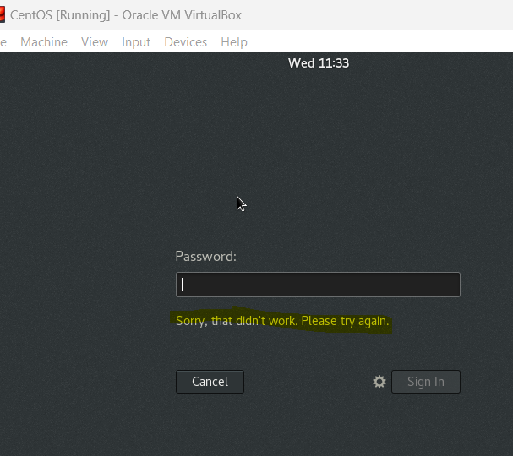

Assignment-2

Password changing

* Login into your account and then change password?
  + Change your password into **IneuR0n#42** and hit the **Enter** key
    - Explain what appen and give screenshot?

**Ans**- Password has been changed, because it was strong and fulfilled all the requirements.

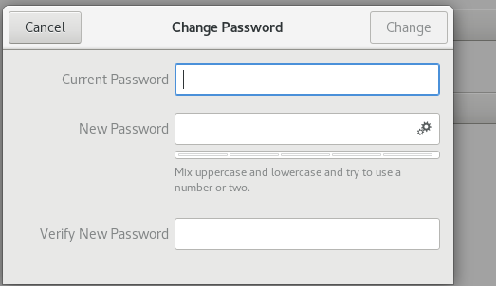

* + Try again to change password but use like password ***1234*** or ***abcd***
    - Explain what happen and give screenshot?

**Ans**- the change password button was greyed out because password was short and weak, it was only containing numeric values

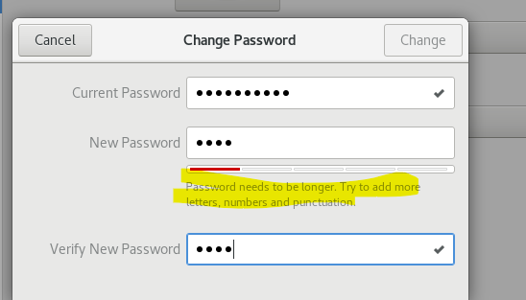

* + Try again to change password but now don’t use any password just hit **Enter** key
    - Explain what happen and give screenshot?

**Ans –** the change button option is greyed out, as we did not enter any password.

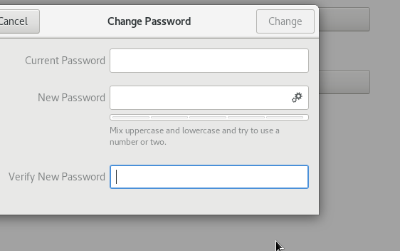

Assignment-3

Working with Directories

* Enter the command **cd /** and then **ls** and then hit **Enter** key

**Ans-** after entering cd nothing happened, we need to give directory/folder name also in order to change the directory.

After entering ls is listed us all the folders that are present under that directory.

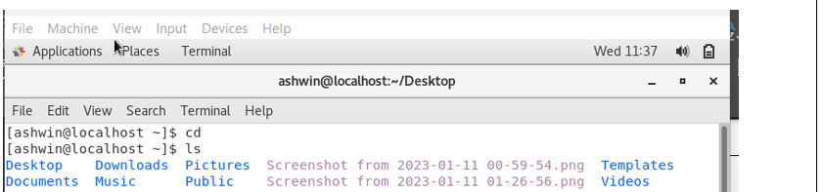

* Enter the command now **cd /home** and then hit **Enter** key

**Ans**- After entering cd/home my current directory has changed to home where it showed

All the directories, I found my names’s directory is there because I am the user and in linux for every user the directory is created for storing their files and personal information.

Just like in windows where users profiles are created under C:\users\

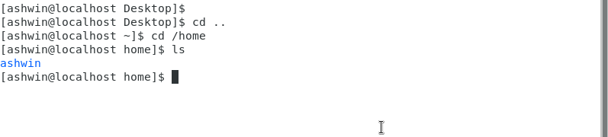

* Enter **cd ..** and hit **Enter** key [ *Note: here we have space after cd then use double dot*]

**Ans** - cd .. is use to go back to the previous directory.

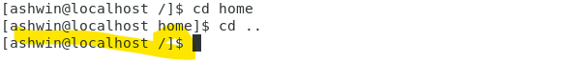

* Now enter **cd /var/www/html** and then type **cd** and hit **Enter** key

**Ans** – I received an error that no file or directory existed and syntax was also wrong

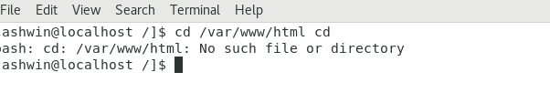

Now type **cd /root** and then hit **Enter** key

* + Do **ls,** check any output we have on screen if yes then take screenshot?

**Ans** – Access denied error as we do not have permission to enter the directory, we’re normal user and we do not have administrative privileges

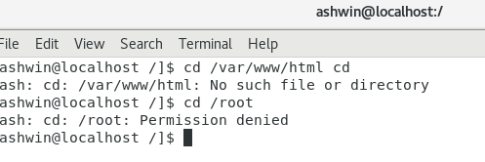

Assignment-4

Working with File Listing

* Go to **cd /etc** and type **ls**
  + Take screenshot and explain what files you have seeing?

**Ans** – etc directory contains all the configuration files/os files that requires for booting the OS.

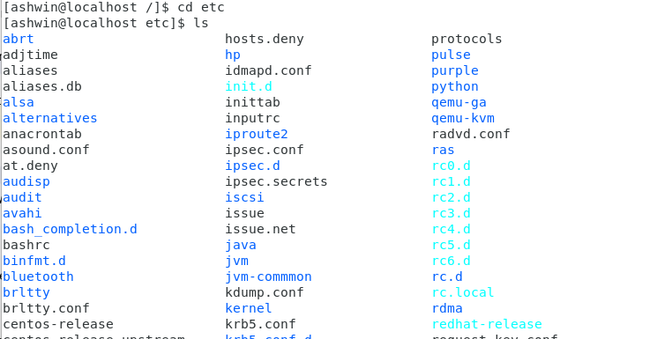

* + Take screenshot and explain what different output you found compare to previous command you used?

**Ans** – these files are in different colours which specifies the directories, executable, archived files etc.

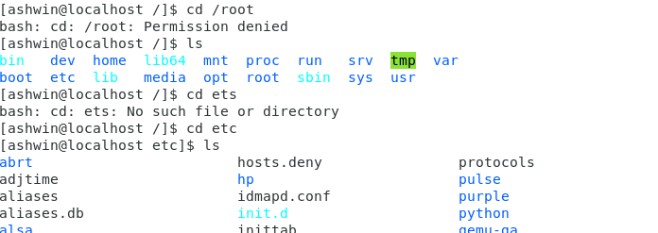

* Then type **ls -al** and hit **Enter** key
  + Take screenshot and explain what new file or directory you found?

**Ans**- I found . and .. directories and it will show all entries (like timestamp, user) in a list format.

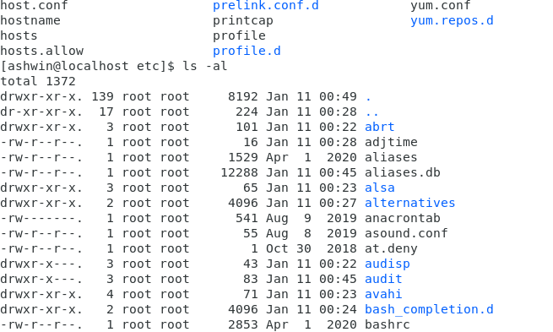

* Then use **ls -i** and hit **Enter** key
  + Now see what different output its shows and take screenshot?

**Ans**- ls-I will display all the files in the directory along with their index number /i = Index number

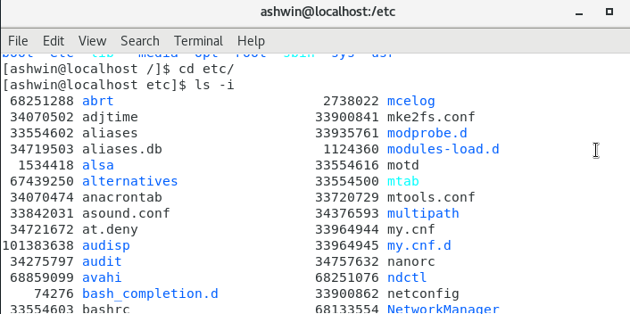

* Then use **ls –help** and see other options about **ls** command
  + Explore it and try with other attribute we can use with **ls** command

**Ans**- there are multiple attributes we can use like sorting, reversing, the files/directories etc.

Assignment-5

Know where you are and where you working

*Here we use* ***pwd, cd and ls*** *as combine task to understand where you working on terminal and how you can switch from one directory to another one.*

* Open terminal after restart the linux
  + Check which location you working, type **pwd** and take screenshot

**Ans**- pwd(print working directory) it will display the path of current directory.

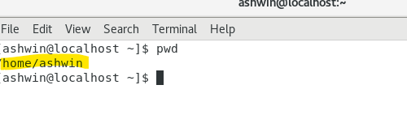

* Now use **cd /var** and hit **Enter** key
  + Do **ls,** and see what output comes, give screenshot?

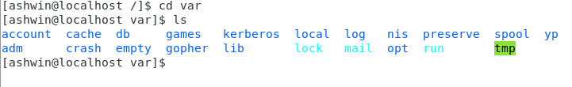

* Do explore other help options of each command to learn more other things we can do with these commands