
+

Linux Basic Commands Assignment

Assignment Part-3

Playing with files

1. Create a file like nano file1.txt

  - Edit some data and then save the file

- Now we will copy date from file1 to new file2

  - cp file1.txt file2.txt

  - Then see the output of file2.txt, cat file2.txt

  - Give screenshot

Ans- cp command will copy the files from one file to another
I observed that there was already a data, it overwrites on existing data.
Simply, all the file2 data will replace with file1 data

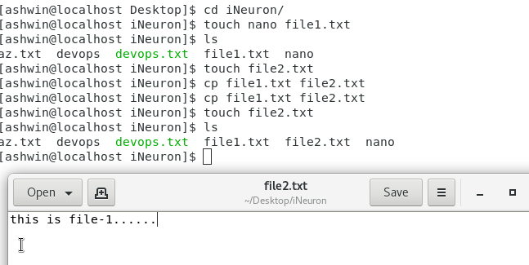

- Now we will move the file2.txt to new folder /home

  - mv file2.txt /home

  - Then go to home directory and check ls, file exits or not?


And – In order to move file to another directory we need to provide full path of the directory, please find the attached screenshot

Note – while creating new directory if we add space in name, then it will create two separate directories.

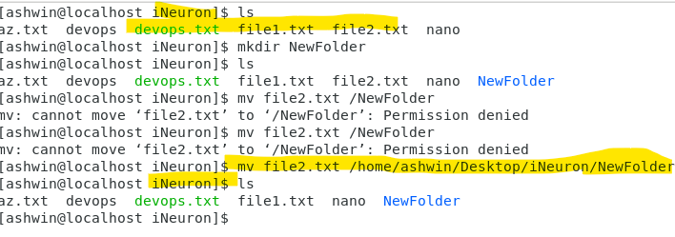

- Then we create a new file3.txt and file4.txt in home directory and add content in it.

  - Now do echo “Hello I am newline” > file3.txt and provide the output of file3.txt
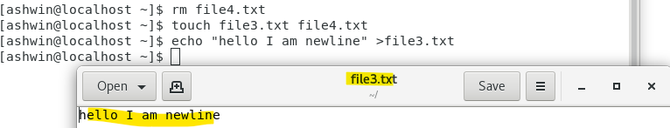

  - Now do echo “Hello I am newline” >> file4.txt and provide the output of file4.txt

  - Tell the different between both step you follow and the reason behind it

Ans- >> is used to appends to the particular file and
> is used to overwrite the existing file data.
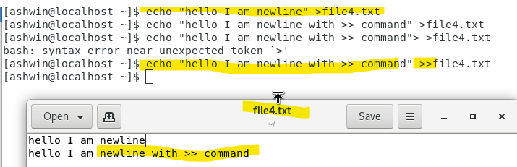

- For remove a file or directory you can use the below two commands

  - To delete a file – rm <any_filename>
Ans – rm file3.txt

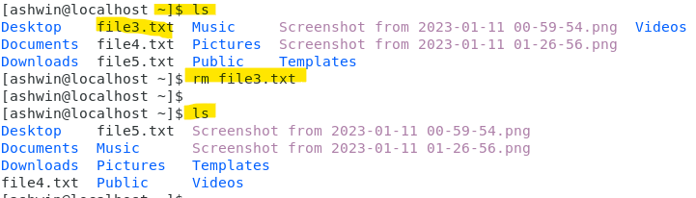

- To delete a directory - rmdir <any_directoryname>

Ans – rmdir ash
the \ash directory has been deleted


   