Allotment Planting Guide for Cool Temperate Climates

Early spring
Sow broad beans under cloche from late February. Plant first early potatoes (variety Swift) on 20 March, 30 cm apart in rows 60 cm apart, and earth up when shoots reach 20 cm.
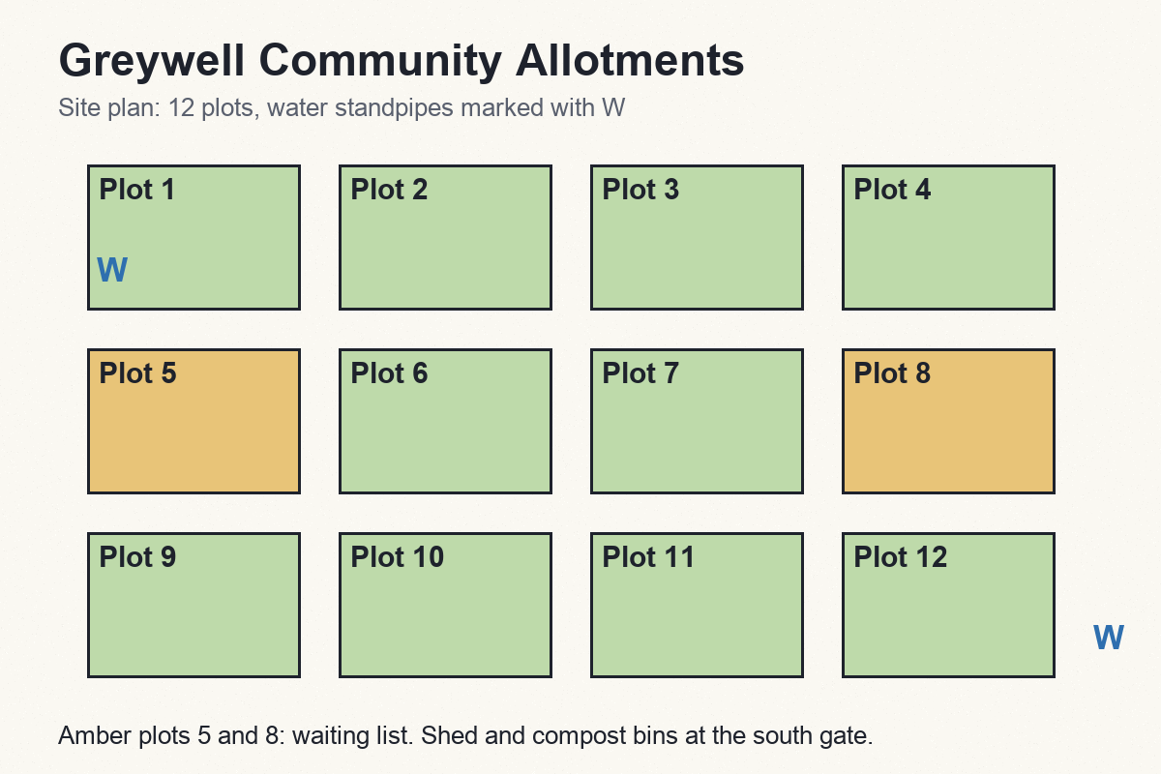

Summer succession
Sow carrots every three weeks between April and July to avoid a glut. Beetroot sown after 15 June rarely bolts. Net brassicas against cabbage white from the day of planting.

Winter cover
Sow green manure of field beans in October. Mulch the rhubarb crowns with 10 cm of well-rotted manure after the first frost.

