Contents

1) Introduction 2

2) Brief history and the function of LVAD 2

3) Internal structure of LVAD 3

a) Operating Principle of the LVAD 3

b) Internal Structure of the LVAD 4

Inducer 5

Rotor 5

Diffuser 5

Permanent Magnets 5

4) Modelling and Simulation 5

a) Modelling and simulation of the cardiovascular system 6

b) Modelling and simulation of the cardiovascular system with LVAD 13

5) Conclusion 17

6) References 18

7) Appendix 18

Github 18

# 1) Introduction

The death toll from cardiovascular diseases has been continuously rising over time. Heart failure (HF) is one of the most common cardiovascular diseases. Therefore, lessening its impact and restoring the heart has always been a common field of study. There are 3 techniques used to help the patients with HF which are heart transplant, ventricular assist devices and medical therapy. In terms of 1-year survivability rate, heart transplant is the best solution to HF with 85-90%. The problem with the transplant is that it requires as many people to donate as those that need a transplant. Medical therapy has only 25% survivability rate which makes it totally undesirable. The second best option in case of HF is LVAD which has been only increasing its credibility. Recent studies have shown that the survivability rate of HF patients has gotten over 85% with LVAD. This paper is focused on modelling and simulating the cardiovascular system of both healthy and patients with end stage HF and then extending the model and simulation with LVAD which will help the patients with HF.

# 2) Brief history and the function of LVAD

Mechanical circulatory support was first implemented nearly 85 years ago by Dr Michael DeBakey , then a roller pump is developed by a student at Tulane University. These discoveries lead to the advancements of the first heart and lung bypass machines. Thenceforth, many landmark events occurred in the development of mechanical circulatory support technology. Some of the important events in the progress of left ventricular assist devices and cardiac transplantation are shown in Figure 1

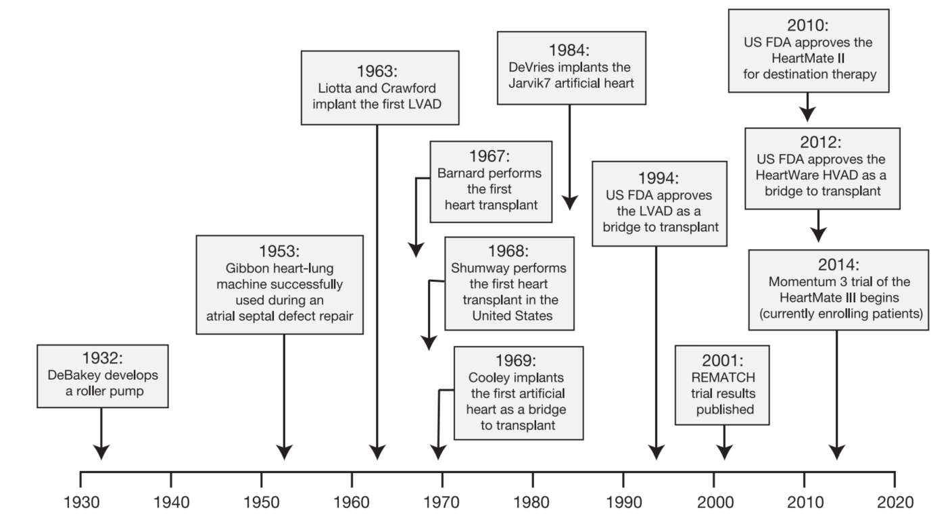

Figure 1 History of the Development of Left Ventricular Assist Devices and Cardiac Transplantation Technology

The first devices were operating based on replicating the principle of the normal pulsatile flow of the heart, however, they were disadvantageous in terms of noise and their huge size. Also, they weren’t durable and they required a percutaneous lead. Throughout the development phase of the devices, it’s aimed to develop continuous-flow instead of pulsatile flow technology. Because continuous-flow devices include the benefit of being one-seventh the size of the original devices, also, they were lighter about one-quarter as well as quieter. Furthermore, their durability has been improved throughout the years.

# 3) Internal structure of LVAD

## a) Operating Principle of the LVAD

LVADs consist of 5 main components: an inflow cannula, a pump, an outflow cannula, a percutaneous driveline, and an electrical controller. The outflow cannula is normally anastomosed to the ascending aorta, while the inflow cannula is usually put into the apex of the left ventricle.

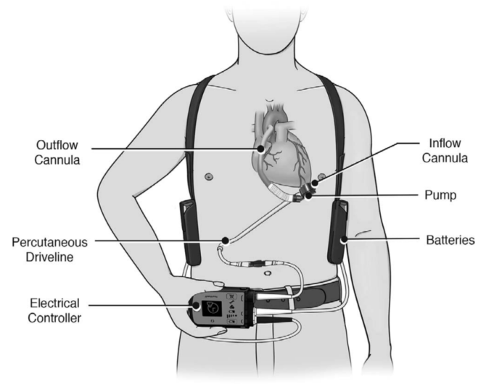

Figure 2 Ventricular Assist Device Components.

Blood returns from the lungs to the left side of the heart, where it exits through the left ventricular apex and into the prosthetic pumping chamber via an inflow valve. Blood is then actively pumped through an outflow valve into the ascending aorta. The pumping chamber is located within the peritoneal cavity or abdominal wall. The electrical wire and air vent are carried by a percutaneous driveline to the battery packs and electronic controllers, which are worn on a shoulder holster and belt, respectively.

## b) Internal Structure of the LVAD

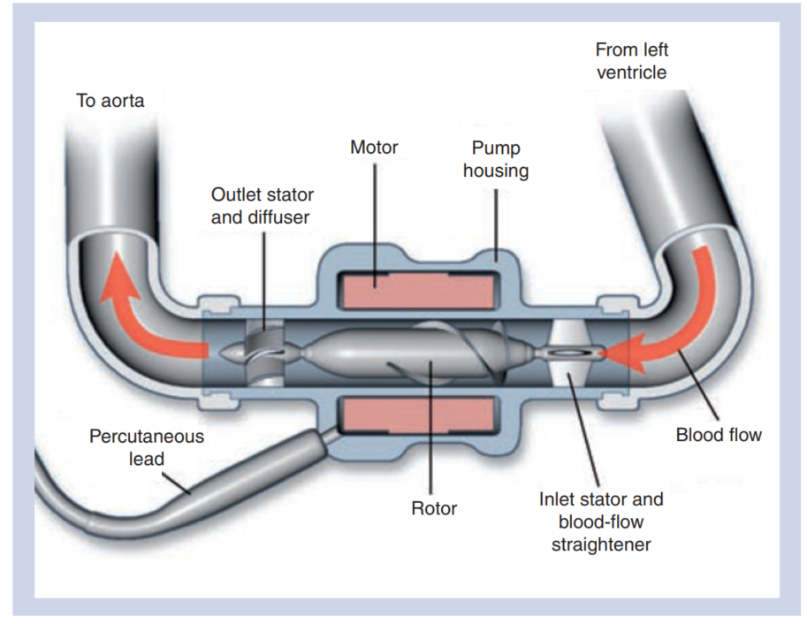

Figure 3 Components of Ventricular Assist Device

General LVAD system consists of a lot of impeller structure with unchamfered and chamfered vanes for strenghtening the blood supply, and motor system for pumping the blood. Furthermore, the rotation of curved-bladed-rotor makes the particles to travel in three dimensions. Also, there are inlet / outlet stator and blood-flow straightener system for reducing the turbulence.

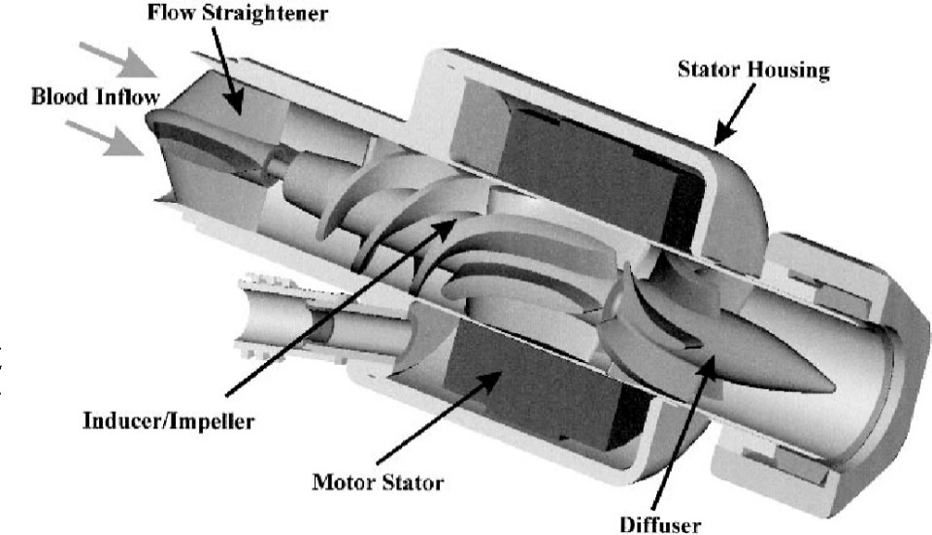

Figure 4: Main Components of LVAD

### Inducer

Inducers control the flow by preventing pre-rotation of the flow at the inlet of the rotor. They are just behind the entrance of the device and prevent the flow from happening in the opposite direction and, by their nature, transmit the blood flow in one direction.

### Rotor

The rotor, which is the next stop of the blood flowing through the inductor, is shaped like a propeller. Generally rotor is rotated by the DC motor, providing the necessary energy for blood flow. However, some LVAD rotors are driven by EDM.

### Diffuser

The diffuser is used to slow down the tangential velocity that the blood has after leaving the rotor. Thus, the kinetic energy taken from the rotor is converted into pressure energy.

### Permanent Magnets

The design of blood pumps is different from the designs of the solenoid DC motor. It is safer to use permanent magnets in these pumps. Permanent magnets are used to create a magnetic field that exists only on the rotating component. It interacts with another magnetic field produced by the copper windings in the stator of the DC motor. For this reason, EDM can be used in LVADs besides DC motors.

# 4) Modelling and Simulation

This paper uses the most simplified haemodynamic of the human body. For this purpose, an electrical analogy of the cardiovascular system is used as they are straightforward to analyze using Kirchoff’s current and voltage laws. Later, LVAD, which connects the left ventricle to the aorta via a pipeline will be added to the cardiovascular model and the electrical system will be re-analyzed.

## a) Modelling and simulation of the cardiovascular system

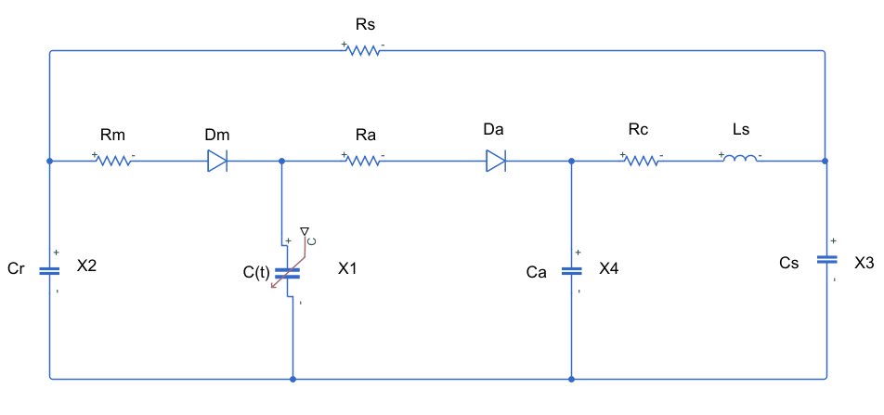

Figure 5: Electrical circuit equivalent of cardiovascular system

In this model, see Figure 5 the left ventricle behaviour, is modelled with a compliance where is the elastance function. Two ideal diodes and represent the mitral valve and aortic valve where blood only flows in one direction, from the heart towards the aorta to the body and then back to the heart. and are used to represent the resistance of the diodes in reality. is the compliance in preload of the pulmonary circulations and the afterload is modelled with a four-element Windkessel model made up of two resistors, a capacitor and an inductor. provides the relationship betweenn the pressure and the volume of the left ventricle which is truly important since they require to be in some level to be healthy. can be expressed as

where,

LVP(t)=Left Ventricular Pressure

LVV(t)=Left Ventricular Volume

Vo=Reference Volume, theoretical volume of the left ventricle when the pressure is zero

An approximation of this function can be given as

where

En (tn)=normalised elastance

tn =t/Tmax

Tmax =0.2+0.15Tc

Tc=60/HR (cardiac cycle)

HR = Heart rate,bpm

For a person with a heart rate of 60, elasticity function and and important parameter which is can be seen in Figure 6 and Figure 7. As seen in in figures, and are observed as 2 and 0.06 mmHg/ml respectively.

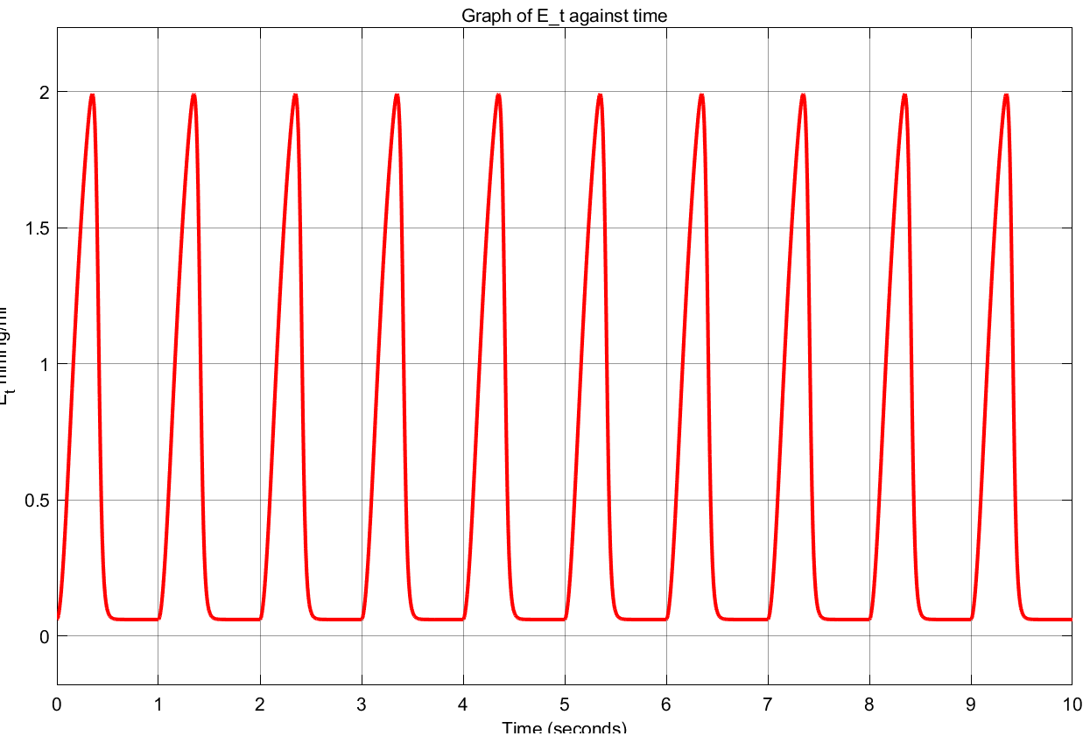

Figure 6: Elastance

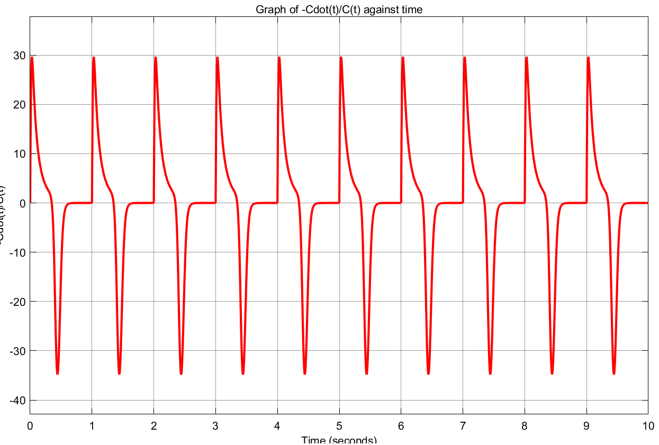

Figure 7:

In table 1, values of the parameters for an average healthy person are given.

|  |  |  |
| --- | --- | --- |
| Parameters | Value | Physical Meaning |
|  |  | Systemic Vascular Resistance |
|  |  | Mitral Valve Resistance |
|  |  | Aortic Valve Resistance |
|  |  | Characteristic Resistance |
|  | Time dependent | Left Ventricular Compliance |
|  |  | Left Atrial Compliance |
|  |  | Systemic Compliance |
|  |  | Aortic Compliance |
|  |  | Intertia of Blood in Aorta |

**Table 1: Parameters of the model and their values**

In table 2, state variables of the model are given.

|  |  |  |
| --- | --- | --- |
| Variables | Names | Physical Meaning |
|  | LVP(t) | Left Ventricular Pressure |
|  | LAP(t) | Left Atrial Pressure |
|  | AP(t) | Arterial Pressure |
|  | AoP(t) | Aortic Pressure |
|  | Qao(t) | Aortic Flow |

**Table 2: State variables of the model**

Using these tables, the state-spaace model of the system can be given as

where

After necessary calculations, left ventricle volume can be found using

where

V0 = Reference volume (chosen as )

Solving the state space model results in Figure 8 to Figure 12 which show the state variables for three seconds for a person with a heart rate of 60.

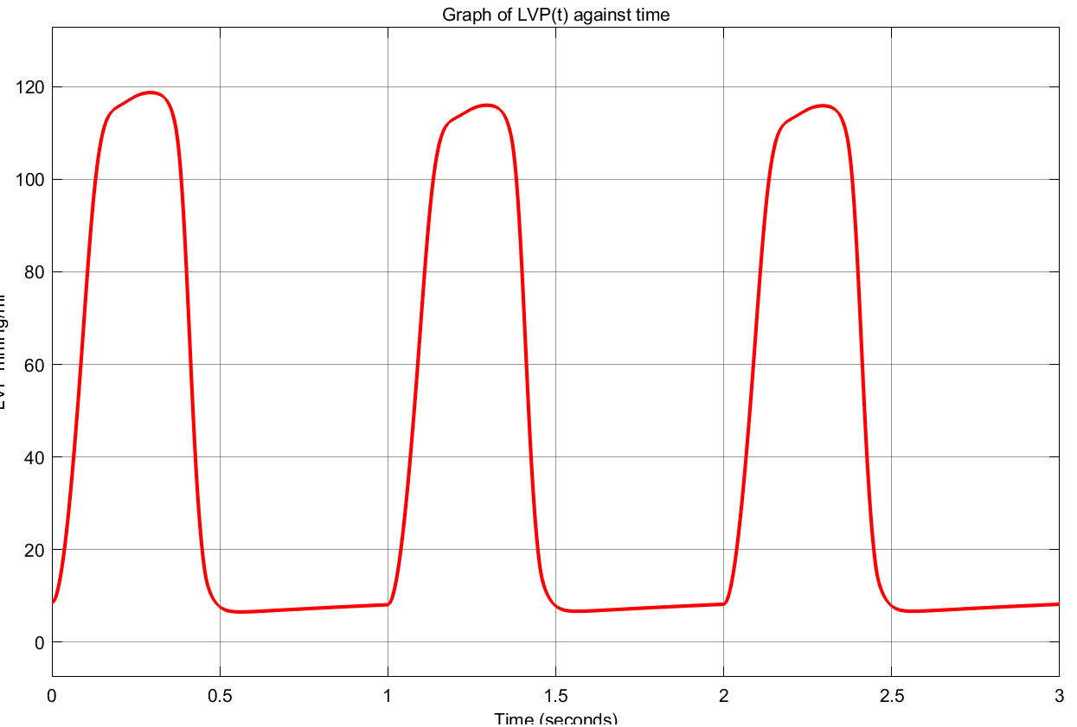

Figure 8: Left ventricular pressure

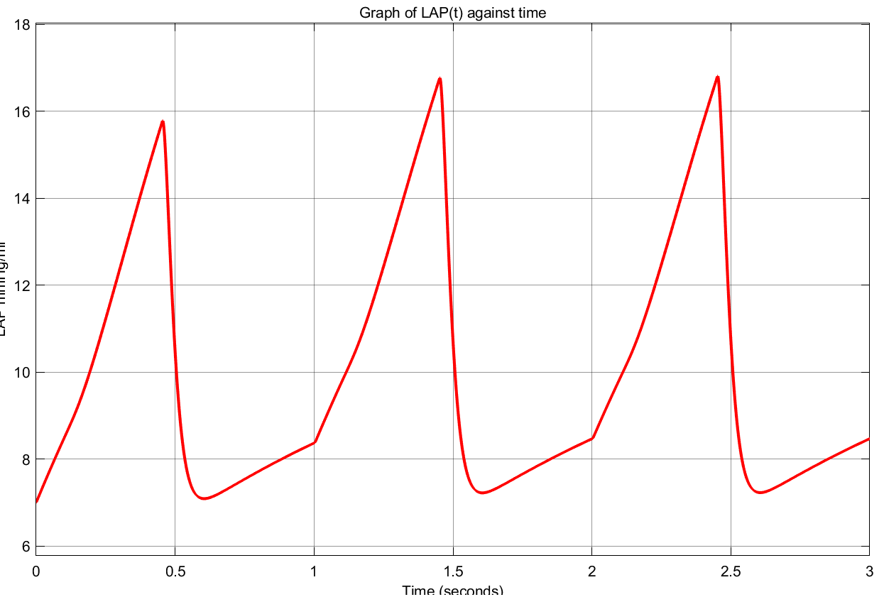

Figure 9: Left atrial pressure

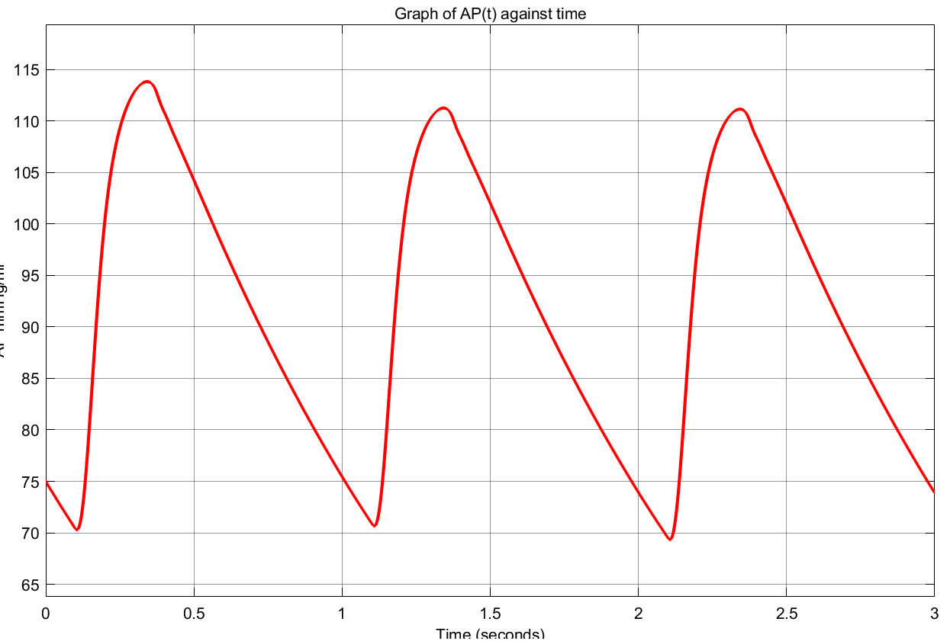

Figure 10: Arterial pressure

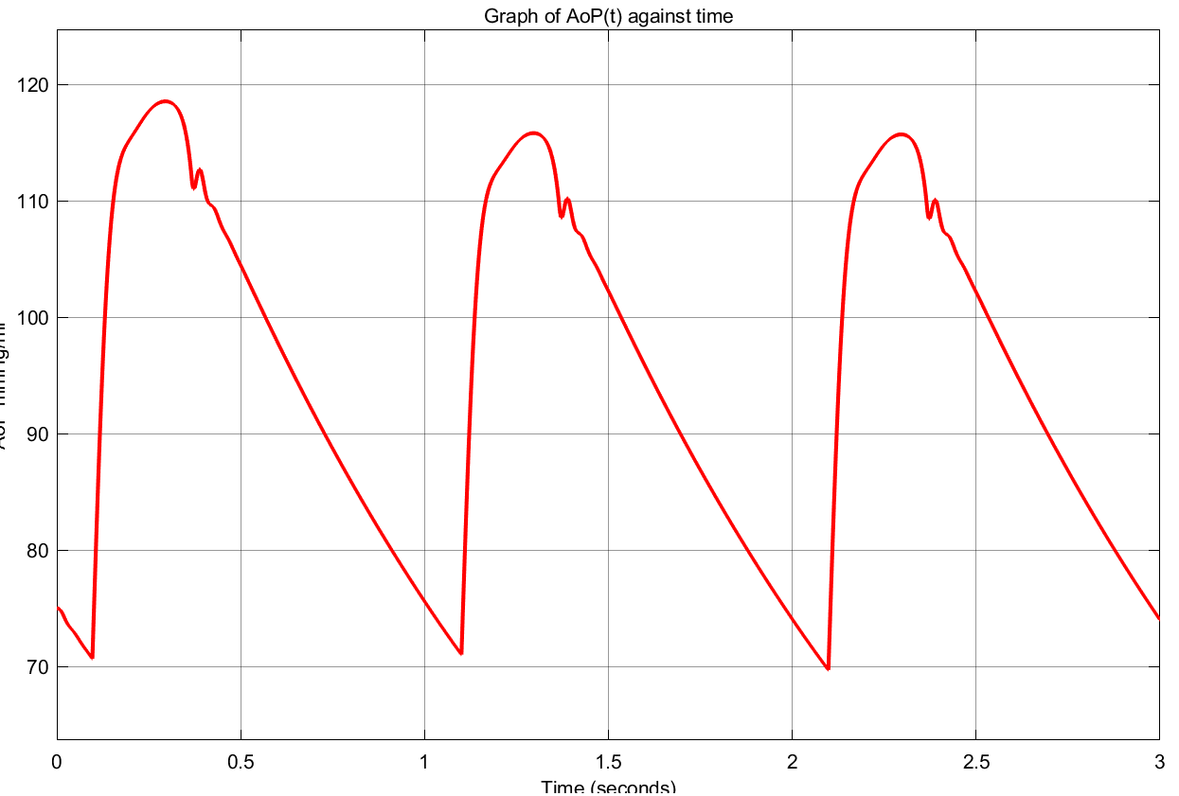

Figure 11: Aortic pressure

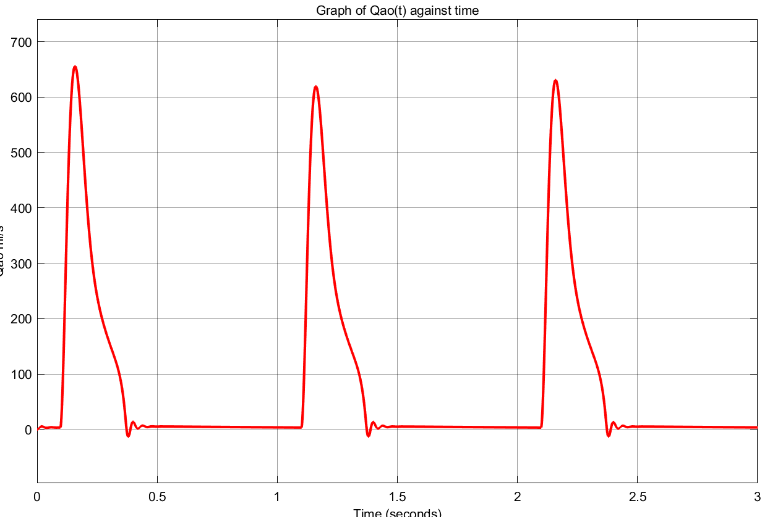

Figure 12: Aortic flow

For different values of pre-load, left ventricle pressure and volume can be seen in Figure 13



Figure 13: Left ventricle pressure and volume

As seen from the figure, as pre-load () increases, the heart is not able to tolerate, hence it can not provide the necessary oxygen to the rest of the body. The same result can be achieved by changing the after-load resistance ().

## b) Modelling and simulation of the cardiovascular system with LVAD

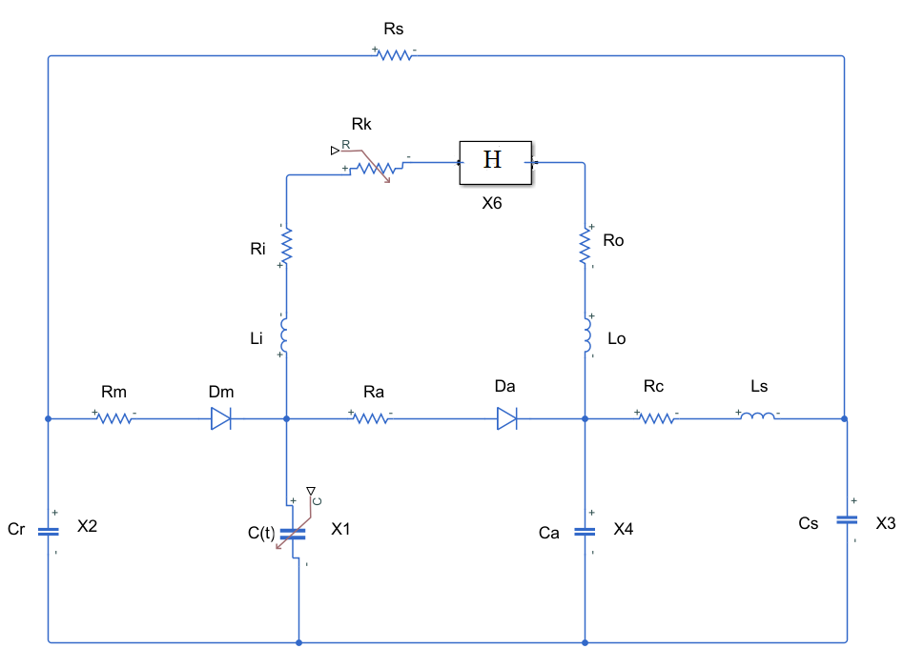

Figure 14: Electrical circuit equivalent of cardiovascular system with LVAD

Now, the model is extended with the addition of LVAD, see Figure 14. A new state emerged as which represents the blood flow through the pump. Here, is given as

where is the threshold pressure of LV which is chosen as 1 mmHg and is a weight term that is chosen as . Before calculating the state-space model, some terms are defined as

and the values of LVAD parameters are given in table 3.

|  |  |  |
| --- | --- | --- |
| Parameters | Value | Physical Meaning |
|  |  | Inlet Resistance of Cannulae |
|  |  | Outlet Resistance of Cannulae |
|  | Time dependent | Suction Resistance |
|  |  | Inertance at the Cannulae Inlet |
|  |  | Inertance at the Cannulae Outlet |
|  |  | Pressure difference parameter 1 |
|  |  | Pressure difference parameter 2 |
|  |  | Pressure difference parameter 3 |

**Table 3: LVAD Parameters**

Using these tables, the new state-space model of the system can be given as

where

and and is the speed of the pump in krpm.

Solving the state space model for a patient with end stage HF and with and without LVAD device can be seen in Table 4.

|  |  |  |
| --- | --- | --- |
|  | Patient with end stage HF | Patient with end stage HF and LVAD |
|  |  |  |
|  |  |  |
|  |  |  |
|  |  |  |
|  |  |  |

**Table 4: States of a patient with and without LVAD**

As seen in table 4, the aortic flow rate has been fixed back to its normal rate. This shows that the LVAD device has been able to provide its purpose, helping the heart supply the necessary oxygen to the body.

# 5) Conclusion

This study has shown that it is possible to model the human cardiovascular system with a state space model with 5 states. Using this model, the states of patients with HF have been observed. Then, this state space model has been extended with an electrical analogy model of an LVAD device. Lastly, this final model has been used to get the patient with end stage HF back to normal in terms of heart parameters. Simulations have shown that the device can change the states as desired.

# 6) References

Dadgar, S. (2014). *Validation of the first Turkish axial-flow left-ventricular assist device using particle image velocimetry (PIV)* (Master's thesis, Fen Bilimleri Enstitüsü).

Englert, J. A., Davis, J. A., & Krim, S. R. (2016). Mechanical circulatory support for the failing heart: Continuous-flow left ventricular assist devices. *Ochsner Journal*, *16*(3), 263-269.

Simaan, M. A., Faragallah, G., Wang, Y., & Divo, E. (2011). Left ventricular assist devices: Engineering design considerations. In *New Aspects of Ventricular Assist Devices* (Vol. 2, pp. 21-42). Intech Publishers.

Simaan, M. A., Ferreira, A., Chen, S., Antaki, J. F., & Galati, D. G. (2008). A dynamical state space representation and performance analysis of a feedback-controlled rotary left ventricular assist device. *IEEE Transactions on Control Systems Technology*, *17*(1), 15-28.

Tan, K. E., Yahya, S., Almurib, H. A., & Moghavvemi, M. (2016, November). Modelling of human cardiovascular system in ventricular assist device simulation. In *2016 IEEE Industrial Electronics and Applications Conference (IEACon)* (pp. 304-311). IEEE.

# GitHub Logos and Usage · GitHub7) Appendix

## Github

<https://github.com/ASemihKarakas99/LVAD->