Ayush Sharma 18 January 2018

(150123046)

S(0) = 100, K = 100, T = 1, M = 100, r = 8%, vol = 20%

Use the following two sets of u and d for your program.

* Set 1: $u=e^{σ\sqrt{Δt}}$; $d=e^{-σ\sqrt{Δt}}$.
* Set 2: $u=e^{σ\sqrt{Δt}+(r-\frac{1}{2}σ^{2})Δt}$; $u=e^{-σ\sqrt{Δt}+(r-\frac{1}{2}σ^{2})Δt}$.

Here $Δt=\frac{T}{M}$, with $M$ being the number of subintervals in the time interval $[0,T]$. Use the continuous compounding convention in your calculations (i.e., both in $\overset{˜}{P}$ and in the pricing formula).

Question 1.

- European Options

For the given two sets of u and d:

* Set 1.
  + Initial call option price = 12.08538 .
  + Initial put option price = 4.397015 .
* Set 2.
  + Initial call option price = 12.12305 .
  + Initial put option price = 4.434682 .

Now, plot of the initial prices of both call and put options (for both the given sets of u and d) by varying one of the parameters at a time (as given below) while keeping the other parameters fixed (as given above) :

1. S(0)

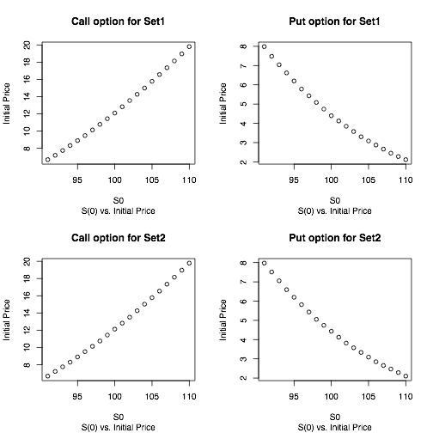

1. K

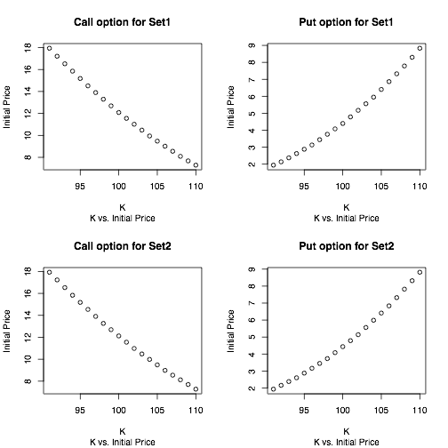

1. r

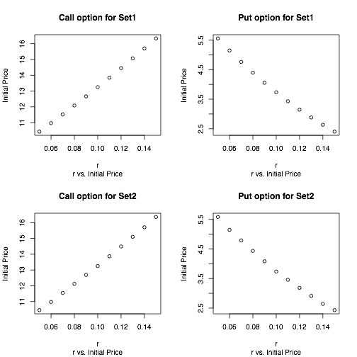

1. vol

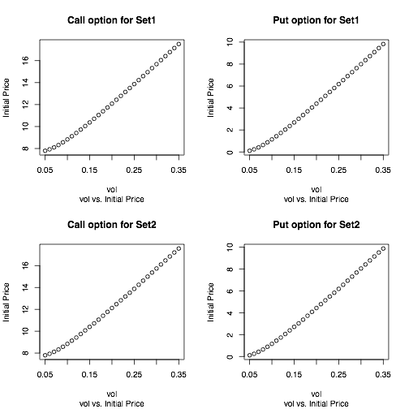

1. M (Do this for three values of K , K = 95; 100; 105 ).
   * K = 95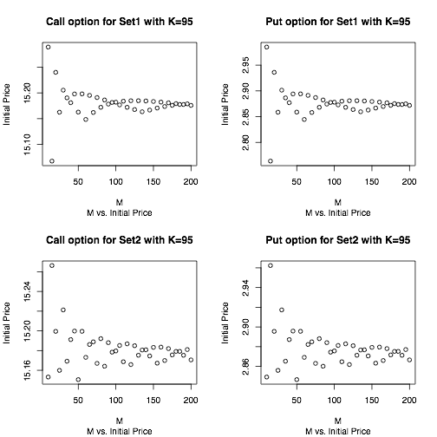
   * K = 100

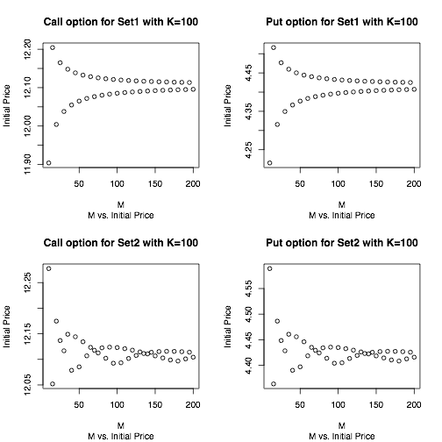

* + K = 105

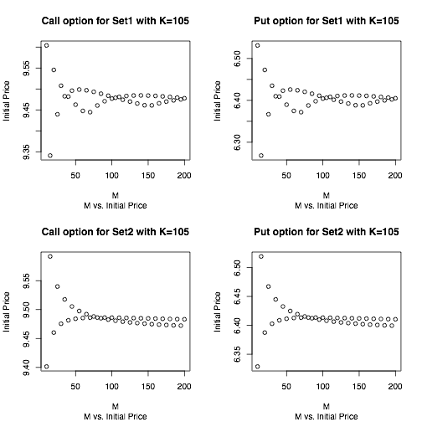

Question 2.

- Look-back Options

For the given two sets of u and d:

* Set 1.
  + Initial call option price = 14.50656 .
  + Initial put option price = 3.530844 .
* Set 2.
  + Initial call option price = 14.9511 .
  + Initial put option price = 3.905206 .

Now, plot of the initial prices of both call and put options (for both the given sets of u and d) by varying one of the parameters at a time (as given below) while keeping the other parameters fixed (as given above) :

1. S(0)

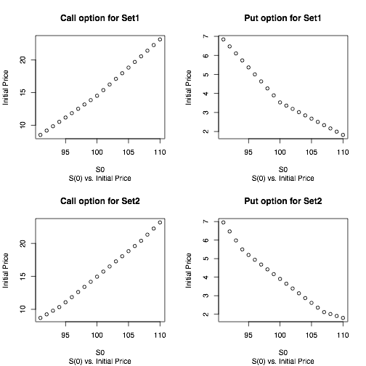

1. K

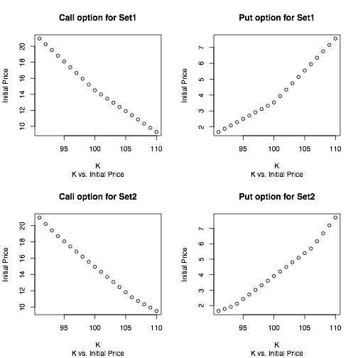

1. r

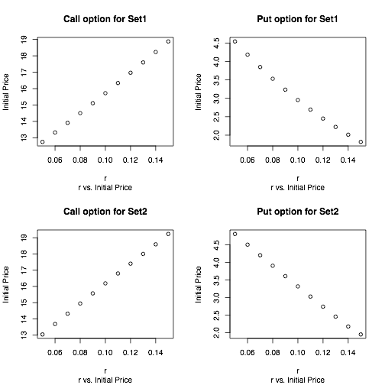

1. vol

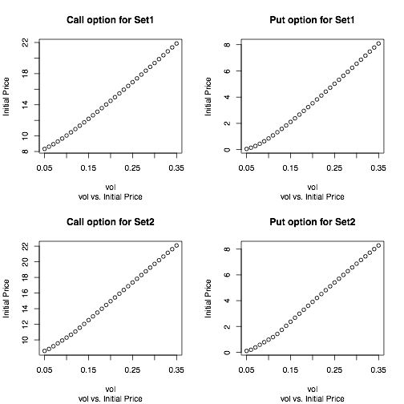

1. M (Do this for three values of K , K = 95; 100; 105 ).
   * K = 95

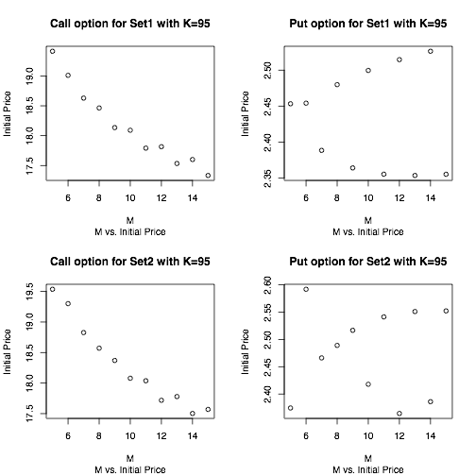

* + K = 100

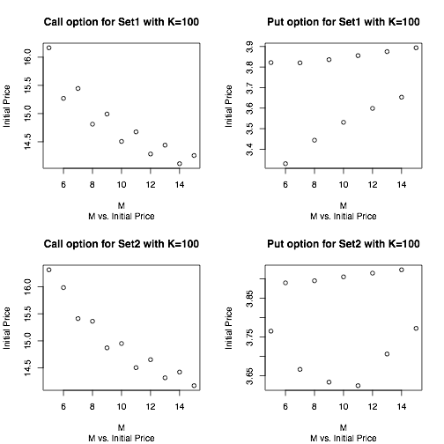

* + K = 105

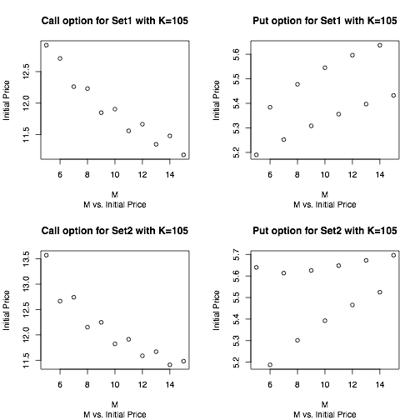

Code (R)

*### Script for question 1.*

#European Options

rm(list = ls());

pos <- function(x){

ind = which(x < 0)

z = x

z[ind] <- 0 ## z now contains the x^+

return(z)

}

binopt <- function( S0, K, r, t, M, vol, Flag, uFlag ){

dt = t/M;

time <- seq(0, t, by=dt);

if (uFlag == 'a'){

u = exp(vol*sqrt(dt));

d = exp(-vol*sqrt(dt));

} else if (uFlag == 'b'){

u = exp(vol*sqrt(dt) + (r-((vol^2)/2))*dt);

d = exp(-vol*sqrt(dt) + (r-((vol^2)/2))*dt);

}

#Continuous Compounding so "exp(r*dt)".

if ((d > exp(r*dt)) | (exp(r*dt) > u)){

stop('ArbitargePossible as "d < exp(r*dt) < u" not true.');

}

AssetPrice <- matrix(0, nrow = (M+1), ncol = (M+1));

OptionValue <- matrix(0, nrow = (M+1), ncol = (M+1));

AssetPrice[1,1] = S0;

for (i in 2:(M+1)){

AssetPrice[1, i] <- AssetPrice[1, (i-1)]*u;

AssetPrice[2:i, i] <- AssetPrice[1:(i-1), (i-1)]*d;

}

#Flag = 1 for a call option, or Flag = 0 for a put option.

if (Flag == 1){

OptionValue[, M+1] <- pos(AssetPrice[, M+1] - K);

}

else if (Flag == 0){

OptionValue[, M+1] <- pos(K - AssetPrice[, M+1]);

}

#Continuous Compounding so "exp(r*dt)".

p_ = (exp(r*dt) - d)/(u-d);

q_ = (u - exp(r*dt))/(u-d);

for (i in seq(M, 1, by=-1)){

OptionValue[1:i, i] <- (p_*OptionValue[1:i, i+1] + q_*OptionValue[2:(i+1), i+1])/exp(r*dt);

}

result <- list("AssetPrice" = AssetPrice, "OptionValue" = OptionValue, "time" = time);

return(result);

}

S0 = 100;

K = 100;

t = 1;

M = 100;

r = 0.08;

vol = 0.2;

cat("Set 1.\n");

cat("Initial call option price =", (binopt( S0, K, r, t, M, vol, 1 , 'a' )$OptionValue)[1,1], ".\n");

cat("Initial put option price =", (binopt( S0, K, r, t, M, vol, 0 , 'a' )$OptionValue)[1,1], ".\n");

cat("Set 2.\n");

cat("Initial call option price =", (binopt( S0, K, r, t, M, vol, 1 , 'b' )$OptionValue)[1,1], ".\n");

cat("Initial put option price =", (binopt( S0, K, r, t, M, vol, 0 , 'b' )$OptionValue)[1,1], ".\n");

##Part a.

S0 = 91:110;

a1c <- 1:length(S0); a1p <- 1:length(S0);

a2c <- 1:length(S0); a2p <- 1:length(S0);

for (i in 1:length(S0)) {

a1c[i] <- (binopt( S0[i], K, r, t, M, vol, 1 , 'a' )$OptionValue)[1,1];

a1p[i] <- (binopt( S0[i], K, r, t, M, vol, 0 , 'a' )$OptionValue)[1,1];

a2c[i] <- (binopt( S0[i], K, r, t, M, vol, 1 , 'b' )$OptionValue)[1,1];

a2p[i] <- (binopt( S0[i], K, r, t, M, vol, 0 , 'b' )$OptionValue)[1,1];

}

pdf("1a.pdf");

par(mfrow=c(2,2));

plot(S0,a1c, main="Call option for Set1", sub="S(0) vs. Initial Price",

xlab="S0", ylab="Initial Price");

plot(S0,a1p, main="Put option for Set1", sub="S(0) vs. Initial Price",

xlab="S0", ylab="Initial Price");

plot(S0,a2c, main="Call option for Set2", sub="S(0) vs. Initial Price",

xlab="S0", ylab="Initial Price");

plot(S0,a2p, main="Put option for Set2", sub="S(0) vs. Initial Price",

xlab="S0", ylab="Initial Price");

dev.off();

S0 = 100;

#*#

##Part b.

K = 91:110;

b1c <- 1:length(K); b1p <- 1:length(K);

b2c <- 1:length(K); b2p <- 1:length(K);

for (i in 1:length(K)) {

b1c[i] <- (binopt( S0, K[i], r, t, M, vol, 1 , 'a' )$OptionValue)[1,1];

b1p[i] <- (binopt( S0, K[i], r, t, M, vol, 0 , 'a' )$OptionValue)[1,1];

b2c[i] <- (binopt( S0, K[i], r, t, M, vol, 1 , 'b' )$OptionValue)[1,1];

b2p[i] <- (binopt( S0, K[i], r, t, M, vol, 0 , 'b' )$OptionValue)[1,1];

}

pdf("1b.pdf");

par(mfrow=c(2,2));

plot(K,b1c, main="Call option for Set1", sub="K vs. Initial Price",

xlab="K", ylab="Initial Price");

plot(K,b1p, main="Put option for Set1", sub="K vs. Initial Price",

xlab="K", ylab="Initial Price");

plot(K,b2c, main="Call option for Set2", sub="K vs. Initial Price",

xlab="K", ylab="Initial Price");

plot(K,b2p, main="Put option for Set2", sub="K vs. Initial Price",

xlab="K", ylab="Initial Price");

dev.off();

K = 100;

#*#

##Part c.

r = seq(0.05, 0.15, by=0.01);

c1c <- 1:length(r); c1p <- 1:length(r);

c2c <- 1:length(r); c2p <- 1:length(r);

for (i in 1:length(r)) {

c1c[i] <- (binopt( S0, K, r[i], t, M, vol, 1 , 'a' )$OptionValue)[1,1];

c1p[i] <- (binopt( S0, K, r[i], t, M, vol, 0 , 'a' )$OptionValue)[1,1];

c2c[i] <- (binopt( S0, K, r[i], t, M, vol, 1 , 'b' )$OptionValue)[1,1];

c2p[i] <- (binopt( S0, K, r[i], t, M, vol, 0 , 'b' )$OptionValue)[1,1];

}

pdf("1c.pdf");

par(mfrow=c(2,2));

plot(r,c1c, main="Call option for Set1", sub="r vs. Initial Price",

xlab="r", ylab="Initial Price");

plot(r,c1p, main="Put option for Set1", sub="r vs. Initial Price",

xlab="r", ylab="Initial Price");

plot(r,c2c, main="Call option for Set2", sub="r vs. Initial Price",

xlab="r", ylab="Initial Price");

plot(r,c2p, main="Put option for Set2", sub="r vs. Initial Price",

xlab="r", ylab="Initial Price");

dev.off();

r = 0.08;

#*#

##Part d.

vol = seq(0.05, 0.35, by=0.01);

d1c <- 1:length(vol); d1p <- 1:length(vol);

d2c <- 1:length(vol); d2p <- 1:length(vol);

for (i in 1:length(vol)) {

d1c[i] <- (binopt( S0, K, r, t, M, vol[i], 1 , 'a' )$OptionValue)[1,1];

d1p[i] <- (binopt( S0, K, r, t, M, vol[i], 0 , 'a' )$OptionValue)[1,1];

d2c[i] <- (binopt( S0, K, r, t, M, vol[i], 1 , 'b' )$OptionValue)[1,1];

d2p[i] <- (binopt( S0, K, r, t, M, vol[i], 0 , 'b' )$OptionValue)[1,1];

}

pdf("1d.pdf");

par(mfrow=c(2,2));

plot(vol,d1c, main="Call option for Set1", sub="vol vs. Initial Price",

xlab="vol", ylab="Initial Price");

plot(vol,d1p, main="Put option for Set1", sub="vol vs. Initial Price",

xlab="vol", ylab="Initial Price");

plot(vol,d2c, main="Call option for Set2", sub="vol vs. Initial Price",

xlab="vol", ylab="Initial Price");

plot(vol,d2p, main="Put option for Set2", sub="vol vs. Initial Price",

xlab="vol", ylab="Initial Price");

dev.off();

vol = 0.2;

#*#

##Part e.

M = seq(10, 200, by=5);

e1c_k95 <- 1:length(M); e1c_k100 <- 1:length(M); e1c_k105 <- 1:length(M);

e1p_k95 <- 1:length(M); e1p_k100 <- 1:length(M); e1p_k105 <- 1:length(M);

e2c_k95 <- 1:length(M); e2c_k100 <- 1:length(M); e2c_k105 <- 1:length(M);

e2p_k95 <- 1:length(M); e2p_k100 <- 1:length(M); e2p_k105 <- 1:length(M);

for (i in 1:length(M)) {

e1c_k95[i] <- (binopt( S0, 95, r, t, M[i], vol, 1 , 'a' )$OptionValue)[1,1];

e1p_k95[i] <- (binopt( S0, 95, r, t, M[i], vol, 0 , 'a' )$OptionValue)[1,1];

e2c_k95[i] <- (binopt( S0, 95, r, t, M[i], vol, 1 , 'b' )$OptionValue)[1,1];

e2p_k95[i] <- (binopt( S0, 95, r, t, M[i], vol, 0 , 'b' )$OptionValue)[1,1];

e1c_k100[i] <- (binopt( S0, 100, r, t, M[i], vol, 1 , 'a' )$OptionValue)[1,1];

e1p_k100[i] <- (binopt( S0, 100, r, t, M[i], vol, 0 , 'a' )$OptionValue)[1,1];

e2c_k100[i] <- (binopt( S0, 100, r, t, M[i], vol, 1 , 'b' )$OptionValue)[1,1];

e2p_k100[i] <- (binopt( S0, 100, r, t, M[i], vol, 0 , 'b' )$OptionValue)[1,1];

e1c_k105[i] <- (binopt( S0, 105, r, t, M[i], vol, 1 , 'a' )$OptionValue)[1,1];

e1p_k105[i] <- (binopt( S0, 105, r, t, M[i], vol, 0 , 'a' )$OptionValue)[1,1];

e2c_k105[i] <- (binopt( S0, 105, r, t, M[i], vol, 1 , 'b' )$OptionValue)[1,1];

e2p_k105[i] <- (binopt( S0, 105, r, t, M[i], vol, 0 , 'b' )$OptionValue)[1,1];

}

pdf("1e_k95.pdf");

par(mfrow=c(2,2));

plot(M,e1c_k95, main="Call option for Set1 with K=95", sub="M vs. Initial Price",

xlab="M", ylab="Initial Price");

plot(M,e1p_k95, main="Put option for Set1 with K=95", sub="M vs. Initial Price",

xlab="M", ylab="Initial Price");

plot(M,e2c_k95, main="Call option for Set2 with K=95", sub="M vs. Initial Price",

xlab="M", ylab="Initial Price");

plot(M,e2p_k95, main="Put option for Set2 with K=95", sub="M vs. Initial Price",

xlab="M", ylab="Initial Price");

dev.off();

pdf("1e_k100.pdf");

par(mfrow=c(2,2));

plot(M,e1c_k100, main="Call option for Set1 with K=100", sub="M vs. Initial Price",

xlab="M", ylab="Initial Price");

plot(M,e1p_k100, main="Put option for Set1 with K=100", sub="M vs. Initial Price",

xlab="M", ylab="Initial Price");

plot(M,e2c_k100, main="Call option for Set2 with K=100", sub="M vs. Initial Price",

xlab="M", ylab="Initial Price");

plot(M,e2p_k100, main="Put option for Set2 with K=100", sub="M vs. Initial Price",

xlab="M", ylab="Initial Price");

dev.off();

pdf("1e_k105.pdf");

par(mfrow=c(2,2));

plot(M,e1c_k105, main="Call option for Set1 with K=105", sub="M vs. Initial Price",

xlab="M", ylab="Initial Price");

plot(M,e1p_k105, main="Put option for Set1 with K=105", sub="M vs. Initial Price",

xlab="M", ylab="Initial Price");

plot(M,e2c_k105, main="Call option for Set2 with K=105", sub="M vs. Initial Price",

xlab="M", ylab="Initial Price");

plot(M,e2p_k105, main="Put option for Set2 with K=105", sub="M vs. Initial Price",

xlab="M", ylab="Initial Price");

dev.off();

M = 100;

#*#

rm(list = ls())

*### Script for Question 2.*

#Lookback Options

rm(list = ls());

pos <- function(x){

ind = which(x < 0)

z = x

z[ind] <- 0 ## z now contains the x^+

return(z)

}

greater <- function(x, y){

ind = which(x < y)

z = x

z[ind] <- y[ind] ## z now contains the max(x,y) iterative.

return(z)

}

binopt <- function( S0, K, r, t, M, vol, Flag, uFlag ){

dt = t/M;

time <- seq(0, t, by=dt);

if (uFlag == 'a'){

u = exp(vol*sqrt(dt));

d = exp(-vol*sqrt(dt));

} else if (uFlag == 'b'){

u = exp(vol*sqrt(dt) + (r-((vol^2)/2))*dt);

d = exp(-vol*sqrt(dt) + (r-((vol^2)/2))*dt);

}

#Continuous Compounding so "exp(r*dt)".

if ((d > exp(r*dt)) | (exp(r*dt) > u)){

stop('ArbitargePossible as "d < exp(r*dt) < u" not true.');

}

AssetPrice <- matrix(0, nrow = (2^M), ncol = (M+1));

OptionValue <- matrix(0, nrow = (2^M), ncol = (M+1));

MaxAsset <- matrix(0, nrow = (2^M), ncol = (M+1));

AssetPrice[1,1] = S0; MaxAsset[1,1] = S0;

for (i in 2:(M+1)){

AssetPrice[seq(1, 2^(i-1), 2), i] <- AssetPrice[(1:2^(i-2)), (i-1)]*u;

AssetPrice[seq(2, 2^(i-1), 2), i] <- AssetPrice[(1:2^(i-2)), (i-1)]*d;

MaxAsset[seq(1, 2^(i-1), 2), i] <- greater(AssetPrice[seq(1, 2^(i-1), 2), i], MaxAsset[(1:2^(i-2)), i]);

MaxAsset[seq(2, 2^(i-1), 2), i] <- greater(AssetPrice[seq(2, 2^(i-1), 2), i], MaxAsset[(1:2^(i-2)), i])

}

#Flag = 1 for a call option, or Flag = 0 for a put option.

if (Flag == 1){

OptionValue[, M+1] <- pos(MaxAsset[, M+1] - K);

}

else if (Flag == 0){

OptionValue[, M+1] <- pos(K - MaxAsset[, M+1]);

}

#Continuous Compounding so "exp(r*dt)".

p_ = (exp(r*dt) - d)/(u-d);

q_ = (u - exp(r*dt))/(u-d);

for (i in seq(M, 1, by=-1)){

#for European Options:

#OptionValue[1:i, i] <- (p_*OptionValue[1:i, i+1] + q_*OptionValue[2:(i+1), i+1])/exp(r*dt);

#for American Options:

#if (Flag == 1){

# OptionValue[1:i, i] <- greater(pos(AssetPrice[1:i, i] - K), (p_*OptionValue[1:i, i+1] + q_*OptionValue[2:(i+1), i+1])/exp(r*dt));

#}

#else if (Flag == 0){

# OptionValue[1:i, i] <- greater(pos(K - AssetPrice[1:i, i]), (p_*OptionValue[1:i, i+1] + q_*OptionValue[2:(i+1), i+1])/exp(r*dt));

#}

#for Lookback Options:

OptionValue[1:2^(i-1), i] <- (p_*OptionValue[seq(1, 2^i, 2), i+1] + q_*OptionValue[seq(2, 2^i, 2), i+1])/exp(r*dt);

}

result <- list("AssetPrice" = AssetPrice, "OptionValue" = OptionValue, "time" = time);

return(result);

}

S0 = 100;

K = 100;

t = 1;

M = 10;

r = 0.08;

vol = 0.2;

cat("Set 1.\n");

cat("Initial call option price =", (binopt( S0, K, r, t, M, vol, 1 , 'a' )$OptionValue)[1,1], ".\n");

cat("Initial put option price =", (binopt( S0, K, r, t, M, vol, 0 , 'a' )$OptionValue)[1,1], ".\n");

cat("Set 2.\n");

cat("Initial call option price =", (binopt( S0, K, r, t, M, vol, 1 , 'b' )$OptionValue)[1,1], ".\n");

cat("Initial put option price =", (binopt( S0, K, r, t, M, vol, 0 , 'b' )$OptionValue)[1,1], ".\n");

##Part a.

S0 = 91:110;

a1c <- 1:length(S0); a1p <- 1:length(S0);

a2c <- 1:length(S0); a2p <- 1:length(S0);

for (i in 1:length(S0)) {

a1c[i] <- (binopt( S0[i], K, r, t, M, vol, 1 , 'a' )$OptionValue)[1,1];

a1p[i] <- (binopt( S0[i], K, r, t, M, vol, 0 , 'a' )$OptionValue)[1,1];

a2c[i] <- (binopt( S0[i], K, r, t, M, vol, 1 , 'b' )$OptionValue)[1,1];

a2p[i] <- (binopt( S0[i], K, r, t, M, vol, 0 , 'b' )$OptionValue)[1,1];

}

pdf("2a.pdf");

par(mfrow=c(2,2));

plot(S0,a1c, main="Call option for Set1", sub="S(0) vs. Initial Price",

xlab="S0", ylab="Initial Price");

plot(S0,a1p, main="Put option for Set1", sub="S(0) vs. Initial Price",

xlab="S0", ylab="Initial Price");

plot(S0,a2c, main="Call option for Set2", sub="S(0) vs. Initial Price",

xlab="S0", ylab="Initial Price");

plot(S0,a2p, main="Put option for Set2", sub="S(0) vs. Initial Price",

xlab="S0", ylab="Initial Price");

dev.off();

S0 = 100;

#*#

##Part b.

K = 91:110;

b1c <- 1:length(K); b1p <- 1:length(K);

b2c <- 1:length(K); b2p <- 1:length(K);

for (i in 1:length(K)) {

b1c[i] <- (binopt( S0, K[i], r, t, M, vol, 1 , 'a' )$OptionValue)[1,1];

b1p[i] <- (binopt( S0, K[i], r, t, M, vol, 0 , 'a' )$OptionValue)[1,1];

b2c[i] <- (binopt( S0, K[i], r, t, M, vol, 1 , 'b' )$OptionValue)[1,1];

b2p[i] <- (binopt( S0, K[i], r, t, M, vol, 0 , 'b' )$OptionValue)[1,1];

}

pdf("2b.pdf");

par(mfrow=c(2,2));

plot(K,b1c, main="Call option for Set1", sub="K vs. Initial Price",

xlab="K", ylab="Initial Price");

plot(K,b1p, main="Put option for Set1", sub="K vs. Initial Price",

xlab="K", ylab="Initial Price");

plot(K,b2c, main="Call option for Set2", sub="K vs. Initial Price",

xlab="K", ylab="Initial Price");

plot(K,b2p, main="Put option for Set2", sub="K vs. Initial Price",

xlab="K", ylab="Initial Price");

dev.off();

K = 100;

#*#

##Part c.

r = seq(0.05, 0.15, by=0.01);

c1c <- 1:length(r); c1p <- 1:length(r);

c2c <- 1:length(r); c2p <- 1:length(r);

for (i in 1:length(r)) {

c1c[i] <- (binopt( S0, K, r[i], t, M, vol, 1 , 'a' )$OptionValue)[1,1];

c1p[i] <- (binopt( S0, K, r[i], t, M, vol, 0 , 'a' )$OptionValue)[1,1];

c2c[i] <- (binopt( S0, K, r[i], t, M, vol, 1 , 'b' )$OptionValue)[1,1];

c2p[i] <- (binopt( S0, K, r[i], t, M, vol, 0 , 'b' )$OptionValue)[1,1];

}

pdf("2c.pdf");

par(mfrow=c(2,2));

plot(r,c1c, main="Call option for Set1", sub="r vs. Initial Price",

xlab="r", ylab="Initial Price");

plot(r,c1p, main="Put option for Set1", sub="r vs. Initial Price",

xlab="r", ylab="Initial Price");

plot(r,c2c, main="Call option for Set2", sub="r vs. Initial Price",

xlab="r", ylab="Initial Price");

plot(r,c2p, main="Put option for Set2", sub="r vs. Initial Price",

xlab="r", ylab="Initial Price");

dev.off();

r = 0.08;

#*#

##Part d.

vol = seq(0.05, 0.35, by=0.01);

d1c <- 1:length(vol); d1p <- 1:length(vol);

d2c <- 1:length(vol); d2p <- 1:length(vol);

for (i in 1:length(vol)) {

d1c[i] <- (binopt( S0, K, r, t, M, vol[i], 1 , 'a' )$OptionValue)[1,1];

d1p[i] <- (binopt( S0, K, r, t, M, vol[i], 0 , 'a' )$OptionValue)[1,1];

d2c[i] <- (binopt( S0, K, r, t, M, vol[i], 1 , 'b' )$OptionValue)[1,1];

d2p[i] <- (binopt( S0, K, r, t, M, vol[i], 0 , 'b' )$OptionValue)[1,1];

}

pdf("2d.pdf");

par(mfrow=c(2,2));

plot(vol,d1c, main="Call option for Set1", sub="vol vs. Initial Price",

xlab="vol", ylab="Initial Price");

plot(vol,d1p, main="Put option for Set1", sub="vol vs. Initial Price",

xlab="vol", ylab="Initial Price");

plot(vol,d2c, main="Call option for Set2", sub="vol vs. Initial Price",

xlab="vol", ylab="Initial Price");

plot(vol,d2p, main="Put option for Set2", sub="vol vs. Initial Price",

xlab="vol", ylab="Initial Price");

dev.off();

vol = 0.2;

#*#

##Part e.

M = seq(5, 15, by=1);

e1c_k95 <- 1:length(M); e1c_k100 <- 1:length(M); e1c_k105 <- 1:length(M);

e1p_k95 <- 1:length(M); e1p_k100 <- 1:length(M); e1p_k105 <- 1:length(M);

e2c_k95 <- 1:length(M); e2c_k100 <- 1:length(M); e2c_k105 <- 1:length(M);

e2p_k95 <- 1:length(M); e2p_k100 <- 1:length(M); e2p_k105 <- 1:length(M);

for (i in 1:length(M)) {

e1c_k95[i] <- (binopt( S0, 95, r, t, M[i], vol, 1 , 'a' )$OptionValue)[1,1];

e1p_k95[i] <- (binopt( S0, 95, r, t, M[i], vol, 0 , 'a' )$OptionValue)[1,1];

e2c_k95[i] <- (binopt( S0, 95, r, t, M[i], vol, 1 , 'b' )$OptionValue)[1,1];

e2p_k95[i] <- (binopt( S0, 95, r, t, M[i], vol, 0 , 'b' )$OptionValue)[1,1];

e1c_k100[i] <- (binopt( S0, 100, r, t, M[i], vol, 1 , 'a' )$OptionValue)[1,1];

e1p_k100[i] <- (binopt( S0, 100, r, t, M[i], vol, 0 , 'a' )$OptionValue)[1,1];

e2c_k100[i] <- (binopt( S0, 100, r, t, M[i], vol, 1 , 'b' )$OptionValue)[1,1];

e2p_k100[i] <- (binopt( S0, 100, r, t, M[i], vol, 0 , 'b' )$OptionValue)[1,1];

e1c_k105[i] <- (binopt( S0, 105, r, t, M[i], vol, 1 , 'a' )$OptionValue)[1,1];

e1p_k105[i] <- (binopt( S0, 105, r, t, M[i], vol, 0 , 'a' )$OptionValue)[1,1];

e2c_k105[i] <- (binopt( S0, 105, r, t, M[i], vol, 1 , 'b' )$OptionValue)[1,1];

e2p_k105[i] <- (binopt( S0, 105, r, t, M[i], vol, 0 , 'b' )$OptionValue)[1,1];

}

pdf("2e_k95.pdf");

par(mfrow=c(2,2));

plot(M,e1c_k95, main="Call option for Set1 with K=95", sub="M vs. Initial Price",

xlab="M", ylab="Initial Price");

plot(M,e1p_k95, main="Put option for Set1 with K=95", sub="M vs. Initial Price",

xlab="M", ylab="Initial Price");

plot(M,e2c_k95, main="Call option for Set2 with K=95", sub="M vs. Initial Price",

xlab="M", ylab="Initial Price");

plot(M,e2p_k95, main="Put option for Set2 with K=95", sub="M vs. Initial Price",

xlab="M", ylab="Initial Price");

dev.off();

pdf("2e_k100.pdf");

par(mfrow=c(2,2));

plot(M,e1c_k100, main="Call option for Set1 with K=100", sub="M vs. Initial Price",

xlab="M", ylab="Initial Price");

plot(M,e1p_k100, main="Put option for Set1 with K=100", sub="M vs. Initial Price",

xlab="M", ylab="Initial Price");

plot(M,e2c_k100, main="Call option for Set2 with K=100", sub="M vs. Initial Price",

xlab="M", ylab="Initial Price");

plot(M,e2p_k100, main="Put option for Set2 with K=100", sub="M vs. Initial Price",

xlab="M", ylab="Initial Price");

dev.off();

pdf("2e_k105.pdf");

par(mfrow=c(2,2));

plot(M,e1c_k105, main="Call option for Set1 with K=105", sub="M vs. Initial Price",

xlab="M", ylab="Initial Price");

plot(M,e1p_k105, main="Put option for Set1 with K=105", sub="M vs. Initial Price",

xlab="M", ylab="Initial Price");

plot(M,e2c_k105, main="Call option for Set2 with K=105", sub="M vs. Initial Price",

xlab="M", ylab="Initial Price");

plot(M,e2p_k105, main="Put option for Set2 with K=105", sub="M vs. Initial Price",

xlab="M", ylab="Initial Price");

dev.off();

M = 100;

#*#

rm(list = ls())