**Amir Shariat**

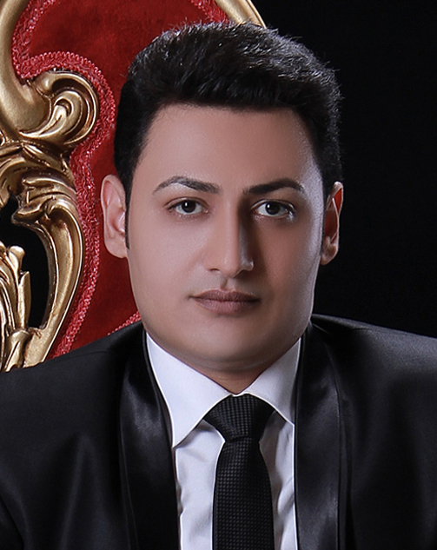

Current Job: Assistant Store Manager at Walmart

Email Address: amirshariat1987@gmail.com

Address: 485 Elizabeth Day Cove, Draper, Utah 84020

Cell Phone: 8017877576

**Work Experiences**

* **Assistant Store Manager**

Walmart - South Jordan, UT

November 2016 to Present

* **Support Manager**

Walmart - West Valley City, UT

November 2015 to October 2016

* **Pharmacy Associate**

Walmart - West Valley City, UT

September 2015 to October 2015

* **CDL Class A Local Delivery Truck Driver**

Admiral Beverage Corporation - Salt Lake City, UT

July 2015 to August 2015

* **CDL Class A Over the Road Truck Driver**

Swift Transportation - Salt Lake City, UT

December 2014 to June 2015

* **Contractor Technician**

SMARTECH and Associates, LP - Salt Lake City, UT

November 2014 to December 2014

* **IMS Associate**

Walmart - Salt Lake City, UT

May 2014 to October 2014

* **Accounting Supervisor/Executive Assistant/Office Manager**

Dr. Akhavi Laboratory – Mashhad, Iran

September 2010 to September 2013

* **Accountant**

Valiasr Shop – Mashhad, Iran

July 2010 to September 2010

* **Quality Control Associate**

Standard Office – Mashhad, Iran

December 2009 to June 2010

* **Delivery Person**

Alys Beverages - Damghan, Iran

June 2009 to December 2009

* **Production Worker**

Electrical Production of Iran Khodro Company – Mashhad, Iran

September 2008 to May 2009

* **Internet Technician**

Paiezan Internet Service – Mashhad, Iran

November 2007 to September 2008

* **Computer Technician**

Aryan Computer Shop and Repair – Mashhad, Iran

May 2007 to November 2007

**Educations**

* **GED**

Salt Lake Community College - Salt Lake City, UT

2014 to 2014

* **Professional Cooking Certificate in Cooking**

Paziresh Toos Hotel Educational Center – Mashhad, Iran

2012 to 2012

* **General Cooking Certificate in Cooking**

Paziresh Toos Hotel Educational Center – Mashhad, Iran

2012 to 2012

* **Accounting Certificate in Accounting**

Taraz Hesab Shargh – Mashhad, Iran

2010 to 2010

* **Associate of Applied Science in Electronics**

Mashhad Technical College – Mashhad, Iran

2005 to 2008

* **High School Diploma in Electronics**

Chamran High School – Mashhad, Iran

2002 to 2004