SOAP!

**Description:**

A simple Soap Lye calculator that is used to determine the amount of lye and water needed to create the desired soap. This app will also give an approximation on different properties of the soap such as the Hardness, Cleansing ability, type of lather, etc. This app was created using React Native and managed by Expo.

**Status:**

Currently in the Internal Test Phase on the Android Play Store. Upload of app build file being processed in the apple Appstore as of May 22,2020.

**ScreenShots:**

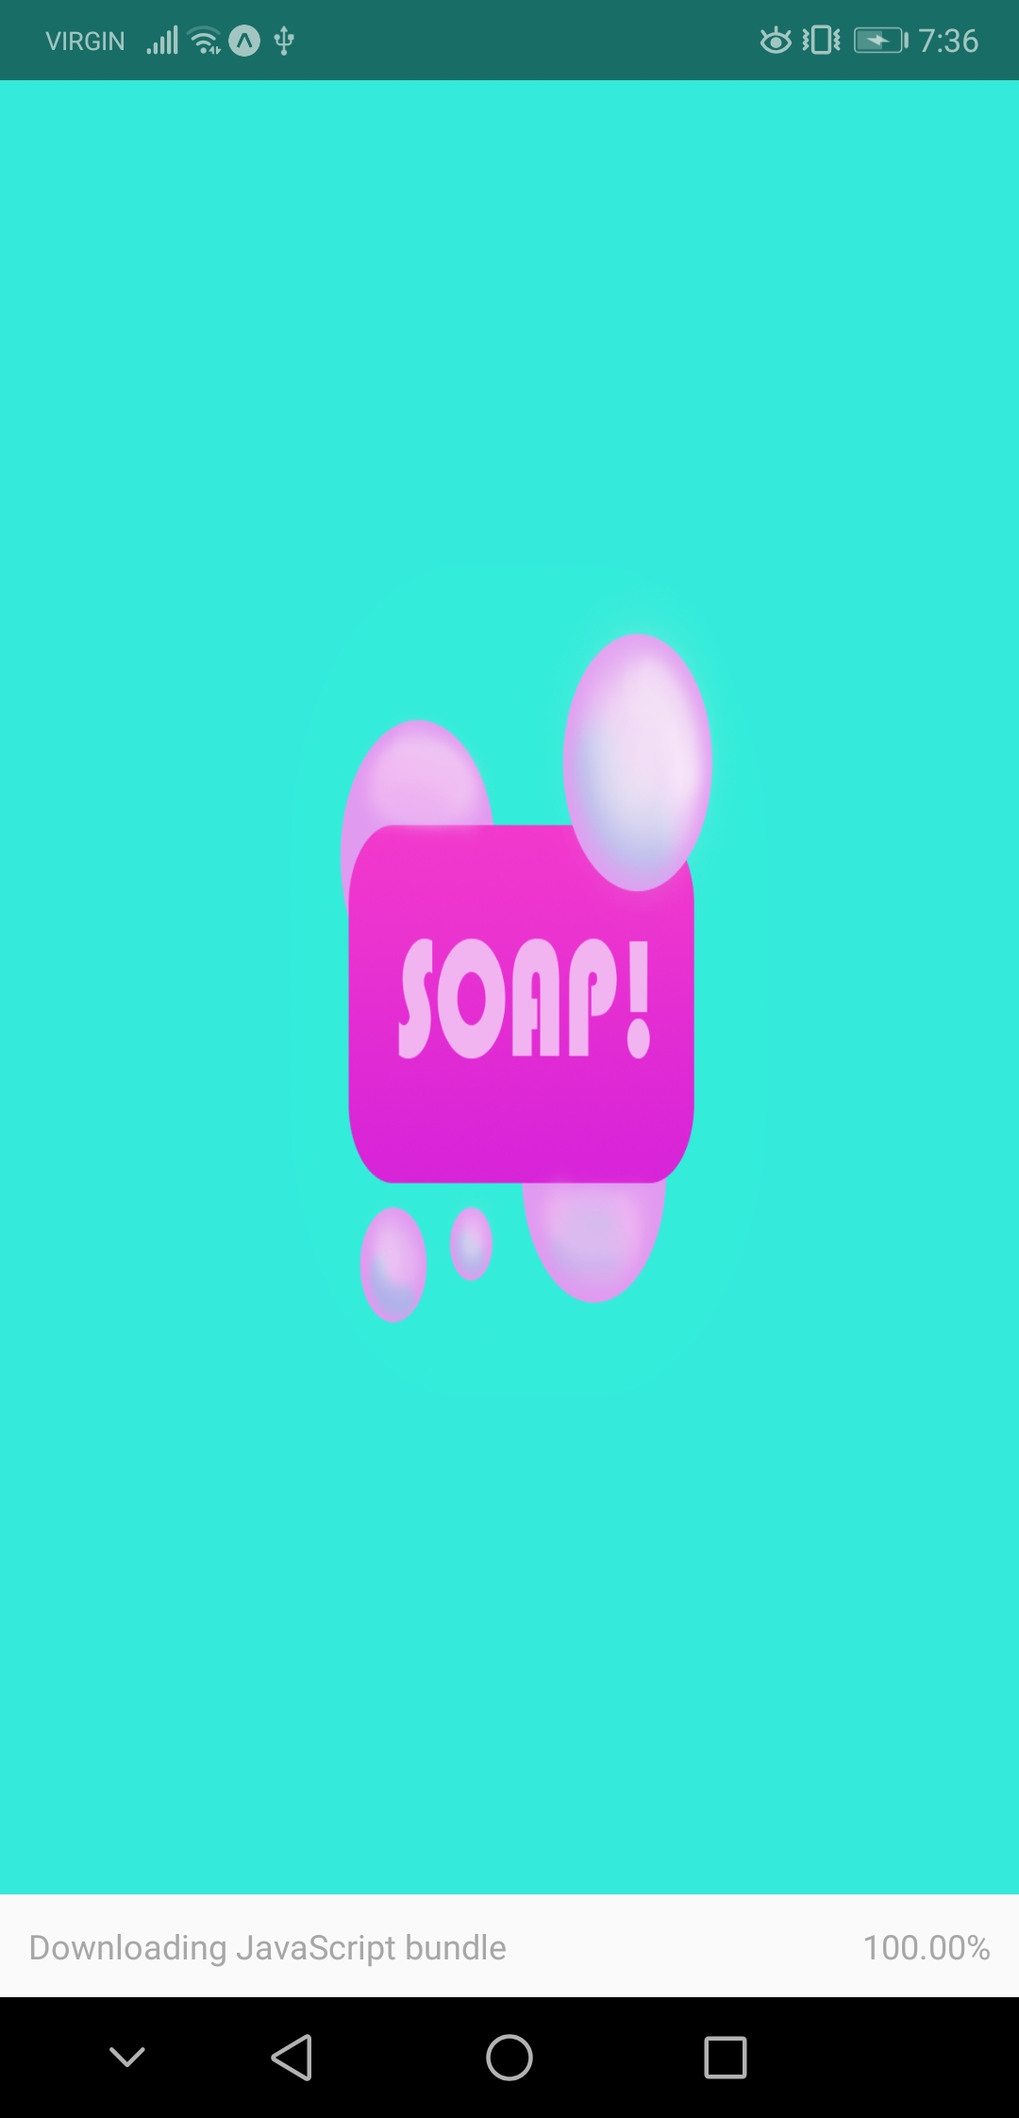

Figure : Splash Screen

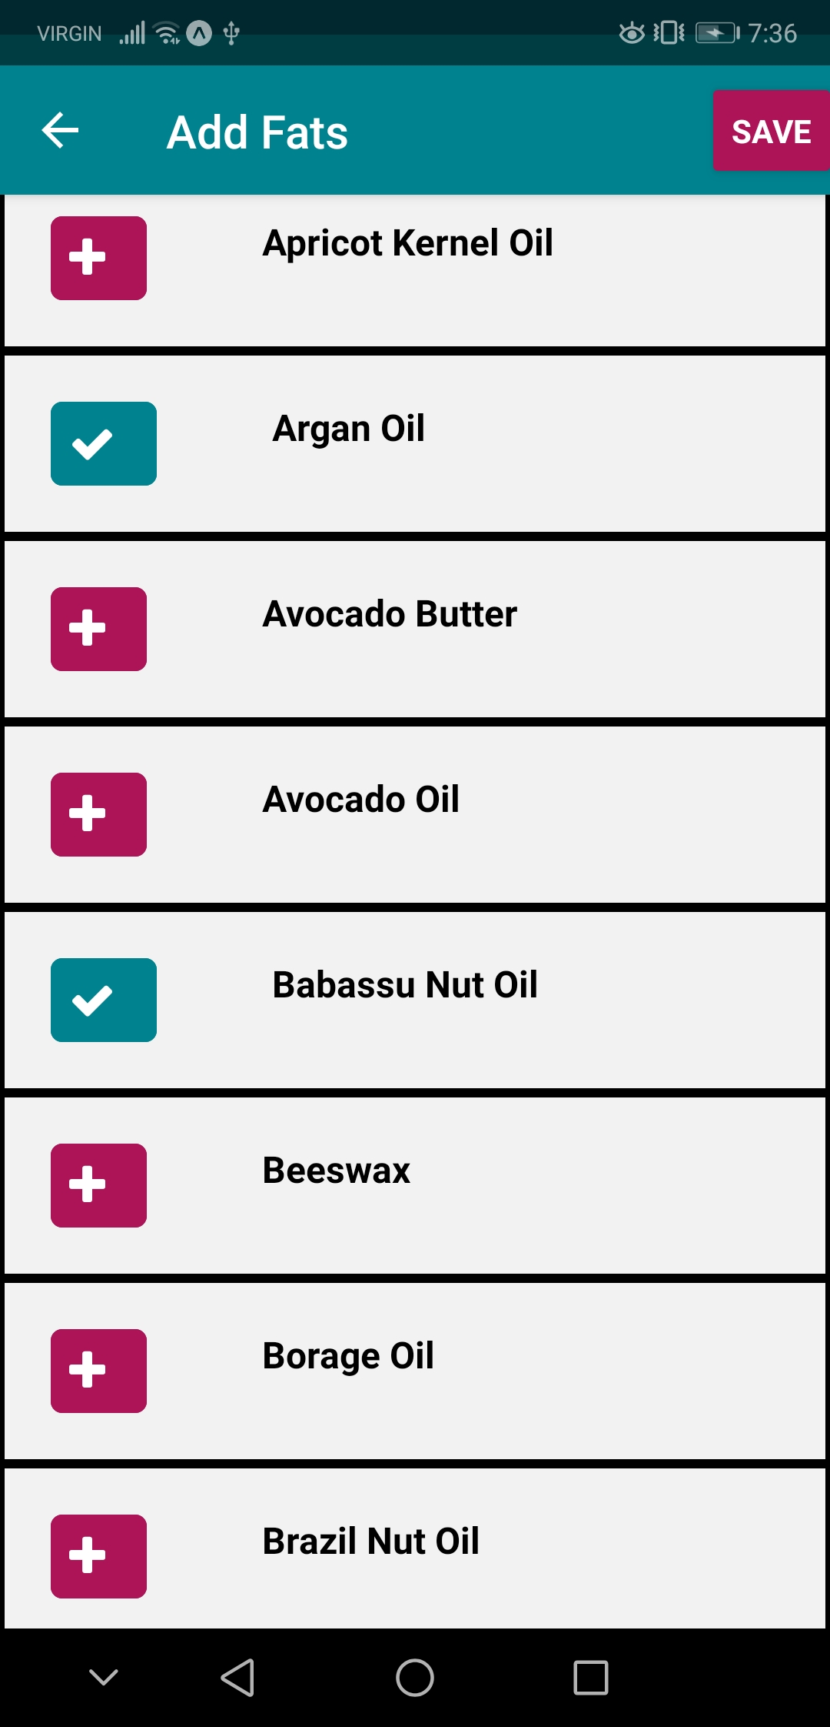

Figure : Section of the Fats and Oils Selection Screen

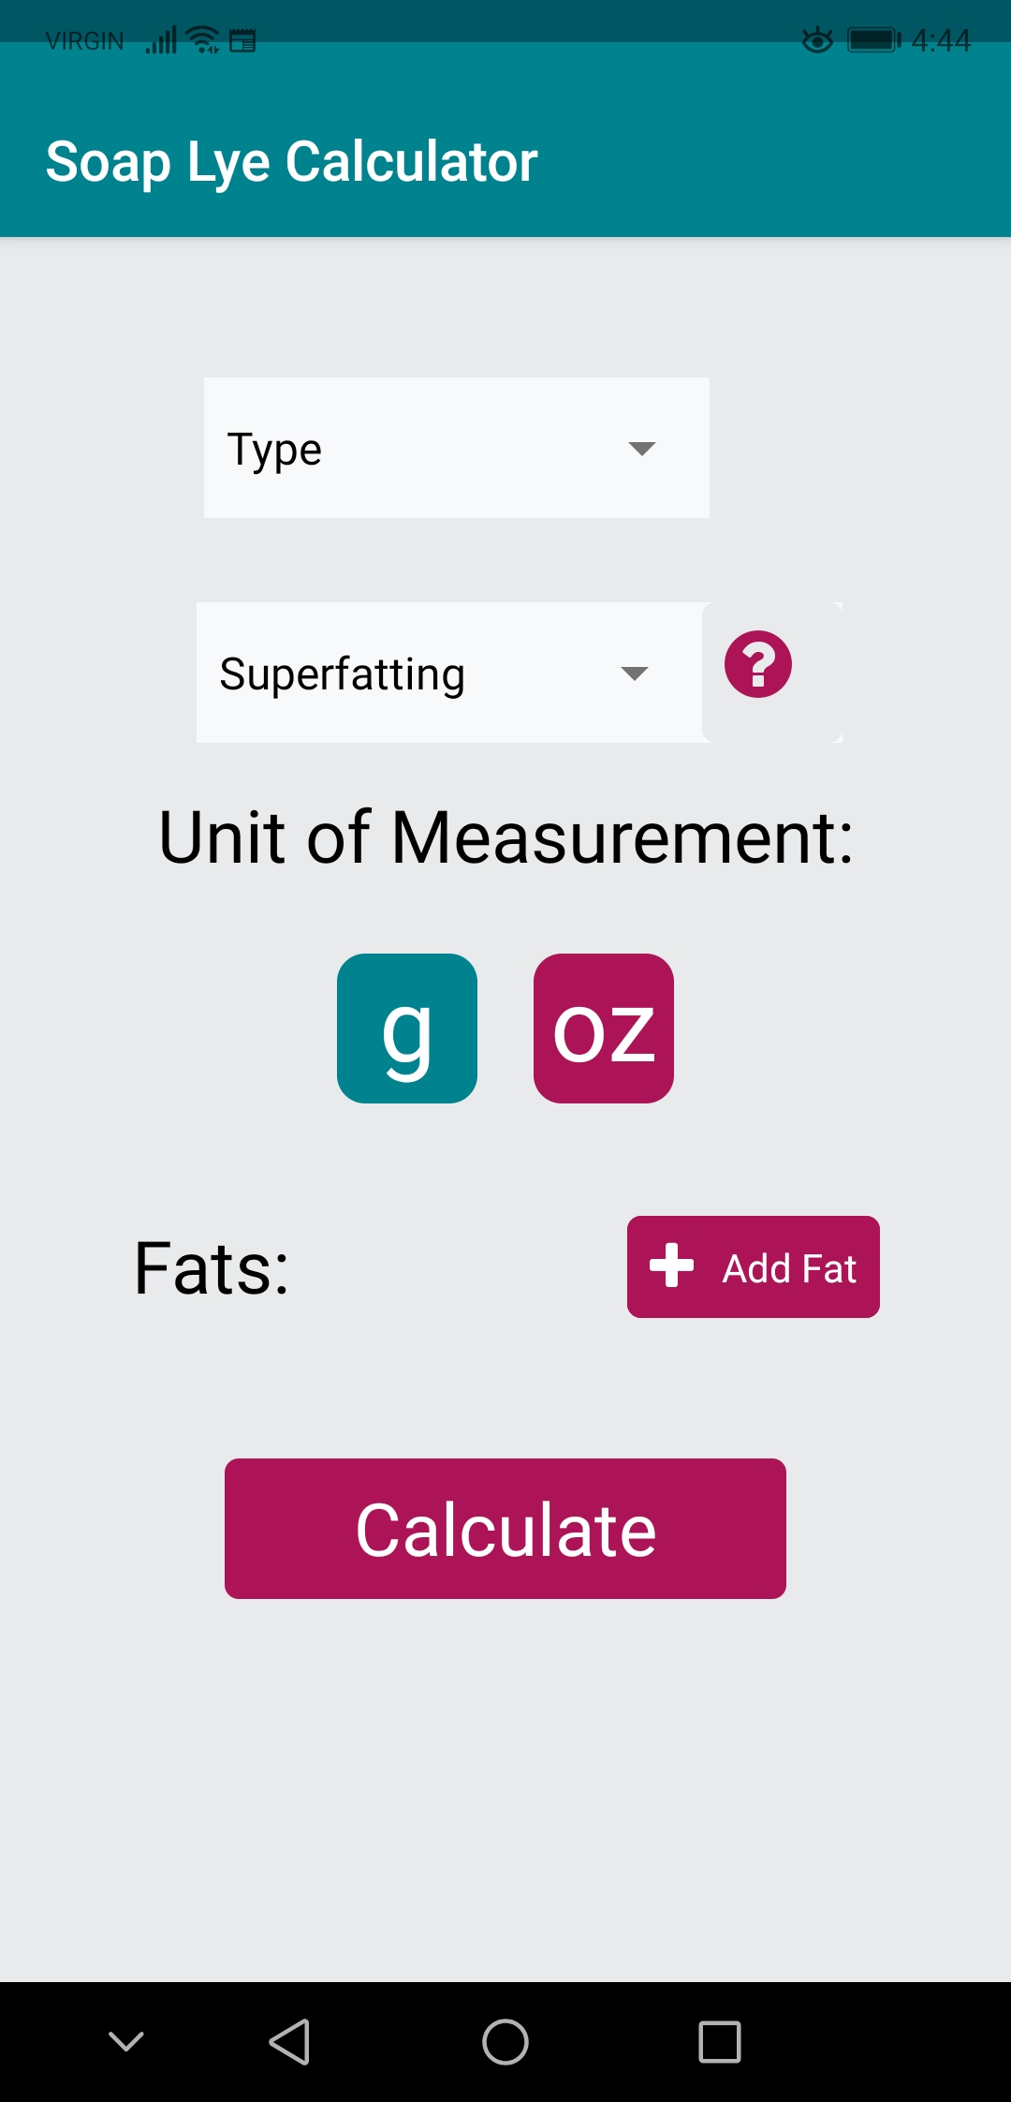

Figure : Initial Form Screen (taken on Android phone)

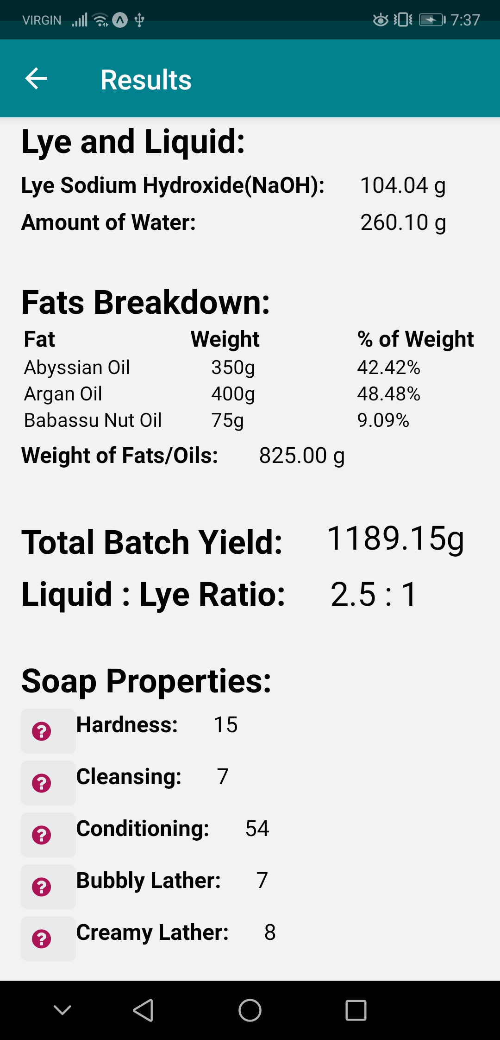

Figure : Results Screen