HW 1 - Group 10 Aniruddha Shivananda (ashivan@ncsu.edu) JonCarlo Migaly (jmigaly@ncsu.edu)

Screenshot of Execution-

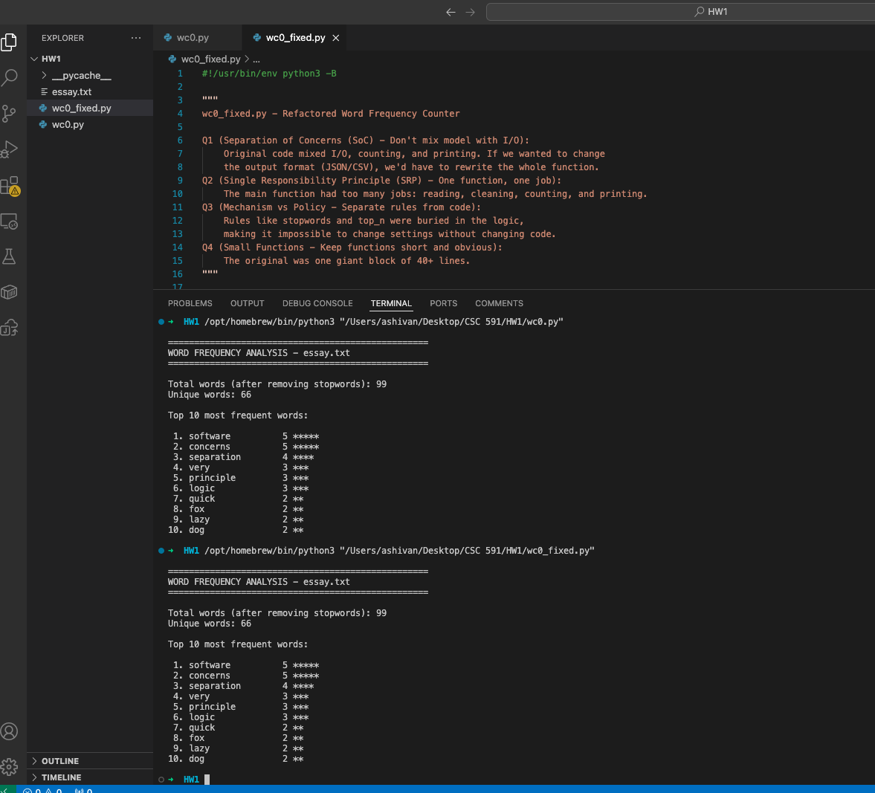

wc0_fixed.py -

#!/usr/bin/env python3 -B

"""
wc0_fixed.py - Refactored Word Frequency Counter

Q1 (Separation of Concerns (SoC) - Don't mix model with I/O):
Original code mixed I/O, counting, and printing. If we wanted to change
the output format (JSON/CSV), we'd have to rewrite the whole function.
Q2 (Single Responsibility Principle (SRP) - One function, one job):
The main function had too many jobs: reading, cleaning, counting, and printing.
Q3 (Mechanism vs Policy - Separate rules from code):
Rules like stopwords and top_n were buried in the logic,
making it impossible to change settings without changing code.
Q4 (Small Functions - Keep functions short and obvious):
The original was one giant block of 40+ lines.
"""

from types import SimpleNamespace as obj
import json # Bonus 1: for JSON output

# Policies (AQ3: Policies seperated from mechanism)
CONFIG = {
"language": "english",

"stopwords_english": [
"the", "a", "an", "and", "or", "but", "in", "on", "at", "to", "for",
"of", "is", "was", "are", "were", "be", "been", "with"
],

# Bonus 4: support for other languages
"stopwords_spanish": ["el", "la", "los", "con", "y", "o", "en"],

# Bonus 2: external stopword file
"stopwords_file": None,

"punctuation": '.,!?;:"()[]',
"top_n": 10
}

# Data Structure
def WordData():
return obj(words={}, total_words=0, unique_words=0)

# Model (AQ1: SoC)
def read_file(file):
"""AQ2: Single Responsibility - Only handles file I/O streaming"""
with open(file) as f:
for line in f:
yield line

def clean_text(line: str):
"""AQ2/AQ4: Focused logic for initial string splitting"""
return line.lower().split()

def clean_punc(word: str):
"""AQ2/AQ4: Specifically handles punctuation stripping policy"""
return word.strip(CONFIG["punctuation"])

def get_stopwords():
"""AQ3: Select stopwords policy"""
if CONFIG["stopwords_file"]:
return load_stopwords(CONFIG["stopwords_file"])
return CONFIG[f"stopwords_{CONFIG['language']}"]

def adjust_count(line: str, word_data):
"""AQ2/AQ4: Only handles dictionary updates and counter increments"""
stopwords = get_stopwords()
for word in line:
word = clean_punc(word)
if word and word not in stopwords:
if word not in word_data.words:
word_data.unique_words += 1
word_data.total_words += 1
word_data.words[word] = word_data.words.get(word, 0) + 1

def sort_word_data(word_data):
"""AQ2: Dedicated function for sorting results for the view"""
sorted_words = sorted(
word_data.words.items(),
key=lambda x: x[1],
reverse=True
)
word_data.words = sorted_words

def processText(file_name: str):
"""AQ2: Orchestrator that coordinates the model logic flow"""
word_data = WordData()
for line in read_file(file_name):
line = clean_text(line)
adjust_count(line, word_data)
sort_word_data(word_data)
return word_data

# --- Presentation (AQ1: Separation of Concerns) ---
def showHeader(file_name: str):
"""AQ4: Small function for header formatting"""
print(f"\n{'='*50}")
print(f"WORD FREQUENCY ANALYSIS - {file_name}")
print(f"{'='*50}\n")

def showStats(words):
"""AQ1: Pure view logic"""
print(f"Total words (after removing stopwords): {words.total_words}")
print(f"Unique words: {words.unique_words}\n")
print(f"Top {CONFIG['top_n']} most frequent words:\n")

# AQ3: Uses the separated policy
top_words = list(words.words)[:CONFIG["top_n"]]
for i, (word, count) in enumerate(top_words, 1):
bar = "*" * count
print(f"{i:2}. {word:15} {count:3} {bar}")

def report(words: dict, file_name: str):
"""AQ2: Master presentation function"""
showHeader(file_name)
showStats(words)
print()

# Bonus 1: Multiple output formats
def toJSON(words):
"""Return results as JSON (no printing)"""
return json.dumps(
{
"total_words": words.total_words,
"unique_words": words.unique_words,
"frequencies": dict(words.words)
},
indent=2
)

def toCSV(words):
"""Return results as CSV (no printing)"""
rows = ["word,count"]
for word, count in words.words:
rows.append(f"{word},{count}")
return "\n".join(rows)

# Bonus 2: Load stopwords from file
def load_stopwords(path):
"""Load stopwords from external file"""
with open(path) as f:
return [w.strip() for w in f if w.strip()]

# Bonus 3: Simple unit tests
# NOTE:
# These tests are provided externally by the instructor.
# They intentionally test the counting mechanism in isolation,
# even though the default policy removes some words (e.g., "and").
# I have kept tests unchanged to match the provided specification.
def test_clean_punc():
assert clean_punc("hello,") == "hello"

def test_adjust_count():
# AQ3 NOTE:
# This test assumes "and" is counted.
# In the full program, this word is removed by policy (stopwords),
# but the test is preserved as provided to validate core behavior.
data = WordData()
adjust_count(["the", "cat", "and", "dog"], data)
assert data.words == {"cat": 1, "and": 1, "dog": 1}

# --- Main ---
if __name__ == "__main__":
# 1. Process data (Model logic)
data = processText("essay.txt")

# 2. Show data (Presentation logic)
report(data, "essay.txt")

