Project 2
Chapters 5–8 (Secure Software Design)
JavaScript Code Injection, eval(), and Their Mitigation
Aashish Shrestha
Secure Software Development
11/15/2026

Overview
This project shows two common security problems in a JavaScript web application and then shows how to fix them. I wrote two small web servers with Node.js. The first one, vulnerable_server.js, has the problems on purpose. The second one, secure_server.js, has the same pages with the problems fixed. I ran both servers on my own computer and tested them in a Chromium browser. All attack texts in this report are harmless, because they only write a red message into the page. The complete source files are attached with this report.

The Vulnerable Application
The vulnerable server has three routes. The route /search shows the text that the user sends. The route /guestbook saves comments and shows them to every visitor. The route /calc is a calculator. Each route has a security problem, and Figures 1 and 2 show the complete code. The server also sets a session cookie without the HttpOnly flag, so JavaScript on the page can read it.
Figure 1: vulnerable_server.js, part 1: setup and the /search route (problem 1)
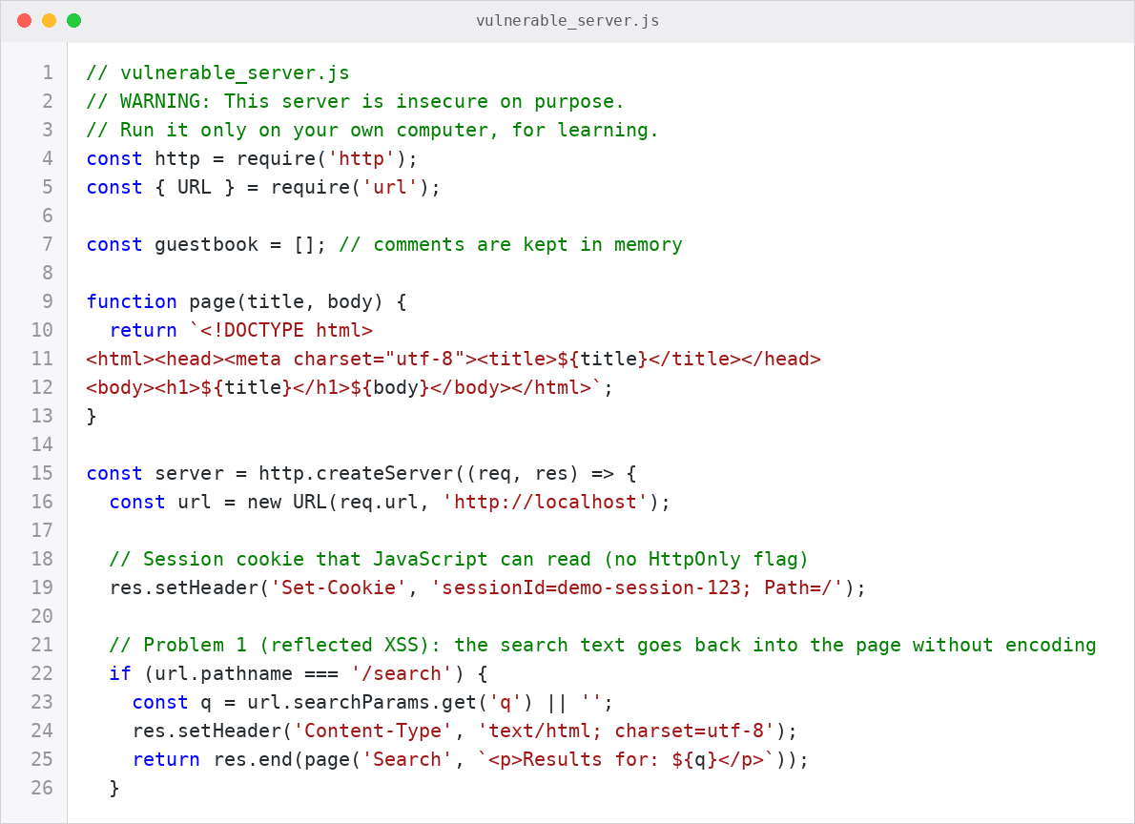

Figure 2: vulnerable_server.js, part 2: the /guestbook route (problem 2) and the /calc route (problem 3)
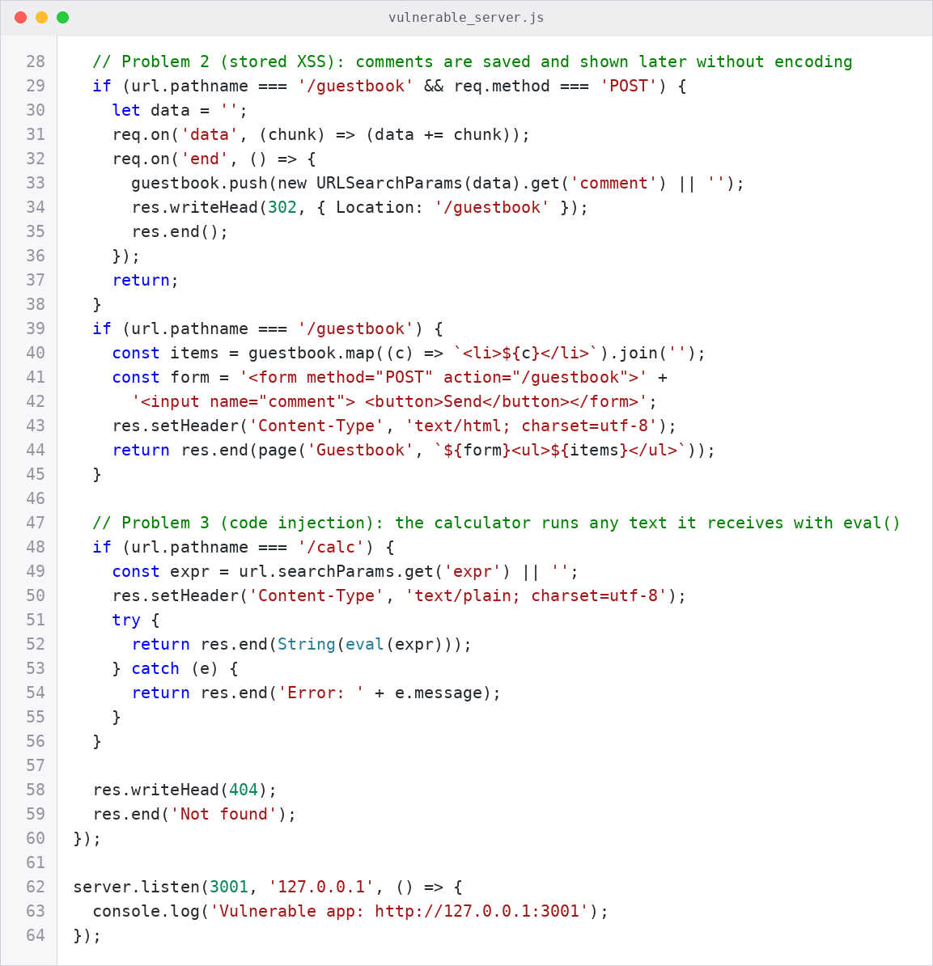

1. JavaScript Code Injection Through a Web Application (XSS)
Cross-site scripting (XSS) happens when an application puts text from a user into a web page without checking or encoding it. The browser cannot tell which part is data and which part is code, so it runs the script that the attacker wrote. XSS attacks are usually grouped into reflected, stored, and DOM-based types (Gupta & Gupta, 2017). My example has the first two types.

Reflected XSS
The route /search puts the value of the q parameter directly inside the HTML. An attacker can send a link like the one below. The browser changes the special characters in the link automatically.
http://127.0.0.1:3001/search?q=<script>document.body.insertAdjacentHTML('afterbegin','<h2 style="color:red">Injected script is running. Cookie:
'+document.cookie+'</h2>')</script>

When a user opens the link, the browser runs the script inside the page of the trusted site. My test script writes a message and the cookie value into the page, and Figure 3 (top) shows the result. The cookie is visible because the server did not set the HttpOnly flag. A real attacker could try to send such data to another server. I did not test this.

Stored XSS
The route /guestbook saves each comment and shows it to every visitor, again without encoding. I saved the comment below. It is an image tag with a wrong source, so the browser runs the on-error code. When a different visitor opened the guestbook, the code ran for that visitor too (Figure 3, bottom). Stored XSS is more dangerous than reflected XSS, because the visitor does not need to open a special link.
<img src=x onerror="document.body.insertAdjacentHTML('afterbegin','<h2
style=color:red>Stored script ran for this visitor</h2>')">
Figure 3: Reflected XSS (top) and stored XSS (bottom) on the vulnerable server
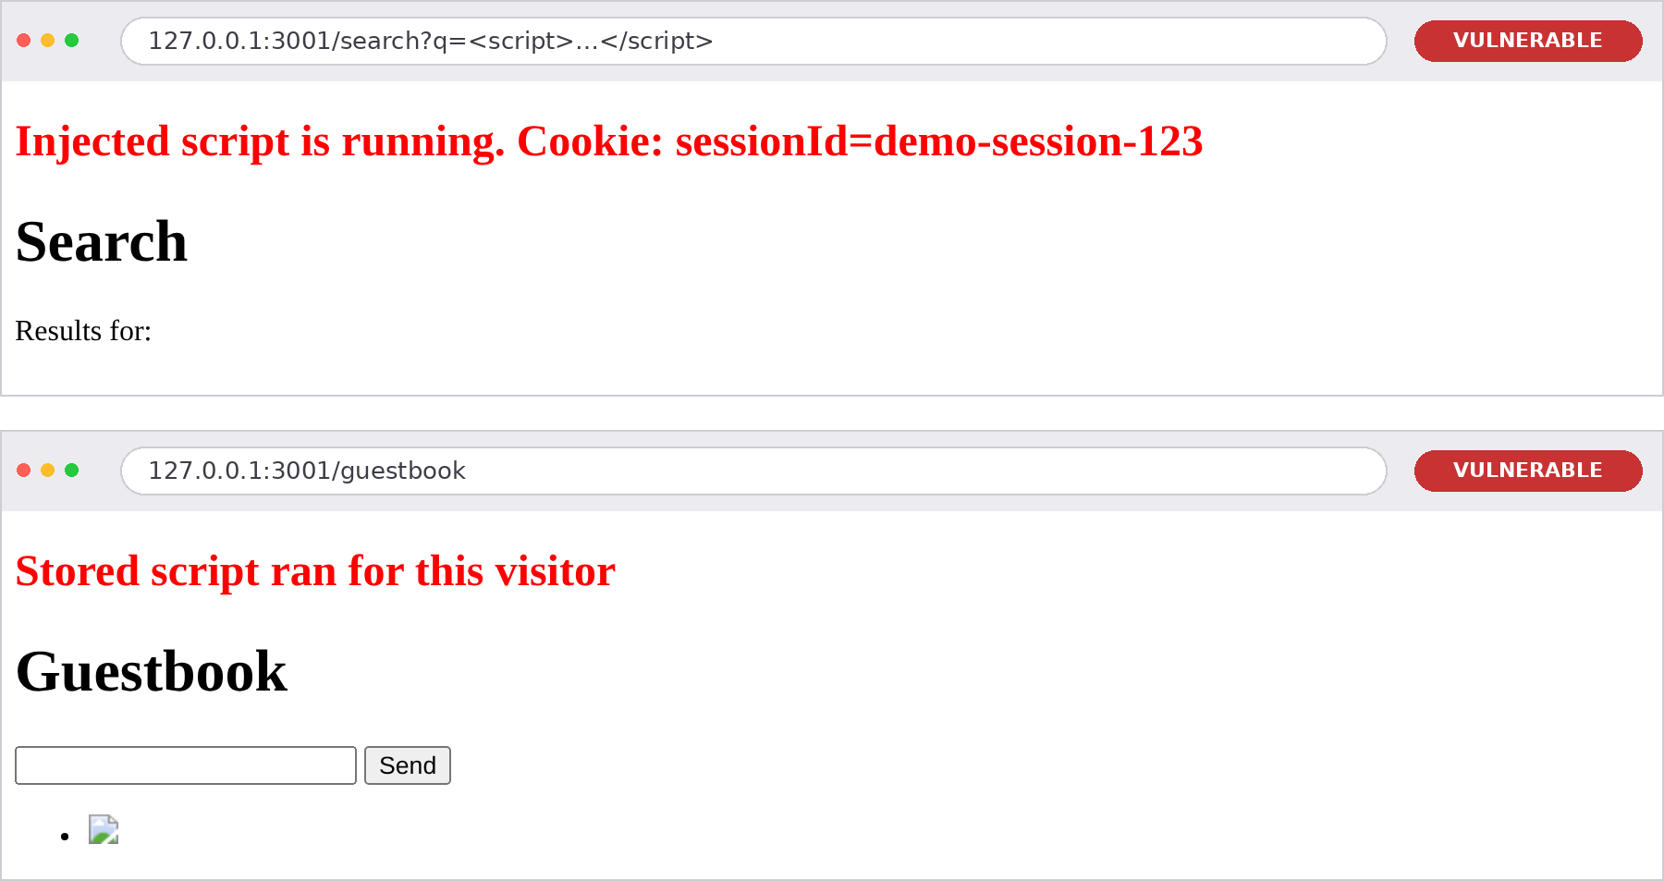

2. Dynamic Evaluation of Code at Runtime: eval()
eval() takes a text and runs it as program code. Richards et al. (2011) studied how eval is used in many JavaScript applications. The risk is that when the text comes from a user, the user can write program code. The root of the problem is the same as in XSS: data is treated as code.
In my example, the route /calc is a calculator that runs eval(expr) on the text of the request (Figure 2). A normal request like 2+2 works and returns 4. But the code runs on the server inside Node.js, so the attacker can also use Node.js objects. In Figure 4, the request process. Version returns the version of Node.js, and require('os').platform() returns the name of the operating system. The second request shows that the attacker can load modules. With other modules, an attacker could read files or start programs on the server. I did not test this on purpose. In a browser, eval() on user text gives the attacker the same power as XSS.
Figure 4
eval() injection on the vulnerable /calc route
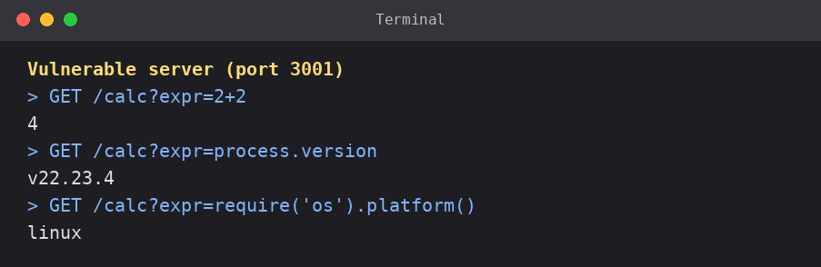

3. Mitigation Code
The secure server fixes each problem. Figures 5 to 8 show the complete file, and each part below explains one fix.

3.1 Output encoding (fix for XSS)
The function escapeHtml changes the characters & < > " and ’ into HTML entities, so they are shown as text and are not run as code. The server uses it in /search and /guestbook every time user text goes into a page. The encoding is done when the text is shown, and not when it is saved, so the comment is stored as plain text and is safe in the page.
Figure 5
secure_server.js, part 1: limits and the escapeHtml function (Fix 1)
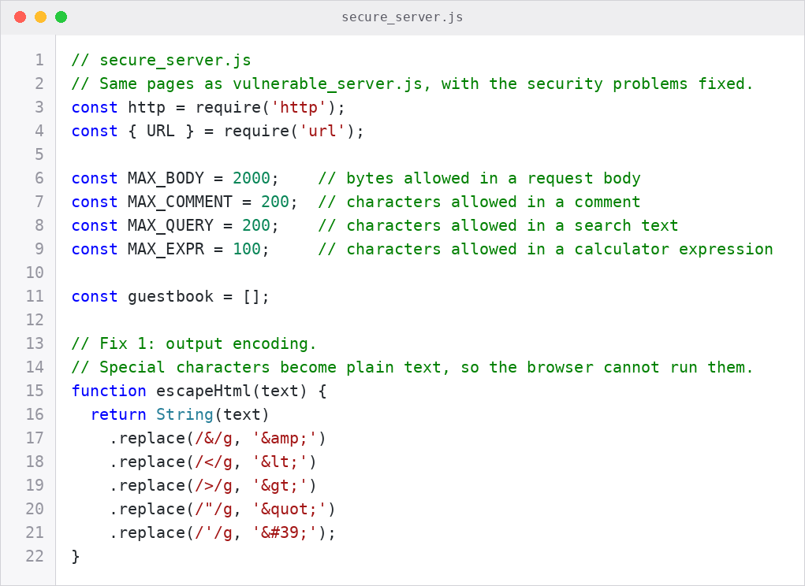

3.2 A safe calculator instead of eval() (fix for code injection)
The function calculate reads the text as small pieces (numbers, brackets, and the four operators) and calculates the result by itself. It never calls eval(). Any other character, for example a letter, a quote, or a dot in a name like process.version, makes the function stop with an error. The text can have only 100 characters, so a very deep nesting of brackets cannot crash the server. The route returns the same short message, Invalid expression, for every error, so the attacker gets no details.
Figure 6
secure_server.js, part 2: the calculate function without eval() (Fix 3)
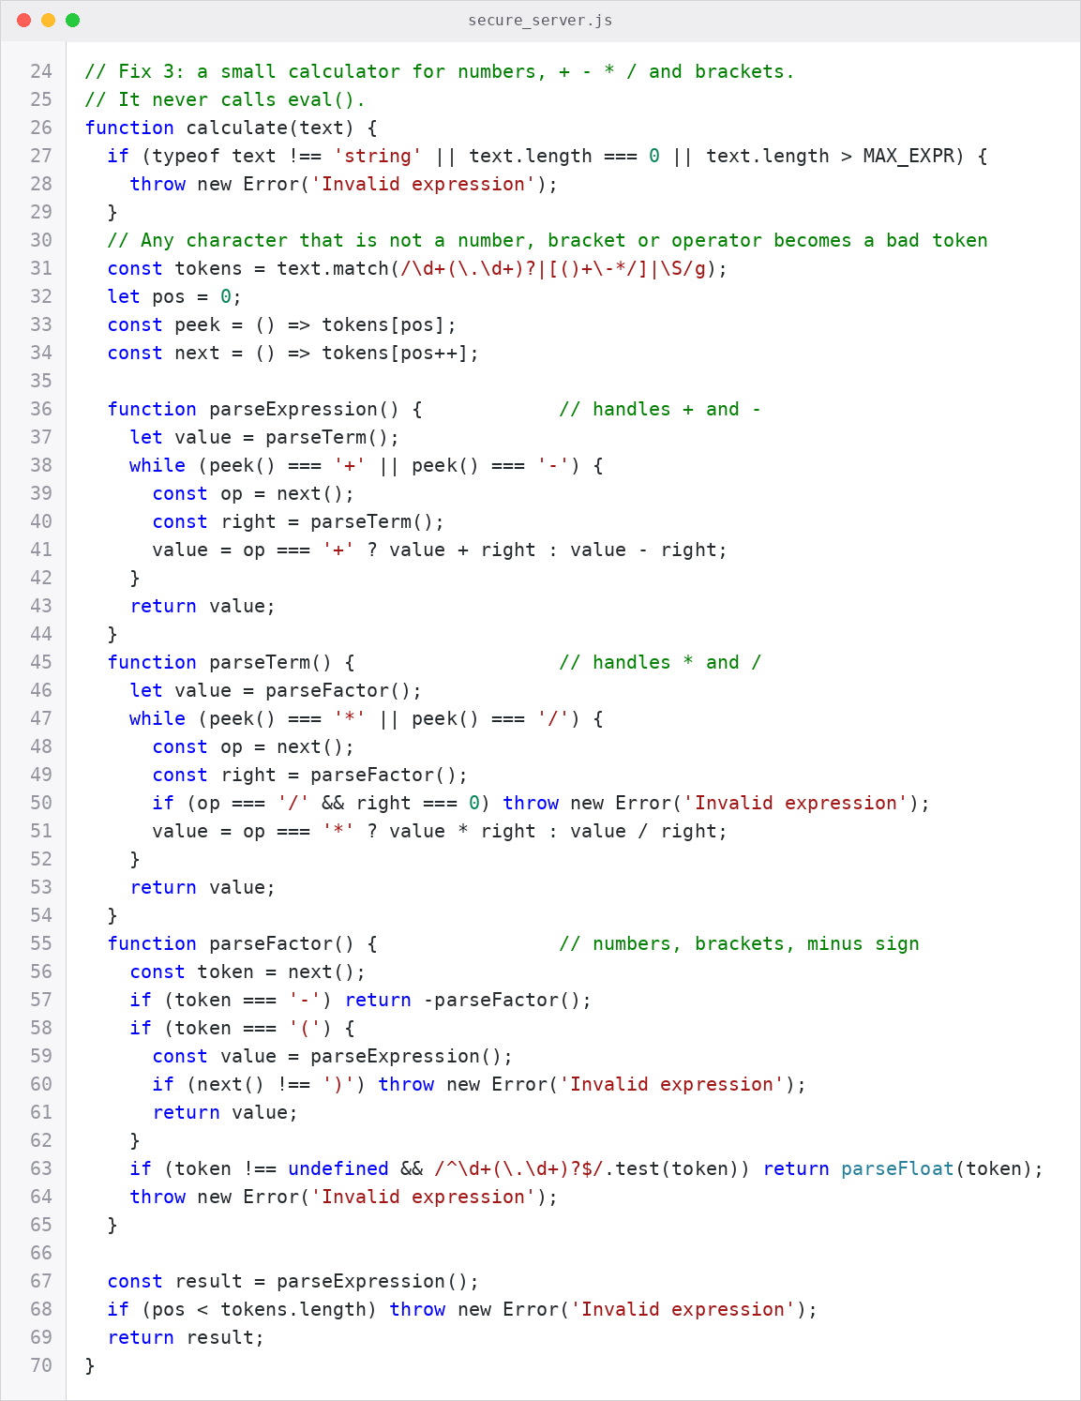

3.3 Security headers and a safe cookie
The Content-Security-Policy header tells the browser which content it may load. My policy is default-src 'none', so scripts, images, and styles are blocked by default, and forms can only send data to the same site. Weichselbaum et al. (2016) analyzed real policies of this type and reported that most of them could be bypassed, and the problem was often the lists of trusted script sources. For this reason, my policy has no such list. Blocking everything by default also follows the fail-safe defaults idea (Saltzer & Schroeder, 1975). In my test, the output encoding had already stopped the attack, so the policy had nothing to block. It is a second layer; in case someone forgets to encode text in a new page.
The other headers and the cookie flags help too. X-Content-Type-Options: nosniff stops the browser from guessing the type of a file. HttpOnly stops JavaScript from reading the cookie. SameSite=Strict keeps the browser from sending the cookie from other sites. The Secure flag is added when the server runs in production with HTTPS.
Figure 7
secure_server.js, part 3: security headers, page helper, and body size limit (Fix 2 and Fix 4)
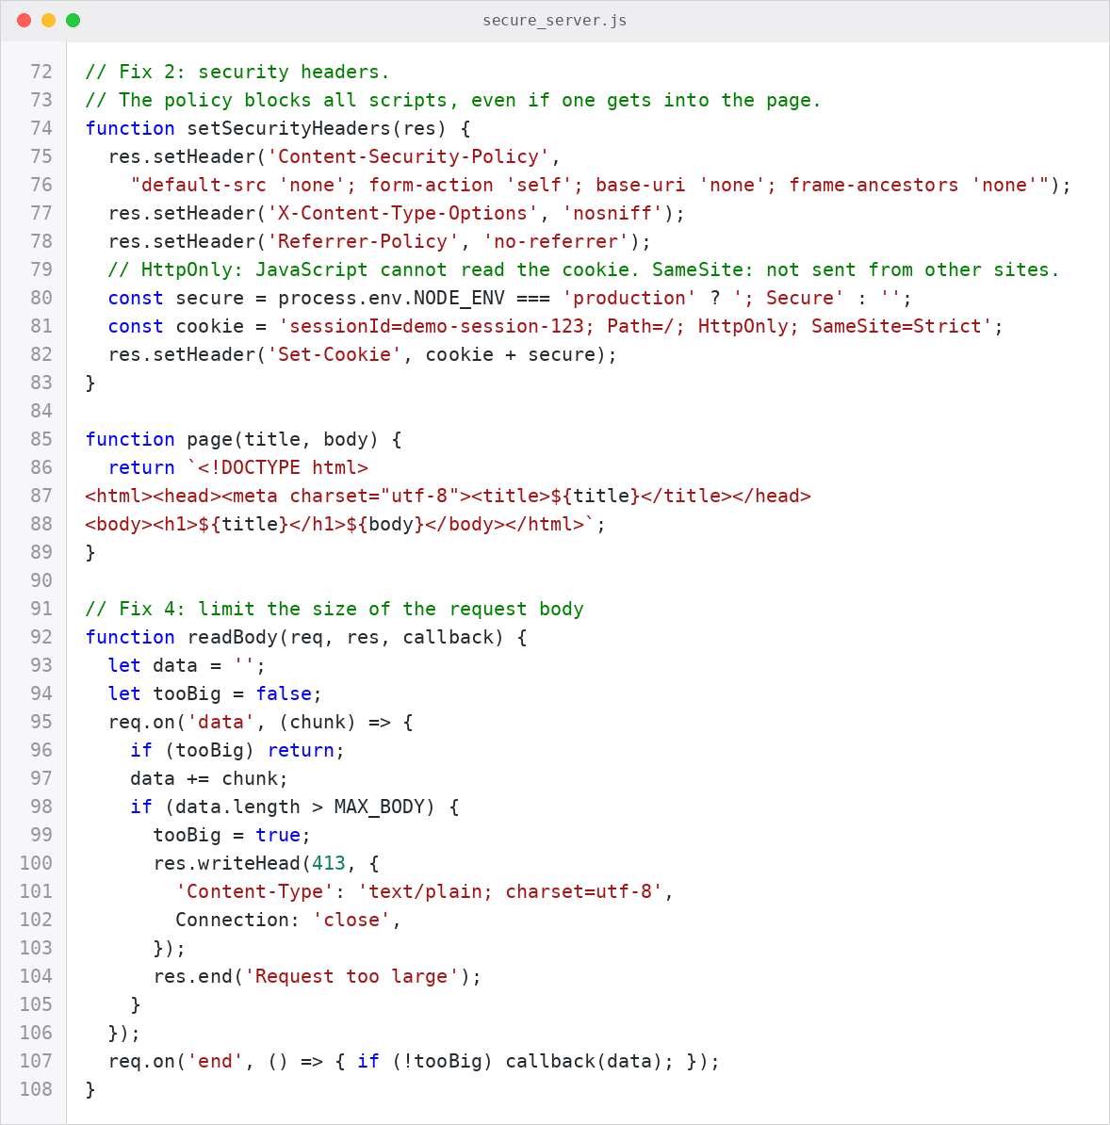

3.4 Input validation and size limits
The server limits the search text and the comment to 200 characters, the expression to 100 characters, and the request body to 2000 bytes. An empty or too long comment gets the answer 400, and a too big body gets 413. Validation alone is not enough, because it is hard to list every bad input, so I use it together with output encoding. The routes also accept only the correct methods, GET or POST.
Figure 8
secure_server.js, part 4: the routes that use the fixes
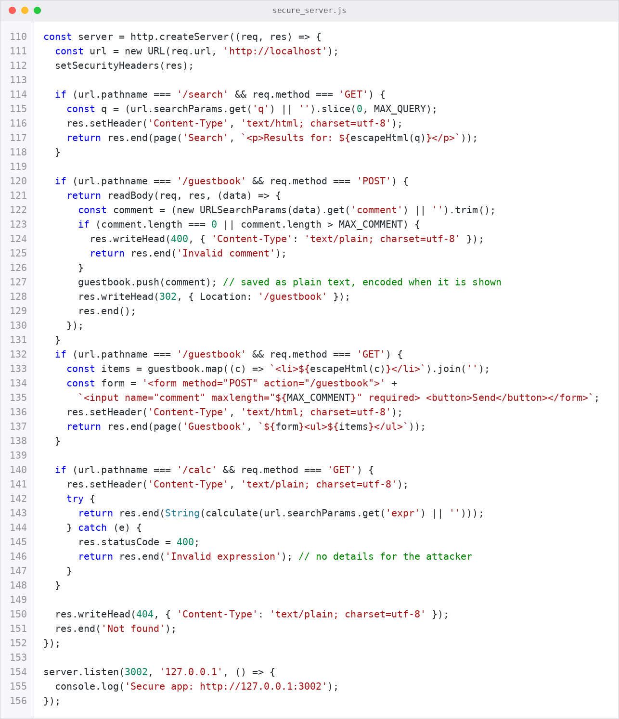

3.5 Test results
I ran the same tests on both servers. Table 1 shows the summary, and Figures 9 to 11 show the evidence from the secure server.

Table 1
Results of the same tests on both servers
Test | Vulnerable server | Secure server
Reflected XSS link | Script ran and showed the cookie (Figure 3) | Shown as plain text, no script (Figure 9)
Stored XSS comment | Script ran for another visitor (Figure 3) | Shown as plain text, no script (Figure 9)
Cookie read by JavaScript | sessionId=demo-session-123 | Empty (HttpOnly flag)
eval request: process. Version | Returned v22.23.4 (Figure 4) | 400 Invalid expression (Figure 10)
Normal request: 2+2 | 4 | 4

Figure 9
The same attacks on the secure server: the text is shown as plain text

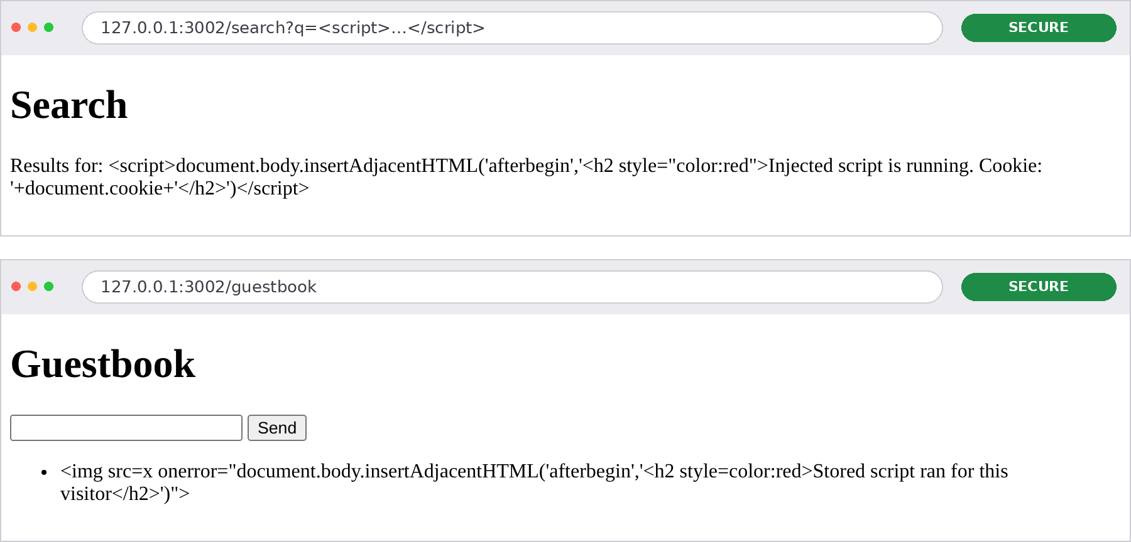

Figure 10
The secure /calc route accepts normal calculations and refuses code
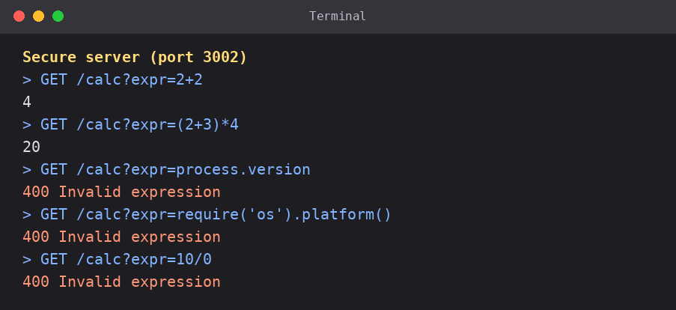
Figure 11
Security headers and input checks on the secure server
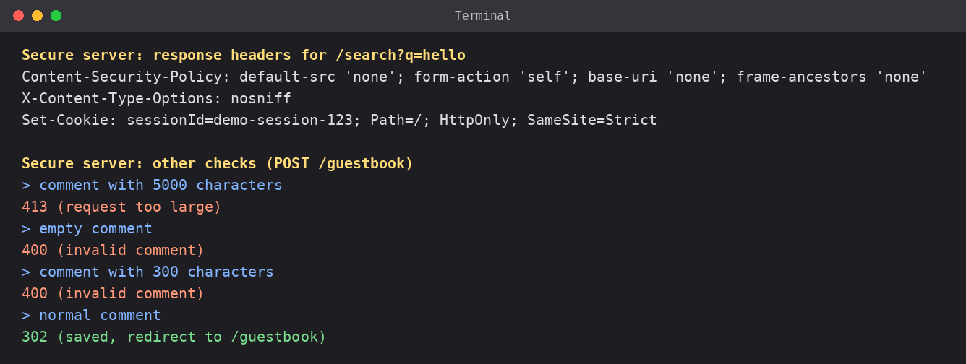

Limits of This Demo
This is a small learning example. The function escapeHtml is correct for text inside HTML and inside quoted attributes, but other places, such as JavaScript code or a URL, need a different encoding. A real application also needs HTTPS, login, protection against CSRF, and regular checks of its libraries. The vulnerable server must never run on a public network.

How to Run the Code
Install Node.js, open a terminal in the folder with the two files, and run each server in its own terminal. Use them only on your own computer.
node vulnerable_server.js (opens http://127.0.0.1:3001)
node secure_server.js (opens http://127.0.0.1:3002)
Then open the /search, /guestbook, and /calc routes of each server in the browser and compare the results.
Then open the /search, /guestbook, and /calc routes of each server in the browser and compare the results.

Conclusion
XSS and eval() injection have the same root: the application treats data from the user as code. The fixes are also similar. Encode the output, do not run user text as code, limit and check the input, and add extra layers such as the Content-Security-Policy header and safe cookie flags. The tests in a real browser show that the attacks work on the vulnerable server and fail on the secure server.

References
Gupta, S., & Gupta, B. B. (2017). Cross-site scripting (XSS) attacks and defense mechanisms: Classification and state-of-the-art. International Journal of System Assurance Engineering and Management, 8(Suppl. 1), 512–530. https://doi.org/10.1007/s13198-015-0376-0
Richards, G., Hammer, C., Burg, B., & Vitek, J. (2011). The eval that men do: A large-scale study of the use of eval in JavaScript applications. In M. Mezini (Ed.), ECOOP 2011 – Object-oriented programming (Lecture Notes in Computer Science, Vol. 6813, pp. 52–78). Springer. https://doi.org/10.1007/978-3-642-22655-7_4
Saltzer, J. H., & Schroeder, M. D. (1975). The protection of information in computer systems. Proceedings of the IEEE, 63(9), 1278–1308. https://doi.org/10.1109/PROC.1975.9939
Weichselbaum, L., Spagnuolo, M., Lekies, S., & Janc, A. (2016). CSP is dead, long live CSP! On the insecurity of whitelists and the future of content security policy. In Proceedings of the 23rd ACM Conference on Computer and Communications Security. ACM.

