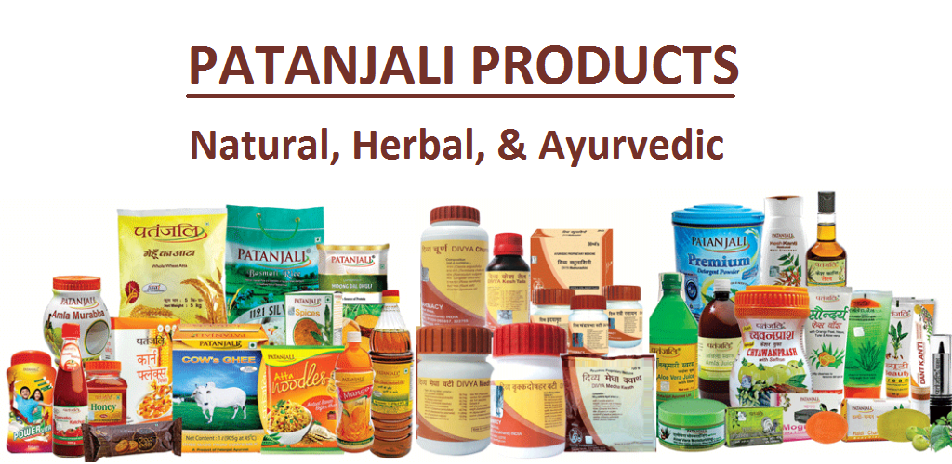

**Developed By :**

**Ajay Shrimali & Krutik Bhatti**

**Web Project Documentation**

**Planning:-**

**Purpose of web portal :-**

1. The purpose of my website is to provide all type of patanjali products to our customers. We are generating online store for our customers where customers can select products and purchase products online according to need. Our customer is basically cannot go market and purchase products.
2. We are providing products in different different categories like biscuits, juice, oil, powder, ayurvedic tablets and some other type of categories.

**Requirements:-**

Team Members:- 2 members

Languages:-HTML, CSS

Browser:-Google Chrome, FireFox

Ram:- 256mb

Hard Disk:- 512MB

**SITE MAP**

**Home Page**

In this home page we describe the products and information about them. The customer can easily go through our web site and get the knowledge about the patanjali products. The customers just enter their relative username and password for attain the product details. Remember is basically used to save username and password in future. On home page we are providing header, menu bar, content box, and login form and footer panel.

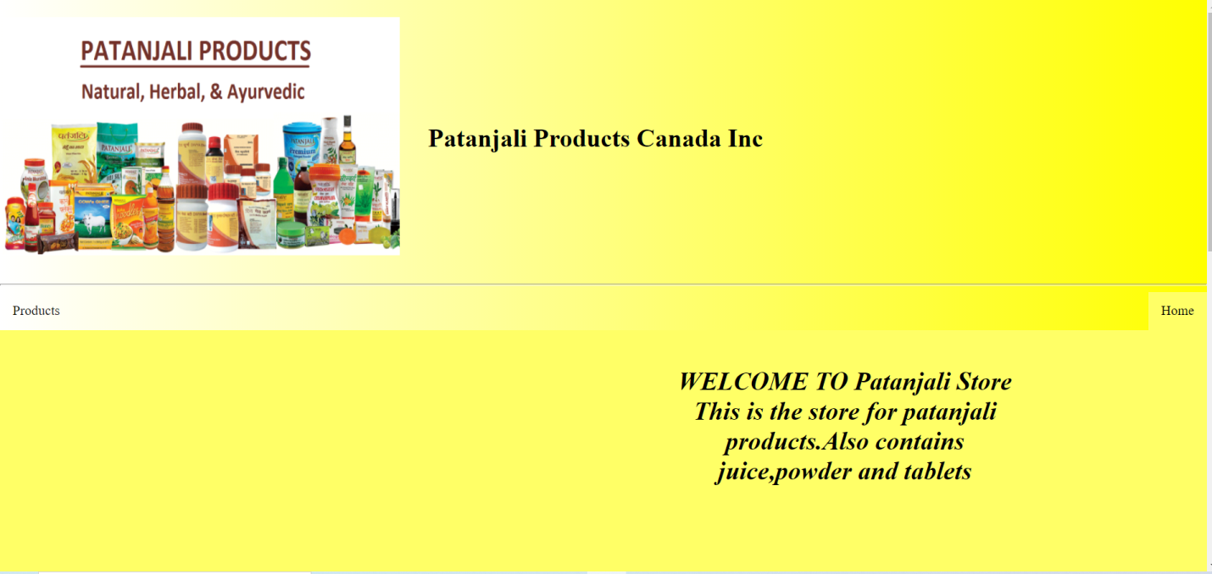 

**About Us**

The basic role of an about us page is to illuminate the peruser about the organization and its activities. This is a clear objective that practically all organizations need to satisfy in some design or another. Notwithstanding, there are different reasons why about us pages are basic installations on business sites.

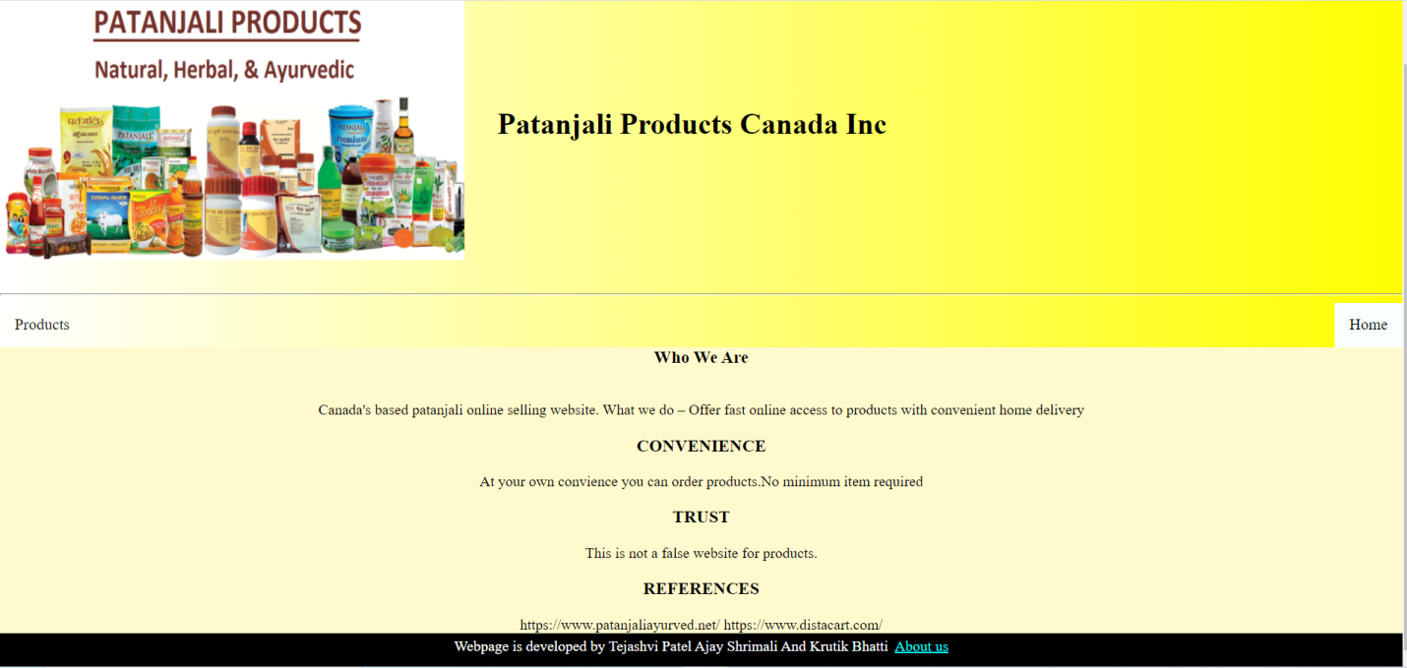

**Products**

In this page we describe the products and further it is described in to some of the categories. The description of the products is given here so that every customer gets the knowledge before purchasing it. The image of the products is also here. By this nobody will confuse and will get the same product as shown in the image. Sometime the customer will get the wrong product then image will help in this cases. When the customer will be satisfied then there is a link through which customer can purchase the product by clink on this link.

* Ayurvedic tablets
* Powder
* Juice
* Biscuits
* Oil
* Other products

