## NIS documentation

### The problem was master and slave where not configured to be in right VLAN the pkey was misconfigured on NIS master and slave. The NIS master and slave where not configured to be in **IPoIB-vserver-shared-storage** network.

### Storage node interfaces

**IPoIB-vserver-shared-storage** network pkey is 8006 on a non-routed internal VLAN network.

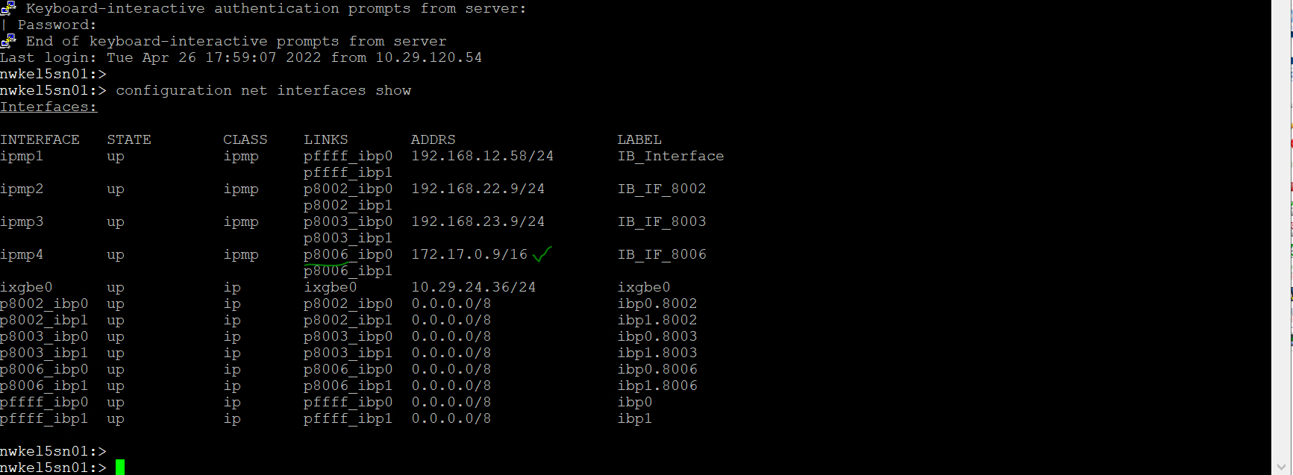

### Changes on MASTER

Stop the NIS Master nwkel3client05

[root@nwkel5cn01 ~]# find /OVS -wholename '*VirtualMachines/*/vm.cfg' -exec grep -H 'simple_' {} \;|grep nwkel3client05

Modify the pkey value to 8006 for port 1 and port 2 as shown below.

[root@nwkel5cn01 ~]# find /OVS -wholename '*VirtualMachines/*/vm.cfg' -exec grep -H 'simple_' {} \;|grep nwkel3client05

/OVS/Repositories/0004fb0000030000ad40225a886111ee/VirtualMachines/0004fb00000600004e06ee76a520a4f8/vm.cfg:OVM_simple_name = 'nwkel3client05'

[root@nwkel5cn01 ~]#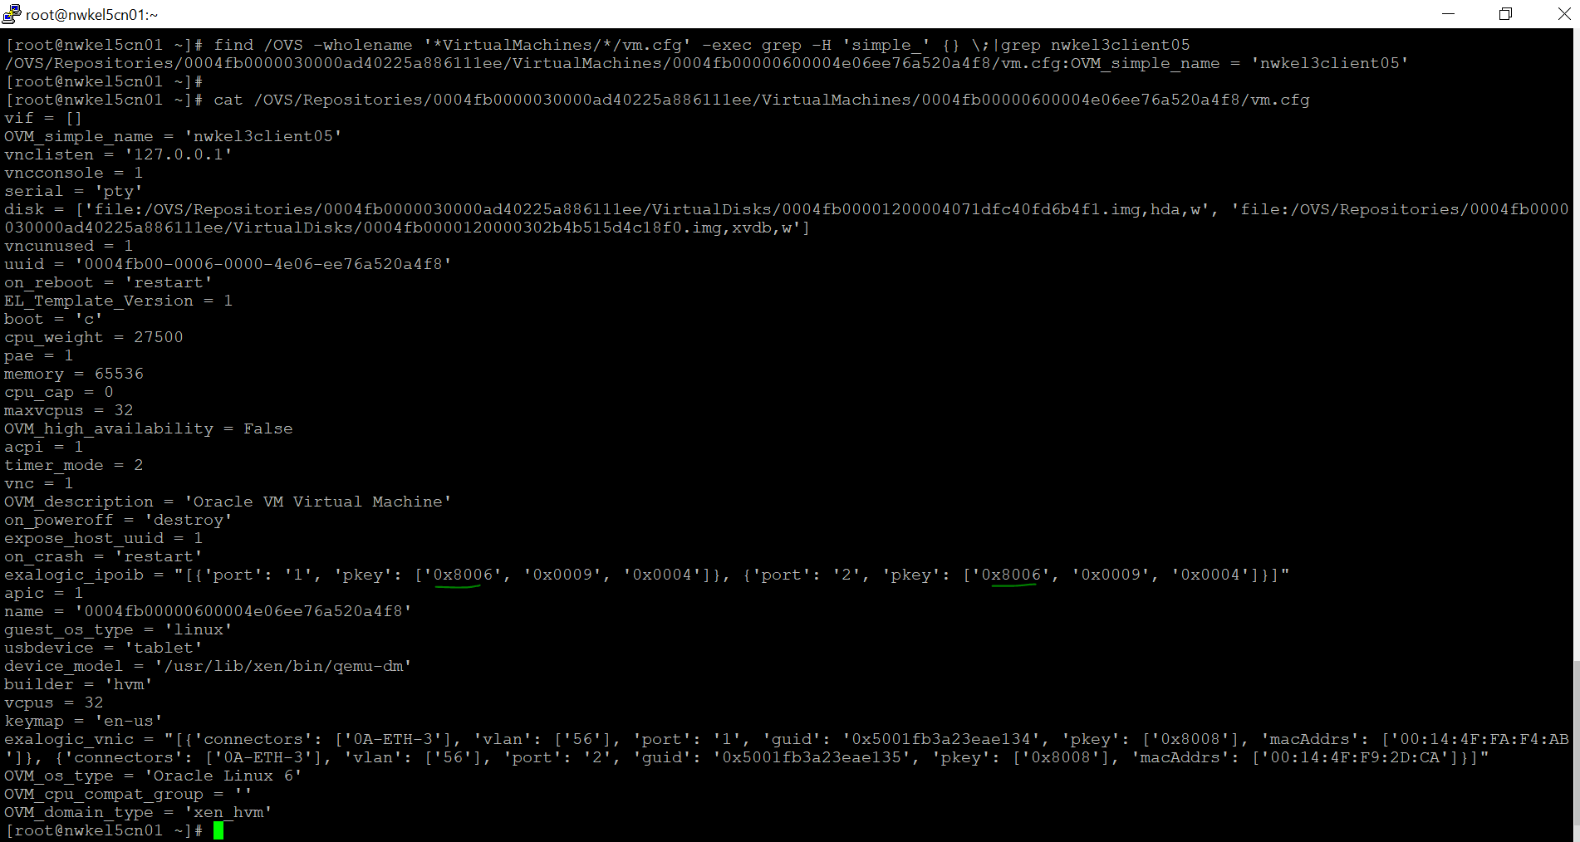

Restart the NIS master

### Changes on SLAVE

Stop exalogic NIS slave nwkel3client06 and change the pkey to 8006 as shown in screen shot below.

[root@nwkel5cn01 ~]# find /OVS -wholename '*VirtualMachines/*/vm.cfg' -exec grep -H 'simple_' {} \;|grep nwkel3client06

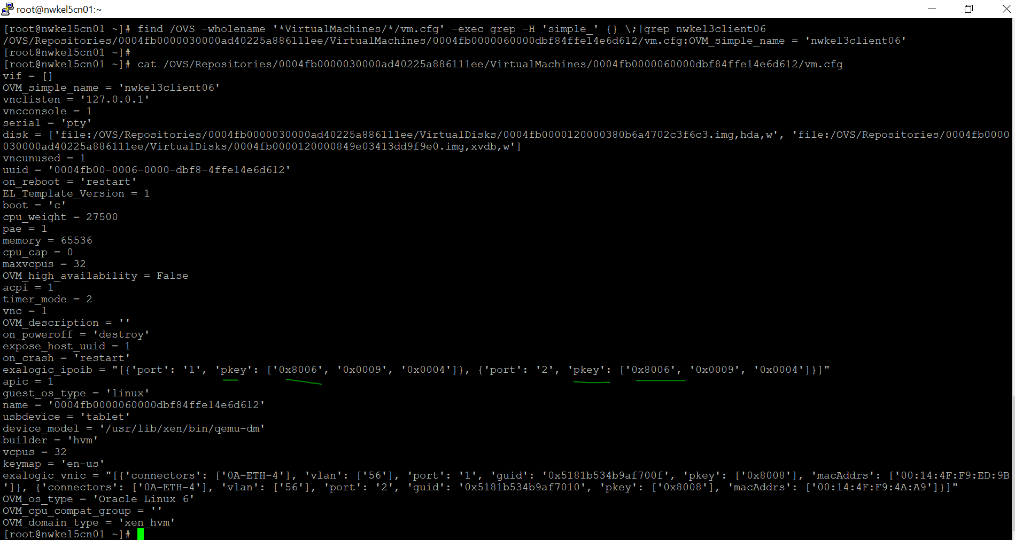

Restart the slave NIS server.

### Changes on CLIENT

Following changes where performed on client VM vserver nwkel5ggs01

The hostname was set to NIS master , this need to be set to Exalogic vserver name. In this e.g. vserver is **nwkel5ggs01**

[root@nwkel5ggs01 ~]#  
[root@nwkel5ggs01 ~]# cat /etc/sysconfig/network  
NETWORKING=yes  
NETWORKING_IPV6=no  
**HOSTNAME=nwkel5ggs01**  
NISDOMAIN=el3nis.gov  
domainname=el3nis.gov

[root@nwkel5ggs01 ~]#

[root@nwkel5ggs01 ~]# date  
Tue Apr 26 18:00:14 UTC 2022  
[root@nwkel5ggs01 ~]#

[root@nwkel5ggs01 ~]# cat /etc/sysconfig/network  
NETWORKING=yes  
NETWORKING_IPV6=no  
HOSTNAME=nwkel5ggs01  
NISDOMAIN=el3nis.gov  
domainname=el3nis.gov  
[root@nwkel5ggs01 ~]#

cat /etc/hosts

10.29.25.100 nwkel5ggs01 🡨 add to /etc/hosts

[root@nwkel5ggs01 ~]# hostname -f  
nwkel5ggs01  
[root@nwkel5ggs01 ~]#

#Ping to NIS master vserver not working   
[root@nwkel5ggs01 ~]#  
[root@nwkel5ggs01 ~]# ping **172.17.0**.168  
PING 172.17.0.168 (172.17.0.168) 56(84) bytes of data.  
From 172.17.0.100 icmp_seq=1 Destination Host Unreachable  
From 172.17.0.100 icmp_seq=2 Destination Host Unreachable  
From 172.17.0.100 icmp_seq=3 Destination Host Unreachable  
From 172.17.0.100 icmp_seq=4 Destination Host Unreachable  
^C  
--- 172.17.0.168 ping statistics ---  
5 packets transmitted, 0 received, +4 errors, 100% packet loss, time 4001ms  
pipe 4

#Ping to NIS slave vserver not working   
  
[root@nwkel5ggs01 ~]#  
[root@nwkel5ggs01 ~]# ping 172.17.0.98  
PING 172.17.0.98 (172.17.0.98) 56(84) bytes of data.  
From 172.17.0.100 icmp_seq=1 Destination Host Unreachable  
From 172.17.0.100 icmp_seq=2 Destination Host Unreachable  
From 172.17.0.100 icmp_seq=3 Destination Host Unreachable  
From 172.17.0.100 icmp_seq=4 Destination Host Unreachable  
  
  
nwkel5sn01:>  
nwkel5sn01:> configuration net interfaces list  
INTERFACE STATE CLASS LINKS ADDRS LABEL  
ipmp1 up ipmp pffff_ibp0 192.168.12.58/24 IB_Interfac e  
pffff_ibp1  
ipmp2 up ipmp p8002_ibp0 192.168.22.9/24 IB_IF_8002  
p8002_ibp1  
ipmp3 up ipmp p8003_ibp0 192.168.23.9/24 IB_IF_8003  
p8003_ibp1  
**ipmp4 up ipmp p8006_ibp0 172.17.0.9/16 IB_IF_8006**  
p8006_ibp1  
ixgbe0 up ip ixgbe0 10.29.24.36/24 ixgbe0  
p8002_ibp0 up ip p8002_ibp0 0.0.0.0/8 ibp0.8002  
p8002_ibp1 up ip p8002_ibp1 0.0.0.0/8 ibp1.8002  
p8003_ibp0 up ip p8003_ibp0 0.0.0.0/8 ibp0.8003  
p8003_ibp1 up ip p8003_ibp1 0.0.0.0/8 ibp1.8003  
**p8006_ibp0 up ip p8006_ibp0 0.0.0.0/8 ibp0.8006  
p8006_ibp1 up ip p8006_ibp1 0.0.0.0/8 ibp1.8006**pffff_ibp0 up ip pffff_ibp0 0.0.0.0/8 ibp0  
pffff_ibp1 up ip pffff_ibp1 0.0.0.0/8 ibp1  
nwkel5sn01:>  
nwkel5sn01:>  
[root@nwkel5ggs01 ~]#  
[root@nwkel5ggs01 ~]# !307  
/bin/systemctl stop ypbind.service  
[root@nwkel5ggs01 ~]# /bin/systemctl stop ypbind.service  
[root@nwkel5ggs01 ~]# !308  
/bin/systemctl start ypbind.service  
Job for ypbind.service failed because the control process exited with error code. See "systemctl status ypbind.service" and "journalctl -xe" for details.  
[root@nwkel5ggs01 ~]# !309  
journalctl -xe  
Apr 26 18:42:48 nwkel5ggs01 su[16784]: (to oracle) root on pts/0  
Apr 26 18:42:48 nwkel5ggs01 su[16784]: pam_unix(su-l:session): session opened for user oracle by root(uid=0)  
Apr 26 18:50:01 nwkel5ggs01 systemd[1]: Started Session 195 of user root.  
-- Subject: Unit session-195.scope has finished start-up  
-- Defined-By: systemd  
-- Support: http://lists.freedesktop.org/mailman/listinfo/systemd-devel  
--  
-- Unit session-195.scope has finished starting

## Reference

**How To Configure NIS Master, Slave And Client Configuration In Exalogic Virtual Environment (Doc ID 1516025.1)**

**How To Configure NIS Master, Slave And Client Configuration On Compute Nodes In Exalogic Elastic Cloud Software 2.x Physical Environment (Doc ID 1470844.1)**

## Action plan details

1. ACTION PLAN 1

-------------------- ACTION PLAN DETAILS BELOW---------------------  
  
Owner (Who)  
------------------------------------------------------  
Arvind  
  
Follow-up (When)  
------------------------------------------------------  
anytime  
  
ACTION PLAN (What, Why)  
-------------------------------------------------------  
=== EEST ===  
  
I have found still more errors  
  
1. /etc/sysconfig/network  
  
Currently  
  
HOSTNAME=nis-master.el3nis.gov  
  
Whats wrong?  
  
This should have HOSTNAME=<NIS client VM hostname>  
  
In other words the name of this VM "nwkel5ggs01"  
  
2. Seems to be a DNS issue for this VM hostname  
  
# hostname -f threw the following error: hostname: Temporary failure in name resolution  
  
3. Found this in /var/log/messages  
  
Apr 25 21:39:16 [localhost] ypbind: Binding NIS service  
Apr 25 21:40:01 [localhost] systemd: Started Session 1127 of user root.  
Apr 25 21:40:16 [localhost] ypbind: Binding took 60 seconds  
Apr 25 21:40:16 [localhost] ypbind: NIS server for domain el3nis.gov is not responding. <<<  
Apr 25 21:40:16 [localhost] ypbind: Killing ypbind with PID 5793.  
Apr 25 21:40:16 [localhost] ypbind: Try increase NISTIMEOUT in /etc/sysconfig/ypbind  
Apr 25 21:40:16 [localhost] systemd: ypbind.service: control process exited, code=exited status=1  
Apr 25 21:40:16 [localhost] systemd: Failed to start NIS/YP (Network Information Service) Clients to NIS Domain Binder.  
Apr 25 21:40:16 [localhost] systemd: Unit ypbind.service entered failed state.  
Apr 25 21:40:16 [localhost] systemd: ypbind.service failed.  
  
TEST Please  
  
Can you ping 172.17.0.168 from VM nwkel5ggs01  
Can you ping 172.17.0.98 from VM nwkel5ggs01  
  
If this ping fails it could be due to misconfig in the NIS VMs vm.cfg file where you were asked to Making NIS VM Full Member of IPoIB Partition.  
  
4. Login to active ZFS head via commandline and execute the following  
  
:> configuration net interfaces list  
  
  
  
---------------------------------  
Regards,  
Gil Hernandez, Engineered Systems ( Exalogic )

1. Action plan 2

-------------------- ACTION PLAN DETAILS BELOW---------------------  
  
Owner (Who)  
------------------------------------------------------  
Arvind  
  
Follow-up (When)  
------------------------------------------------------  
via SR  
  
ACTION PLAN (What, Why)  
-------------------------------------------------------  
  
Hello Avind,  
  
A proper working NIS environment is a MUST for using NFSv4  
  
NIS is not provided out of the box by Exalogic , it is a customer responsibility.  
  
Please note that Per Documentation in the Exalogic Machine Ownersh Guide  
  
Link: https://docs.oracle.com/cd/E18476_01/doc.220/e18478/GUID-8D52DB09-1FD4-4033-9182-843881653B86.htm#ELMOG77396  
  
9.1.3 Naming Service  
  
NFSv4 requires a naming service, such as Network Information Service (NIS) or LDAP, for ID mapping. You can continue to use the naming service on your existing network. The naming service is not related to the file locking problem.  
  
Note:  
  
It is assumed that you have a working NIS or LDAP service on your network. <<<< NIS is not part of the Exalogic Software, this is a customer responsibility >>>>>  
  
  
I see you replied to Ashok stating that you followed How To Configure NIS Master, Slave And Client Configuration In Exalogic Virtual Environment ( [Doc ID 1516025.1](https://support.oracle.com/epmos/faces/DocumentDisplay?parent=SrDetailText&sourceId=3-29310186741&id=1516025.1) )  
  
to set up your NIS servers and configure your clients.  
  
  
Question:  
  
If that is the case can you please tell my why there is no defined DOMAIN name for your VM nwkel5ggs01?  
  
The sosreport you attached, I look at file: /etc/idmapd.conf  
  
There is no specified DOMAIN, why have you not specifed in this file el3nis.gov ??  
  
this is part of the reason this error in your logs says "does not map into domain "localdomain"  
  
nss_getpwnam: name 'oracle@el3nis.gov' does not map into domain 'localdomain'  
  
  
  
Whats Next?  
  
Exalogic Team will not join you on Zoom to implement NIS, we don't provide consulting services. If that is what you require I can suggest you contact ACS for consulting services.  
  
I recommend you go back and re-visit How To Configure NIS Master, Slave And Client Configuration In Exalogic Virtual Environment ( [Doc ID 1516025.1](https://support.oracle.com/epmos/faces/DocumentDisplay?parent=SrDetailText&sourceId=3-29310186741&id=1516025.1) )  
  
as I see mis-configurations on your NIS client in the following places so far:  
  
A. /etc/sysconfig/network missing domainname=< domain name>  
  
B. /etc/hosts is missing vserver-shared-storage network(172.17.0.x) IPs for your NIS Master and NIS Slave VMs  
  
C. /etc/yp.conf shows you only added a NIS Master, where is the NIS slave? Also your NIS master does not have FQDN  
  
D. /etc/idmapd.conf is missing a domain  
  
  
  
Conclusion:  
  
I see many missed steps for "Configuring NIS Client VMs" on this one VM.  
  
Please go back and check you setting against How To Configure NIS Master, Slave And Client Configuration In Exalogic Virtual Environment ( [Doc ID 1516025.1](https://support.oracle.com/epmos/faces/DocumentDisplay?parent=SrDetailText&sourceId=3-29310186741&id=1516025.1) )  
  
  
  
  
---------------------------------  
Regards,  
Gil Hernandez, Engineered Systems ( Exalogic )

|  |  |
| --- | --- |
| DETAILED NIS configuration MASTER / SLAVE / CLIENT in | Per documentation ( [Doc ID 1516025.1](https://support.oracle.com/epmos/faces/DocumentDisplay?parent=SrDetailText&sourceId=3-29310186741&id=1516025.1) ) |

**How To Configure NIS Master, Slave And Client Configuration In Exalogic Virtual Environment (Doc ID 1516025.1)**

## TESTING of NIS MASTER / SLAVE / CLIENT

<<TBD >>

<https://support.oracle.com/epmos/faces/DocumentDisplay?_afrLoop=100829320061205&parent=DOCUMENT&sourceId=1516025.1&id=1470844.1&_afrWindowMode=0&_adf.ctrl-state=4ijwgnl36_70#aref_section329>