Consider the following discrete version of the Logarithmic Gambler problem:

The state variable is the current wealth. The control is the amount to bet at each play. Both states and actions are restricted to whole dollars. The goal is to maximize the natural log of the natural log of wealth after 5 plays. The probability of winning a play is 0.7. Bets must be chosen so that the wealth does not fall below $1 and the wealth does not exceed the maximum. If the player loses at a play the wealth is decreased by the bet. If the player wins at a play, the wealth is increased by the bet. Assume that the initial wealth is $20.

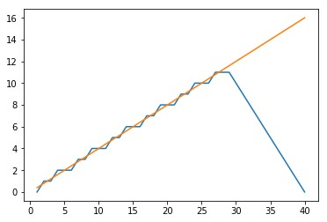

Smooth Line represents the continuous optimal bet for different Initial wealth, the zigzag line is the optimal value when the bet values are constraints are restricted to integer values.

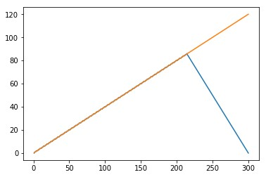

Notice that both the plots almost converge for higher upper limits. The Discrete line takes a sharp plunge to respect the constraints put on the maximum amount of wealth in the discrete case.