**Expense Manager**

**Contents**

1. Introduction
2. Requirements
3. Installation
4. Usage

**Introduction**

A simple expense manager that can track users’ expense. User’s can set an initial budget and track all the expense which can be split between the groups for people.

**Acknowledgement**

I would like to thank my tutor and opportunity provide by Internshala for this project. This project help me to learn basic of web development using HTML, CSS, MySQL and PHP. This project helped me to understand real life problem and using the above knowledge to solve it.

**Requirement**

1. **MySQL:** This website requires MySQL for storing information. MySQL can be installed using Wamp server.
2. **WAMP server:** Apache server is required to run the project which can be installed using WAMP Server.
3. **Browser:** Latest version of Chrome, Firefox or Edge should be used to run the website.

**Installation:**

1. Extract the content of project.zip to   
   C:/wamp/www/expense (32-Bit OS)  
   C:/wamp64/www/expense (64-Bit OS)
2. Go to C:/wamp64/www/expense/ folder and run the budget.sql script.
3. Start the wamp server, make sure its all services are running and icon is green in color.
4. Open desired browser and go to localhost/expense.

**Usage:**

* Index page of website.

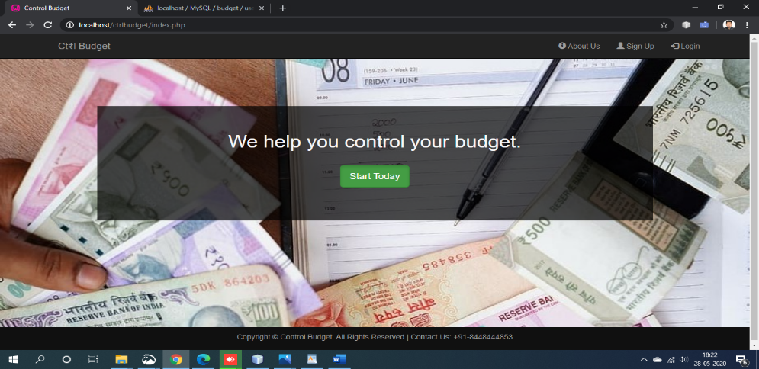

1. About Us Page

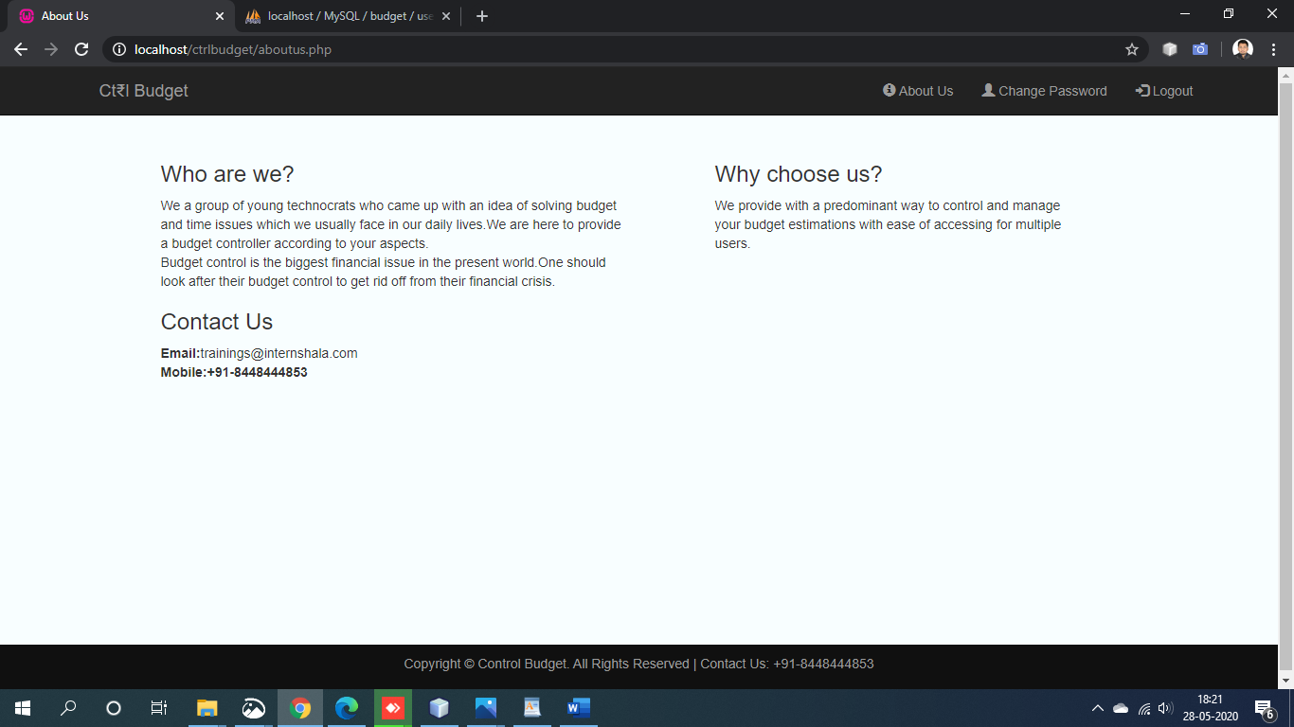

2. Sign Up page

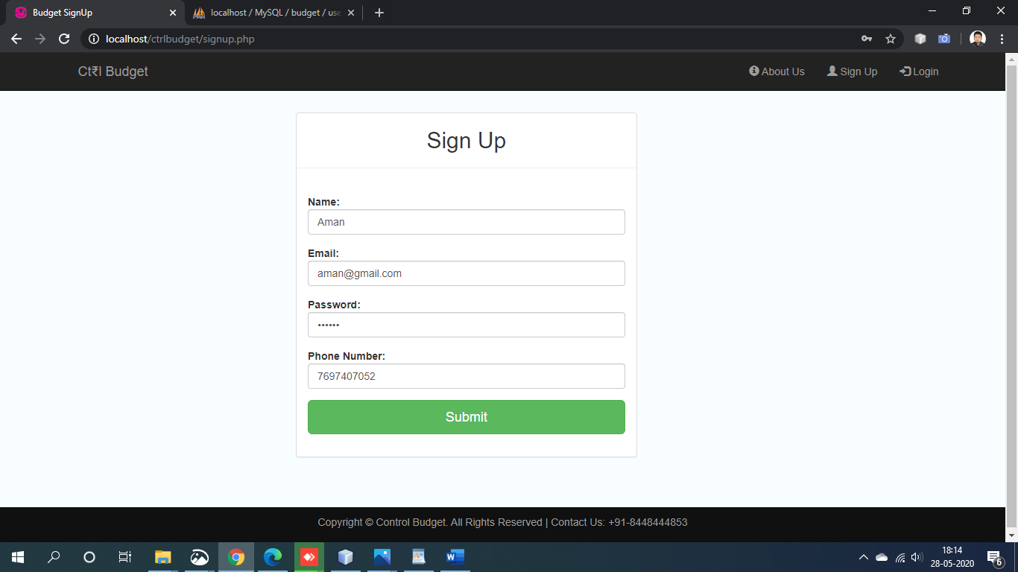

(Pop up alert message for successfully registration)

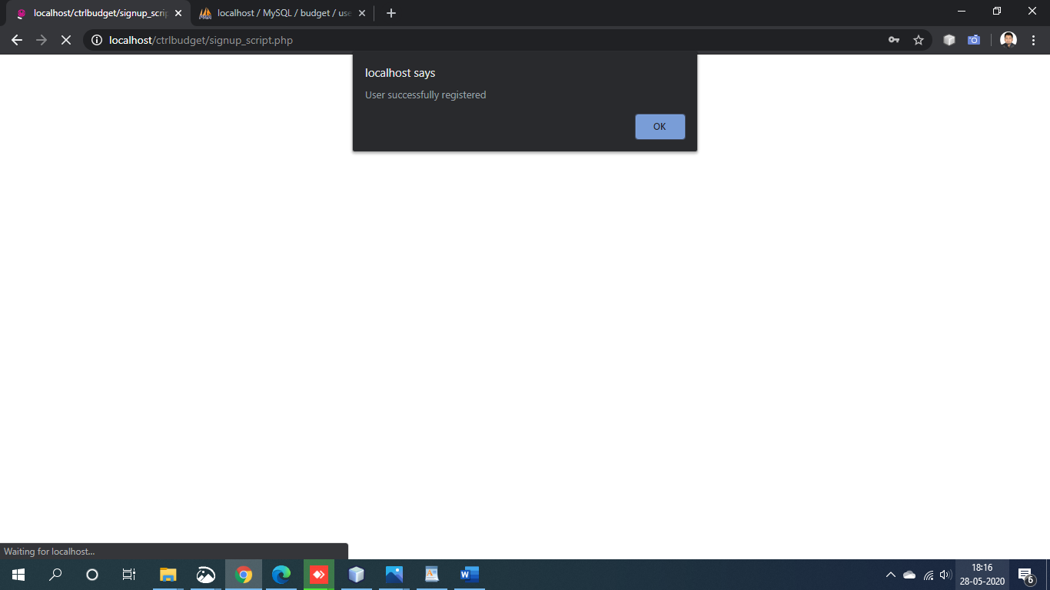

1. Home Page:

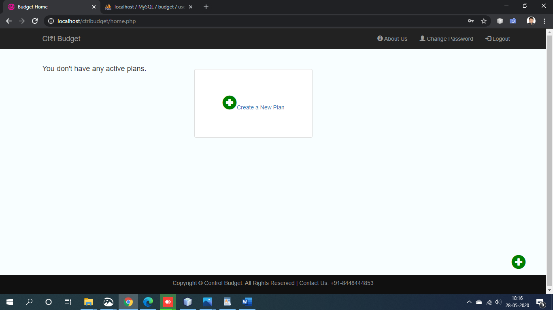

1. Create New Plan for user

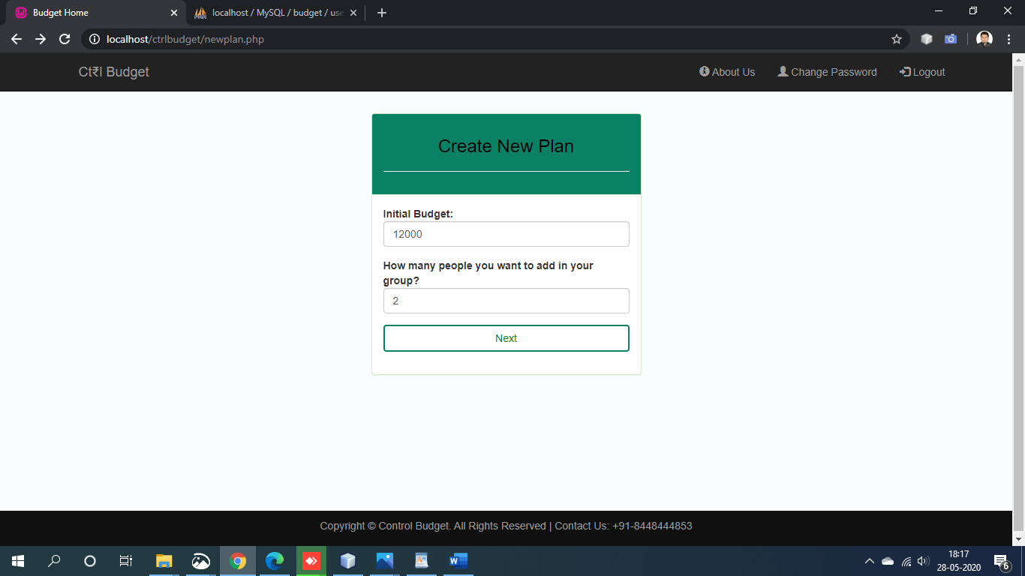

(Second part of the form)

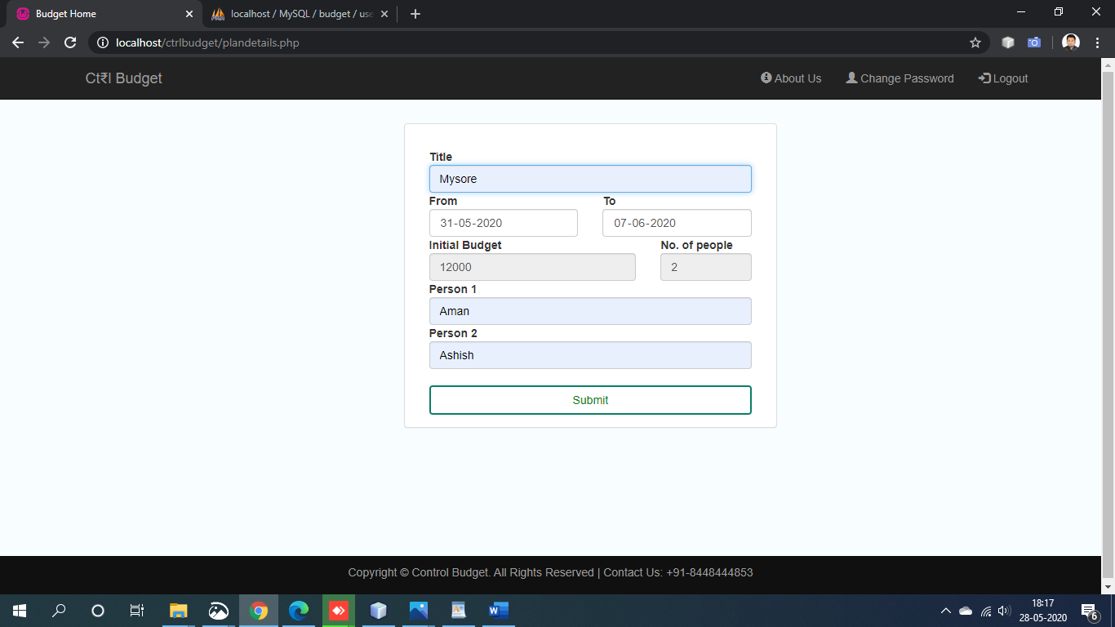

(after submission, redirect to homepage with new plan created, user can create more plan using add button )

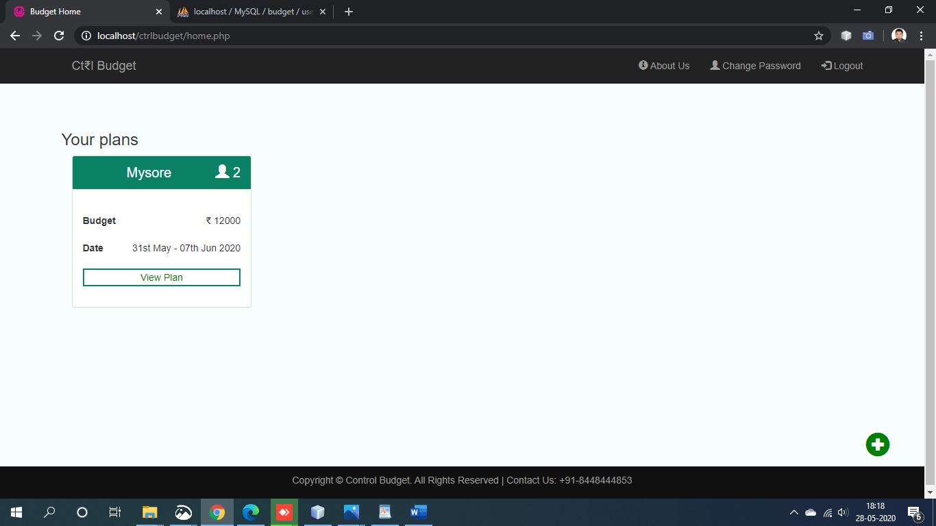

1. View Plan page

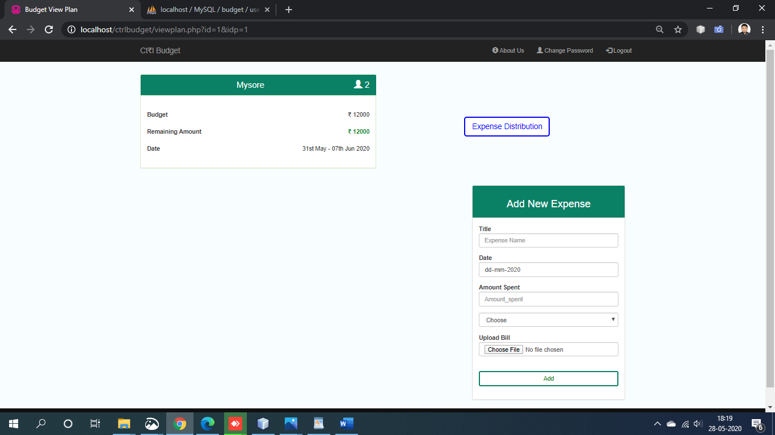

(Add new expense form )

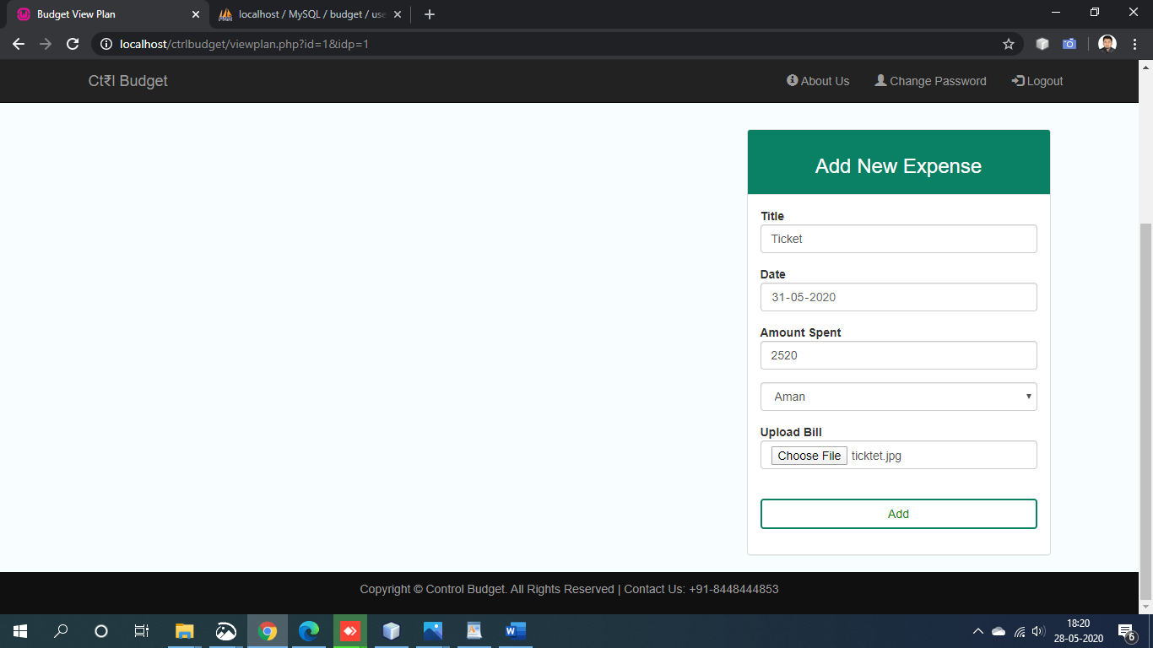

(expense are added in view plan page)

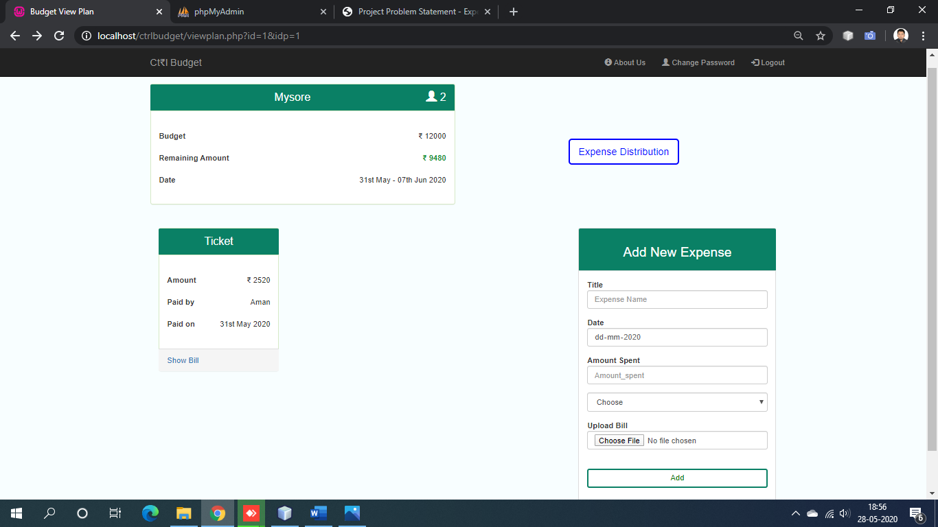

1. View Distribution page

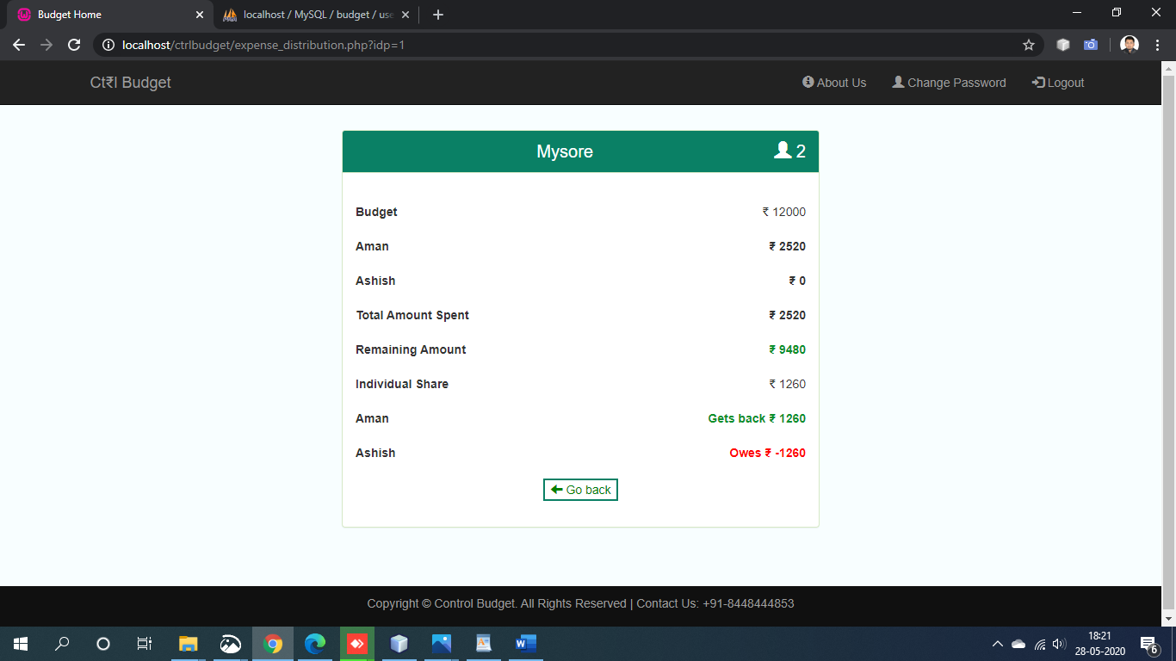

1. Change Password page

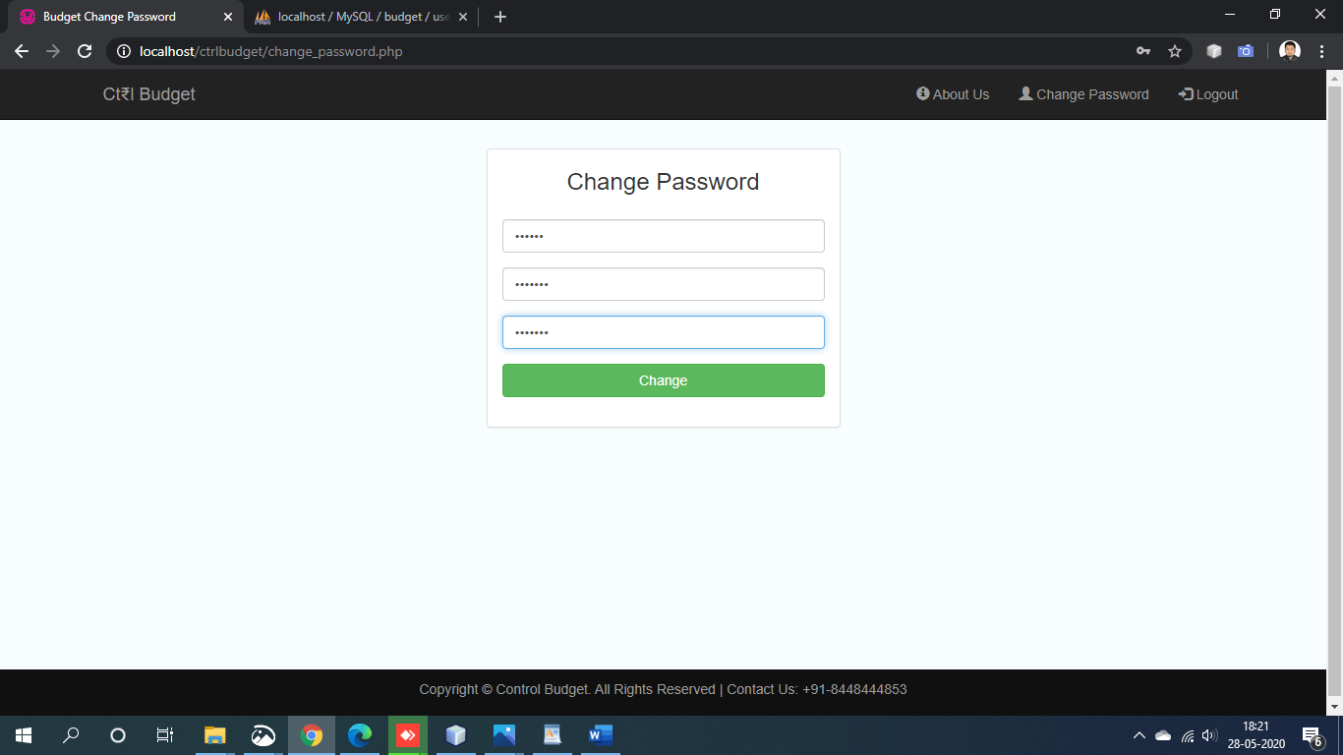

(Password updated alert message)

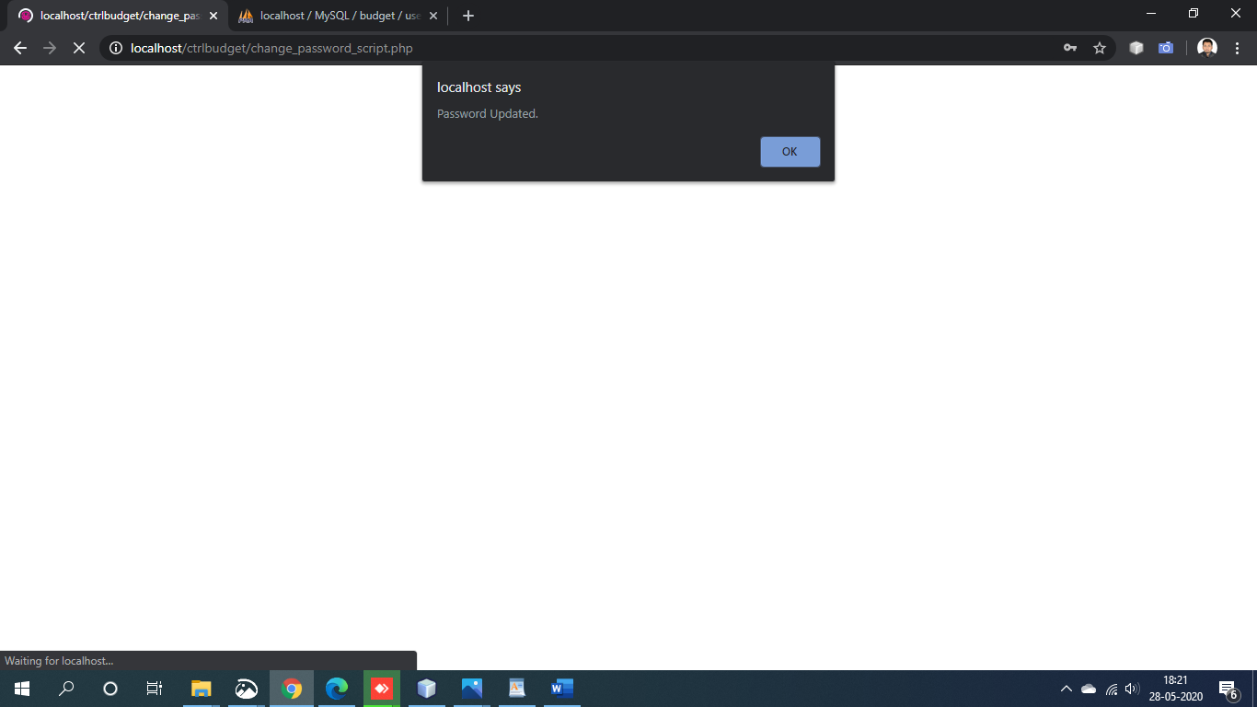

**About the coder**

**Name – Aman Soni**

**E-mail –** [**amansoni.nitraipur@gmail.com**](mailto:amansoni.nitraipur@gmail.com)

**Collage – NIT Raipur**

**Branch – ECE**