Game Design Document

Fill up the following document

1. Write the title of your project.

Electroplating

1. What is the goal of the game?

To make someone learn about reactive series easily.

1. Write a brief story of your game.

Their will be options of chemicals and we have to chosse that what will be our cathod and anode to do electroplating. Game will also have some condition like if gold is cathod then what can be ANODE

1. Which are the playing characters of this game?

* Playing characters are the ones who respond to the user based on the input from the user.
* Cars, monkeys, dinos, wizards, etc., are the playing characters in the game.

|  |  |  |
| --- | --- | --- |
| Number | Character Name | What can this character do? |
| 1 | Liquid conducter | To conduct electricity |
| 2 | potassium | options |
| 3 | gold | options |
| 4 | Sodium | options |
| 5 | silver | options |
| 6 | carbon | options |
| 7 |  |  |
| 8 |  |  |

1. Which are the Non-Playing Characters of this game?

* Non-Playing characters are the ones that don't have an action or behavior when the user interacts with the game.
* Hurdles, stones, bananas, coins, etc., are non-playing characters in the game.

|  |  |  |
| --- | --- | --- |
| Number | Character Name | What can this character do? |
| 1 | Liquid conducter | To conduct electricity |
| 2 | batteries | Give power |
| 3 | wire | connect |
| 4 | background |  |
| 5 |  |  |
| 6 |  |  |
| 7 |  |  |
| 8 |  |  |

Draw your imagination of this game. What does this game look like?

* Draw the game either on your computer or on paper.
* Add images of the game scenes to show each of the playing and non-playing
* 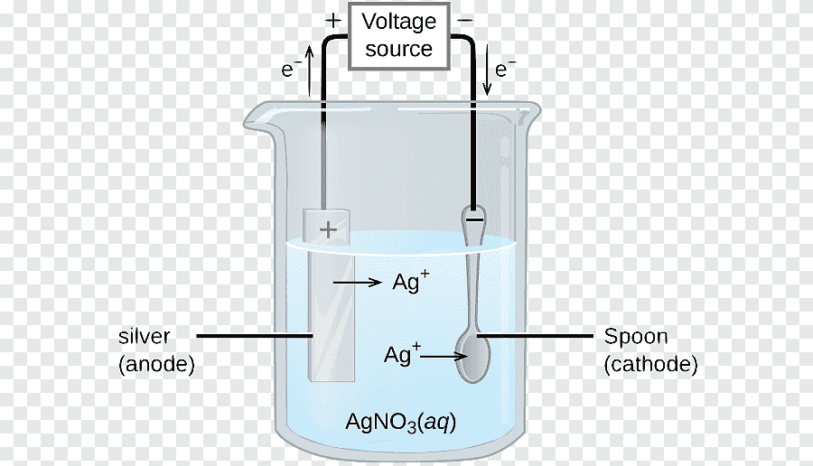
* characters at least once.

How do you plan to make your game engaging? It will have some conditions