**Run Book:**

**To Run the code on Windows:**

1.Install Java8 :

To install Apache Spark on windows, you would need Java 8 or the latest version hence download the Java version from Oracle and install it on your system. If you wanted OpenJDK you can download it from [here](https://www.oracle.com/java/technologies/downloads/#java8).

After download, double click on the downloaded .exe ([jdk-8u371-windows-x64.exe](https://www.oracle.com/java/technologies/downloads/#license-lightbox)) file in order to install it on your windows system. Choose any custom directory or keep the default location.

After installation set JAVA_HOME environment variable.

Eg: JAVA_HOME= C:\Program Files\Java\jdk1.8.0_333

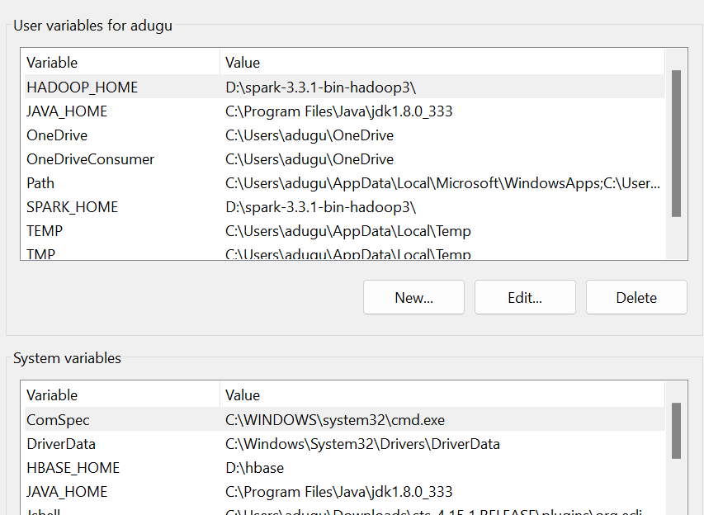

2.Install Scala-IDE for eclipse:

i. Download and install Scala-IDE for eclipse from [here](http://downloads.typesafe.com/scalaide-pack/4.7.0-vfinal-oxygen-212-20170929/scala-SDK-4.7.0-vfinal-2.12-win32.win32.x86_64.zip)

ii. Extract the zip file and run eclipse.exe.

iii. Select Workspace

Eg: D:\Workspace

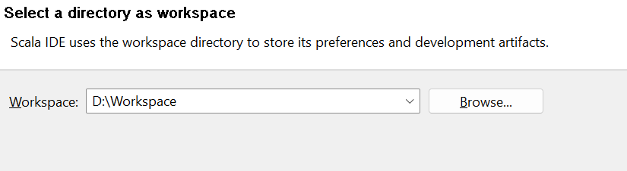

3. Import the project from by clicking File -> Import -> Maven -> Existing Maven Project

Then browse the project name and select the project path.

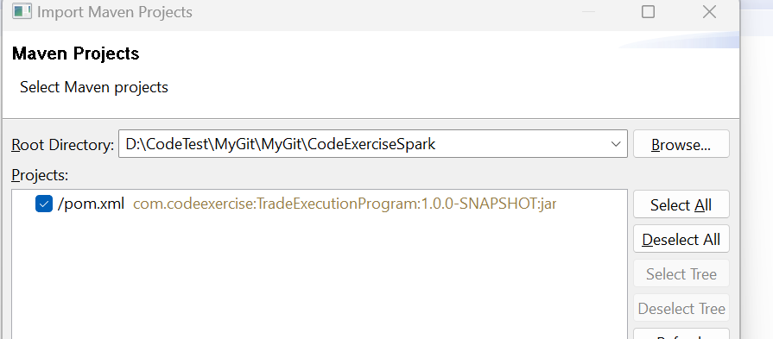

3.Configure scala build path :

Right Click on Project ->BuildPath -> Configure Build Path -> Libraries ->Scala Library container

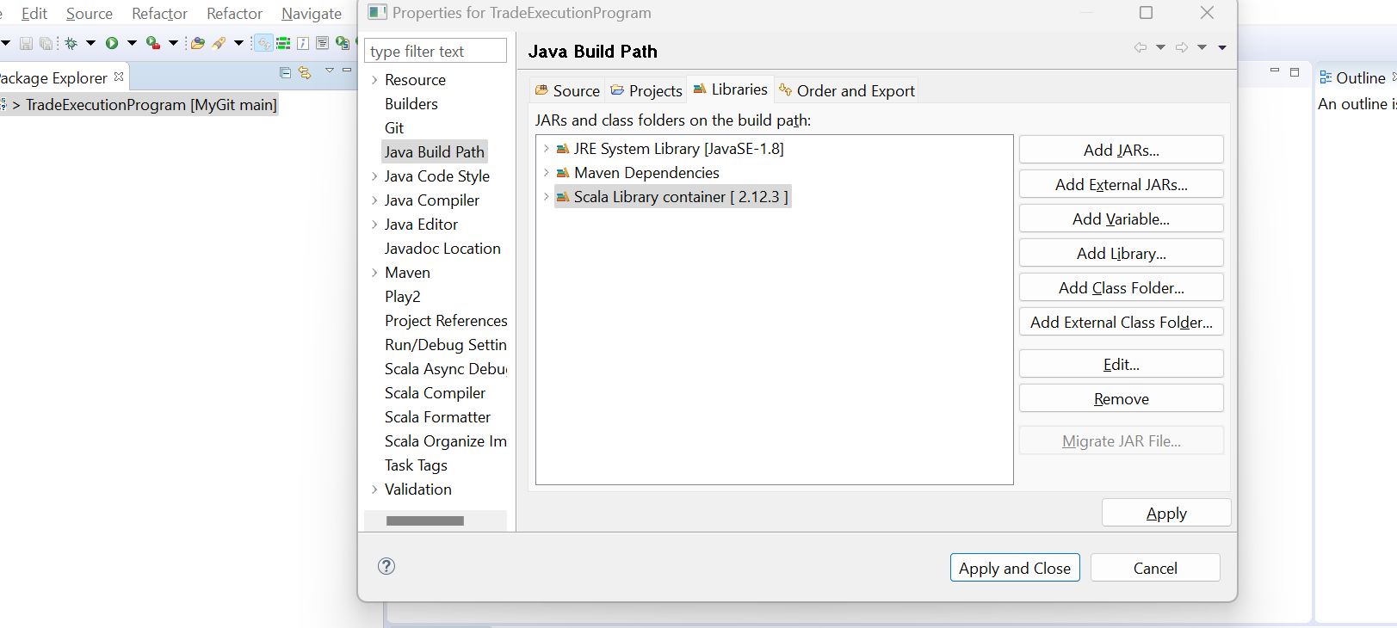

Change the scala version to Latest 2.11 dynamic then click Finish

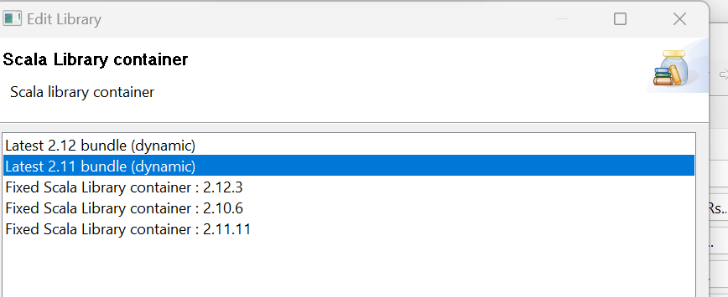

4.Setup run configurations:

1.Click on project and navigate to src/main/scala/com/exercise/code/TradeExecution.scala

2.Right click on TradeExecution.scala and do Run As -> Run Configurations -> Scala Application

Provide The Name as **TradeExecution$**

Provide **com.exercise.code.TradeExecution** in Main Class

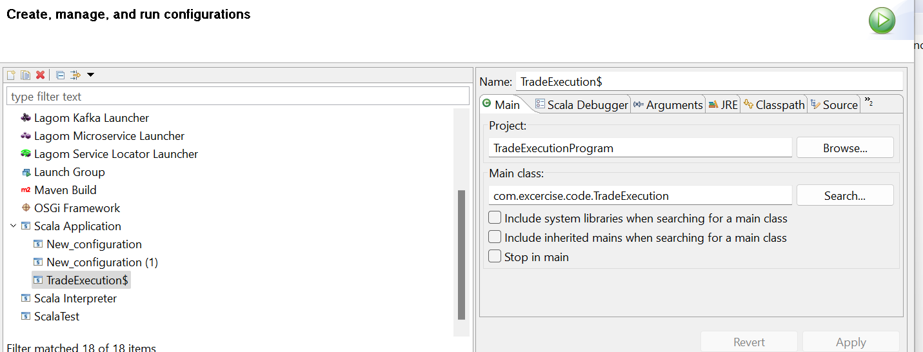

Click on Arguments and pass the appropriate arguments then click Run

Example: D:\\CodeTest\\orders orders.csv D:\\CodeTest\\book books.csv D:\\CodeTest\\tradematch tradematch.csv D:\\CodeTest\\orders\\archive D:\\CodeTest\\orderbooks\\archive

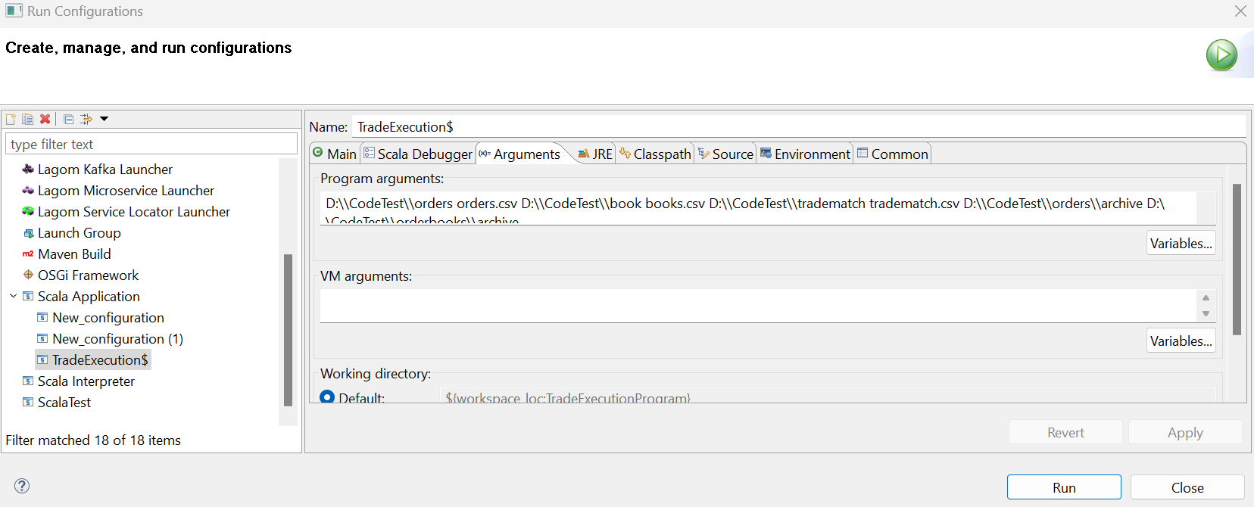

After successful run check the output path and archive paths.

**To Run the code on Unix Environment with Hadoop Cluster:**

Pre-Requisites:

1. The Hadoop version should be greater then 2.10

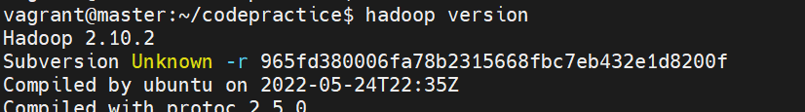

1. Check Java version . It should be 1.8

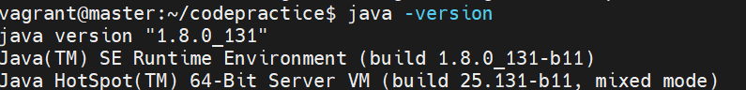

1. Spark version should be greater than or equal to 2.4.3

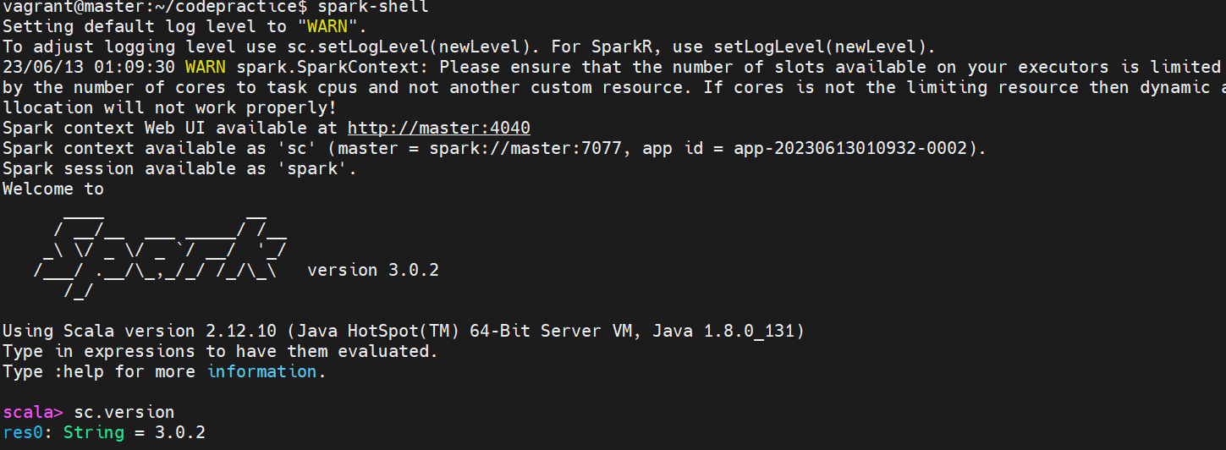

Run Procedure:

1.Place the jar in desired path

Eg : /home/vagrant/codepractice/jars/TradeExecutionProgram-1.0.0-SNAPSHOT-jar-with-dependencies.jar_bkp

2. Create the following folders in Hadoop

1.ordersFilePath - File path where the order files are present

Eg: hdfs dfs -mkdir /home/vagrant/codepractice/input

2.orderBookFilePath - File path where the Booking will be Stored

Eg: hdfs dfs -mkdir /home/vagrant/codepractice/orderbook

3.closedOrdersFilePath - Output file path where the closed/matched orders will be stored

Eg: hdfs dfs -mkdir /home/vagrant/codepractice/output

4.orderFileArchivalPath - Path where the input/Order files will be archived after processing

Eg : hdfs dfs -mkdir /home/vagrant/codepractice/archive/orderFiles

5.orderBookArchivalPath - Path where the orderBook files will be archived after processing

Eg: hdfs dfs -mkdir /home/vagrant/codepractice/archive/orderBooks

3.Upload the input files (orderFile , OrderBookFile(If Exists)) to their respective paths.

4.Now run the jar with the spark-submit command.

Example:

spark-submit --name "TradeExecEngine" --master yarn --deploy-mode cluster --driver-memory 1g --executory--memory 1g --executor-cores 4 --class com.excercise.code.TradeExecution /home/vagrant/codepractice/jars/TradeExecutionProgram-1.0.0-SNAPSHOT-jar-with-dependencies.jar /home/vagrant/codepractice/input exampleOrders.csv /home/vagrant/codepractice/orderbook orderbook.csv /home/vagrant/codepractice/output tradematch.csv /home/vagrant/codepractice/archive/orderFiles /home/vagrant/codepractice/archive/orderBooks

5.Verify the output path after successful execution

Example : hdfs dfs -ls /home/vagrant/codepractice/output

6.Verify the archive paths to check if the files have been archived