WACC Estimation

# Estimation of cost of debt and effective corporate tax rate:

## Cost of Debt:

The first step in calculating the cost of debt, is identifying the total debt of company A through the Balance Sheet. This value equates to £143.3 million for the latest financial year. To determine how the cost of debt is calculated, the structure of the company’s debt needs to be examined. If the company issues bonds, he yields need to be accounted for. If the company has loans and makes interest payments, then these need to be accounted for.

In the case of company A, the debt structure is exclusively loans. This means that to determine the cost of debt is to divide the interest paid in the latest financial year by the total debt accrued by the company:

|  |  |  |
| --- | --- | --- |
|  | 𝑅𝑑 $=\frac{Interest expenses}{Total Debt}$ | (1) |

Where $R_{d}$, is the cost of debt.

The calculated cost of debt is 2.99%.

## Effective Corporate Tax Rate:

The effective corporate tax rate of company A also needs to be estimated. This can be done by dividing the year’s tax expenses by the company’s earnings before interest and tax (EBIT):

|  |  |  |
| --- | --- | --- |
|  | 𝑇𝑐 $=\frac{Tax expenses}{EBIT}$ | (2) |

Where $T_{c}$, is the effective corporate tax rate.

The corporate tax rate was estimated to be 22.64%. This was calculated using the total current tax expense found in the Income Statement. It includes deferred tax since the current tax is calculated based on earnings for this financial year. The amount of deferred tax does not influence the taxation rate, it only influences how much tax will be paid by company A at the end of this year.

# WACC estimation:

The Weighted Average Cost of Capital (WACC) is vital to evaluating the profitability and viability of a new project. It is the discount rate used when calculating the Net Present Value (NPV), which is ultimately used to decide whether a project should be chosen.

To estimate the WACC, the equation below was used:

|  |  |  |
| --- | --- | --- |
|  | 𝑅𝑝 $=1-$ 𝐺𝑅𝑒 $+G$ 𝑅𝑑 $\left(1-T_{c}\right)$ | (3) |

Where $R_{p}$ is the WACC, $G$ is gearing ratio, $R_{e}$ is cost of equity, $R_{d}$ is cost of debt and $T_{c}$ is the effective corporate tax rate.

## Gearing:

The first step for the calculation of WACC is the evaluation of the gearing ratio of company A:

|  |  |  |
| --- | --- | --- |
|  | $G=$ 𝐷 $D+$ 𝐸 | (4) |

Where $D$ is total debt and $E$ is total equity.

Using the Thomson-Reuters Eikon database, the total debt was evaluated at £143.9 million, while the total equity was given to be £508.8 million (both values were obtained from the Balance Sheet for 2020). This gives a gearing ratio, $G$, of 22.05%.

## Cost of Equity:

The cost of equity, $R_{e}$, of company A also needs to be evaluated using the Capital Asset Pricing Model (CAPM) equation:

|  |  |  |
| --- | --- | --- |
|  | $R_{e}=$ 𝑅𝑓 $+\text{β}$ 𝑒𝑅𝑚−𝑅𝑓 | (5) |

Where $R_{f}$ is the risk-free rate, $β_{e}$ is the beta of equity and $\left(R_{m}-R_{f}\right)$ is the equity premium.

## Beta of Equity:

The risk-free rate is assumed to 1.1%, while the equity premium is determined as 5.8%. The $β_{e}$ for company A is unknown, since there is no data on a project like this, which was taken on by company A. It needs to be calculated using information taken from company B (the comparison company), which is an established company in this sector. The evaluation of $β_{e}$ is achieved by using the equation below:

|  |  |  |
| --- | --- | --- |
|  | $β_{e}=1-\text{G}$ ∗𝛽𝑒∗ $\left(1-G\right)$ | (6) |

Where $G^{*}$ is the gearing ratio of company B and $β_{e}^{*}$ is the beta of equity for company B.

Equation 6 can be used only if the gearing ratios of company A and company B are similar. If they are indeed similar, then the assumption can be made that the beta of debt for both companies is equal to zero. This assumption allows for the use of equation 6.

|  |  |  |
| --- | --- | --- |
|  | $$β_{d}≈β_{d}^{*}≈0$$ | (7) |

Where $β_{d}$ and $β_{d}^{*}$ are the betas of debt for company A and company B respectively.

Using equation 4, $G^{*}$ was estimated at 26.56%, as the value for total debt was £607.5 million and total equity was £1,680 million (from the 2020 Balance Sheet for company B on Eikon). This means that the assumption is valid, since gearing for both companies is similar. The beta equity of company B was taken directly from Eikon, which was calculated using monthly data for the past 5 years. This value was given as 1.37 on 10/12/2020. Therefore, by using equation 6, $β_{e}$ was calculated as 1.29.

Now that we have obtained $β_{e}$, $R_{e}$ can be evaluated. By using equation 5, the cost of equity was computed to be 8.59%.

## WACC Evaluation:

Since all variables for equation 3 have been determined, the WACC can be evaluated. The value for the weighted average cost of capital is estimated as 7.20%.

## Sources of error:

It should be noted that the above calculations are estimations of each value. This suggests that there are multiple sources of error.

Note: All values used in the calculations were calculated using the latest available values for 2020 from the Financial Statements available on Eikon. The same values for the previous 3 years were calculated for comparison purposes.

As mentioned in the first section, the method of calculation for the cost of debt is dependent on the debt structure of the company. For this reason, since company A’s debt comprises loans only, equation 1 needs to be used. Compared to data available, the value is close to the arithmetic mean of all costs of debts calculated for the previous 3 years (only 0.22% higher). This suggests that there is a possibility that the cost of debt estimation has a satisfactory degree of accuracy.

There is variation in the corporation tax paid year on year, most likely due to tax deductible items. The value of these items is likely to change each year, hence the amount deducted from company A’s earnings is different each year. Despite the 2020 value giving the lowest tax rate out of the Balance Sheet values, it is the closest to the benchmark value for corporate tax stated on the UK government website. The corporation tax rate in the UK is 19% (HMRC, 2020).

Both companies’ gearing ratios are another source of possible error within the estimation of WACC. Company A’s gearing ratio is less than 1% different from the arithmetic mean of the gearing ratios calculated for all years from 2017 to 2020. This suggests that company A’s gearing is likely estimated to a good degree of accuracy. The gearing for company B, on the other hand, is the lowest value compared to previous years.

Lastly, the beta of equity for company B likely contains the highest degree of inaccuracy of inaccuracy. The accuracy of estimation for $β_{e}^{*}$ heavily depends on the time period, over which it was calculated and the frequency of the collection of data. The $β_{e}^{*}$ taken directly from Eikon is calculated over a 5-year period, with information taken monthly. The accuracy of estimation for company B’s beta of equity would most certainly increase if either the time period or the frequency of data was to increase. (394)

Sensitivity Analysis:

The role of sensitivity analysis in capital budgeting is to prepare for circumstances in which the devised calculations and estimates are deemed unreliable. By using company B as a benchmark to calculate the required WACC, company A creates a realistic model for their purposes of project valuation. However, as company B has been established in the field of food manufacturing for over 45 years, they have a much more efficient process of reducing overhead costs, variable costs, and fixed costs on their production. To base the entire WACC off their current financials would create a certain margin for error. In order to prepare for this uncertainty, the sensitivity analysis provides an in-depth look at input variables that would influence the overall WACC.

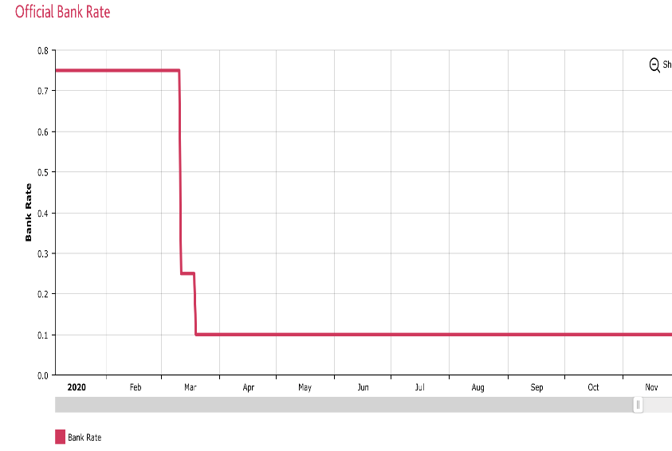The biggest impact on the WACC is the capital structure taken on to finance the project of Company A. Although the tax benefits of debt financing are attractive, the uncontrollable residual impacts of Brexit and COVID create an unpredictable outcome. The Bank of England has currently agreed to hold the rate at .10% (until the next addendum) when just previously interest rates had dropped from .75% to .25% in March due to the bearish impact of COVID. The values for the cost of debt were compared to the industry average (food wholesale) which was roughly 3.3%. By inputting numbers in small increments along this range, we found that a realistic upper bound for the WACC is 10.96%. This was estimated

As seen in the figure below, using a range of equity premiums caused the overall WACC to vary by nearly 10%. In a study conducted by KPMG, analysts suggested using a market premium of 6.75% as investors would require a higher return over the risk-free rate to hold stock in the current financial environment. By inputting incremented values along this range, we found that equity premium impacts not only the cost of equity but the overall WACC very significantly. This calculation was used to find the upper bound of 12.2%.

Conclusion:

From the conducted sensitivity analysis, it can be inferred that the optimal discount rate to use for project appraisals lies between x and 12.2%. Company A’s WACC appears to be sensitive to changes in the Equity Market Premium and the cost of debt. Due to current rise in risk levels, a higher equity premium will be required[1] for investors to hold stock in Company A, increasing the cost of equity and the WACC. However, the WACC appeared to be less sensitive to changes in the cost of debt, as 5% fluctuations only accounted for a 1.5% increase in the cost of capital. This would imply that the optimal capital structure would rely on heavy debt financing despite the unpredictable nature in interest rates. Bond volatility is considerably less impactful than volatility in stock.

Cost of Debt vs WACC

Citation list:

<http://www.market-risk-premia.com/gb.html>

<https://assets.kpmg/content/dam/kpmg/nl/pdf/2020/services/equitiy-market-risk-premium-research-summary-march-2020.pdf>

<https://www.statista.com/statistics/664833/average-market-risk-premium-united-kingdom/>

<https://assets.kpmg/content/dam/kpmg/ch/pdf/cost-of-capital-study-2018.pdf>

<https://www.which.co.uk/news/2020/11/what-will-the-brexit-trade-deal-and-coronavirus-mean-for-interest-rates/>

<https://www.bankofengland.co.uk/boeapps/database/Bank-Rate.asp>

Deviation calculations: (Scratchwork to be deleted)

Assuming 7.21% WACC is X bar

|  |  |  |  |
| --- | --- | --- | --- |
| Xi cost of debt WACC | (Xi-X) | (Xi-X)^2 | n |
| 6.87% | -.34 | 0.1156 | 1 |
| 7.25% | .04 | .16 | 2 |
| 7.21% | 0 | 0 | 3 |
| 7.55% | .34 | .1156 | 4 |
| 8.40% | 1.19 | 1.4161 | 5 |
| 10.96% | 3.75 | 14.0625 | 6 |

Summation Xi-X^2= 15.8698

(Xi-X)^2/n= 2.644 (variance)

Std deviation= 1.62633

1. The current equity premium for this financial quarter was found and calculated by KPMG and accounts for current volatile fluctuations in the market due to the economic impact of covid-19 as well as brexit