**DSA HW3 Report**

Zhongze Tang (zt67)

**Q1**

In Line 7, you can change the number of random input. Then you will see the output of in-order traversal of this tree.

**Q2**

The experiment is based on the tree written in Q1.

The result is shown in the table:

|  |  |  |
| --- | --- | --- |
| N | Ave path len(ordered) | Ave path len(random) |
| 1 | 1.0 | 1.0 |
| 2 | 1.5 | 1.5 |
| 4 | 2.5 | 2.225 |
| 8 | 4.5 | 3.165 |
| 16 | 8.5 | 4.188125 |
| 32 | 16.5 | 5.3846875 |
| 64 | 32.5 | 6.496875 |
| 128 | 64.5 | 8.089921875 |
| 256 | 128.5 | 9.2400390625 |
| 512 | 256.5 | 10.5942578125 |
| 1024 | 512.5 | 12.00736328125 |
| 2048 | 1024.5 | 13.3846533203125 |
| 4096 | 2048.5 | 14.75482177734375 |
| 8192 | 4096.5 | 16.236561279296875 |

Adding the depths of all nodes, we get a quantity known as the internal path length of the tree. So, I use this formula to calculate the internal path length PN:

*PN = N + PL + PR*

where N is the size of Node P, and PL and PR are its two subtrees.

I use Curve Fitting Tool in MATLAB to fit the number and the average length (with random input), and the result is:

*f(x) = 1.212*log2(x) – 0.1438*

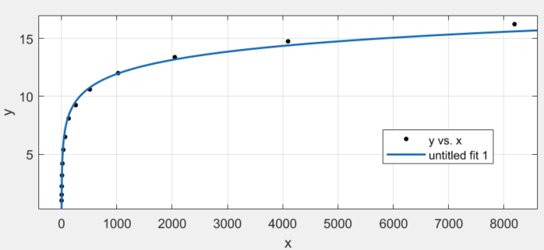

As for the ordered input,

*the average path length = (N / 2 + 0.5).*

The curve fitting file is Q2/Q2curvefit.sfit.

**Q3**

The results are:

Result of 10000 is: 0.25411100000000003

Result of 100000 is: 0.2539944

Result of 1000000 is: 0.25390362999999994

We can safely conclude that the average percentage of red nodes in a random-input red-black tree is 25.4%.

The code of Red-Black BST is from *Algorithms* book website.

**Q4**

The calculation method of internal path length is the same in Q1.

I use Curve Fitting Tool in MATLAB to fit the number and the average length, and the result is:

*f(x) = log2(x) – 0.5426*

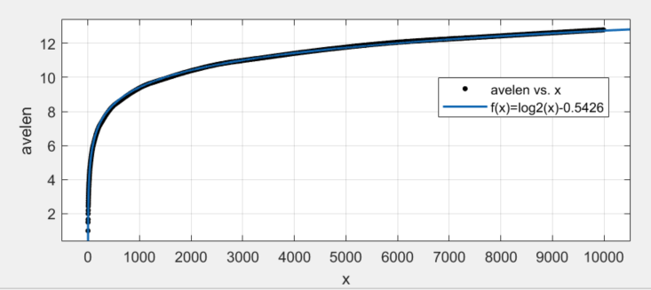

At the same time, the standard deviation is quite small, and its average value is 0.077.

All the results are stored in Q4/result.csv, and the curve fitting file is Q4/curvefit.sfit. The code of Red-Black BST is from *Algorithms* book website.

Note that it took almost 3 hours on my computer (i7-4710MQ, 8G RAM) to work out all the results.

**Q5**

1. The value of *select(7)* is 8.
2. The value of *rank(7)* is 6.