GOOGLE_AUTH_DIAGNOSTIC_REPORT
Purpose: Diagnose the complete Google OAuth authentication flow for a Supabase + Vercel application.

Scope
Trace:
1. User clicks “Continue with Google”
2. Frontend calls Supabase Auth
3. Redirect to Google
4. Google redirects to Supabase
5. Supabase redirects to application
6. Session is created
7. Profile record is created/retrieved
8. User enters protected application

Observed UI Screenshots
Password updated confirmation
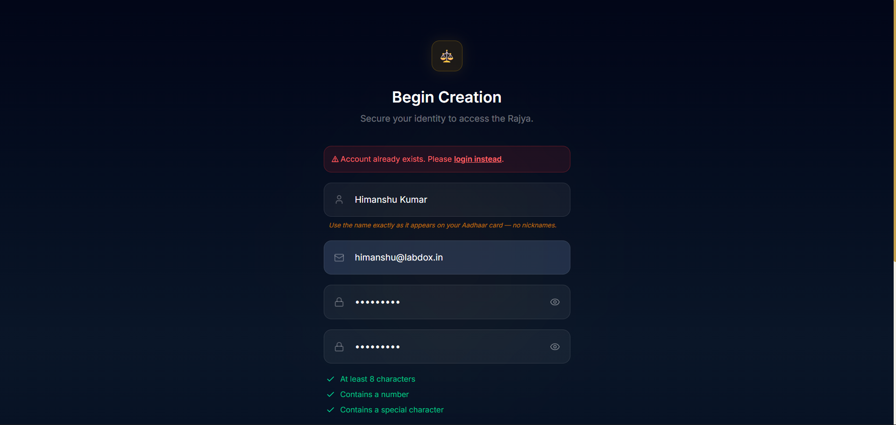
Login page after reset link
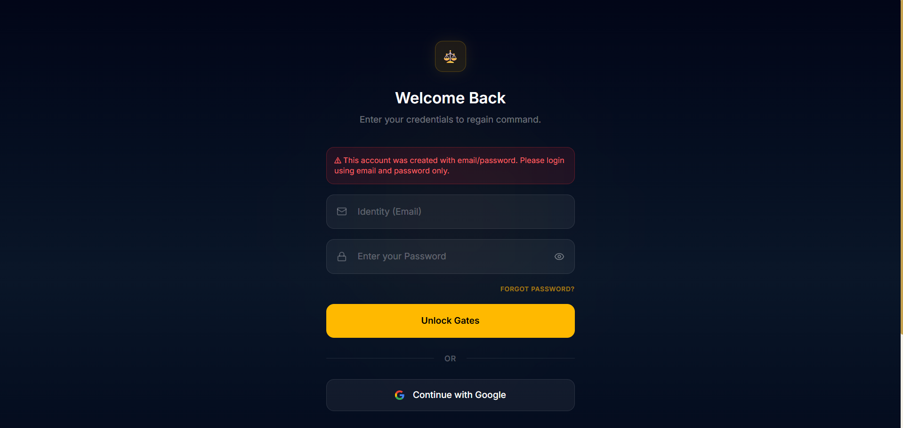
Incorrect password message
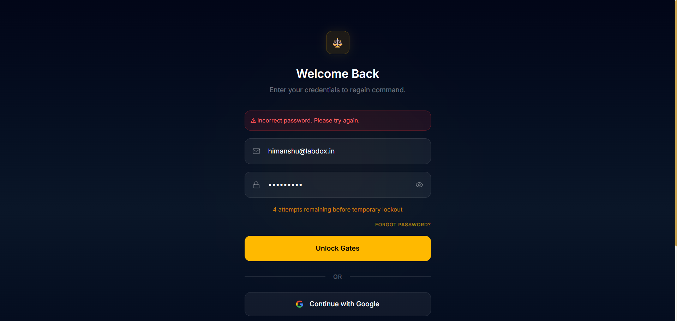
Email/password required instead of Google
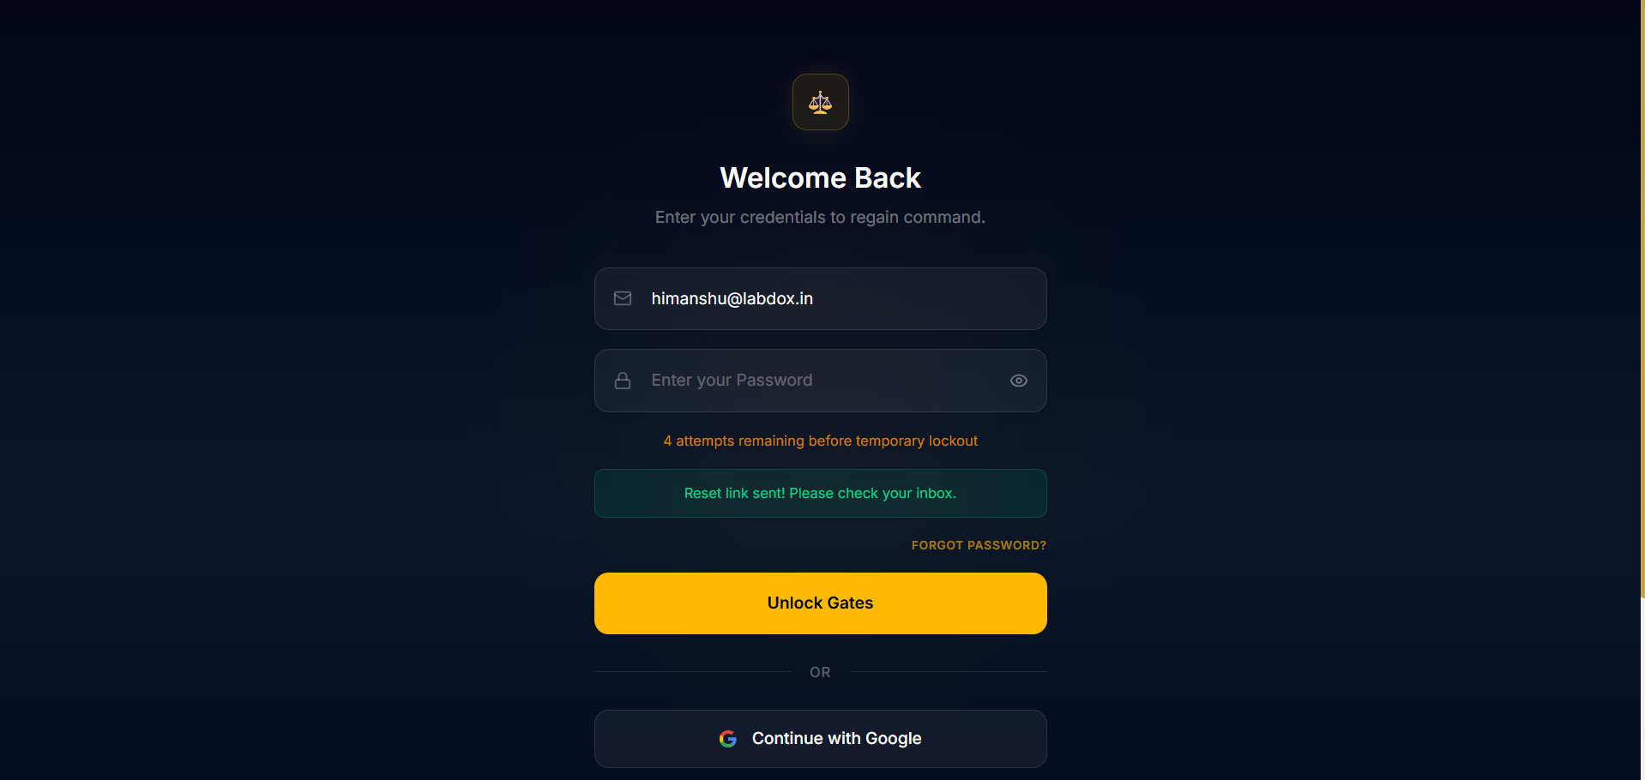
Account already exists during sign-up
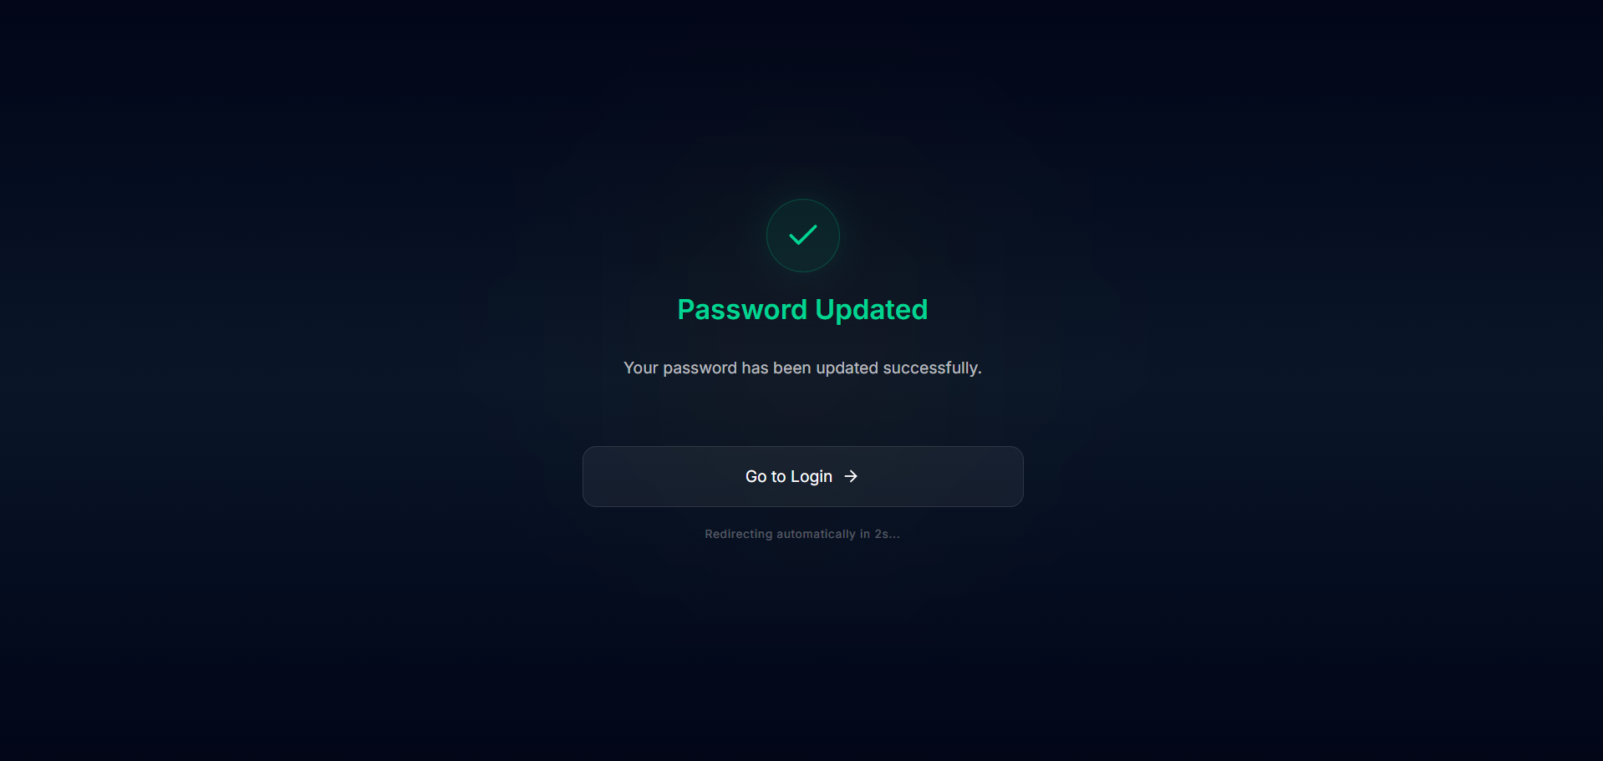

Video Evidence
Insert or link a screen recording of the complete Google sign-up/sign-in process here.
Checklist:
• Click 'Continue with Google'
• Google consent screen
• Redirect to Supabase
• Redirect back to application
• Session established
• Profile creation/retrieval
• Entry into protected application
Video Link: https://drive.google.com/file/d/1Teh4c20B5fe1Cz4OT6GBvDT5T6Y-7hjW/view?usp=drive_link

