**VU Empirische Wirtschaftsforschung: Impact Evaluation (404050)**

**Short test 3: November 27, 2024**

Name: _________________________________ StudentID: ___________________________

1. A researcher is interested in the effect of D on Y. Which of the following variable(s) can serve as an instrument for *D*? Encircle it/them. (2 points)

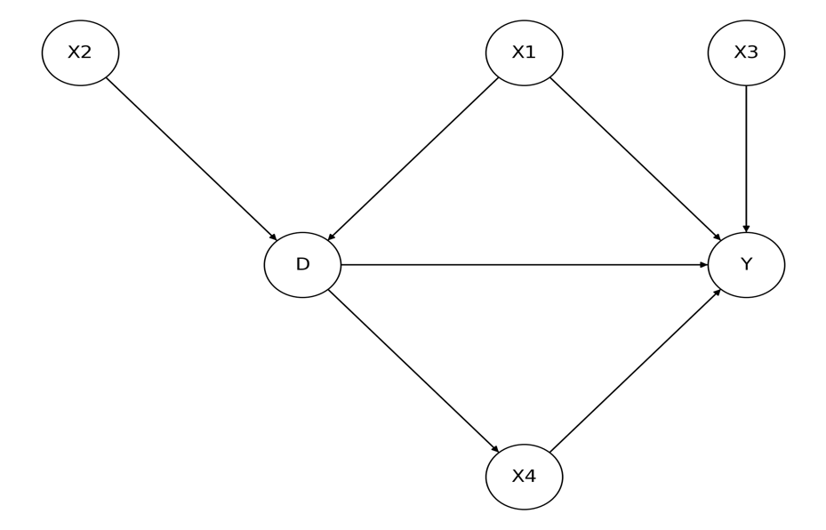

1. Explain what always- and never-takers are in the context of instrument variables. (2 points)

______________________________________________________________________________________________________________________________________________________

______________________________________________________________________________________________________________________________________________________

1. What’s the difference between a sharp and a fuzzy RDD? Explain or illustrate in a figure. (2 points)

______________________________________________________________________________________________________________________________________________________

______________________________________________________________________________________________________________________________________________________