README:

1. Upon starting the program, the following screen will be displayed:

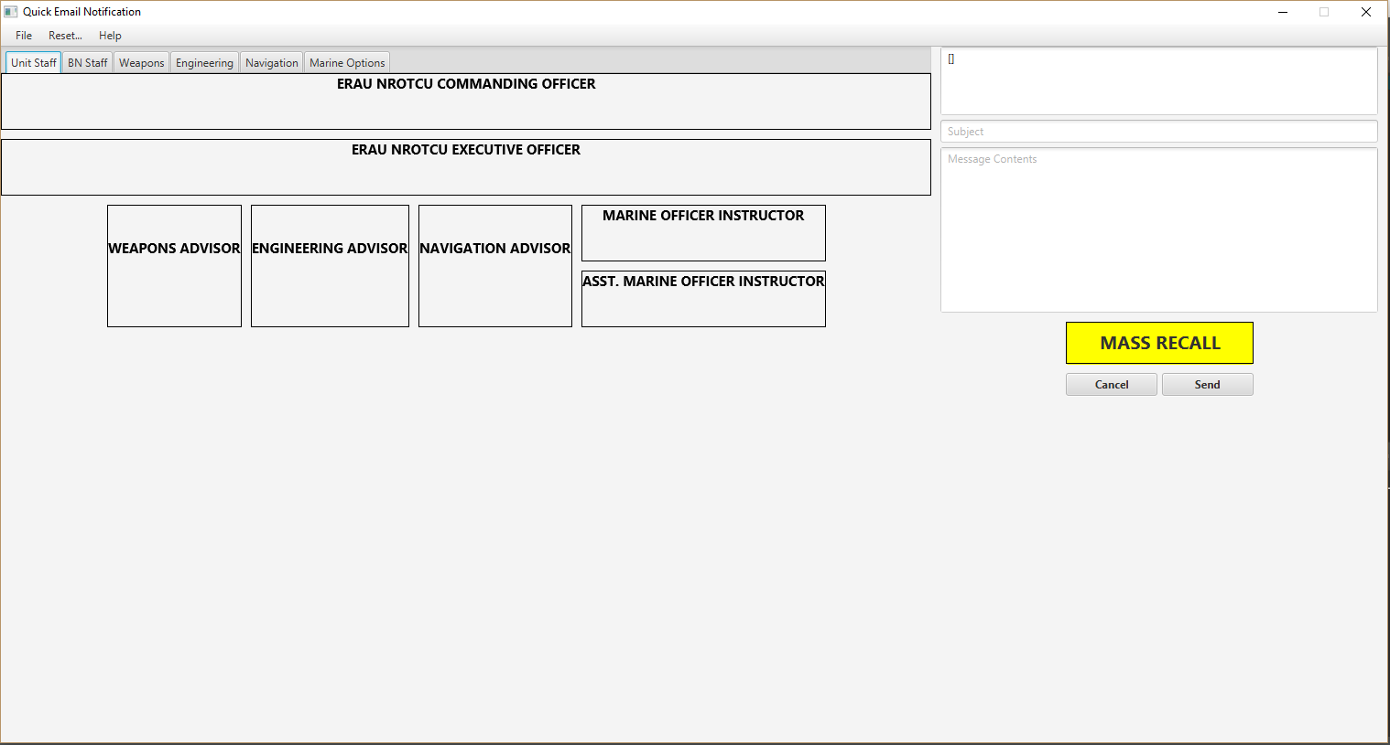

**Figure 1: Main Screen**

1. This screen will serve as the launching point for all further functionality provided by this program. Along the top, a menu bar is positioned, below that is a diagram with tabs attached in order to switch between recipient sections within the Battalion. On the right side, from top to bottom, there is a field that displays selected users, a field that can be edited to modify message subject, and a field that a custom message can be entered in.

## **Battalion Recall**

1. A recall begins by selecting the yellow “Mass Recall” button in the bottom right of the user interface. The screen will update and prompt for a confirmation to begin the process:

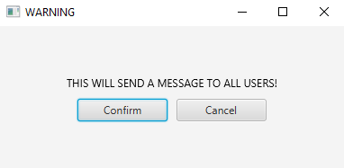

**Figure 2: Confirmation of Battalion Recall**

1. Upon confirmation, the screen will update and all fields will be set for a recall:

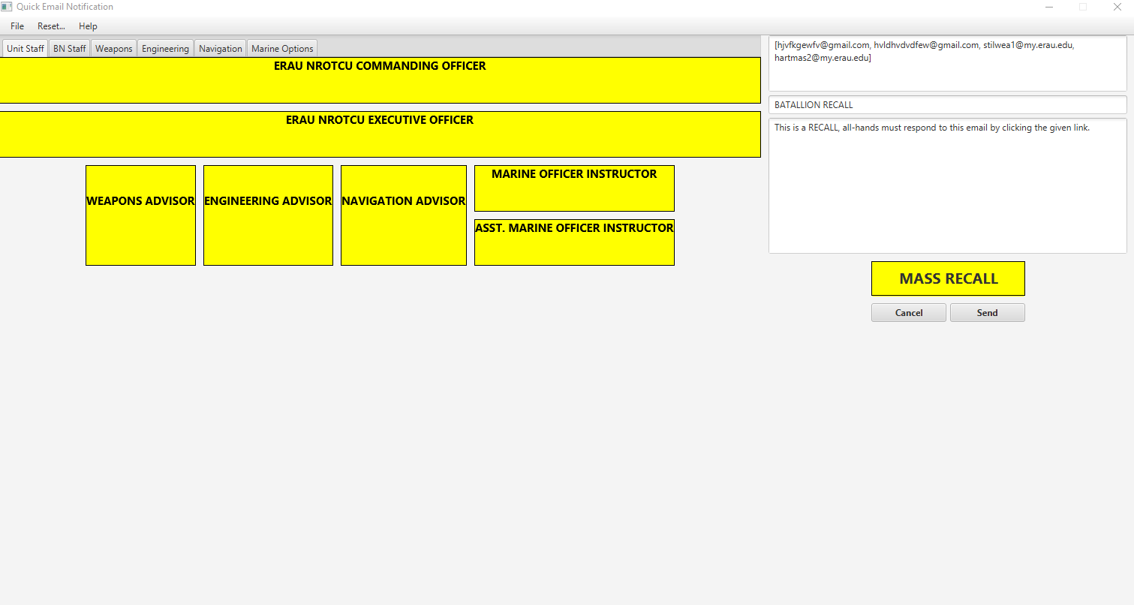

**Figure 3: Screen configuration for Battalion Recall after confirmation**

1. The next step is to click the send button and the program will prompt for an email address and password from the sender:

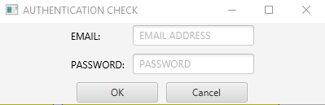

**Figure 4: Authentication Window**

1. Once the username and password is entered and does receive an authentication error (if the credentials are incorrect or there is a problem connecting to the email server an error will occur), the program will proceed to send the emails containing the link and instructions to the selected recipients. The program will then display screen with the current status of the recipients:

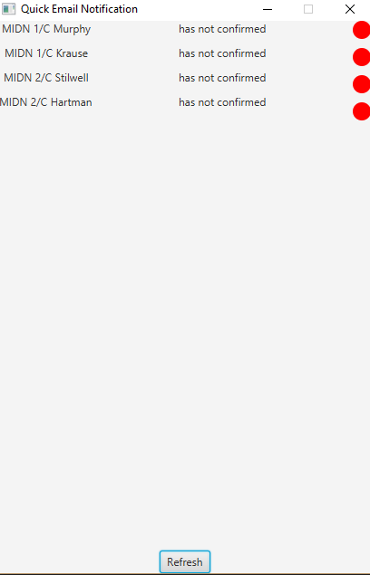

**Figure 5: Confirmation Window**

1. The refresh button may need to be clicked in order to display the list of recipients and must be used to refresh the list. As the recipients start to confirm, the red circles will turn to green circles. When all recipients are confirmed, the screen will change and display an all confirmed message. Be sure to leave the confirmation window open until all recipients have confirmed or the confirmation information is no longer needed, as confirmation information for a message cannot be retrieved after closing the window.

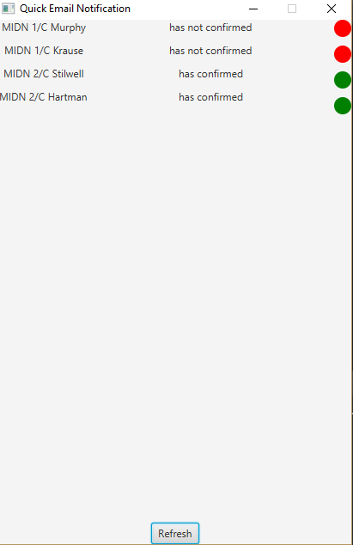

**Figure 2: Confirmation Window with Status Updates**

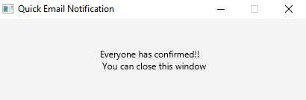

**Figure 2: All Confirmed Status Window Update**

## **Selection of Individual/Groups of Users**

1. In order to select an individual user, left click on the user’s node with information on the diagram. Right click on the same node or the “Reset…” menu option can be used to clear all selections. The node should change colors to yellow. Yellow represents the selected recipients for this session.
2. Group selection can be done by navigating to the appropriate tab in the diagram and then **TRIPLE CLICKING** anywhere within the diagram. All nodes within the diagram should be highlighted. Further isolation of recipients can be performed by right clicking on the ones that need to be excluded from this session.

## **Modification of Subject/Message Fields**

1. The subject and message fields on the right side of the screen can be manipulated to the user’s preferences. The user **DOES NOT** need to worry about formatting the link or relative instructions for modifying the spreadsheet.
2. Execute program titled userInterface.java
3. In LHS of GUI select users that you want to email (Views can be switched by selecting “Switch View” on the menu bar at the top.
   1. Right click users to remove them from the list
   2. Left click users to add them to the list
   3. Selected users will be highlighted in yellow
4. The RHS contains text fields for manual message and email entry
   1. The text fields are placeholders for the information being sent to the email client