**COSC 412 Project: Healthy Living**

By: Eric Cheatwood, Edmund Gladzah, Aziz Akbari, Andrew Stoerkel, Joel Torney, David Leksen

**Table of Contents**

1.Introduction................................................................................................................................3

1.1 Project overview ....................................................................................................................3

1.2 Project Deliverables...............................................................................................................3

1.3 Evolution of this document.....................................................................................................4

1.4 References.............................................................................................................................4

1.5 Definitions and Acronyms………………………………………………………………………….4

2. Project organization ..................................................................................................................5

2.1 Process model ....................................................................................................................... 5

2.2 Project responsibilities.............................................................................................................5

2.3 Organizational Interfaces………………………………………………………………………...….6

3. Managerial process ..................................................................................................................6

3.1 Objectives and priorities..................................................................................………………...6

3.2 Risk management................................................................................................................... 6

3.3 Risk Management....................................................................................................................7

3.4 Staffing Plan............................................................................................................................7

3.5 Monitoring and Controlling Mechanisms................................................................................7

4. Technical process.....................................................................................................................8

4.1 Methods, tools and techniques.............................................................................................. 8

4.2 Software documentation ....................................................................................................... 8

4.3 Project Support Functions…………………………………………………………………………..8

5. Work elements, schedule, and budget......................................................................................8

**Scope and Purpose:** The purpose of our project is to develop a website that includes a game about creating a healthy lifestyle among students in the middle and high school levels. Using a web development application to create our website we will then program the game and upload it to our website.

Part 1: Introduction

**1.1 Overview**: Healthy teen’s healthy life committee’s (HTHL) objective is to develop a web-based/ mobile application game to stimulate teen’s interests in a healthy, active lifestyle. With the assistance of Subject Matter Experts (SMEs) from various related industries including fitness, teaching, medical, health/nutrition and technology, to determine the initial needs of the product HTHL will formulate an accurate interactive forum for the user.

**1.2 Project Deliverables**

**All items to be delivered, including delivery dates and location**

1. February 21st, 2020 - Virtual Classroom
   1. GitHub Repository Creation
   2. Communication plan establishment
   3. Use cases and Requirement
2. February 24th, 2020 - YR128 Classroom
   1. SPMP Submission
3. March 9th, 2020 - Test Skeleton
   1. Create skeleton of unit tests
      1. Fill in skeleton of unit test as code is written
      2. Unit test completed by end of project
   2. Create skeleton of integration tests
      1. Fill in skeleton of integration test as code is written
      2. Integration test completed by end of project
   3. Write end to end System Test procedure
   4. Write regression test procedure (Using Prioritization Method)
4. March 23rd, 2020 - Code Review
5. Mid Semester - Technical Status Presentation
6. End of Semester - URL to a live website which fulfills the project requirements

**Communication Plan**

Project members will communicate regularly via the mobile application GroupMe. Due to social distancing, In-person meetings will not be possible. Therefore, extensive meetings will be held through a Discord server.

Members and stakeholders will utilize GitHub to coordinate production and submit deliverables.

Link to GitHub: <https://github.com/Ericc15/COSC412-Group1.git>

Point of Contact for GitHub: Eric Cheatwood

**1.3 Plans for Change**

* **Anticipated**:
  + - Update Gantt chart
    - Update requirements,
    - Use Trello for task distribution

* **Unanticipated:** Different areas of the project plan can be compressed if shortcomings arise. Should problems arise before or during the Design stage, we can compress and overhaul the System Design process to make up for lost time, while still staying on schedule for the other parts of the project plan.

**1.4 Reference Materials**:

Github link: <https://github.com/Ericc15/COSC412-Group1.git>

**1.5 Definitions and Acronyms**

|  |  |
| --- | --- |
| **DB** | Database |
| **GUI** | Graphical User Interface |
| **SPMP** | Software Project Management Plan |
| **SRS** | Software Requirements Specification |
| **PROJECT DELIVERABLE** | A work product to be delivered to the acquirer |

Part 2: Project Organization

**2.1 Process Model**: We will be using Agile for this project because all of us are new to web development and there are problems that we will not be able to plan for. Agile will allow us to be flexible enough to confront unforeseen circumstances.

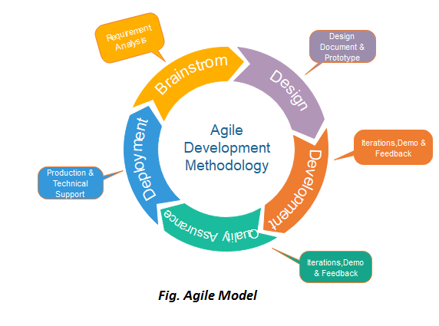

**2.2 Project Responsibilities**: Andrew Stoerkel is the lead on this project, the major functions of the site will allow the user to create an account which will be stored in a database. The user will be able to take a quiz about healthy lifestyle choices and manage a profile. The profile will hold graded quizzes.

**Team Members**

|  |  |  |
| --- | --- | --- |
| **Name** | **Role** | **Notes** |
| Joel Torney | Back End | jtorne2@students.towson.edu |
| Eric Cheatwood | Front End | echeat2@students.towson.edu |
| Andy Stoerkel | Back End | astoer1@students.towson.edu |
| Azizullah Akbari | Front End | aakbar2@students.towson.edu |
| Edmund Gladzah | Front End | egladz1@students.towson.edu |
| David Lesken | Back End | dlekse1@students.towson.edu |

**2.3 Organizational Interfaces:**

* Use WordPress for the website
* Throughout each development phase, we will be responsible for coordinating updates, communications, and project deliverables

Part 3: Managerial Process

**3.1 Objectives and Priorities:**

The management objective is to deliver the product on time and of high quality while using a reasonable budget. We will achieve this by respectively checking that progress is made as planned and monitoring the quality of the product at various stages.

**3.2 Assumptions, Dependencies, and Constraints**

In this project plan, a number of factors are taken into account:

• The team budget of 6-persons x 125 hours = 750 hours;

• The project deadline of May 1st

• The final presentation of May 1st

The project will be conducted with the following assumptions:

* Work will be periodically reviewed and updated by group members and client
* A working prototype will be constructed by the end of the semester

The following constraints are observed:

* Inexperienced team working with new technologies requires a steep learning curve
* Scheduling difficulty between teammates
* Working in a virtual environment
* Short time span

**3.3 Risk Management:**

* **Size of Project:** If the project becomes too large, I will reassess the assigned tasks and eliminate all non-essential ones.
* **Complexity of project:** We are currently behind on saving progress information and allowing gov users to view usage statistics. If we are unable to complete the site on time for the end of semester deadline, we may be able to scale back some features in order to get a basic working product to present. Some features we could down size are the functionality of parental monitoring.

**3.4 Staffing Plan**

The project will consist of 6 team members. We will be handling the design of the end product. We are responsible for making everything visually appealing. Specific roles are listed above at the project responsibility section.

**3.5 Monitoring and Controlling Mechanisms**

We will be using GitHub to monitor the progress of the project. We have a schedule established and when any updates are made to the project it will be on GitHub.

Part 4: Technical Process

**4.1 Methods, Tools and Techniques:**

We will use cloud networks including google docs and GitHub for us to be able to access our work from anywhere allowing us to work remotely and faster. Tools used will include HTML, CSS, JavaScript, Node.js and WordPress. HostGator will be used for hosting. Techniques used by the our team will include problem solving skills, time management skills, conflict resolution, and risk management

**4.2 Software Documentation:**

* For Software Documentation, GitHub Version Control will be used to maintain access to every version of the project as it is developed. If any major mistakes are made, an older version can be recovered to fix the mistake.

Repo link: <https://github.com/Ericc15/COSC412-Group1.git>

* Ultimate Member Plugin will be used of user profile membership

Ultimate Member: <https://docs.ultimatemember.com/>

**4.3 Project Support Functions:**

To ensure quality assurance, a reliable server host (HostGator) will be purchased. The current plan for the server host is hostgator.com, due to the website having a good reputation while still being affordable. The website will be tested once it is up, and the web application code will be tested during development. The Configuration Management Plan is to use GitHub Version Control in order to ensure reliable CM so that no work is lost.

Part 5: Work Elements, Schedule, Budget

**Work Breakdown Structure (WBS):**

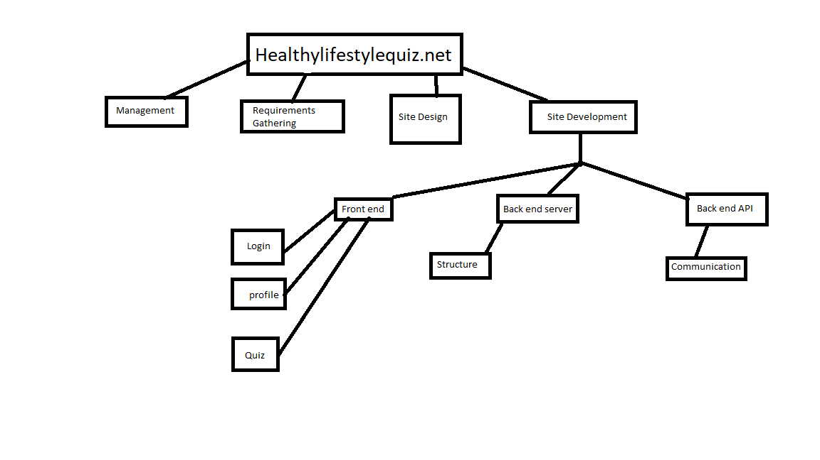

**Tasks:**

1. SPMP
2. research tools
   1. Check out “Quiz Maker” plugin for more functionality
3. Determine backend infrastructure
   1. Determine how to save the quiz data
   2. Determine how to save and display the usage data

**Gantt Chart**

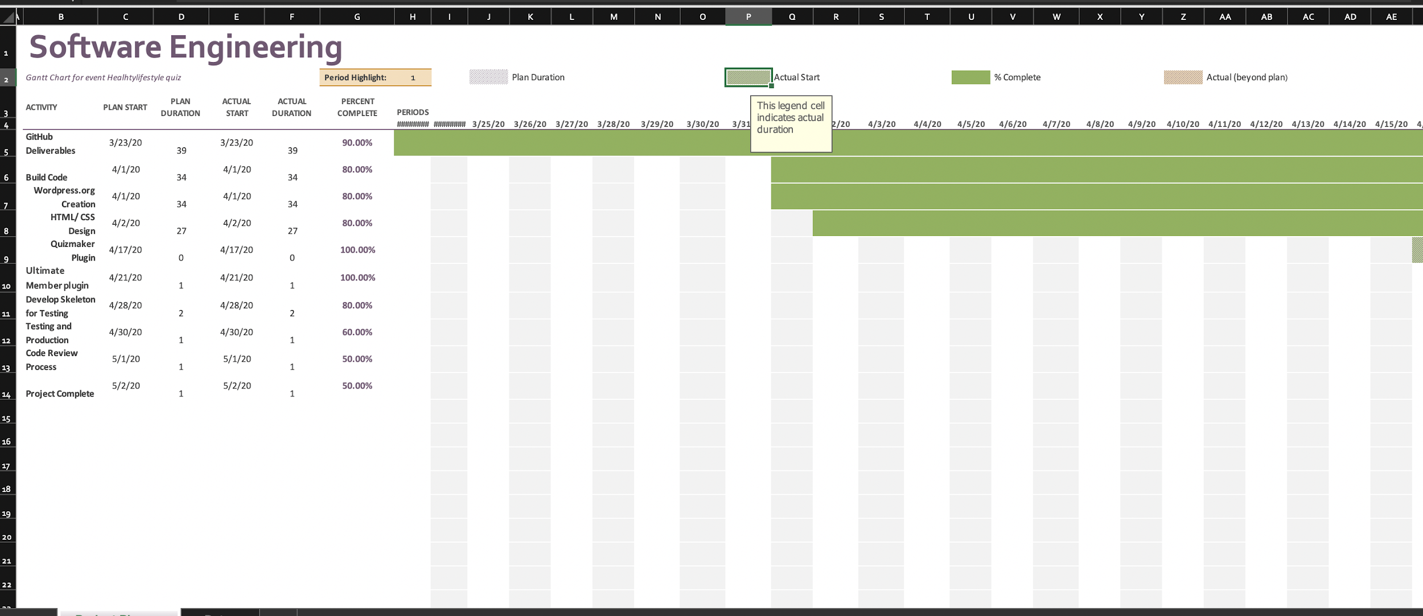

**Budget:**

**Hosting: $60**