A Practicum Project Report for the Blockchain Project
Submitted on December 16, 2018 to the
Department of Data Science of the
College of Computer & Information Sciences
Regis University
in partial fulfillment of the requirements for a
Master of Science in Database Technology
by
Adam Stone
Anita Overgaard
John Poteete
Matt Duncan
Nany Cook

Database Practicum Project Advisor

Bob Mason, Ph.D.

Table of Contents

Table of Contents ii
List of Figures iii
List of Tables iv
Chapter 1 - Introduction 1
Chapter 2 - Methodology 2
Chapter 3 - Results 12
Chapter 4 - Conclusions ??
Appendix A
??

List of Figures
Figure 1: ?

List of Tables
Table 1: ?

Chapter 1-Introduction
Overview

The MSCD696 - Database Practicum II course satisfies the Graduate Final Project requirement for graduation from the Master of Science in Database Technologies program. A total of 36 credit hours of course work is required to graduate. The MSCD696 course is taken as one of the last courses within the program and the student is required to participate in the Database Practicum for six months. The course facilitator enrolls the practicum students in the MSCD692 course automatically for the third eight week term of the six month practicum. The MSCD692 Database Practicum I course is optional and the student may or may not take the course depending upon whether the student needs an additional 3 credit hours to graduate. However, the student is still required to work through the practicum exercises from the Practicum I that include Linux, OEM and Oracle Apex. The course facilitator may require proof that each student is proficient in these three areas prior to enrolling the student in the MSCD696 course.

The goal of the Database Practicum project is to facilitate a real-life hands-on learning experience via the development of functional software. Each student is given a portion of a new application to build and will use the System Development Life Cycle (SDLC) that includes: requirements modeling, analysis, design, software construction, software integration and system testing. The Database Practicum Project allows students to demonstrate the database knowledge that they have learned throughout their course work within the Database Technologies program. The Spring 2015 DB Practicum will work on requirements modeling, analysis and design documentation for the project.

Deliverables

For this project, our team decided to explore blockchain technology and use this knowledge to create a small project that utilized this technology. As we learned more about blockchain we ultimately decided to use Hypeledger Fabric using Composer, a blockchain framework, to create a network that tracked information on a vehicles mileage and maintenance needs as the vehicle changes locations.

Each DB Practicum participant will:
- Provide documentation (using the methodology outline below) at various lifecycle steps depending upon which phase of the project they are assigned. For example, the Spring Practicum 2015 team will document functional requirements, create analysis & design documentation, create Web pages, test and then implement the application.

- Provide two types of final reports that will document the accomplishments of the team. One consolidated team report and a series of individual reports from each team member that has only the accomplishments of the individual. It is okay to make the comprehensive report first and then let each individual customize the report for an individual report or create the individual reports and then consolidate into a team report (whatever works).

Chapter 2 - Methodology
The practicum software development project will follow the Concurrent Object Modeling and Architecture Design Methodology (COMET) that includes the Unified Modeling Language (UML). UML is a software engineering industry standard notation for the modeling of objects and was pioneered by Booch, Rumbaugh, and Jacobson (1998). Note that in the diagram below, the development process is an iterative one and feedback from the later stages feeds back into the earlier stages. Gomaa (2000) defines the six major steps for the COMET development lifecycle as:

- Requirements Modeling
- Analysis Modeling
- Design Modeling
- Incremental Software Construction
- Incremental Software Integration
- System Testing

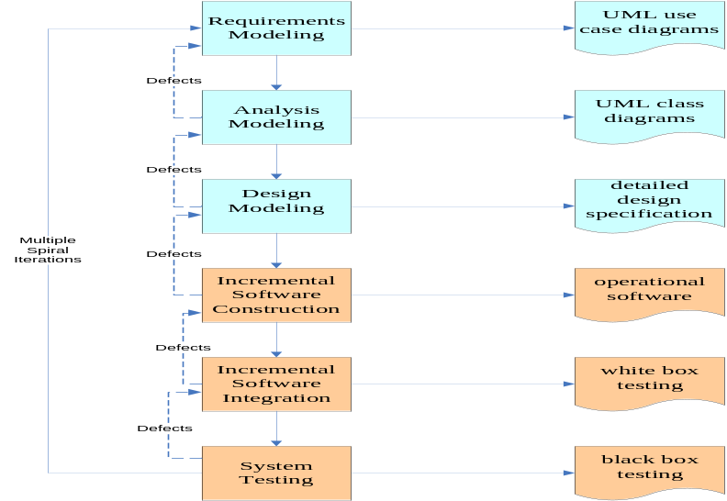
Figure 7. COMET Development Lifecycle

Requirements Modeling

Gomaa (2000) defines COMET Requirements Modeling as a process where the functional requirements are defined in terms of actors and use cases. Initially, a list of functional requirements will be developed and approved by the practicum development team and the faculty coordinator. Sample functional requirements from a previous project are listed below.

Sample Project Requirements

- The Vehicle is an asset which is identified by vehicleId
- The Location is a participant which is identified by locationId.
- The Transfer of the vehicle will be a transaction.

The list of functional requirements will then be developed into UML use cases by each developer.

Within a use case, actors are defined as the users of an application and the associated use cases. A use case identifies a sequence of interactions between one or more actors and the application. Use cases for Requirements Modeling will define the inputs to the application and the responses of the application without revealing the internal processing. For this project, the deliverables from Requirements Modeling will be a series of UML use case diagrams that will define all possible inputs from actors and the resulting outputs to actors for the application.

The UML use case diagrams will be reviewed at the weekly meetings with the course facilitator and will include an explanation of how the use case diagrams support the list of functional requirements. Feedback from the facilitator will be reviewed by the developer and suggestions for improvement will be applied to the UML use case diagrams when appropriate.

An example of a fully dressed use case diagram with the appropriate documentation from a sample application is shown on the next page. All use cases submitted to the instructor must be fully dressed (diagrams by themselves will not be accepted). The example of use case 3 shown below can be used as a template for creating your use cases.

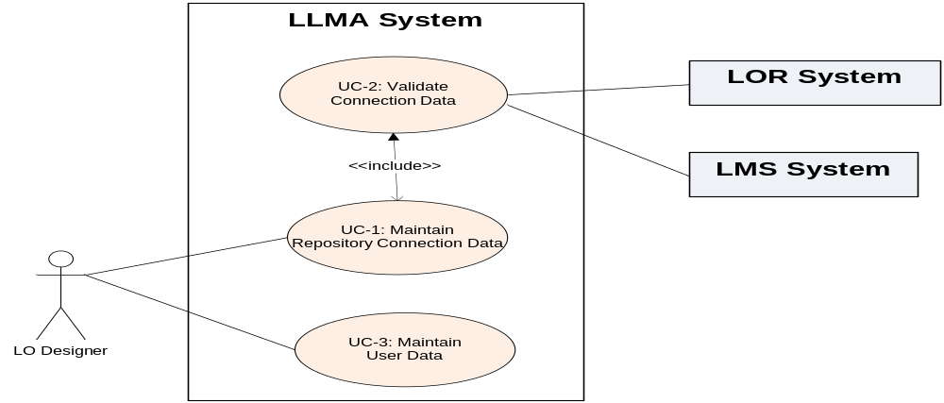
Figure 10. UML Use Case Diagrams for Maintaining Metadata.

Use Case | UC-3: Maintain User Data
Description | A use case that provides for the creation and storage of application user reference data into the LLMA Metadata Repository via the Web-based interface.  This use case was based on the functional requirement 14 that stated the middleware should offer multiple user definitions (e.g., student, instructor, admin) with appropriate permissions.  This user case supports the assignment of different roles to a user that will enable various levels of permissions to the user within the Web-based interface.  Required information for user registration includes the user email address, role (instructor, LO designer, student, admin), organization affiliation, and their full name. A phone number is optional. The user email address i required so that the WSCP can notify the user when the request for data movement is complete.
Actors | A LO Designer (instructor) who is interested in moving a LO from a LMS to a LOR or vice versa.
Assumptions | The LO designer must enter the basic user information including an email address.
Steps | A LO Designer (instructor) enters the basic user data using the LLMA Web-based interface.  The data is stored in the LLMA Metadata Repository when the data is complete.  If incomplete data is entered, the user will receive an error message about missing data in Web-based interface.
Variations | If specific fields are left blank, the user will receive an error message on the web page.
Non-Functional | This use case does not require the use of web services.

Analysis Modeling

Analysis Modeling examines the problem domain (real-world) to identify objects and the information that is passed between those objects (Gomaa, 2000). Activities in this modeling phase can include:

- Static modeling
- Object structuring
- Finite state machine modeling
- Dynamic modeling

Sequence Diagram

As part of the deliverables for this project, each practicum tean will create a UML sequence diagram that is appropriate for their functional requirements or a work flow diagram. Below is an example of a simple sequence diagram that can be used as a template for identifying the web pages and activities that will take place in their portion of the system.

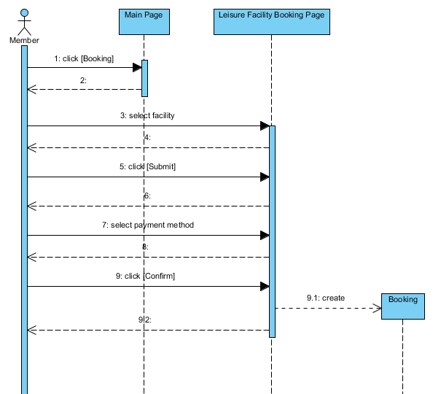

Sample work flow diagram as an alternate to the sequence diagram.
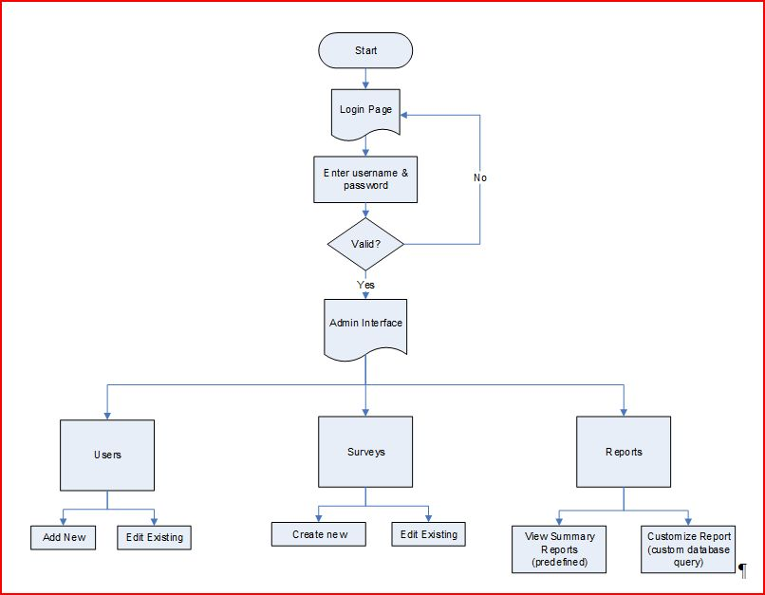
Another example of a more detailed work flow diagram.
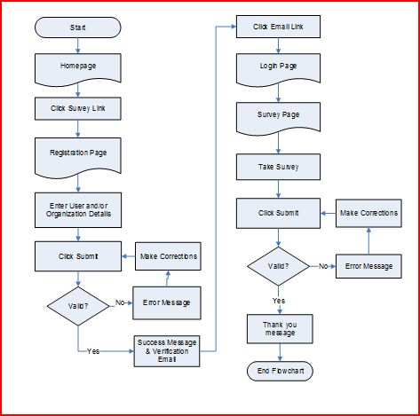
ERD Modeling Analysis Process
The class diagrams will be used to develop an ERD as shown in the example below. The objects identified in the class diagram will be used to create entities. The many-to-many relationships between objects will be resolved with new entities called intersection entities. The objects will also normalized to the third normal form, thus a few additional entities might be added to your ERD.
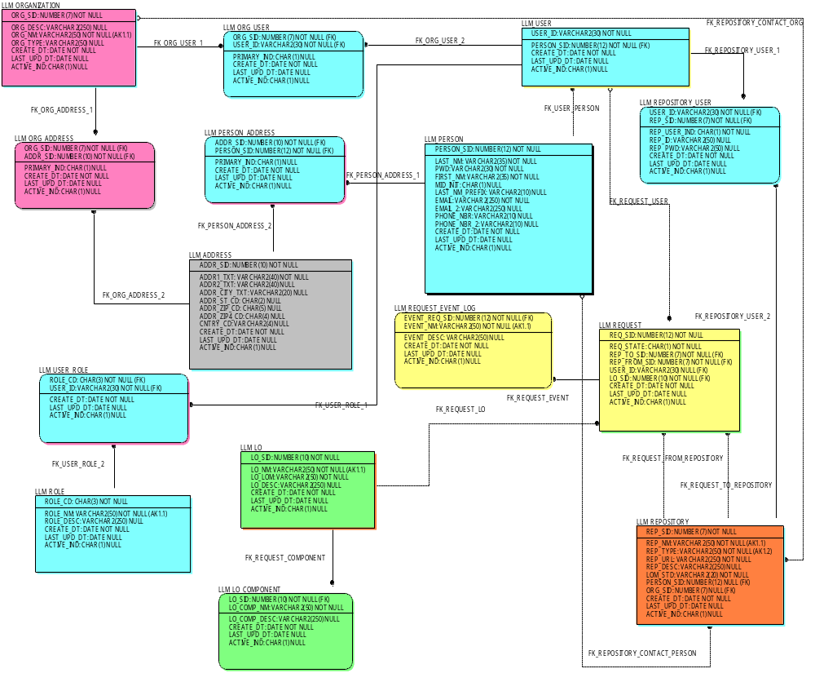

Design Modeling

Design Modeling, in terms of this project, is the process of mapping the analysis models into a detailed design model as the architectural solution (Gomaa, 2000). The major deliverable for each developer from the Design Modeling process will be wireframes. Below is a sample of three wireframes (web page mock-ups).

Sample Wire Frames
Wire Frames are mockups of what the User Interface should look like. There are three sample wire frames shown below. Please remove these samples and include your own wireframes as part of this document.

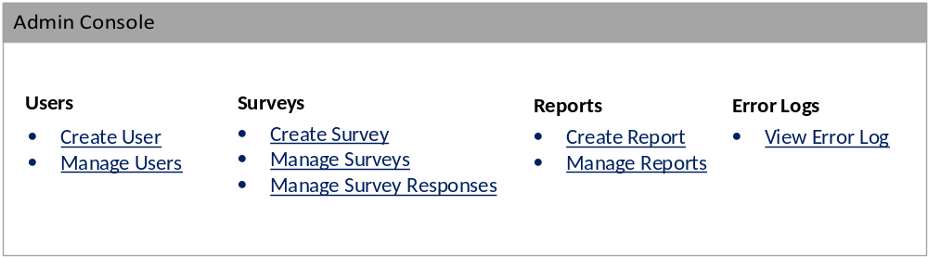
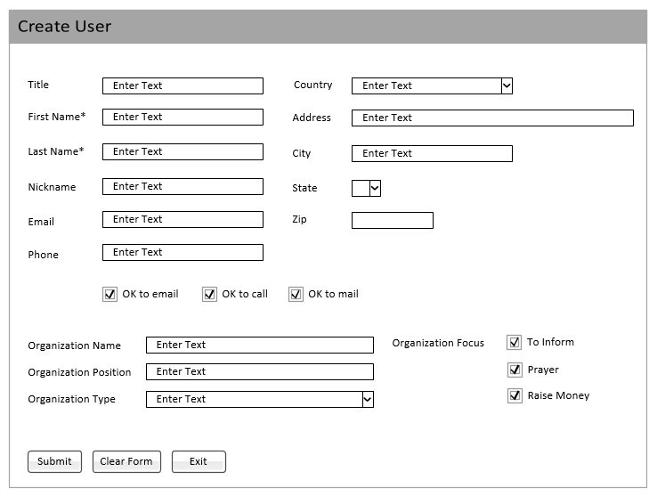

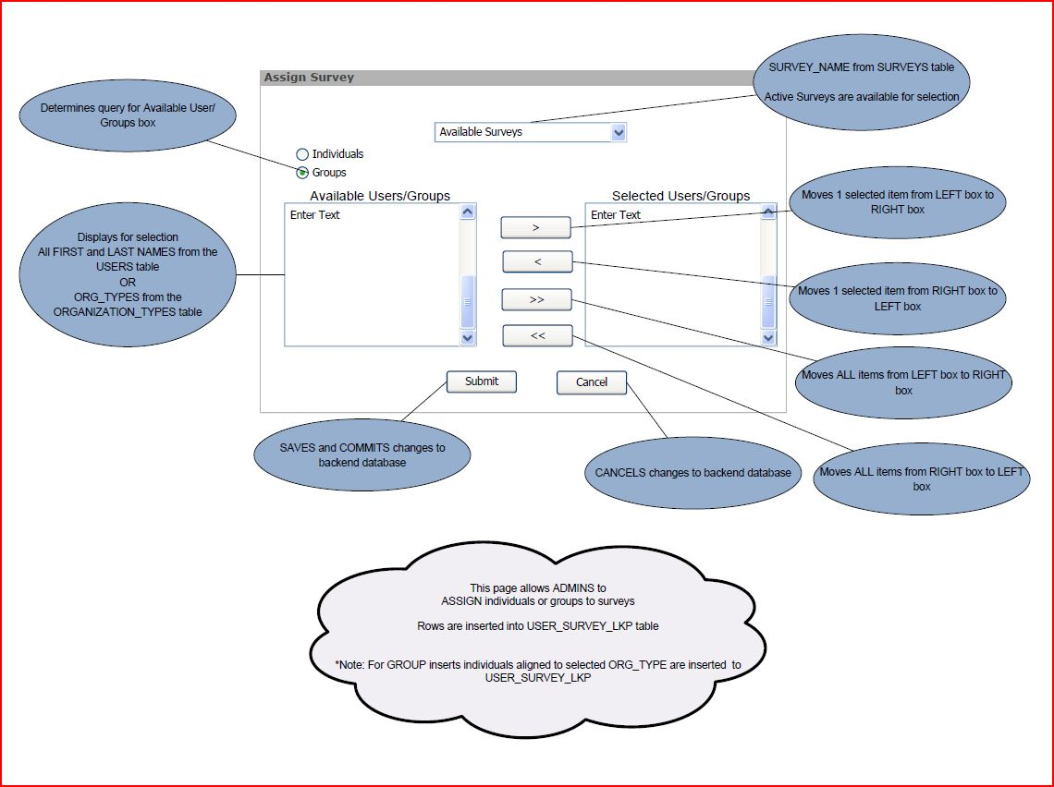

Incremental Software Construction and Integration

Document the web pages that will be developed and other technical details about the new application such as stored procedures, custom code, etc. Show the team assignments for the work and include a time schedule. Specify who will develop each webpage, DDL, enter test data, etc.

Unit, System and User Accepting Testing

Unit Testing – please explain how each web page or other component was unit tested.

System Testing – Test plans must be provided to indicate that new application was tested completely.

User Acceptance Testing – is the process of reviewing the new application with stakeholder (end user). Please provide user feedback from this process.

Implementation to Production
Depending upon the project, you may or may not implement this into the cloud environment. Please describe the final implementation for your particular project.
Chapter 3 –Results

<<< please add your results to this section and use the headings listed below. What do the actual webpages look like (snipping tool samples), how did the testing go, etc. >>

Additional non-project work completed in the Practicum over the last six months

Chapter 4 – Conclusions

<<< Please add your conclusions about the project. This can include lessons learned, comments about using Apex, project timeline, ideas for the next practicum, team members that annoyed you, etc. >>>

References
Booch, G., Rumbaugh, J., & Jacobson, I. (1998). The Unified Modeling Language User Guide. Reading, MA: Addison Wesley.

Gomaa, H. (2000). Designing Concurrent, Distributed, and Real-Time Applications with Uml (1st ed.) Boston, MA: Addison-Wesley Longman Publishing Co., Inc.

Susman, G. I. and Evered, R. D. (1978). An assessment of the scientific merits of action
research. Administrative Science Quarterly 23: 582–603.

