QA Tester: Amanda Szampias

Date: May 24, 2019

**Notification Feature:**

* Create Notification as Admin.
* JavaScript Client-side validation works on Admin Page.
* Notification shows on Team Notification Page.
* Notification displays for 5 minutes on Dashboard and then goes away.
* Notification displays “No Messages to Show” if 0 notifications.
* Team-only Notifications display for designated teams only.

**Password Change Feature:**

* Create Password Change Request as a User.
* JavaScript Client-Side validation works on createpasschange.php page.
* Admin page redirects to view=passchange after submitting.
* Status field is changed to “T” after Admin approves.
* JavaScript Client-Side validation works on Admin page.

**My Account Feature:**

* Displays Account Age on myaccount.php

**Create Category Feature:**

* Makes new directory for team via uploads/*Category.*
* Create new record in Category table.

**Create Inject Feature:**

* Create Inject in table.
* Save PDF to CCDC_Injects folder.
* JavaScript Client-Side validation works on Admin page.

**Create Team Feature:**

* Makes new directory for team via uploads/Category/*team_name*.
* Creates new record in Team table.

**Dashboard Page**

* Page refreshes every 60 seconds
* Page displays a notification for 5 minutes.
* Notification gets replaced if a new notification is created.
* Service status table is dynamic. Displays correct values.

**Notification Page**

* Page refreshes every 60 seconds
* Page displays Notifications

**Password Change Page**

* Page refreshes every 60 seconds
* Page displays Password Change requests

**Future Feature Ideas:**

* Set a max-point check on Grade Submitted Injects page. Currently no limit.
* Have a graph displaying inject and service points between teams.

**Install Yourself (Medium):**

**Ubuntu:**

$ apt-get update

$ apt-get upgrade

$ apt-get install apache2

$ apt-get install mysql-server

$ apt-get install php

$ apt install git

$ apt install vim

$ sudo apt-get install php7.2-gd

$ sudo apt-get install php7.2-mbstring

$ sudo apt-get install php-mysqli

$/var/www/html/ git clone https://github.com/ASzampiasSWD/CCDC-InjectScoringEngine.git

$/var/www/html/injectscoringengine: sudo apt install composer

$/var/www/html/injectscoringengine: composer require mpdf/mpdf

chmod -R 777 uploads/ (Note: mkdir() won’t work if uploads isn’t 777. I tried 766 and no work).

chmod -R 777 vendor/

chmod -R 777 CCDC_Injects/

**MySQL:**

sudo mysql -u root

COPY ALL OF notes/tablenotes.sql and PASTE into mysql command line. This will create ALL the tables needed.

INSERT INTO Category VALUES ('0', 'ISE Manager Admin', 'Fri, 31 May 2019 18:07:50 -0400', 'Fri, 31 May 2019 19:07:50 -0400', 0);

INSERT INTO Team (group_id, team_name, team_password, team_score, creation_date) VALUES('0', 'Amanda', 'duck', 0, 'Fri, 31 May 2019 19:07:50 -0400');

CREATE USER 'ise'@'localhost' IDENTIFIED BY 'password';

GRANT ALL PRIVILEGES ON *.* TO 'ise'@'localhost';

FLUSH PRIVILEGES;

**service mysql restart**

**service apache2 restart**

Go to line 63 in functions.php and change path of config.ini. You should get an error about this when you first login.

Go into /var/www/html/CCDC-InjectScoringEngine/config.ini and change username and password to ‘ise’ and ‘password’. (whatever you used).

**Easy Install:**

**Ubuntu:**

Username: aszampias

Password: toor

**MySQL:**

Username: ise

Password: password

1. I moved the “config.ini” file to a directory called /var/config-files.
2. 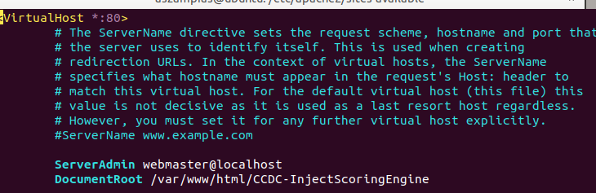I removed Indexing. (aka people can easy-see whatever they want) <https://support.qualityunit.com/496941-How-to-disable-directory-browsing-in-apache-configuration>

I changed the DocumentRoot in sites-available/000-default.conf

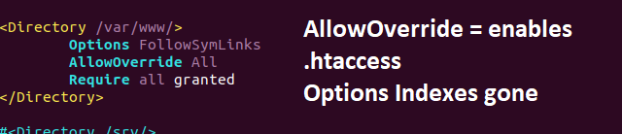

Text is explanatory up there.

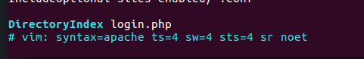

I added login.php as the default file. (acts like an index.html).

**Steps YOU need to Do:**

1. Change the “ise” user password in mysql and /var/config-files/config.ini
2. Remove the .git folder if you are hosting this website online.
3. Remove all the example accounts. Or change the password duck.