**Ping Pong Party**

**Software Requirements Specification**

**CEN3031, Fall, 2019**

**Modification history:**

|  |  |  |  |
| --- | --- | --- | --- |
| Version | Date | Who | Comment |
| v1.0 | 10/8/2019 | Austin Nolz | Added shall statements, Use-case diagram, Introduction |
| v1.1 | 10/11/2019 | Jonathan Robertson, Alexander Thieler, Austin Nolz | Added assumptions, use case descriptions |
| v1.2 | 10/17/2019 | Amanda Smith, Alexander Thieler, Adam Dressel, Jonathan Robertson, Oscar Garcia, Austin Nolz | Changed project topic to Ping Pong Party, adjusted use cases and specific requirements |
| V1.3 | 12/5/2019 | Amanda Smith, Alexander Thieler, Adam Dressel, Jonathan Robertson, Oscar Garcia, Austin Nolz | Updated Use-Case Diagram and Requirements |

**Team Name:** 5 and 1

**Team Members:**

* Amanda Smith, [atsmith6881@eagle.fgcu.edu](mailto:atsmith6881@eagle.fgcu.edu)
* Alexander Thieler, [alexander.thieler@gmail.com](mailto:alexander.thieler@gmail.com)
* Adam Dressel, [amdressel7336@eagle.fgcu.edu](mailto:amdressel7336@eagle.fgcu.edu)
* Jonathan Robertson, [jdrobertson08@eagle.fgcu.edu](mailto:jdrobertson08@eagle.fgcu.edu)
* Oscar Garcia, [Ovgarcia5138@eagle.fgcu.edu](mailto:Ovgarcia5138@eagle.fgcu.edu)
* Austin Nolz, [nolzaj93@gmail.com](mailto:nolzaj93@gmail.com)

**Contents of this Document**

[Introduction](https://word-edit.officeapps.live.com/we/wordeditorframe.aspx?new=1&ui=en%2DUS&rs=en%2DUS&wdenableroaming=1&mscc=1&wdodb=1&hid=F1D40D9F-90F6-9000-50C8-B4A8CBB47EAF&wdorigin=ohpAppStartPages-instant&wdhostclicktime=1571071084814&jsapi=1&newsession=1&corrid=0e2b49a6-3eb0-4955-9599-955a44a7703f&usid=0e2b49a6-3eb0-4955-9599-955a44a7703f&instantedit=1&filesrc=SharePoint%20Online&pmorigin=https%3A%2F%2Feaglefgcu-my.sharepoint.com#Introduction)

* [Software to be Produced](https://word-edit.officeapps.live.com/we/wordeditorframe.aspx?new=1&ui=en%2DUS&rs=en%2DUS&wdenableroaming=1&mscc=1&wdodb=1&hid=F1D40D9F-90F6-9000-50C8-B4A8CBB47EAF&wdorigin=ohpAppStartPages-instant&wdhostclicktime=1571071084814&jsapi=1&newsession=1&corrid=0e2b49a6-3eb0-4955-9599-955a44a7703f&usid=0e2b49a6-3eb0-4955-9599-955a44a7703f&instantedit=1&filesrc=SharePoint%20Online&pmorigin=https%3A%2F%2Feaglefgcu-my.sharepoint.com#SoftwareToBeProduced)
* [Definition, Acronyms, and Abbreviations](https://word-edit.officeapps.live.com/we/wordeditorframe.aspx?new=1&ui=en%2DUS&rs=en%2DUS&wdenableroaming=1&mscc=1&wdodb=1&hid=F1D40D9F-90F6-9000-50C8-B4A8CBB47EAF&wdorigin=ohpAppStartPages-instant&wdhostclicktime=1571071084814&jsapi=1&newsession=1&corrid=0e2b49a6-3eb0-4955-9599-955a44a7703f&usid=0e2b49a6-3eb0-4955-9599-955a44a7703f&instantedit=1&filesrc=SharePoint%20Online&pmorigin=https%3A%2F%2Feaglefgcu-my.sharepoint.com#DefinitionsAcronymsAbbreviations)

[Product Overview](https://word-edit.officeapps.live.com/we/wordeditorframe.aspx?new=1&ui=en%2DUS&rs=en%2DUS&wdenableroaming=1&mscc=1&wdodb=1&hid=F1D40D9F-90F6-9000-50C8-B4A8CBB47EAF&wdorigin=ohpAppStartPages-instant&wdhostclicktime=1571071084814&jsapi=1&newsession=1&corrid=0e2b49a6-3eb0-4955-9599-955a44a7703f&usid=0e2b49a6-3eb0-4955-9599-955a44a7703f&instantedit=1&filesrc=SharePoint%20Online&pmorigin=https%3A%2F%2Feaglefgcu-my.sharepoint.com#ProductOverview)

* [Assumptions](https://word-edit.officeapps.live.com/we/wordeditorframe.aspx?new=1&ui=en%2DUS&rs=en%2DUS&wdenableroaming=1&mscc=1&wdodb=1&hid=F1D40D9F-90F6-9000-50C8-B4A8CBB47EAF&wdorigin=ohpAppStartPages-instant&wdhostclicktime=1571071084814&jsapi=1&newsession=1&corrid=0e2b49a6-3eb0-4955-9599-955a44a7703f&usid=0e2b49a6-3eb0-4955-9599-955a44a7703f&instantedit=1&filesrc=SharePoint%20Online&pmorigin=https%3A%2F%2Feaglefgcu-my.sharepoint.com#Assumptions)
* [Use Case Diagram](https://word-edit.officeapps.live.com/we/wordeditorframe.aspx?new=1&ui=en%2DUS&rs=en%2DUS&wdenableroaming=1&mscc=1&wdodb=1&hid=F1D40D9F-90F6-9000-50C8-B4A8CBB47EAF&wdorigin=ohpAppStartPages-instant&wdhostclicktime=1571071084814&jsapi=1&newsession=1&corrid=0e2b49a6-3eb0-4955-9599-955a44a7703f&usid=0e2b49a6-3eb0-4955-9599-955a44a7703f&instantedit=1&filesrc=SharePoint%20Online&pmorigin=https%3A%2F%2Feaglefgcu-my.sharepoint.com#UseCaseDiagram)
* [Use Case Descriptions](https://word-edit.officeapps.live.com/we/wordeditorframe.aspx?new=1&ui=en%2DUS&rs=en%2DUS&wdenableroaming=1&mscc=1&wdodb=1&hid=F1D40D9F-90F6-9000-50C8-B4A8CBB47EAF&wdorigin=ohpAppStartPages-instant&wdhostclicktime=1571071084814&jsapi=1&newsession=1&corrid=0e2b49a6-3eb0-4955-9599-955a44a7703f&usid=0e2b49a6-3eb0-4955-9599-955a44a7703f&instantedit=1&filesrc=SharePoint%20Online&pmorigin=https%3A%2F%2Feaglefgcu-my.sharepoint.com#UseCaseDescriptions)

[Specific Requirements](https://word-edit.officeapps.live.com/we/wordeditorframe.aspx?new=1&ui=en%2DUS&rs=en%2DUS&wdenableroaming=1&mscc=1&wdodb=1&hid=F1D40D9F-90F6-9000-50C8-B4A8CBB47EAF&wdorigin=ohpAppStartPages-instant&wdhostclicktime=1571071084814&jsapi=1&newsession=1&corrid=0e2b49a6-3eb0-4955-9599-955a44a7703f&usid=0e2b49a6-3eb0-4955-9599-955a44a7703f&instantedit=1&filesrc=SharePoint%20Online&pmorigin=https%3A%2F%2Feaglefgcu-my.sharepoint.com#SpecificRequirements)

**SECTION 1: Introduction**

Software to be Produced: Competition Project

* Ping Pong Party is a JavaFX 8 application that will have both standard 1 vs. 1 matches and tournament style matches with 4 users. Users will play Ping Pong and log their scores. Statistics for both 1 vs. 1 and tournament matches can be found in the leaderboards or individual statistics can be found on the user profile.

Definitions, Acronyms, and Abbreviations:

* Overall Leaderboard – a ranked list of player names and profile pictures sorted by game statistics including total wins, total losses, total points, and average game time.
* Tournament Leaderboard- a ranked list of player names and profile pictures sorted by tournament wins, losses, and points.

**SECTION 2: Product Overview**

Assumptions:

* We assume that our team will have enough time and skills to complete a functional application before the deadline.
* We assume that we will be able to migrate our local database to a cloud-based database.
* We assume that the program will run on Windows, Linux, and Mac. In the future we will adapt the application to mobile devices.
* We assume that the computer running the software will have enough storage and memory to run the program.

Use Case Diagram:

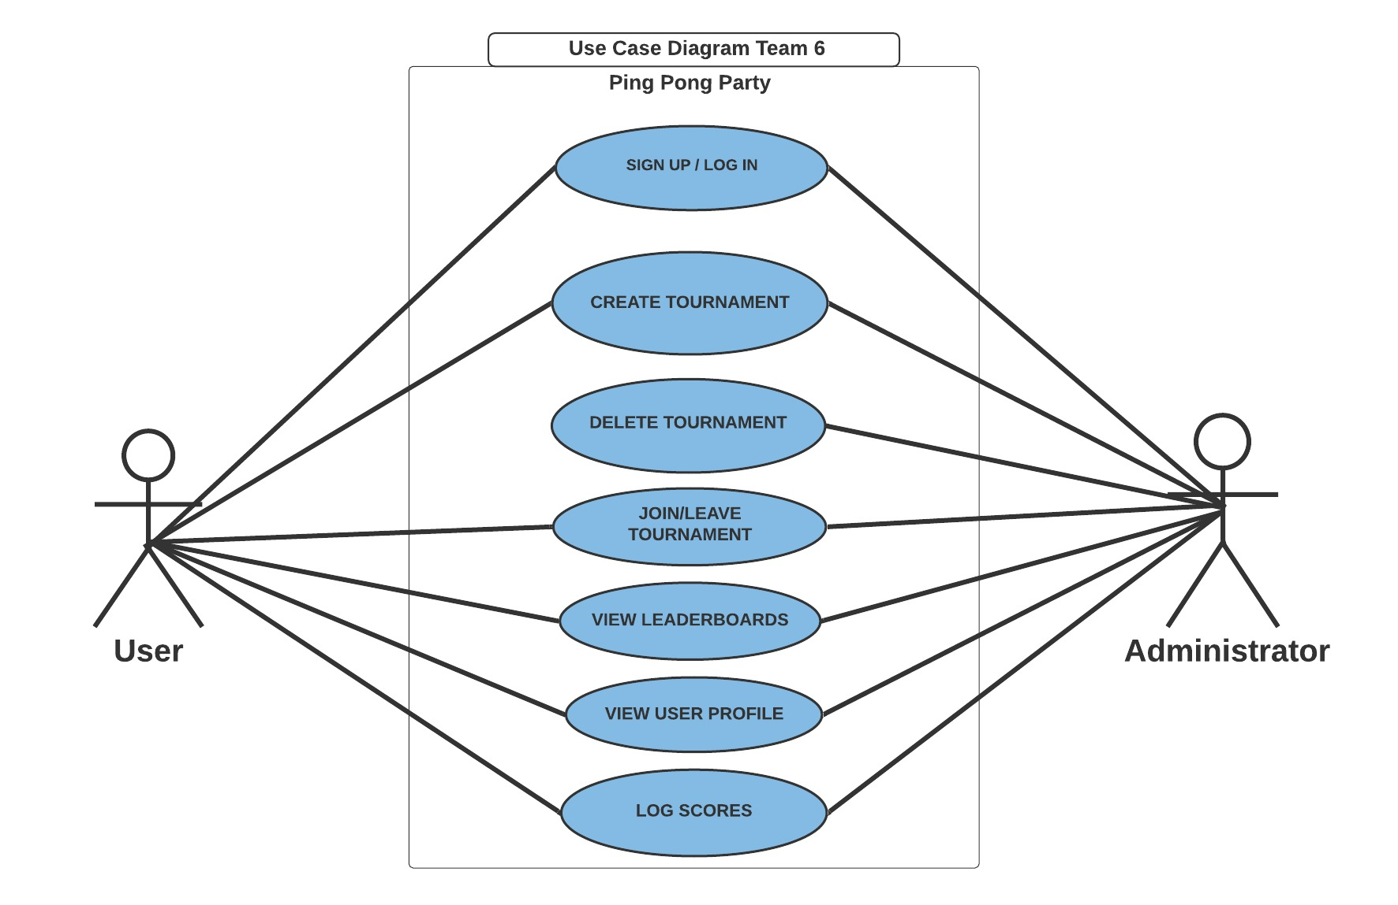

Use Case Descriptions:

|  |
| --- |
| **Brief Description**  The *Sign Up* / *Log in* use case prompts users to enter username and password to sign up or log in before a match. |

|  |
| --- |
| **Brief Description**  The *Create Tournament* use case allows users and administrators to create a tournament with a start date, time, and number of users required. |

|  |
| --- |
| **Brief Description**  The Delete Tournament use case allows administrators to delete any tournament. |

|  |
| --- |
| **Brief Description**  The *Join/Leave Tournament* use case allow users to join a tournament if there are openings and leave if it is before the start date by selecting an upcoming tournament. |

|  |
| --- |
| **Brief Description**  The *View Leaderboards* use case allows the user to view the leaderboards. This includes a tournament leaderboard listing wins, losses, and points for each participant, and an overall leaderboard listing total wins, total losses, and total points. |

|  |
| --- |
| **Brief Description**  The *View User Profile* use case allows users to view another user profile, which contains individual tournament statistics and overall statistics. |

|  |
| --- |
| **Brief Description**  The *Log Score* use case allows users to log the number of points earned within a Ping Pong match. |

**SECTION 3: Specific Requirements**

|  |
| --- |
| **No:** 0 |
| **Statement:** The system shall create an account storing a unique username with 8+ characters, and password that needs one uppercase letter, lowercase letter, and number. |

|  |
| --- |
| **No:** 1 |
| **Statement:** The system shall request two users to log in or sign up, then verify the entered username and password before a match begins. |

|  |
| --- |
| **No:** 2 |
| **Statement:** The system shall allow users to create a tournament with a start date, time, and number of users required. |

|  |
| --- |
| **No:** 3 |
| **Statement:** The system shall allow users to join a tournament if there are openings and leave if it is before the start date by selecting an upcoming tournament. |

|  |
| --- |
| **No:** 4 |
| **Statement:** The system shall only start a tournament with 4 users and randomly match the players for each round. |

|  |
| --- |
| **No:** 5 |
| **Statement:** The system shall allow the user to submit their score and verify the score of his or her opponent. |

|  |
| --- |
| **No:** 6 |
| **Statement:** The system shall allow the user to view any user profile in the database, which shows the user’s match history, total wins, losses, and points scored. |

|  |
| --- |
| **No:** 7 |
| **Statement:** The system shall allow a user who created a tournament to delete it before the start date and allow an administrator to delete any tournament. |

|  |
| --- |
| **No:** 8 |
| **Statement:** The system shall store tournament results in a Tournament Leaderboard including username, wins, and losses. |

|  |
| --- |
| **No:** 9 |
| **Statement:** The system shall store 1v1 match results including name, total wins, total losses, and total points in an Overall Leaderboard. |

|  |
| --- |
| **No:** 10 |
| **Statement:** The system shall allow users to view profiles of other users showing history of 1v1 and. Tournament matches, as well as total wins, total losses, and total points scored. |

|  |
| --- |
| **No:** 11 |
| **Statement:** The system shall allow users to select between a 1v1 match or a Tournament match. |

|  |
| --- |
| **No:** 12 |
| **Statement:** The system shall allow a tournament to start if the required number of users is met after the start time/date. |

|  |
| --- |
| **No:** 13 |
| **Statement:** The system shall allow two users in a tournament match to login and submit their scores, which will be stored in the Tournament Leaderboard. |

|  |
| --- |
| **No:** 14 |
| **Statement:** The system shall allow users to log points earned within a 1v1 Ping Pong match, which will be stored in the Overall Leaderboard. |

|  |
| --- |
| **No:** 15 |
| **Statement:** The system shall allow users to search the database for a username. |

|  |
| --- |
| **No:** 16 |
| **Statement:** The system shall allow users to view statistics for all Tournaments or for a specific Tournament. |

Template created by G. Walton ([GWalton@mail.ucf.edu](mailto:GWalton@mail.ucf.edu)) on Aug 30, 1999 and last updated Aug 15, 2000; updated by A. Koufakou, Aug 2014

This page last modified by <your name here> (<your e-mail address text and link here> ) on <modification date here>