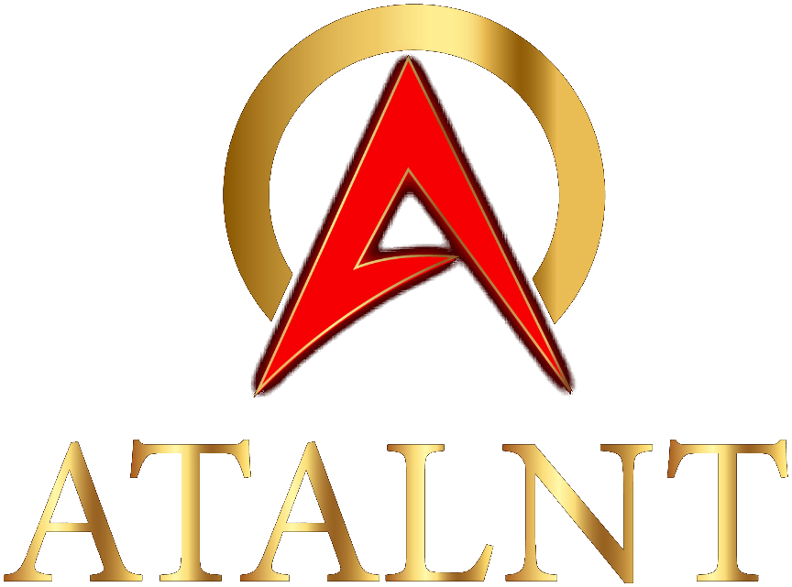
Digital Platform Project Summary
www.atalnt.com | Full-Stack Web Platform | Zoho One Ecosystem
950+  Placements | 98%  Client Retention | 30+  Years Experience

Website Build
- Built full company website from scratch with React 18, TypeScript, Tailwind CSS, and Vite
- 9 pages: Home, ROI Calculator, About, Contact, Jobs, Apply, Privacy, Terms, 404
- Premium dark theme with gold accents, Space Grotesk/Inter typography, custom animations
- Deployed on Vercel with SPA routing, responsive across all breakpoints
AI ROI Calculator
- Interactive 3-step calculator: Business Info, Operations, personalized Results
- 6 workflow categories with dynamic hour-based savings, ROI %, and payback period
- Lead capture form connected to Zoho Forms with PageSense conversion tracking
Zoho One Integrations (5 Products)
- Forms: ROI lead capture via hidden iframe submission, bypassing CSRF restrictions
- Recruit: Embedded job board with 58 live listings, dark-themed to match site design
- Bookings: Consultation scheduling links integrated across all site CTAs
- PageSense: Visitor analytics, heatmaps, session recordings, and conversion event tracking
- SalesIQ: Live chat and chatbot widget enabled on all pages
Custom Analytics Dashboard
- Password-protected /dashboard with serverless API layer on Vercel
- Real-time Zoho Recruit data: jobs, applications, pipeline KPIs with Recharts
- Zoho Voice integration: calls, texts, agent stats with date filtering and auto-refresh
SEO & Compliance
- TCPA/CCPA-compliant Privacy Policy and Terms of Service
- Sitemap.xml, robots.txt, Open Graph/Twitter meta tags, branded link previews
Partner Ecosystem
- 12 enterprise logos in scrolling marquee: Landstar, Forward Air, Armstrong Transport, RXO, Pegasus, Bettaway, EFW, Aeronet, Stevens Global, 007 Freight, Brown Integrated, Serve Freight

35+ commits | 9 pages | 5 Zoho integrations | React + TypeScript + Tailwind | Vercel

