ADT Hub – Product Specification Plan
Version: 1.0 – Initial Draft
Date: March 2026
Modules: Intake · Onboarding · Assets · Employees

Document Overview
This Specification Plan defines the functional scope, objectives, user flows, and requirements for four core modules of ADT Hub. It is intended to align product, engineering, and business stakeholders before detailed design and development begins.

Application Architecture
ADT Hub is a web application. Each module is a dedicated section of the application with its own pages, accessible via a shared navigation. All modules store and retrieve data from a central database, and modules are connected to each other — meaning data created in one module (such as an employee record) can be referenced and used in another (such as assigning that employee an asset or including them in an onboarding workflow).
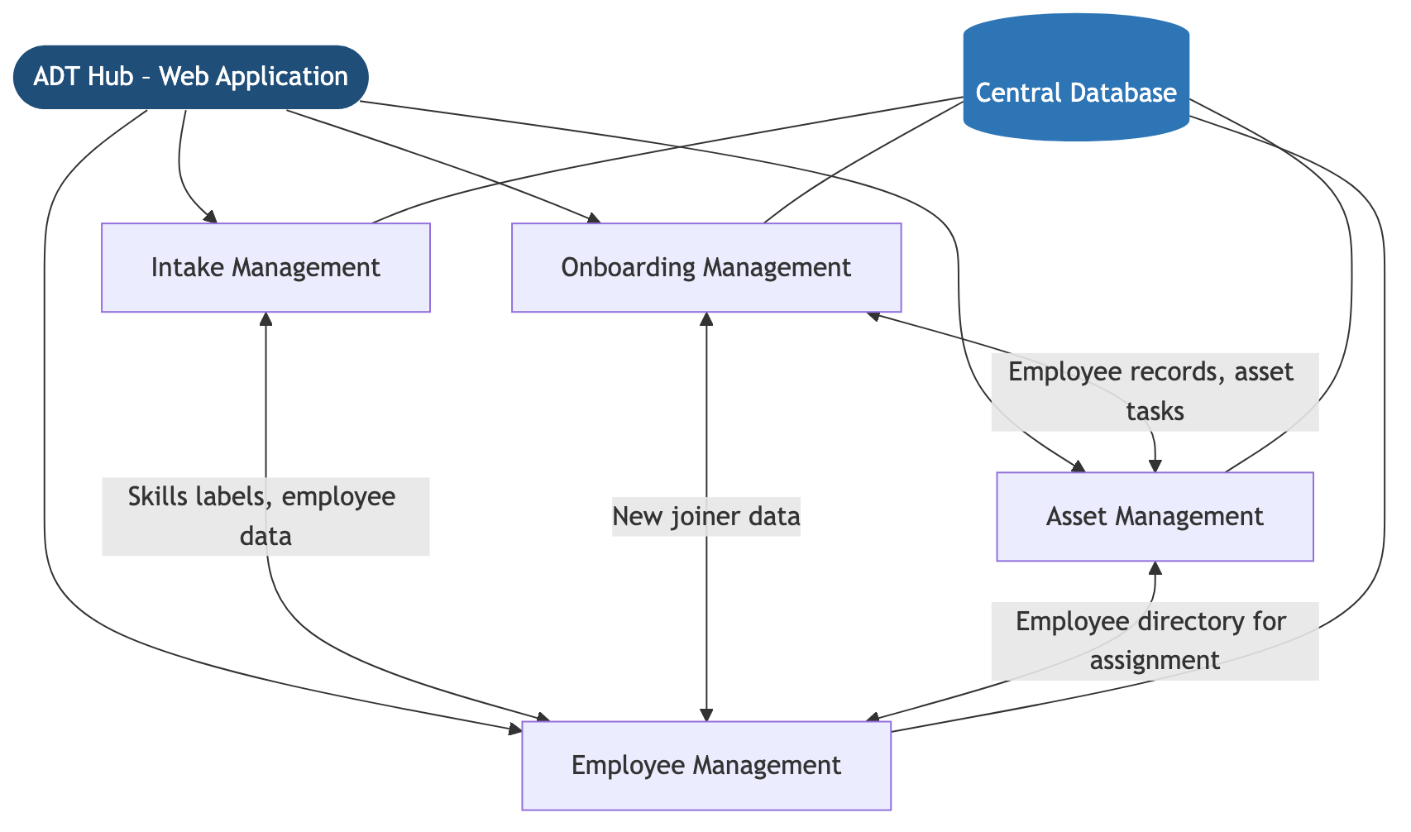
Each module also supports connections to external services where relevant — such as email notifications, AI generation, and importing data from external sources — without requiring users to leave the application.

Module Summary
Module | Purpose | Primary Users
Intake Management | Capture and approve hiring requirements; auto-generate job requisitions and JDs | Recruiters, Hiring Managers, Admins
Onboarding Management | Orchestrate cross-team onboarding tasks for new joiners from offer acceptance to Day-1 | Recruiters, HR, IT, Admin, Hiring Managers
Asset Management | Register, assign, and track company assets throughout their full lifecycle | Admins, IT, HR
Employee Management | Manage employee records and self-service skills/certifications with AI-powered insights | HR, Admins, Employees, Managers

Epic 1 – Intake Management

Overview
The Intake Management module is a dedicated section of the ADT Hub web application and serves as the starting point of the hiring lifecycle. It allows recruiters to capture structured hiring information through an online form and automatically generates a Job Requisition and a draft Job Description upon approval. Data entered here is stored centrally and connects to the Employee Management module for skills data.

Business Objectives
- Reduce time to create and approve job requisitions
- Improve quality and consistency of job descriptions
- Create a single source of truth for hiring requirements
- Enable scalable hiring processes as the organisation grows

Scope
In Scope - Intake form creation and management - Structured data capture (budget, location, skills, role level, employment type, business context) - Skill tagging with smart label creation and reuse - Validation of mandatory fields - Conversion of intake into Job Requisition - AI-assisted JD generation based on intake data and existing JD formats - AI-generated intake summary saved to the intake record and emailed to hiring managers - Status tracking: Draft → Submitted → Approved → Converted

Key Features
Feature | Description
Configurable Intake Form | Form fields can be tailored by Admin to reflect organisation needs
Skill Tagging | Type a skill to search existing labels; select a match to add it as a tag, or create a new label if it doesn’t exist. All labels are searchable and reusable across future intake forms
Role-Based Access | Recruiter, Hiring Manager, and Admin roles with appropriate permissions
Approval Workflow | Optional and configurable approval step before intake is converted
AI JD Generation | System generates a draft JD using predefined templates and existing JD formats
AI Intake Summary | AI generates a contextual summary of the intake form in the style of a job description. The summary is saved to the intake record and can be sent directly to the hiring manager via email
Audit Trail | Version history and change log for each intake record
Downstream Integration | Seamless handoff to the Job Requisition module upon approval

Skill Tagging – Behaviour
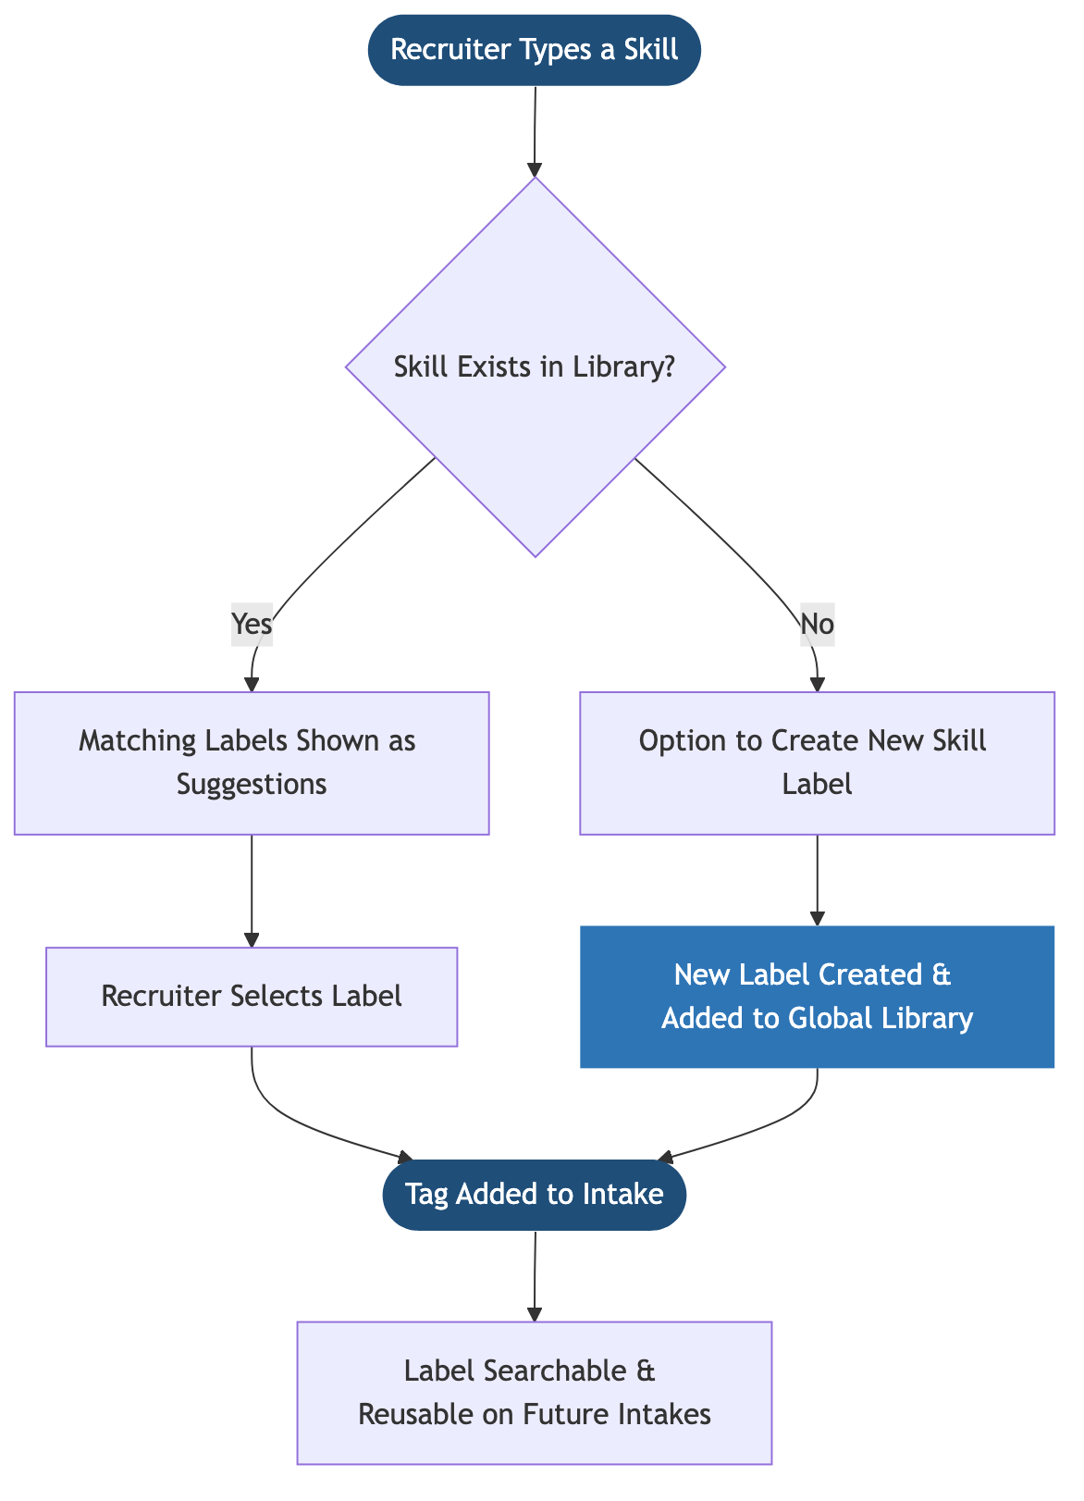

AI Intake Summary – Flow
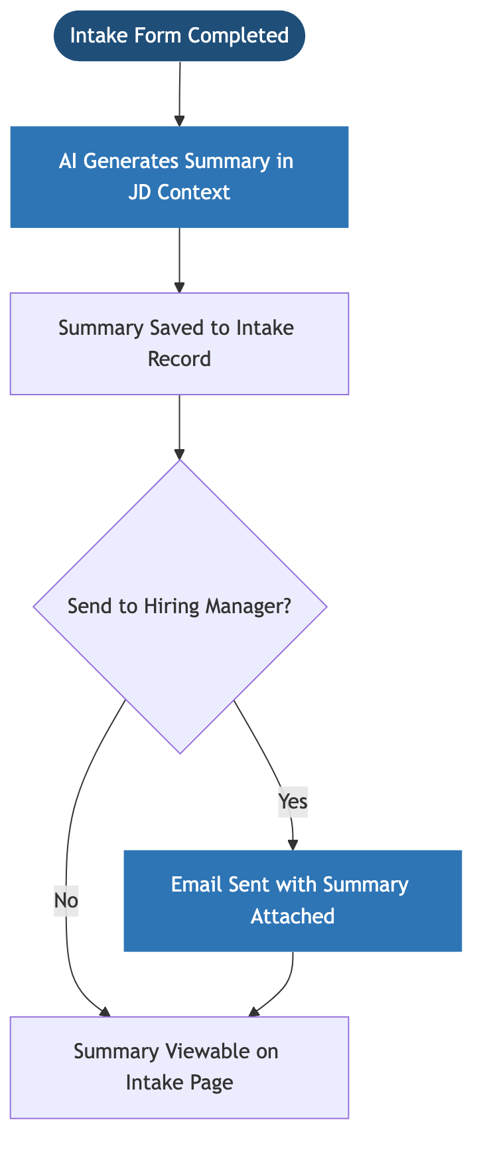

User Flow
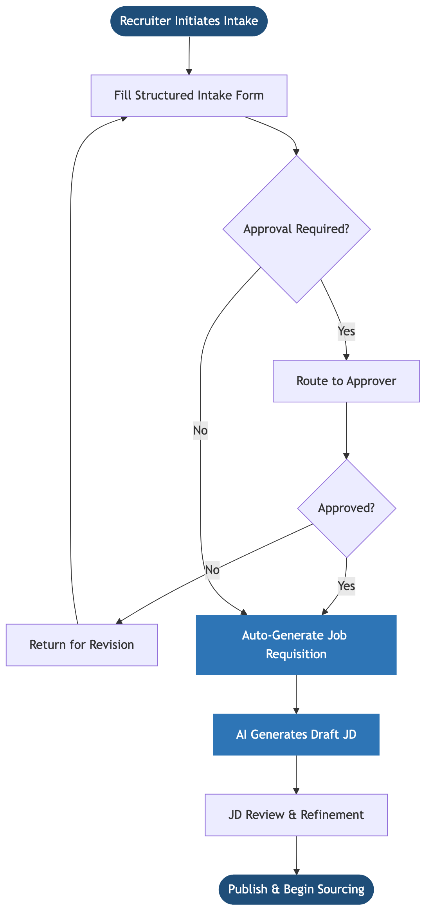

Status Lifecycle
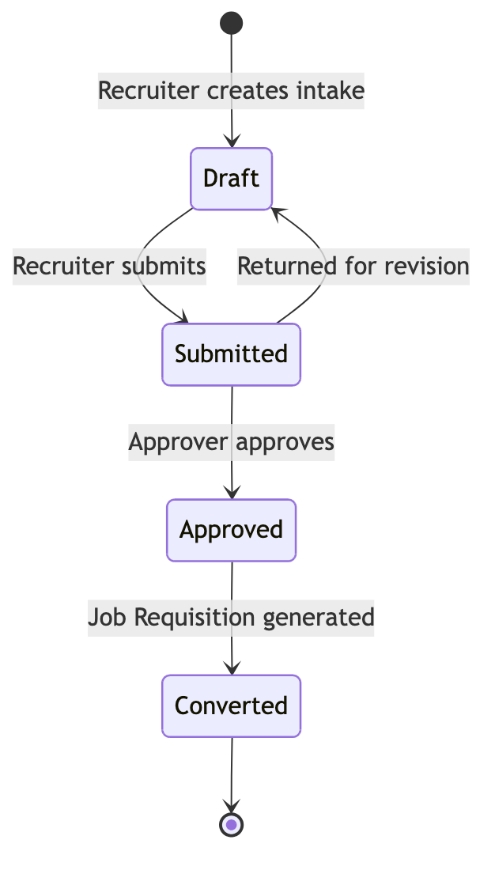

Acceptance Criteria
- Recruiters can create and submit a complete intake form
- Mandatory fields are validated before submission
- Skills can be typed and matched against the existing label library; new labels can be created and are immediately available for reuse
- All skill labels are searchable and filterable across intake records
- Approval workflow routes intake to the correct approver (where configured)
- Job Requisition is auto-created upon approval
- Draft JD is generated in the existing organisation format using AI
- AI-generated intake summary is saved to the intake record
- Summary can be emailed to the hiring manager directly from the intake
- All intake records include a full audit trail and version history

Epic 2 – Onboarding Management

Overview
The Onboarding Management module is a dedicated section of the ADT Hub web application. It enables structured, dependency-driven onboarding workflows for new joiners from the moment an offer is accepted. It coordinates tasks across HR, IT, Admin, Finance, and Hiring Teams, drawing on data from the Employee Management and Asset Management modules to ensure every new hire is fully onboarded on time.

Business Objectives
- Ensure consistent and error-free onboarding for every new joiner
- Reduce Day-1 productivity gaps caused by incomplete setup
- Eliminate manual coordination and follow-up across teams
- Provide real-time visibility and accountability across all onboarding tasks
- Scale onboarding efficiently as hiring volume increases

Scope
In Scope - Onboarding workflow initiation from offer/joining confirmation - Task and dependent task orchestration across teams - Cross-team task ownership and assignment - Configurable onboarding templates defining tasks, owners, dependencies, and notifications - Status tracking and SLA monitoring - Automated notifications and reminders - Central onboarding dashboard for all stakeholders
Out of Scope - Offboarding workflows - Payroll processing - Performance management - Learning and development content delivery

User Flow
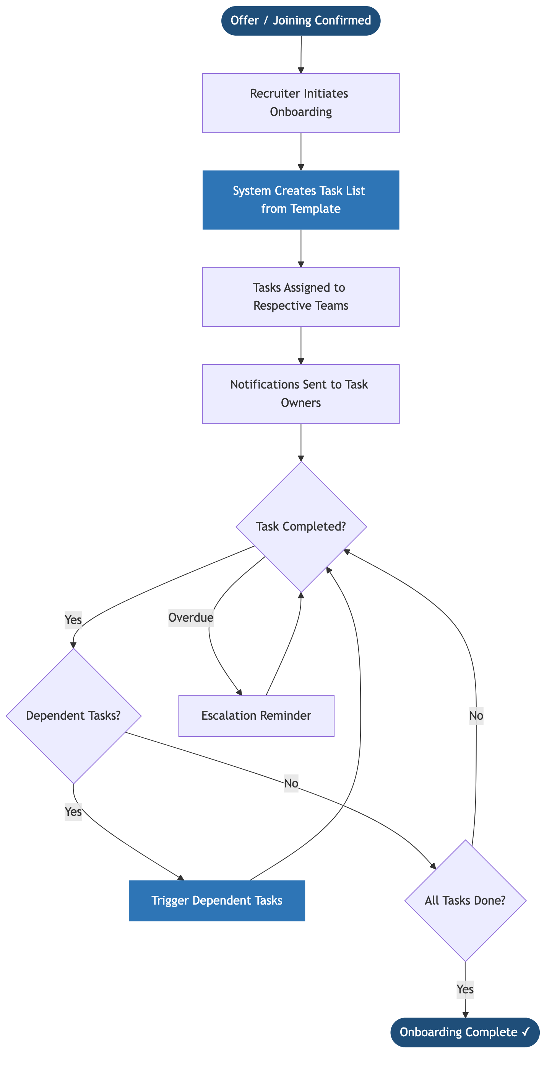

Task Dependency Map
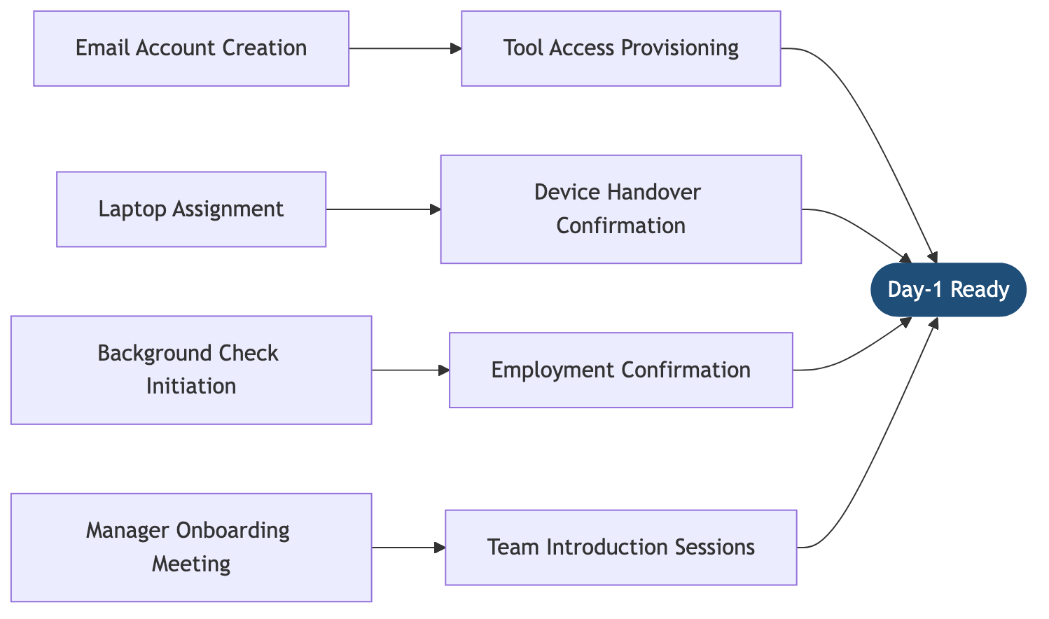

Key Features
Feature | Description
Workflow Template Builder | Admins can create and manage named onboarding templates (e.g. “New Employee – Engineering”). Each template defines the full set of tasks, assigned teams, due date rules, dependencies, and who gets notified at each step
Template Versioning | Templates can be updated without affecting in-progress onboardings; new onboardings always use the latest version
Task Dependency Management | Dependent tasks triggered only after prerequisite completion
Multi-Team Assignment | Tasks auto-assigned to IT, HR, Admin, Finance as appropriate
SLA Enforcement | Due dates tracked; overdue tasks escalated automatically
Real-Time Dashboard | All stakeholders view live onboarding progress per new joiner
Audit Trail | Full activity log with timestamps for compliance

Template Structure
Each onboarding template defines:
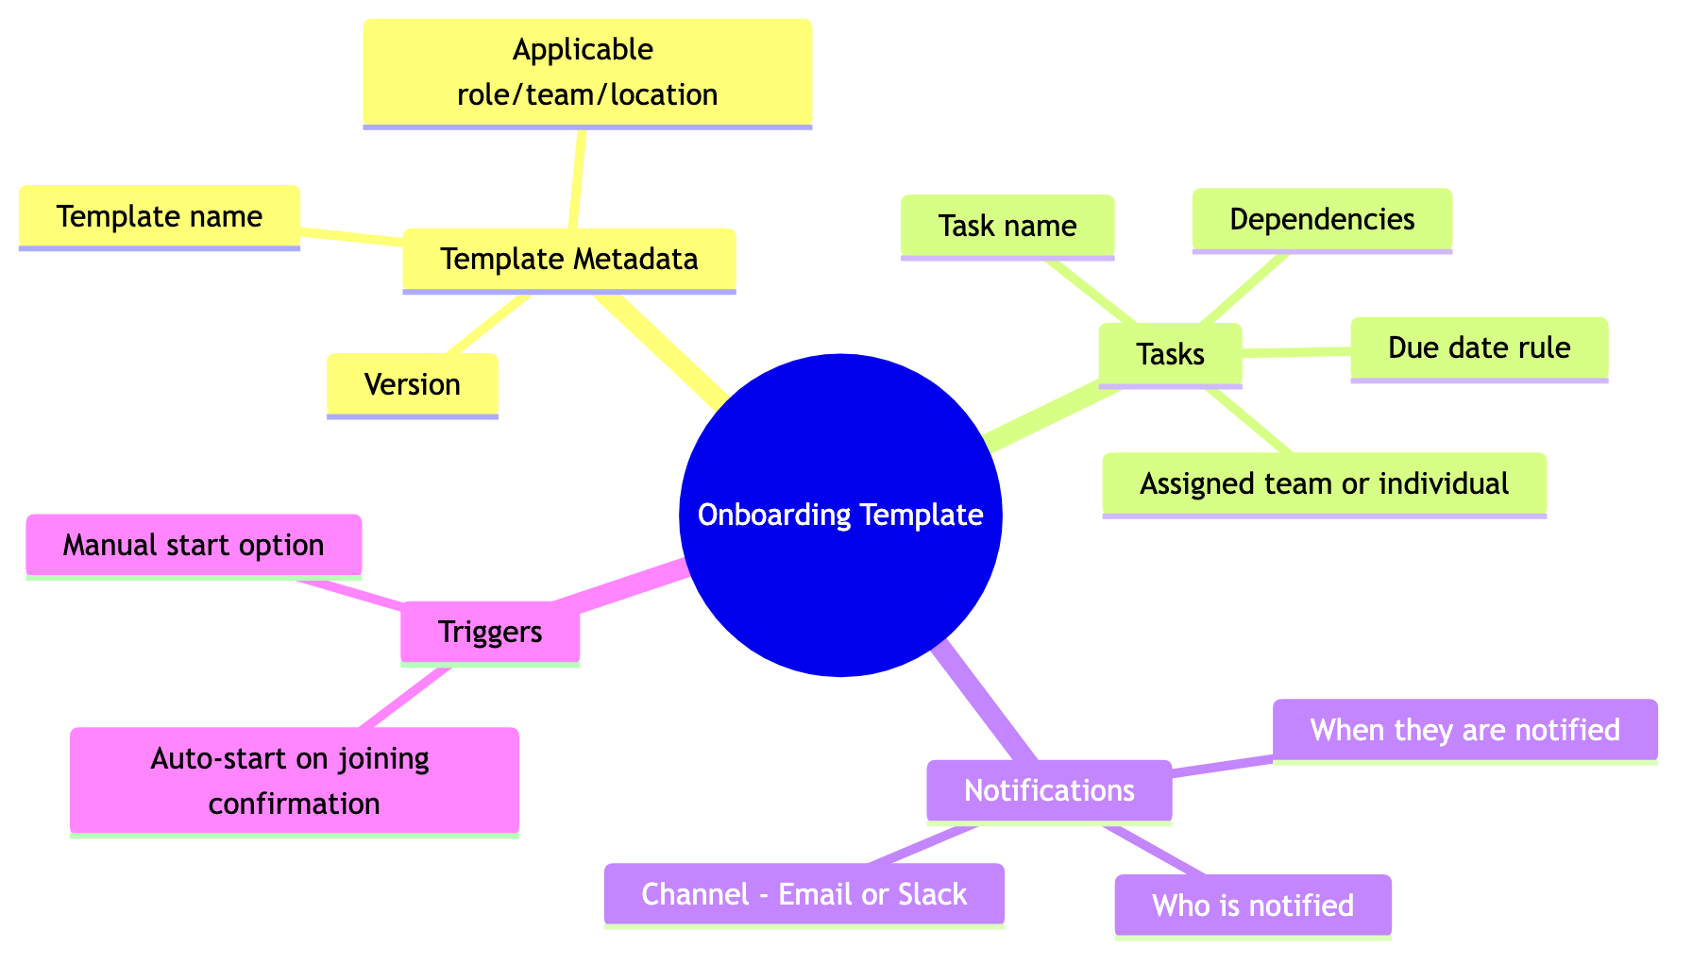

Roles & Permissions
Role | Access
Admin | Configure workflows, templates, and task dependencies
Recruiter | Initiate onboarding and track overall progress
Task Owner (IT/HR/Admin) | View and complete assigned tasks
Hiring Manager | View onboarding status for their new joiners

Acceptance Criteria
- Admins can create, edit, and version onboarding workflow templates
- Templates define tasks, team assignments, due date rules, dependencies, and notification rules
- Recruiters can initiate onboarding for a confirmed new joiner using a selected template
- Tasks are automatically created and assigned based on the template
- Dependent tasks are triggered only after prerequisite completion
- Notification rules in the template control who is alerted and when
- All stakeholders can view real-time onboarding status
- Notifications are sent for pending and overdue tasks

Success Metrics
- % of onboarding tasks completed before Day-1
- Reduction in onboarding delays
- Average onboarding completion time
- New joiner satisfaction score
- Reduction in manual follow-ups by recruiters

Epic 3 – Asset Management

Overview
The Asset Management module is a dedicated section of the ADT Hub web application and acts as the system of record for all company-owned assets. Admins can register assets, assign them to employees using data from the Employee Management module, and track their full lifecycle. The module also supports importing asset data from external sources and attaching invoices for verification, with all records stored centrally and linked to employee profiles.

Business Objectives
- Maintain a single, reliable source of truth for all company assets
- Ensure complete asset traceability and audit compliance
- Reduce asset loss and mismanagement
- Enable proactive warranty and replacement planning
- Improve onboarding efficiency through faster asset assignment

Scope
In Scope - Asset registration and master data management - Asset assignment and reassignment via Employee Management integration - Dedicated asset detail page per asset record - Immutable asset records (non-deletable; status changes only) - Search and filter across all asset records - Automated warranty expiry notifications - Bulk asset import from external data sources with configurable field-matching criteria - Invoice attachment and asset-to-invoice verification
Out of Scope - Asset procurement workflows and vendor payments - Asset depreciation and accounting - Asset disposal approval workflows

Asset Lifecycle
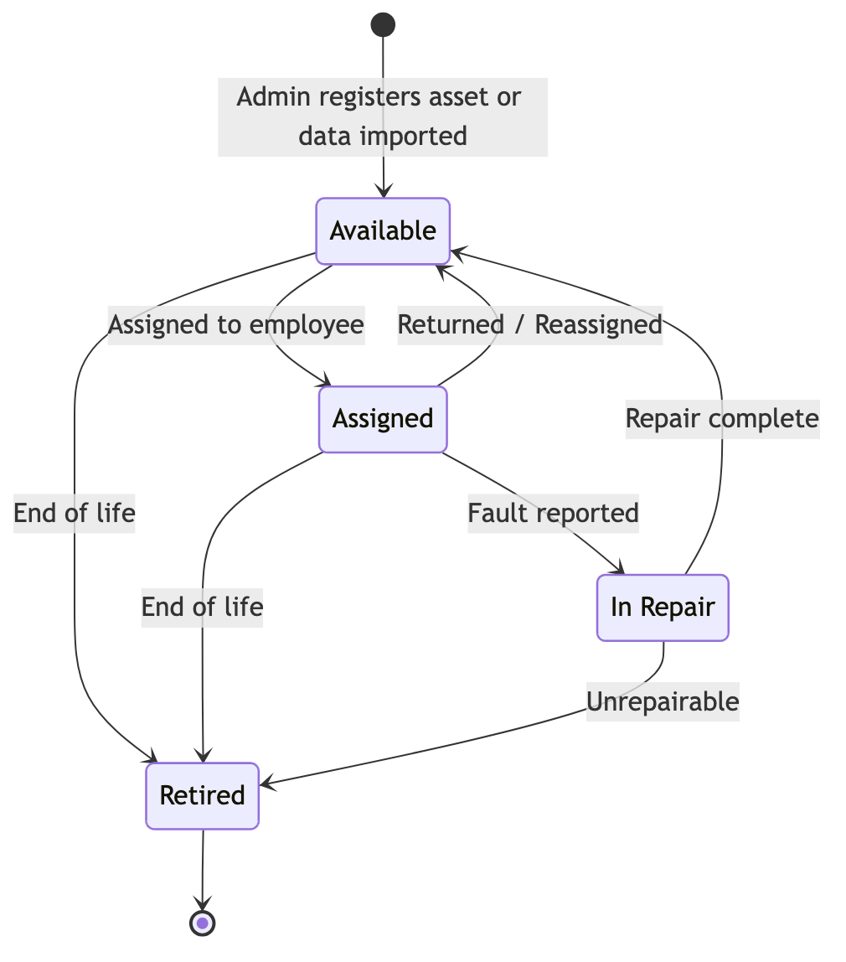

Warranty Alert Flow
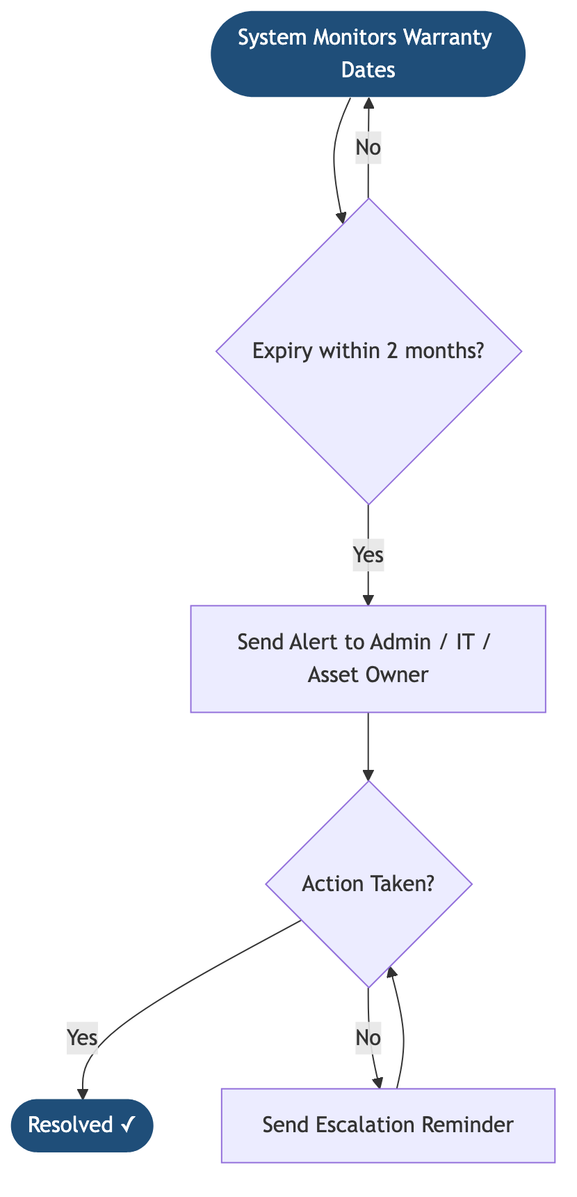

Key Features
Feature | Description
Asset Registration | Capture all asset details upon procurement
Asset Detail Page | Dedicated page per asset with full history, status, invoices, and assignment records
Employee Assignment via Employee Management | Assets are assigned by searching and selecting from the Employee Management directory. The asset record links directly to the employee profile
Immutable Records | Assets cannot be deleted; status transitions replace deletions
Lifecycle Tracking | Statuses: Available, Assigned, In Repair, Retired
Global Search & Filters | Search by category, status, employee, serial number, etc.
Warranty Alerts | Automated alerts 2 months before expiry with escalation reminders
Bulk External Data Import | Import asset records from an external data file. The system applies configurable field-matching criteria to determine which entries to bring in, skipping any that don’t meet the required criteria. A preview is shown before records are created
Invoice Attachment & Verification | Upload invoices to an asset record. System allows matching the invoice to the asset as a verification step, confirming procurement and supporting audit compliance

Employee Assignment Flow
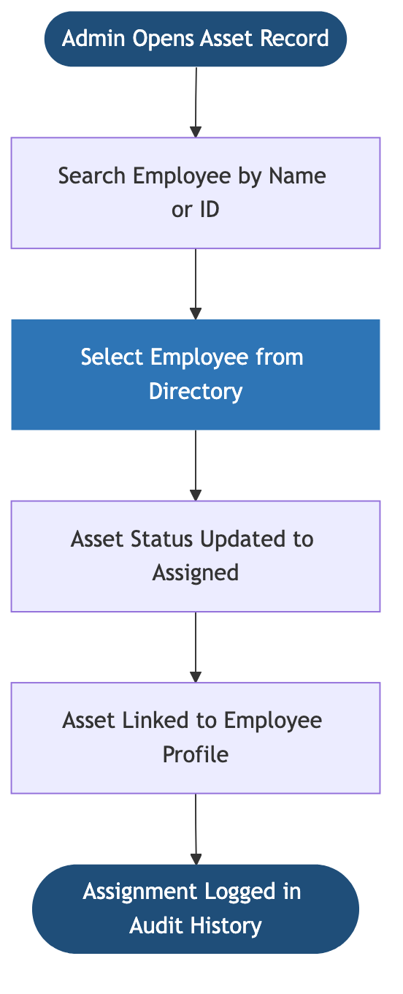

External Data Import Flow
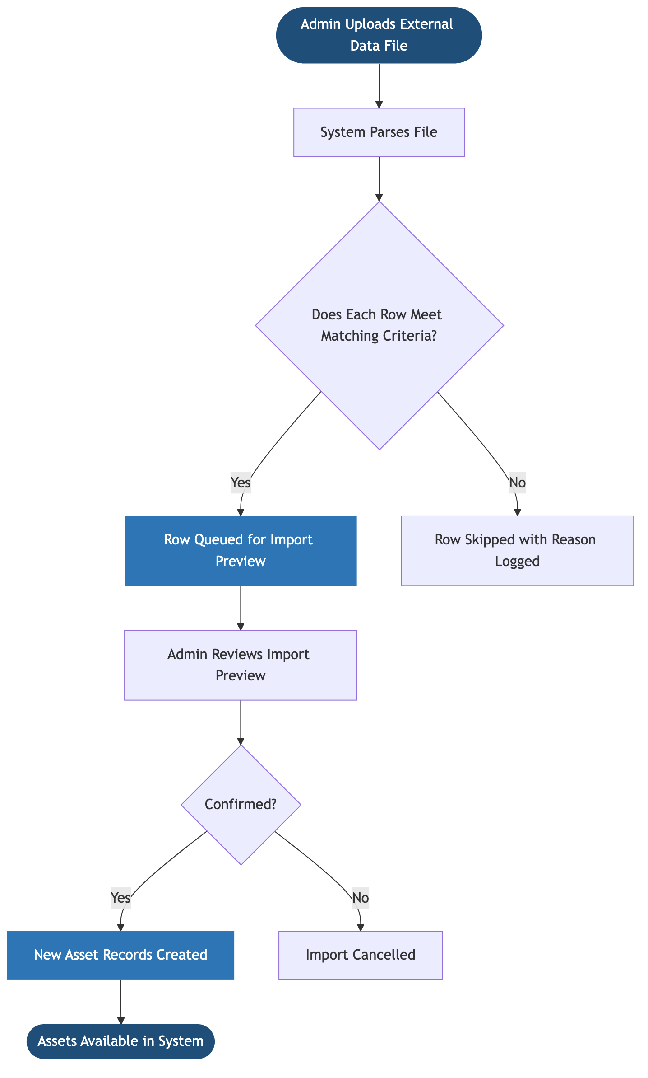
Import matching criteria are configurable by Admin and define which fields must be present and valid for a record to be accepted into the system.

Invoice Attachment & Verification Flow
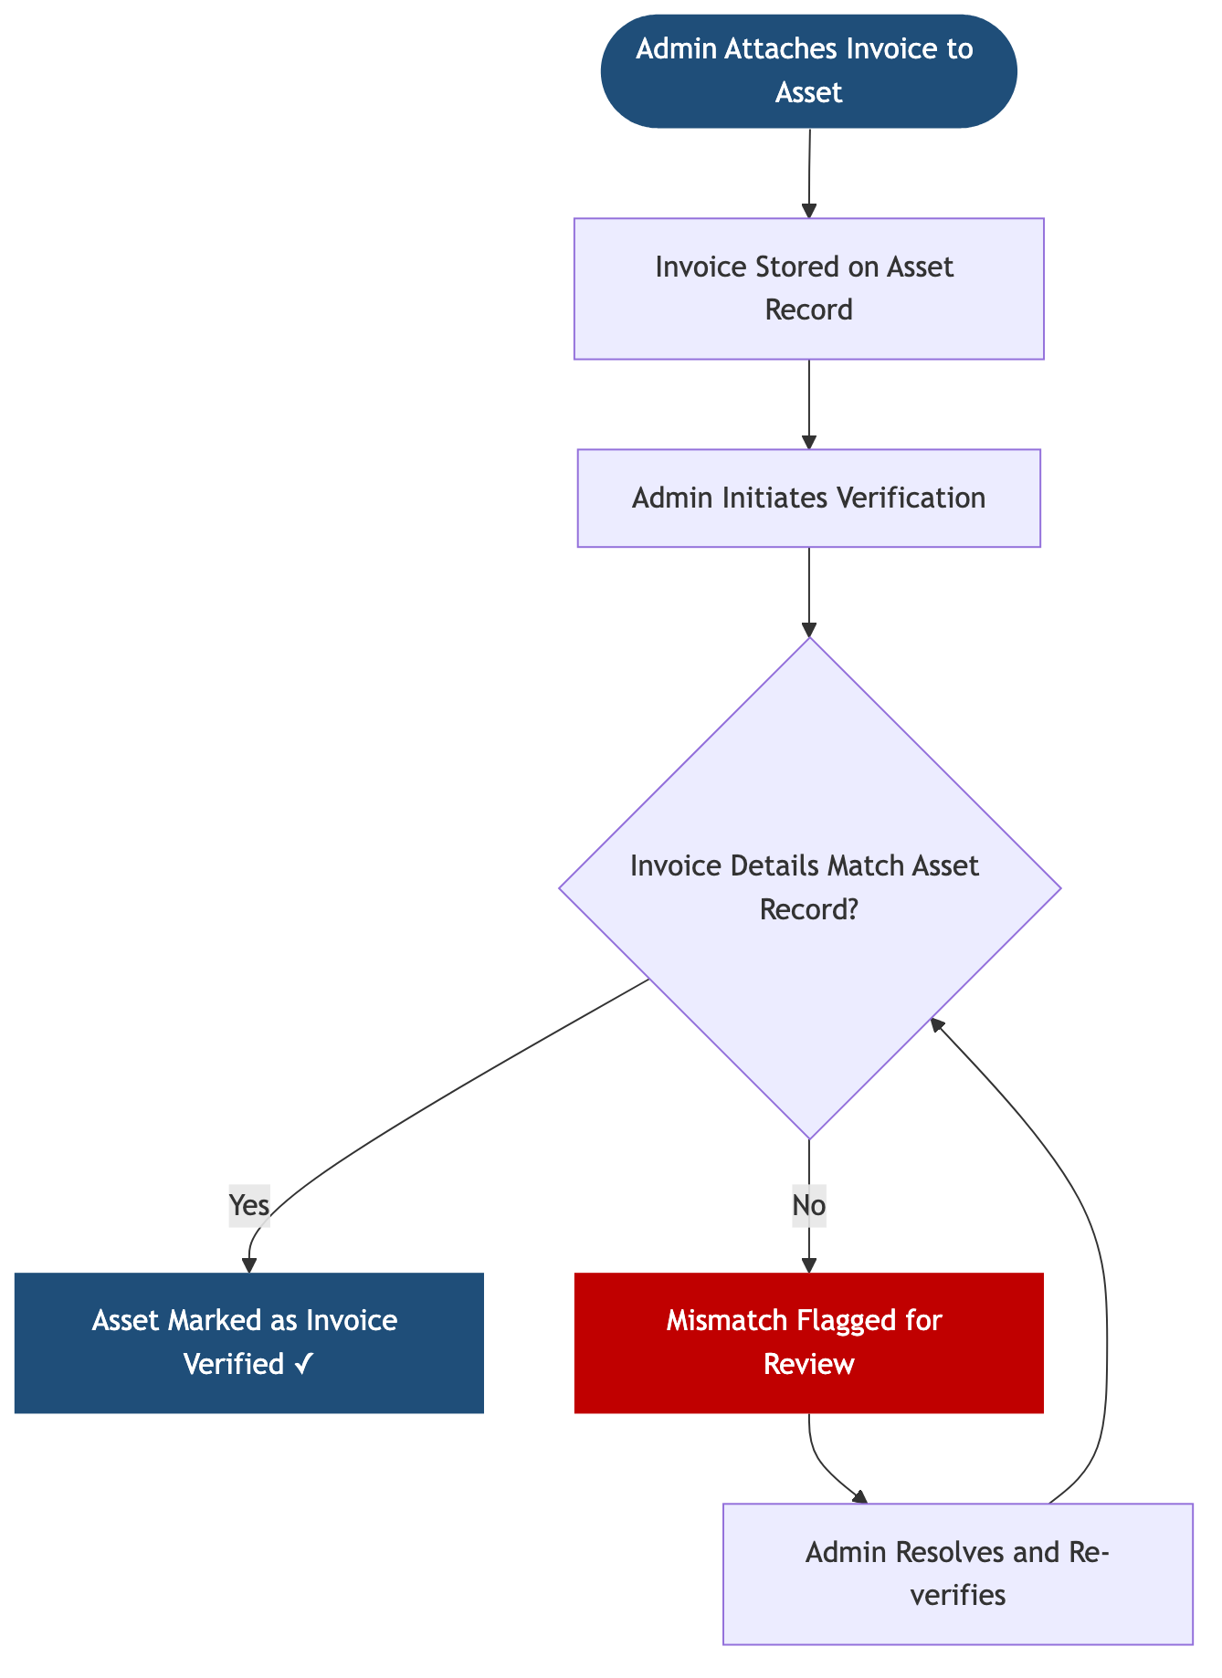

Asset Data Captured
Field | Details
Asset Category | Laptop, Headphones, Monitor, Peripherals, etc.
Manufacturer & Model | Free text
Serial Number / Asset Tag | Unique identifier
Procurement Date | Date of purchase
Vendor | Optional
Warranty Start & End Date | Used for automated alerts
Warranty Type | Standard / Extended
Current Status | Available / Assigned / In Repair / Retired
Assigned Employee | Linked from Employee Management directory; current and historical
Location | Office / Remote / Warehouse
Invoice Attachments | Uploaded invoices with verification status (Unverified / Verified / Mismatch)
Import Source | Populated if record was created via external data import; includes import date
Notes & Attachments | Warranty documents and general notes

Acceptance Criteria
- Admins can create asset records for newly procured assets
- Assets can be assigned by searching the Employee Management directory
- Asset records cannot be deleted once created
- All asset updates are logged with timestamps and user details
- Assets can be assigned and reassigned to employees
- Asset detail page displays complete asset history including assignments and invoices
- All records are searchable and filterable
- System sends automated warranty alerts 2 months in advance
- Admins can upload an external data file; system applies matching criteria and presents a preview before creating records
- Skipped rows from import are logged with a reason
- Invoices can be attached to asset records and verified against asset details
- Mismatched invoices are flagged for admin review

Success Metrics
- % of assets accurately tracked in the system
- Reduction in missing or unaccounted assets
- % of warranty expiries proactively addressed
- Reduction in onboarding delays due to asset unavailability

Epic 4 – Employee Management

Overview
The Employee Management module is a dedicated section of the ADT Hub web application and serves as the central employee record for the platform. It enables HR and Admins to manage employee profiles, and allows employees to maintain their own skills and certifications. The data stored here is shared across other modules — employee records are used in Onboarding to manage new joiner tasks, in Asset Management for assigning equipment, and in Intake to connect skills to hiring requirements.

Business Objectives
- Maintain a single source of truth for all employee data
- Enable skills-based staffing and internal mobility
- Improve workforce planning and capability visibility
- Encourage continuous learning and certification tracking
- Use AI to surface hidden talent and identify skill gaps

Scope
In Scope - Employee master record management (HR/Admin managed) - Employee self-service skills and certification capture - Organisation-wide skills search and reporting - Certification notifications to employees and managers - AI-driven skill insights and recommendations
Out of Scope - Payroll and compensation processing - Performance appraisal workflows - External LMS integration

User Flow
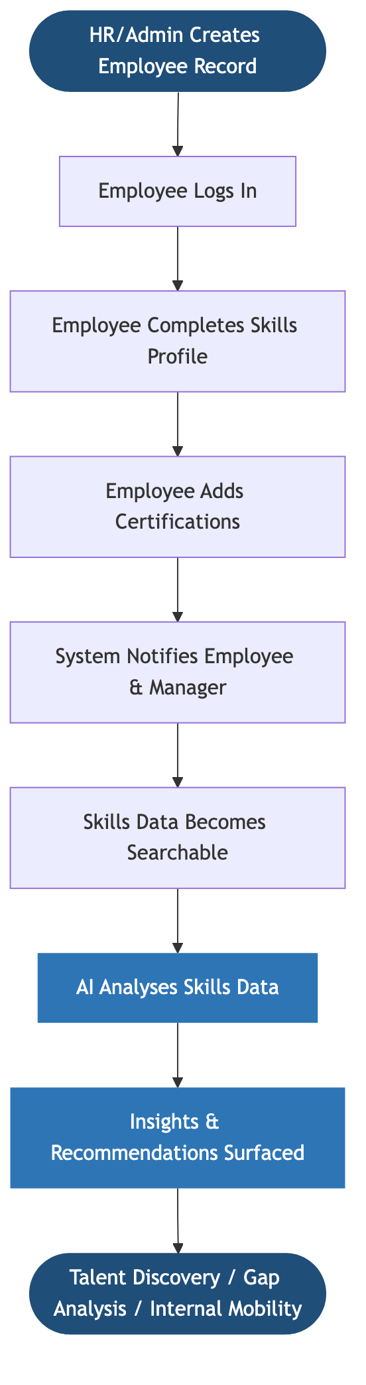

AI Capabilities Map
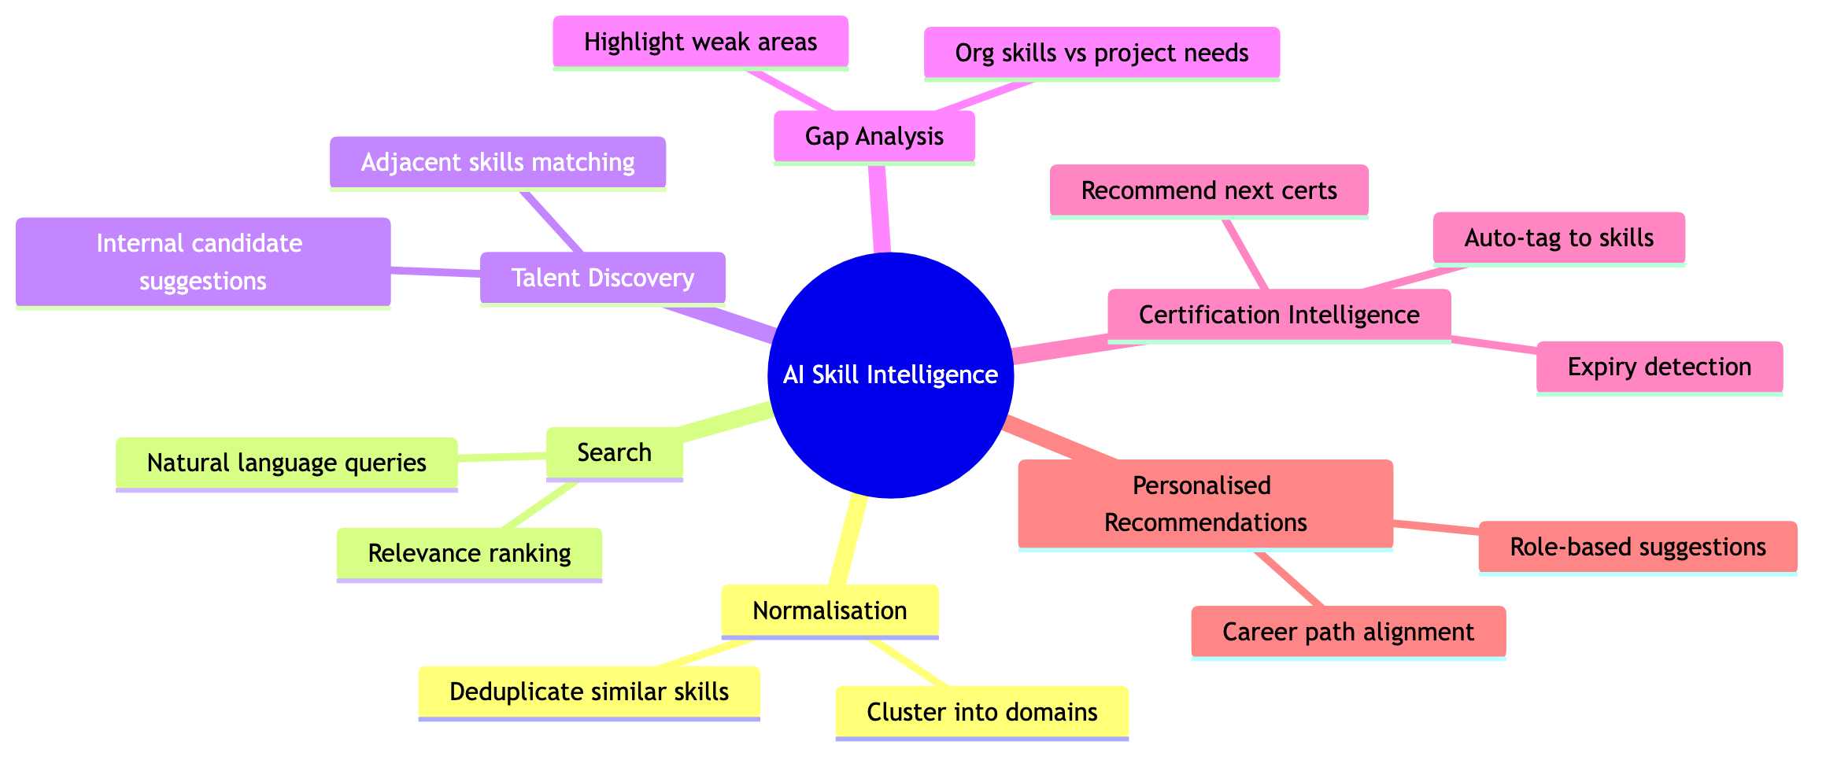

Key Features
Feature | Description
Unified Employee Profile | Single page for all employment details, managed by HR/Admin
Self-Service Skills Page | Employee-managed skills and certifications profile
Organisation Skills Directory | Searchable directory of all employee skills
Skills Search & Reporting | Filter and report by skill, proficiency, team, and more
Certification Notifications | Notify employee and manager when cert is added or nearing expiry
AI Skill Insights | AI-powered talent discovery, gap analysis, and recommendations

Roles & Permissions
Role | Access
Admin | Full access to all employee data and reports
HR | Create and manage employee records
Employee | Edit own skills and certifications only
Manager | View team skills and receive certification notifications

Acceptance Criteria
- HR/Admin can create and update employee records on a single page
- Employees can add and update skills and certifications independently
- Skills data is searchable and reportable across the organisation
- Notifications are sent when certifications are added
- AI features provide actionable insights and recommendations
- Role-based access is enforced across all data

Success Metrics
- % of employees with completed skills profiles
- Average time to find skilled internal resources
- Reduction in external hiring for roles fillable internally
- Increase in certification adoption
- Manager satisfaction with skills visibility

Appendix – Cross-Module Connections
Each module in ADT Hub is a webpage within the same web application. They share a central database and reference each other’s data where relevant. The diagram below shows the key connections between modules and the external services the application relies on.
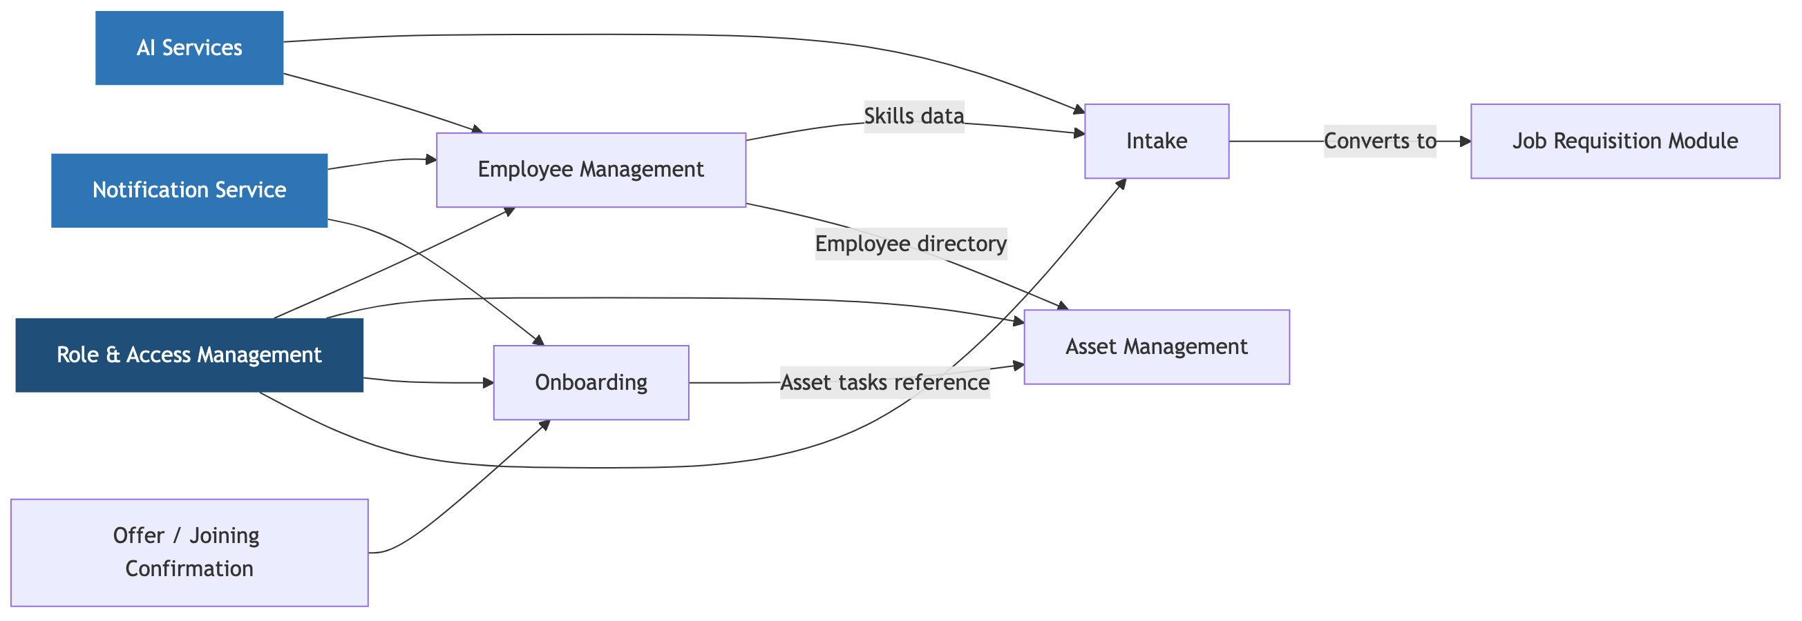
Module | Connected To | How They Connect
Intake | Employee Management | Skills labels from the global library are shared across both modules
Intake | Job Requisition Module | An approved intake automatically creates a Job Requisition
Onboarding | Employee Management | New joiner data is pulled from employee records to initiate workflows
Onboarding | Asset Management | Asset assignment tasks within onboarding reference the Asset module
Onboarding | Notification Service | Task alerts and reminders are sent via email or messaging
Asset Management | Employee Management | Employee directory is used to search and assign assets to people
Employee Management | Notification Service | Certification alerts are sent via email or messaging
Employee Management | AI Services | AI skill features draw on employee skills and certification data
Intake | AI Services | AI JD generation and intake summary use intake form data
All Modules | Role & Access Management | User roles and permissions are enforced across the entire application

Appendix – Stakeholders
Stakeholder | Relevant Modules
HR Operations | Intake, Onboarding, Employee Management
Recruiting Team | Intake, Onboarding
IT / Infrastructure | Onboarding, Asset Management
Admin & Facilities | Onboarding, Asset Management
Hiring Managers | Intake, Onboarding, Employee Management
Finance / Compliance | Intake, Onboarding
Talent Management | Employee Management
Employees | Employee Management
Leadership | Asset Management, Employee Management

