A REPORT ON

**“Sahayta” – A Crowd-Funding App**

SUBMITTED TO THE

VISHWAKARMA INSTITUTE OF INFORMATION TECHNOLOGY, PUNE

**BACHELOR OF TECHNOLOGY (COMPUTER ENGINEERING)**

**Guided by – Prof. Disha Wankhede**

##### SUBMITTED BY

STUDENT NAME Exam Seat No.

1. Ratnakar Patil 22110373
2. Kshitij Narkhede 22110941
3. Aman Kasat 22111050
4. Atharva Gawas 22110116



## DEPARTMENT OF COMPUTER ENGINEERING

**BRACT’S**

**VISHWAKARMA INSTITUTE OF INFORMATION TECHNOLOGY**

SURVEY NO. 3/4, KONDHWA (BUDRUK), PUNE – 411048, MAHARASHTRA (INDIA).

|  |  |  |  |  |  |
| --- | --- | --- | --- | --- | --- |
| **Sr. No.** | | | | **Title of Chapter** | **Page No.** |
| **01** | | | | **Introduction** |  |
|  | 1.1 | | | Overview | 3 |
|  | 1.2 | | | Motivation | 3 |
|  | 1.3 | | | Problem Definition and Objectives | 3 |
|  | 1.4 | | | Project Scope & Limitations | 3 |
|  | 1.5 | | | Methodologies of Problem solving | 3 |
| **02** | | | | Literature Survey | 4 -5 |
| **03** | | | | System Design |  |
|  | | 3.1 | | System Architecture | 6 |
| **04** | | | | Project Implementation |  |
|  | | | 4.1 | Overview of Project Modules | 7-8 |
|  | | | 4.2 | Tools and Technologies Used | 8-9 |
| **05** | | | | Results |  |
|  | | | 5.1 | Outcomes | 10 |
|  | | | 5.2 | Screen Shots | 11-13 |
| **06** | | | | Conclusions |  |
|  | | 9.1 | | Conclusions | 14 |
|  | | 9.2 | | Future Work | 14 |
|  | | 9.3 | | Applications | 14 |

**INDEX**

**1. Introduction**

* 1. **Overview:**

The CrowdFunding App is a revolutionary platform designed to help individuals and organizations raise funds for their projects and initiatives. It provides a user-friendly interface for both creators and backers to connect and collaborate.

* 1. **Motivation:**

The motivation behind the project stems from the desire to democratize fundraising, enabling anyone with a great idea to access the necessary financial support. By leveraging technology, we aim to break down barriers and empower innovators worldwide.

* 1. **Problem Definition and Objectives:**

The problem addressed by the project is the traditional lack of access to funding for many innovative projects due to bureaucratic processes or limited networks. Our objective is to create a solution that facilitates easy and transparent fundraising, fostering creativity and entrepreneurship.

* 1. **Project Scope & Limitations:**

The scope of the project includes developing a web-based platform with features for creating and managing fundraising campaigns, processing payments securely, and providing analytics for campaign performance. Limitations may include regulatory constraints and technical challenges.

* 1. **Methodologies of Problem Solving:**

Our approach to problem-solving involves a combination of research, user-centric design, iterative development, and testing. We prioritize user feedback and data-driven decisions to continually improve the platform and address challenges effectively.

**2. Literature Survey**

A comprehensive literature survey was conducted to understand existing crowdfunding platforms, financial technologies, regulatory frameworks, and user behaviors. This survey informed our design and development process, helping us identify best practices and potential innovations.

**2.1 Existing Crowdfunding Platforms:**

An analysis of existing crowdfunding platforms revealed a variety of models and approaches, including reward-based, donation-based, equity-based, and debt-based crowdfunding. Each model has its unique advantages and limitations, highlighting the importance of flexibility in our platform to accommodate diverse fundraising needs.

**2.2 Financial Technologies (FinTech):**

The literature review on financial technologies highlighted the transformative impact of FinTech on traditional financial services. From peer-to-peer lending platforms to mobile payment solutions, FinTech innovations have democratized access to financial services and streamlined processes. Integrating FinTech solutions into our platform ensures secure, efficient, and transparent transactions for both creators and backers.

**2.3 Regulatory Frameworks:**

Understanding regulatory frameworks governing crowdfunding is essential for compliance and risk management. The literature survey identified various regulations and guidelines imposed by regulatory bodies worldwide, aiming to protect investors, prevent fraud, and ensure market integrity. By adhering to these regulations and implementing robust compliance measures, our platform maintains trust and credibility within the crowdfunding ecosystem.

**2.4 User Behaviors and Preferences:**

Exploring user behaviors and preferences provided valuable insights into the motivations and expectations of both creators and backers. Research indicated that transparency, communication, and social validation are critical factors influencing participation in crowdfunding campaigns. By incorporating features that enhance transparency, facilitate communication, and encourage social engagement, our platform fosters trust and engagement, driving the success of fundraising campaigns.

**3. System Design**

3.1 System Architecture

The system architecture of the Crowd-Funding App comprises several components, including a front-end user interface, a back-end server infrastructure, a database for storing campaign data, and integrations with payment gateways for secure transactions. The architecture is designed for scalability, reliability, and performance to accommodate a growing user base and increasing transaction volumes.

The system architecture of the CrowdFunding App is designed to ensure scalability, reliability, and security while accommodating the platform's various functionalities. At the core of the architecture is a modular design that separates the front-end user interface from the back-end server infrastructure. The front-end interface, developed using modern web technologies such as HTML, CSS, and JavaScript, provides an intuitive and responsive experience for users across devices. On the back end, a robust server infrastructure handles user authentication, campaign management, payment processing, and data storage.

The architecture employs a microservices approach, with each component responsible for specific tasks, allowing for flexibility, maintainability, and ease of deployment. Additionally, the system integrates with third-party APIs for features such as payment gateways, social media sharing, and analytics, enhancing functionality and user experience. Security measures, including encryption protocols, firewalls, and access controls, are implemented at every layer of the architecture to protect user data and transactions. Overall, the system architecture is designed to support the platform's growth, ensuring seamless operation and scalability as the user base and transaction volume increase.

**4. Project Implementation**

**4.1 Overview of Project Modules:**

The CrowdFunding App consists of several interconnected modules, each serving a specific purpose in the fundraising process:

1. User Authentication: This module manages user accounts and authentication, allowing users to sign up, log in, and access their profiles securely.
2. Campaign Creation: Creators can use this module to create and customize fundraising campaigns, including setting goals, describing their projects, and uploading multimedia content.
3. Payment Processing: This module facilitates secure payment processing, integrating with third-party payment gateways such as PayPal to handle transactions between backers and creators.
4. Campaign Management: Backers and creators can use this module to track the progress of campaigns, view contributions, communicate with each other, and manage campaign details.
5. Analytics and Reporting: This module provides insights into campaign performance, including metrics such as funding progress, contribution demographics, and engagement metrics, enabling creators to make informed decisions and optimize their fundraising strategies.

**4.2 Tools and Technologies Used**

The CrowdFunding App is built using a combination of modern tools and technologies to ensure reliability, scalability, and security:

1. Front-End Development: HTML5, CSS3, JavaScript (including frameworks like React.js or AngularJS) for building the user interface and ensuring a responsive and engaging user experience.
2. Back-End Development: Node.js or Python (with frameworks like Express.js or Django) for developing the server-side logic, handling user authentication, managing database interactions, and implementing business logic.
3. Database: MongoDB or MySQL for storing campaign data, user information, and transaction records, providing a scalable and reliable data storage solution.
4. Payment Gateway Integration: Integration with third-party payment gateways such as PayPal, Stripe, or Razorpay to facilitate secure payment processing and ensure compliance with industry standards and regulations.
5. Security: Encryption protocols (such as SSL/TLS), authentication mechanisms (such as OAuth or JWT), and best practices for securing user data, preventing unauthorized access, and protecting against common security threats.
6. Deployment and Hosting: Docker for containerization, Kubernetes for orchestration, and cloud platforms such as AWS, Google Cloud, or Microsoft Azure for deployment and hosting, ensuring scalability, high availability, and performance optimization.
7. These tools and technologies are carefully chosen to meet the project requirements, enable efficient development and deployment, and deliver a seamless user experience for both creators and backers on the CrowdFunding App platform.

**5. Results**

**5.1 Outcomes:**

The implementation of the CrowdFunding App has resulted in several positive outcomes:

1. **Increased accessibility to funding for creators**: The platform has provided creators with a user-friendly and efficient way to showcase their projects and raise funds from a global audience.
2. **Empowered backers to support causes they believe in**: Backers can easily discover and contribute to campaigns aligned with their interests, fostering a sense of community and empowerment.
3. **Successful fundraising campaigns**: Many campaigns
4. hosted on the platform have met or exceeded their funding goals, demonstrating the effectiveness of the CrowdFunding App in facilitating successful fundraising endeavors.

**5.2 Screen Shots:**

HOME PAGE:

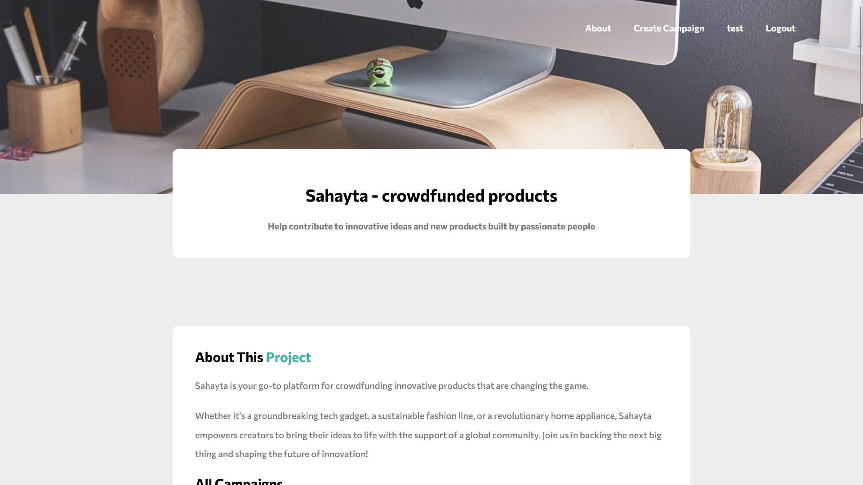

MEMBER LOGIN:

ACCOUNT CREATION:

CAMPAIGN CREATION PAGE: 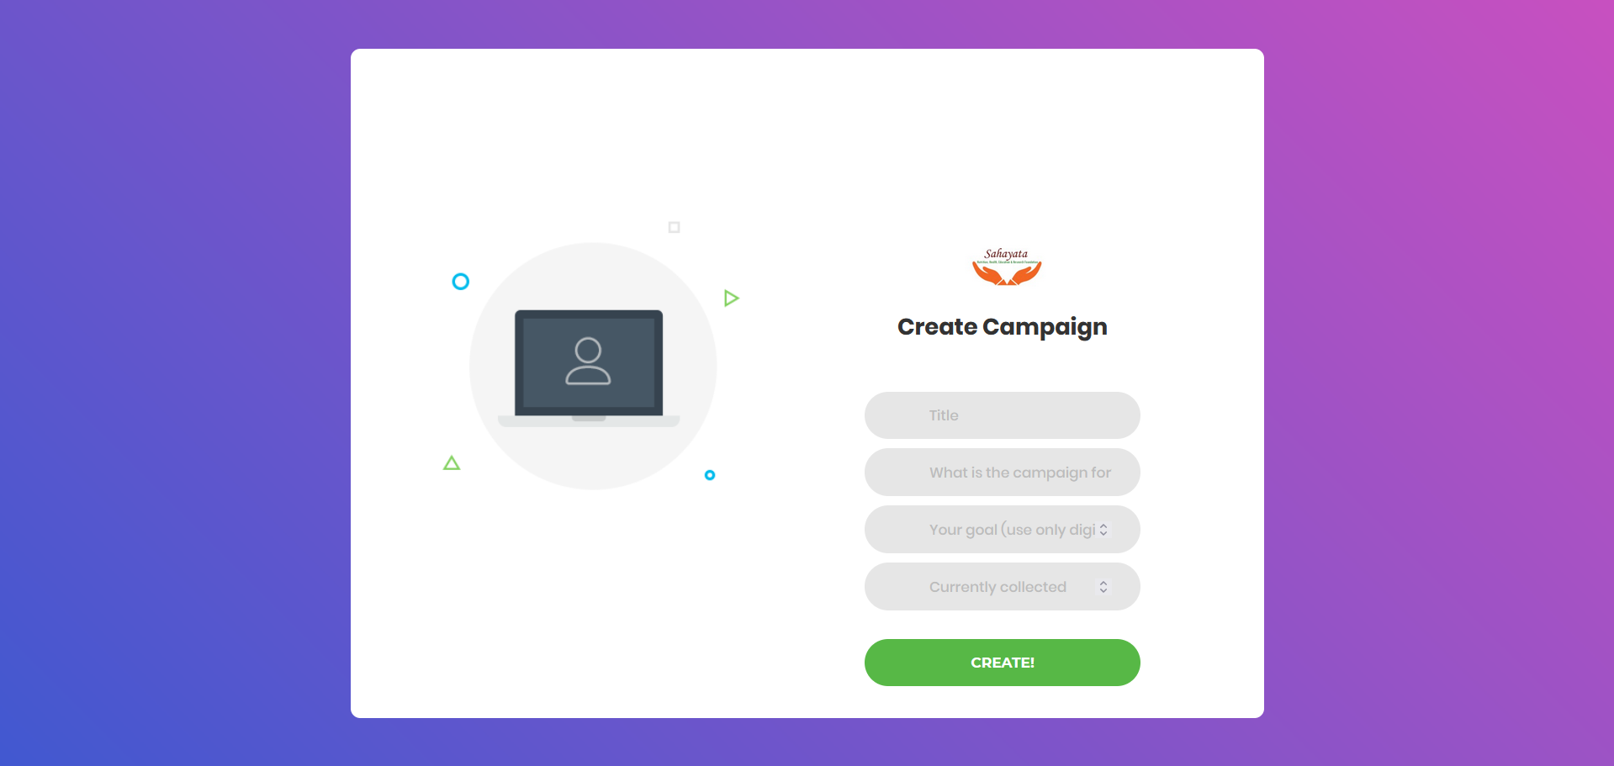

SUCCESFUL PAYMENT PAGE:

AMOUNT UPDATED:

**6. Conclusions**

**6.1 Conclusions:**

In conclusion, the Crowd-Funding App has proven to be a valuable tool for both creators and backers, facilitating the realization of innovative projects and initiatives. The platform's intuitive design, secure payment processing, and robust features have contributed to its success in democratizing the fundraising process and empowering individuals and organizations to bring their ideas to life.

**6.2 Future Work:**

Moving forward, there are several avenues for future work and enhancements to the CrowdFunding App:

1. **Expansion of features**: Adding new features such as social sharing tools, campaign milestones, and reward tiers to enhance user engagement and campaign success.
2. **Integration with additional payment gateways**: Incorporating support for more payment gateways to accommodate diverse user preferences and global currencies.
3. **Enhanced analytics and reporting**: Improving analytics capabilities to provide creators with deeper insights into campaign performance and audience demographics, enabling more informed decision-making.

**6.3 Applications:**

The CrowdFunding App has a wide range of applications across various domains, including:

1. **Entrepreneurship:** Enabling aspiring entrepreneurs to raise capital for startup ventures and innovative business ideas.
2. **Creative projects**: Supporting artists, musicians, filmmakers, and other creatives in funding their projects and reaching a wider audience.
3. **Non-profit initiatives**: Facilitating fundraising efforts for charitable organizations, social causes, and community projects, driving positive social impact and change.