**Beginner Level Task**

**Task 1 : Variables**

**1. Create a variable named pi and store the value 22/7 in it. Now check the data type of this variable.**

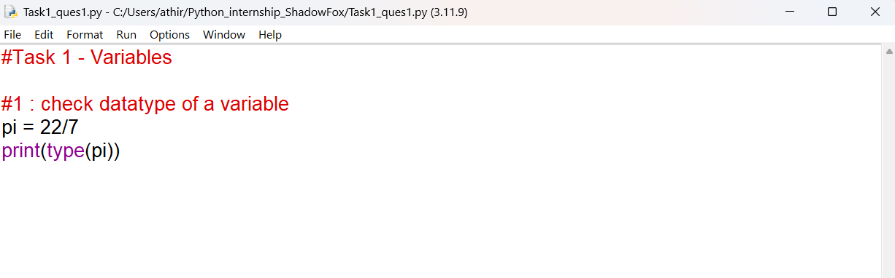

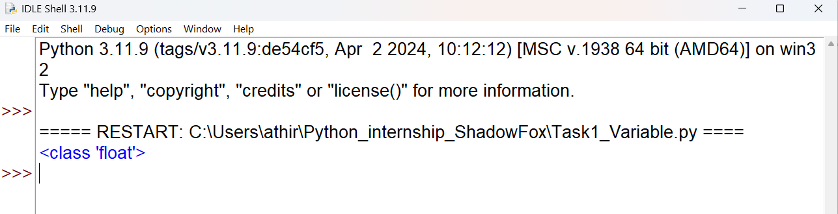

Remark: The type() function is used which is a built in function in python to check the datatype of a variable

**2. Create a variable called for and assign it a value 4. See what happens and find out the reason behind the behaviour that you see.**

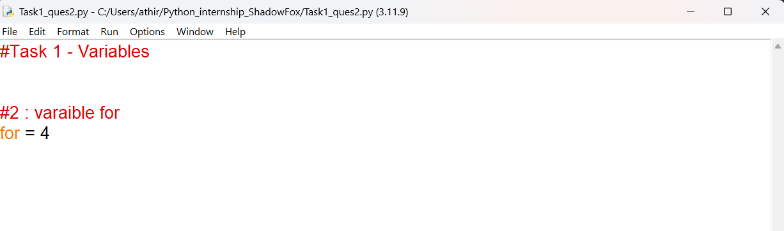

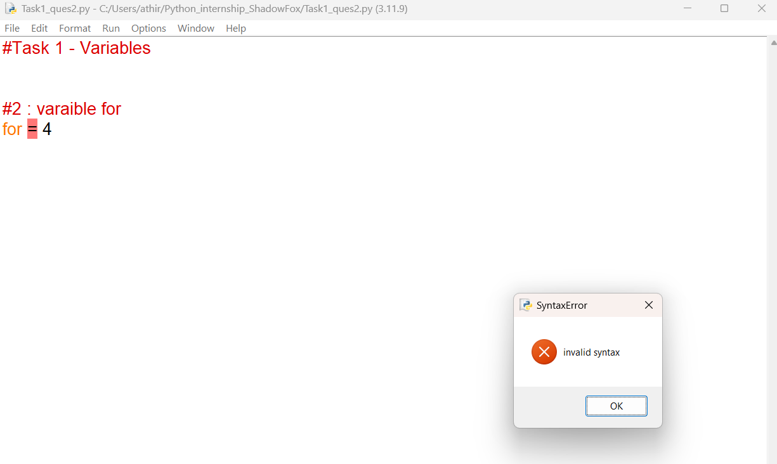

Remark : Creating a variable named ‘for’ and then assigning a value to it, throws error because for is a keyword in python with a reserved meaning, hence it can’t be used as a variable or for other purposes.

**3. Store the principal amount, rate of interest, and time in different variables and then calculate the Simple Interest for 3 years. Formula: Simple Interest = P x R x T / 100**

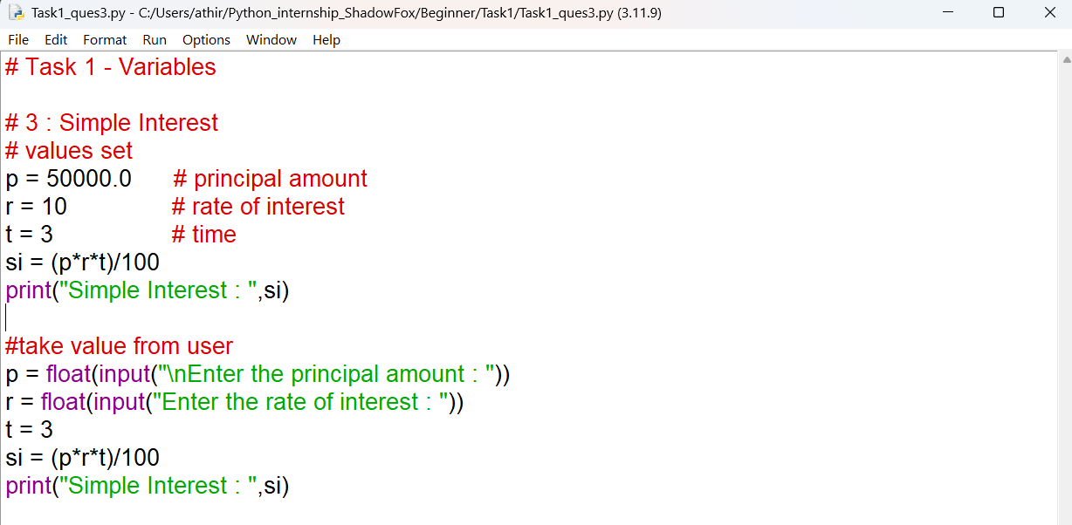

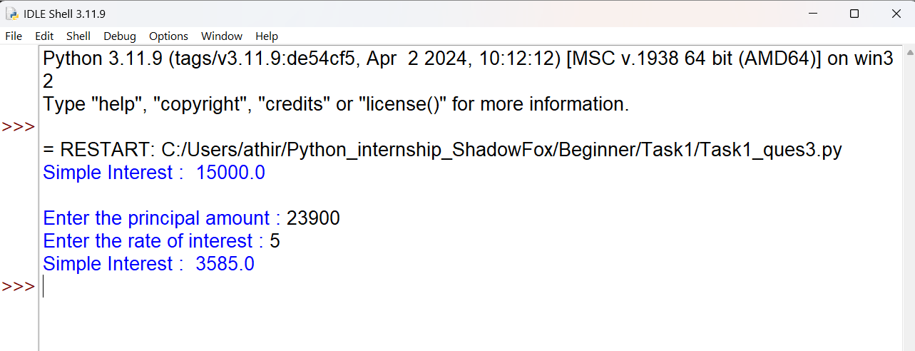

Remark : Used 2 approaches , first directly stored values in variables, then found the simple interest. Next got input from user and then found the interest.