**Task 4 : IF condition**

1. Write a program to determine the BMI Category based on user input.

Ask the user to:

Enter height in meters

Enter weight in kilograms

Calculate BMI using the formula: BMI = weight / (height)2

Use the following categories:

If BMI is 30 or greater, print "Obesity"

If BMI is between 25 and 29, print "Overweight"

If BMI is between 18.5 and 25, print "Normal"

If BMI is less than 18.5, print "Underweight"

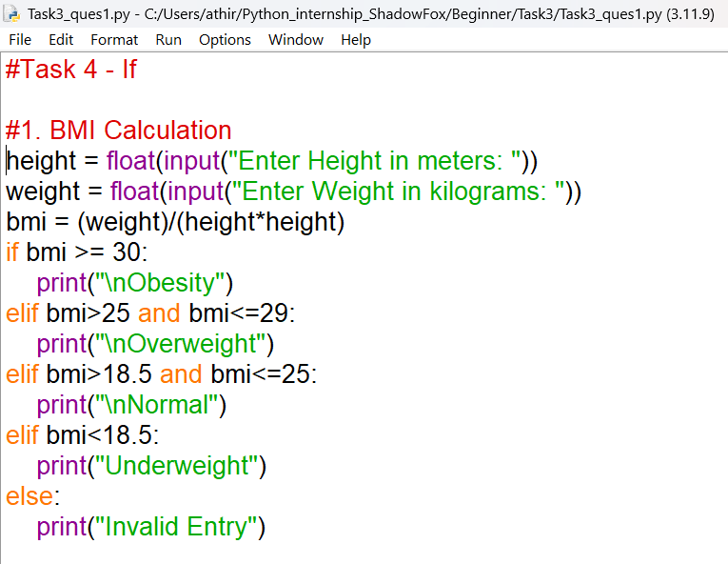

OUTPUT

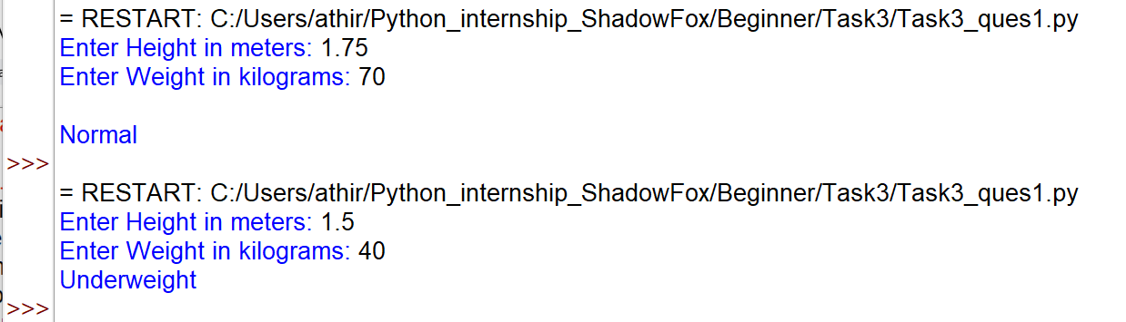

2. Write a program to determine which country a city belongs to. Given

list of cities per country:

Australia = ["Sydney" , "Melbourne" , "Brisbane" , "Perth"]

UAE = ["Dubai" , "Abu Dhabi" , "Sharjah" , "Ajman"]

India = ["Mumbai" , "Bangalore" , "Chennai" , "Delhi"]

Ask the user to enter a city name and print the corresponding country.

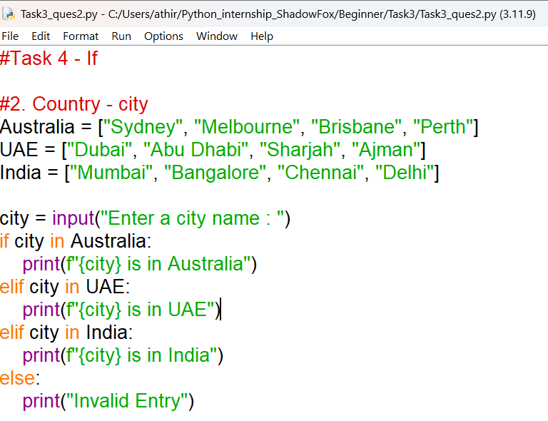

OUTPUT

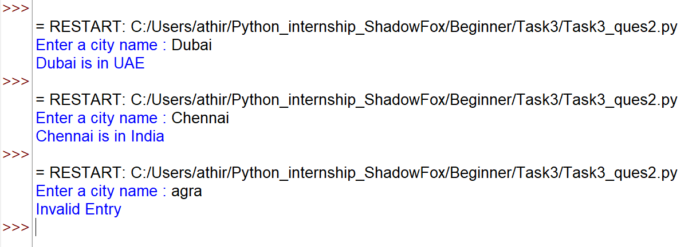

3. Write a program to check if two cities belong to the same country.

Ask the user to enter two cities and print whether they belong to the

same country or not.

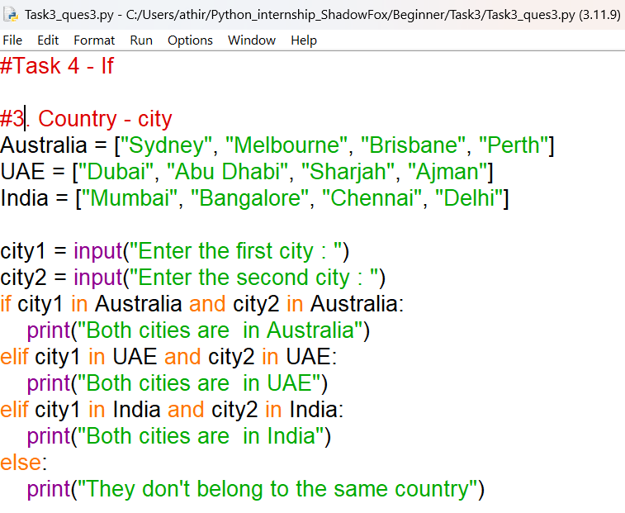

OUTPUT

