**Task 4 : Dictionaries**

1.Create a list of your friends' names. The list should have at least 5 names. Create a list of tuples. Each tuple should contain a friend's name and the length of the name.

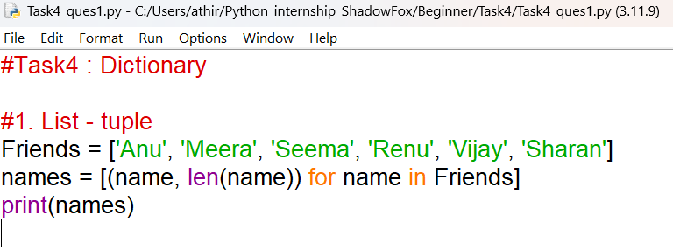

OUTPUT

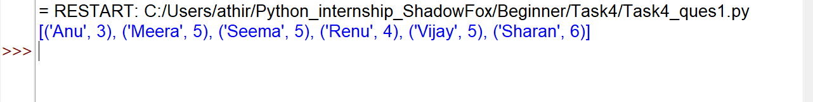

2. You and your partner are planning a trip, and you want to track expenses. Create two dictionaries, one for your expenses and one for your partner's expenses. Each dictionary should contain at least 5 expense categories and their corresponding amounts. Calculate the total expenses for each of you and print the results. Determine who spent more money overall and print the result. Find out the expense category where there is a significant difference in spending between you and your partner. Print the category and the difference.

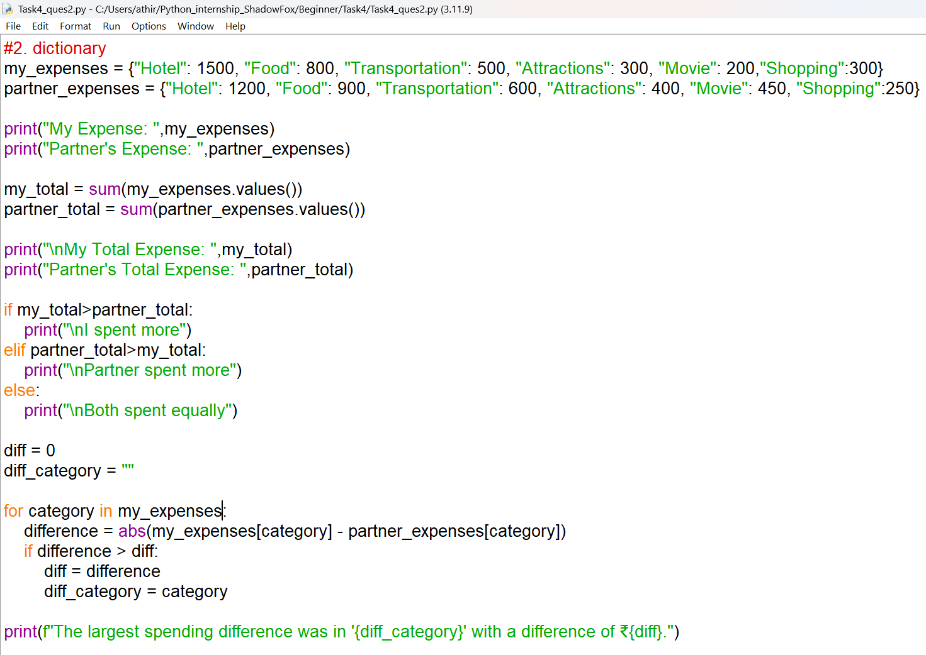

OUTPUT

