**Task 5 : Classes and Objects**

Avengers is a Marvel’s American Superheroes team, Now you want to

showcase your programming skills by representing the Avengers team using

classes. Create a class called Avenger and create these six superheroes using this

class.

super_heroes = ["Captain America", "Iron Man", "Black Widow", "Hulk",

"Thor", "Hawkeye"]

Your Avenger class should have these properties: Name ,Age ,Gender , Super Power ,Weapon

Captain America has Super strength, Iron Man has Technology, Black Widow

is superhuman, Hulk has Unlimited Strength, Thor has super Energy and

Hawkeye has fighting skills as superpowers.

Weapons: Shield, Armor, Batons, No Weapon for hulk, Mjölnir, Bow, and

Arrows

Create methods to get the information about each superhero

Create a method is_leader() which will tell if the superhero is a leader or not.

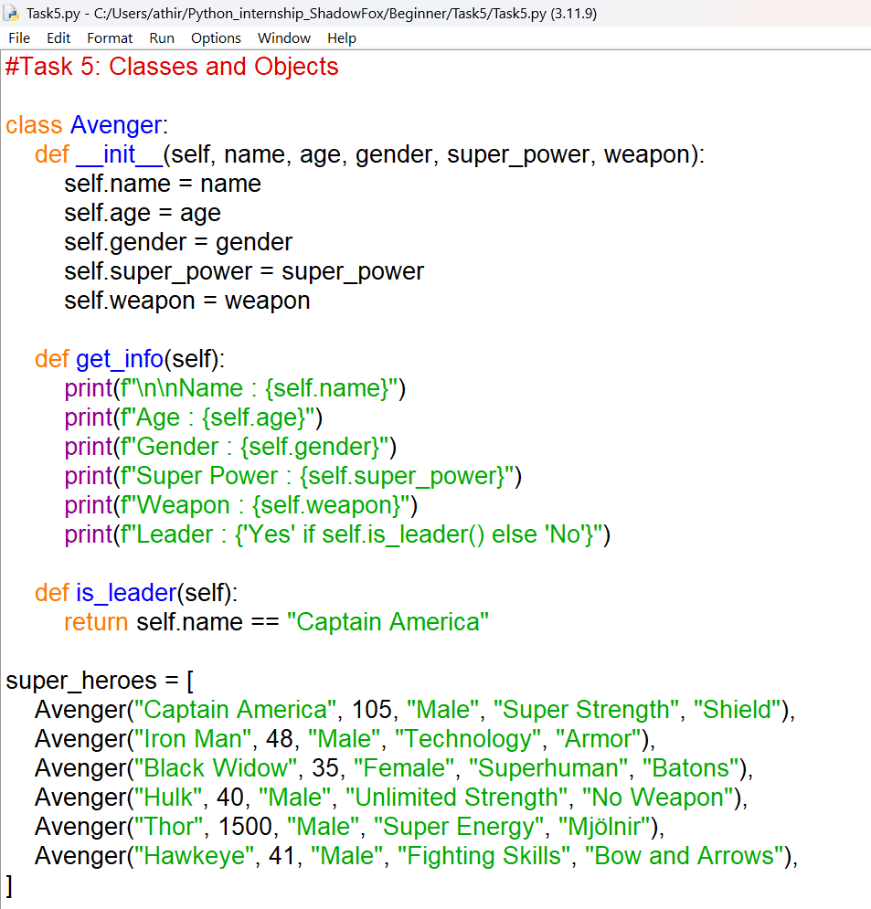



OUTPUT

