

American International University-Bangladesh (AIUB)  
**Department of Computer Science and Engineering   
Faculty of Science &Technology (FST)  
Spring 21-22  
CSC 00191- Object Oriented Analysis And Design (OOAD)**

**Section: B**

**Project Title:** “Travel Agency Management System”

**Submitted by:**

**Athoy Kanti Ray**

**ID : 20-43259-1**

**DEP : CSE**

**Submitted to:**

**Mohaimen – bin- Noor**

**Sr. Assistant Professor**

**Department of Computer Science**

**1. Project Title:** **“Travel Agency Management System”**

**2. Project Overview:**

In a Travel Agency Management System travel agents uses the system to serve a customer. Many agents work to show the tour packages for many customer. In a company there can be many tour packages. A customer can search for a tour by his choice. The travel agent will help the customer to book a tour by contacting the tourism company. A tourism company have many travel agents can serve for the customers. The agents will be conscious about customer likes and dislikes. He will arrange a tour for the customer. A travel agent can rent a room for customers staying purpose from many hotel, but a hotel manager has to check if the room has prior booking or not then he will reserve a room. The agent delivers the room reservation paper to the customer. A travel agent can book airline seats by the help of many airline company for customers. The airline company first checks if seats are available or not. Then after confirming the agent delivers the ticket to the customer. For payment customer has to log in to the system via userid and password. One customer might pay for only one package. Agents have a commission for their work. Customer will give the payment to the travel agent directly. The customer will pay one bill from the elements written in the system including airline tickets, agent commission, tour service, room bill. The payment can be given via cash, credit card.

**3. Justification:**

By using Travel Agency Management System, a customer can easily find his/her tour packages. It makes travel Agency Management System very convenient for the customer. The customer can easily rent a room without even travelling to that particular location as the travel agent are always there to full-fill the customer needs. It saves the time and money of the customer. The system offer different categories for the customer. Customer can easily book airline seat if the seat is available. The customer can select any category and location from the website besides after confirming the customer can contact with the travel agent to know further details about renting. The payment system is also very secure and easy. The customer can visit the website at anytime with the userid and password which is provided by the agent. Overall travel agency management system is very useful for the customers/users.

**4.Overall Use Case of the project:**

**ACTOR & THEIR RELATED USE CASES**

|  |  |
| --- | --- |
| **Actor** | **Use cases** |
| Travel agent | A travel agent can book a room with the help of hotel manager for customer.  The travel agent is authorized to book rooms.  Travel agent must accept the terms & condition.  Travel Agent confirms that the tour package is available.  Travel agent selects the rooms & payment option.  Travel agent selects the alternative package and confirm the booking. |
| Customer | Customer requires a tour package  Customer selects the tour package & payment option.  Customer confirm the booking.  The customer is authorized to payment. Customer must fill the information form for payment. |
| Hotel manager | Hotel manager proposes an alternative room.  Hotel manager confirms room is available.  hotel manager has to check if the room has prior booking or not then he will reserve a room |
| Airline company | The airline company first checks if seats are available or not.  Then after confirming the agent delivers the ticket to the customer |
| Tourism company | Tourism company have many travel agents can serve for the customers.  Tourism company confirms that the payment is done |

**USE CASE DIAGRAM**

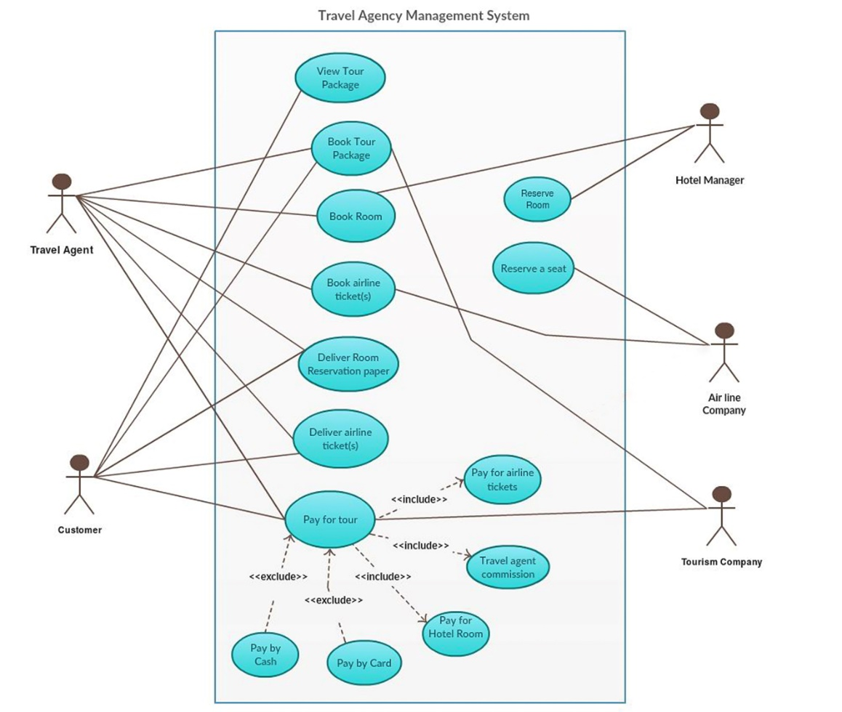

5. Class diagram of the project:

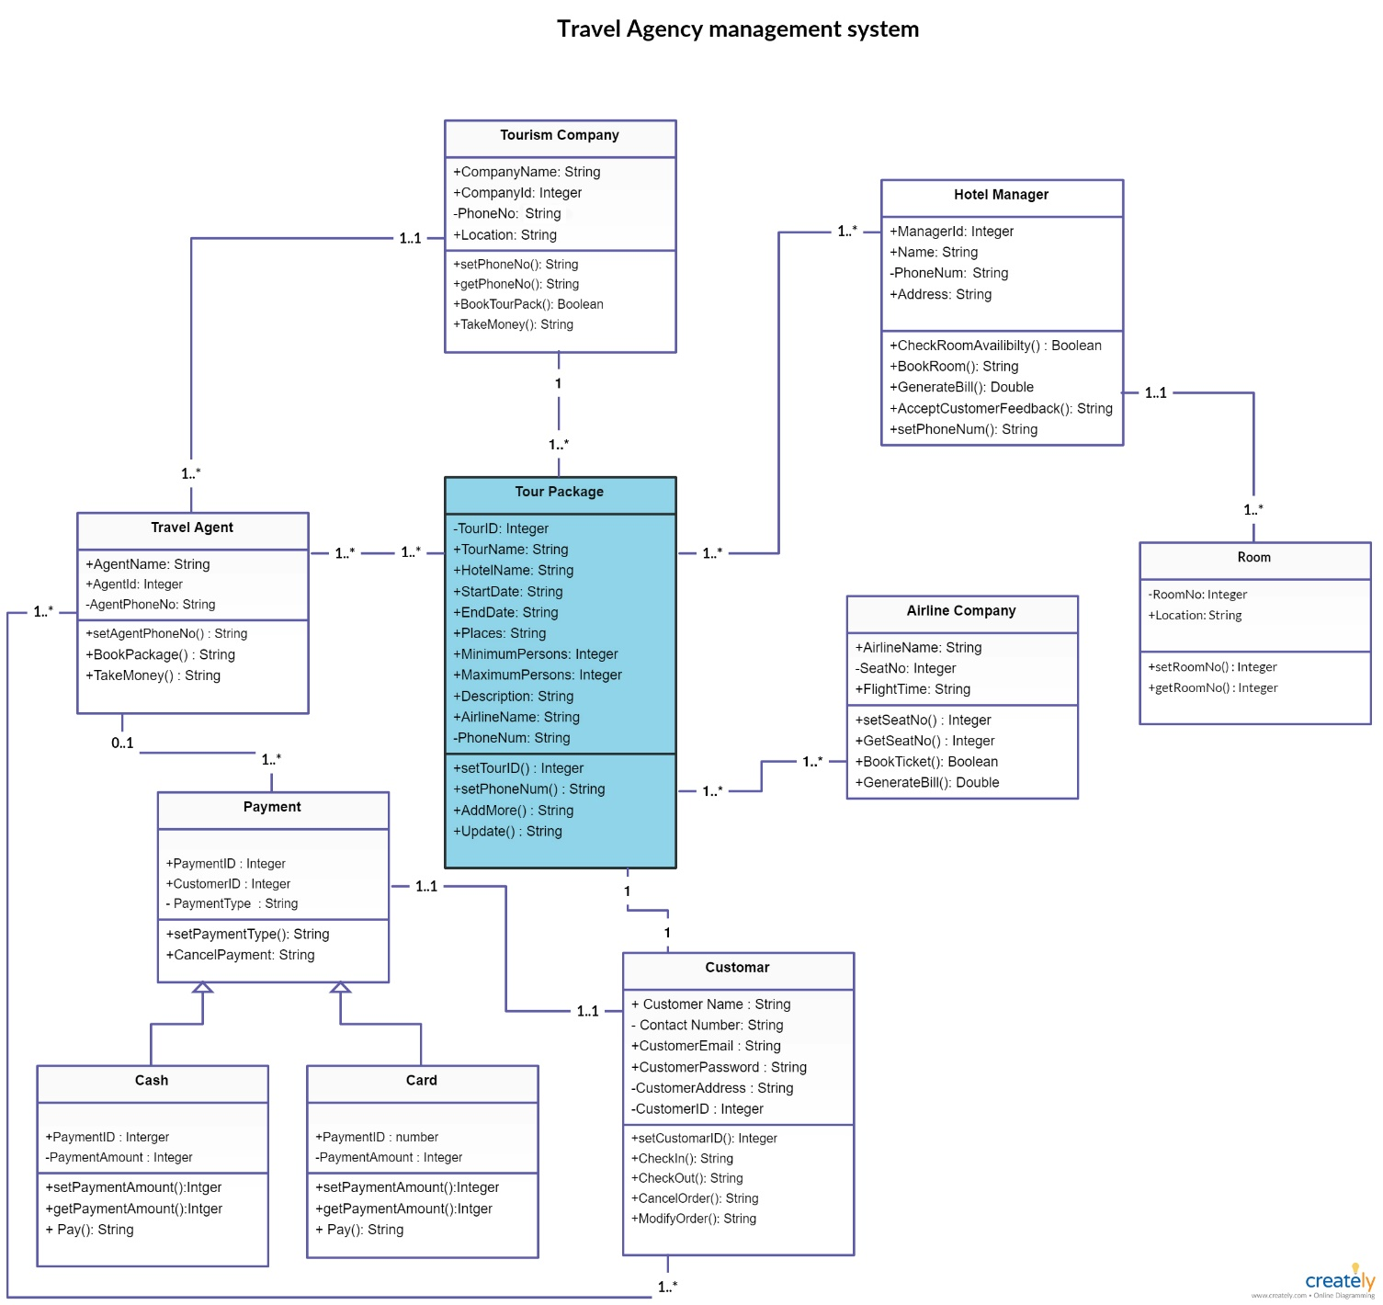

6. Activity Diagram of the project:

Activity Diagram 1: Book Tour Package

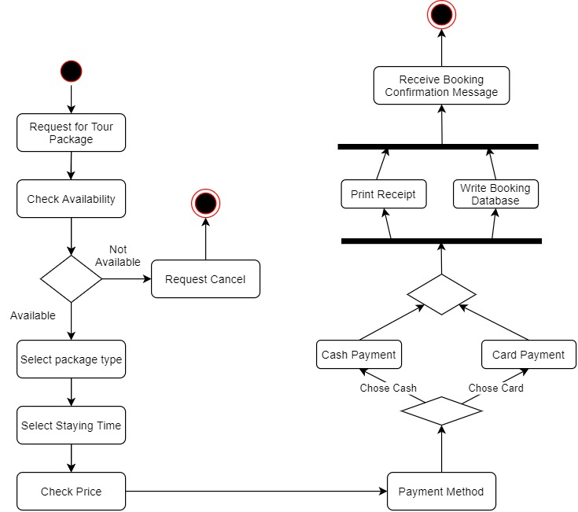

Activity Diagram 2: Book Airline Ticket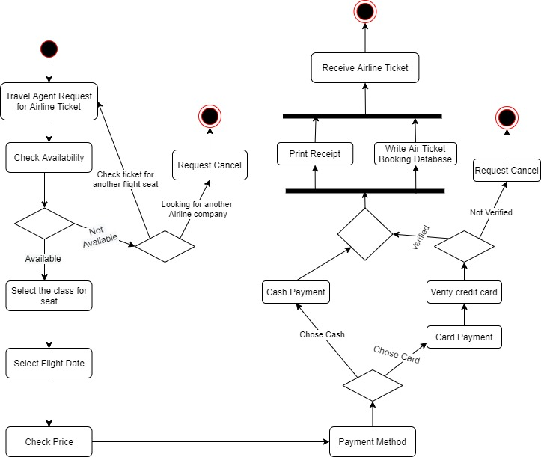

7. Sequence Diagram of the project:

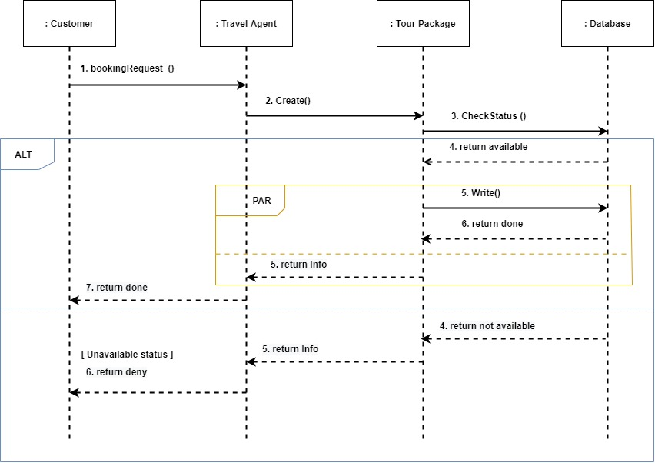

8. Statechart Diagram:

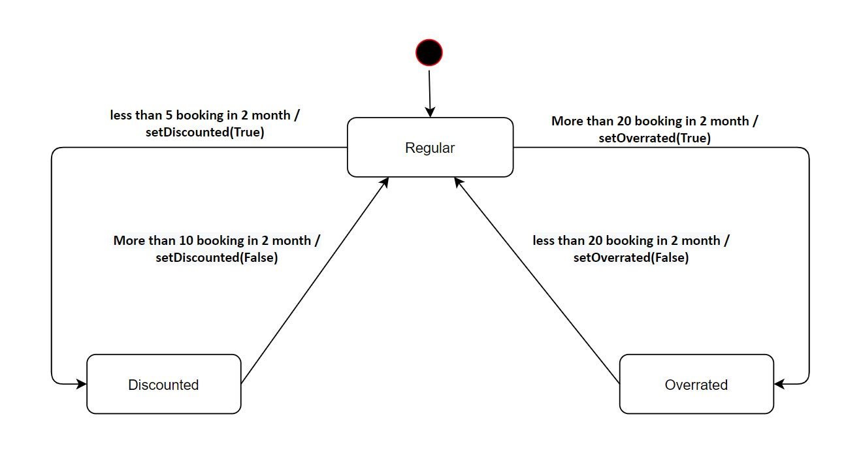

9. Conclusion: