Create a simple cloud software application for Flight Reservation System using any Cloud Service Provider to demonstrate SaaS

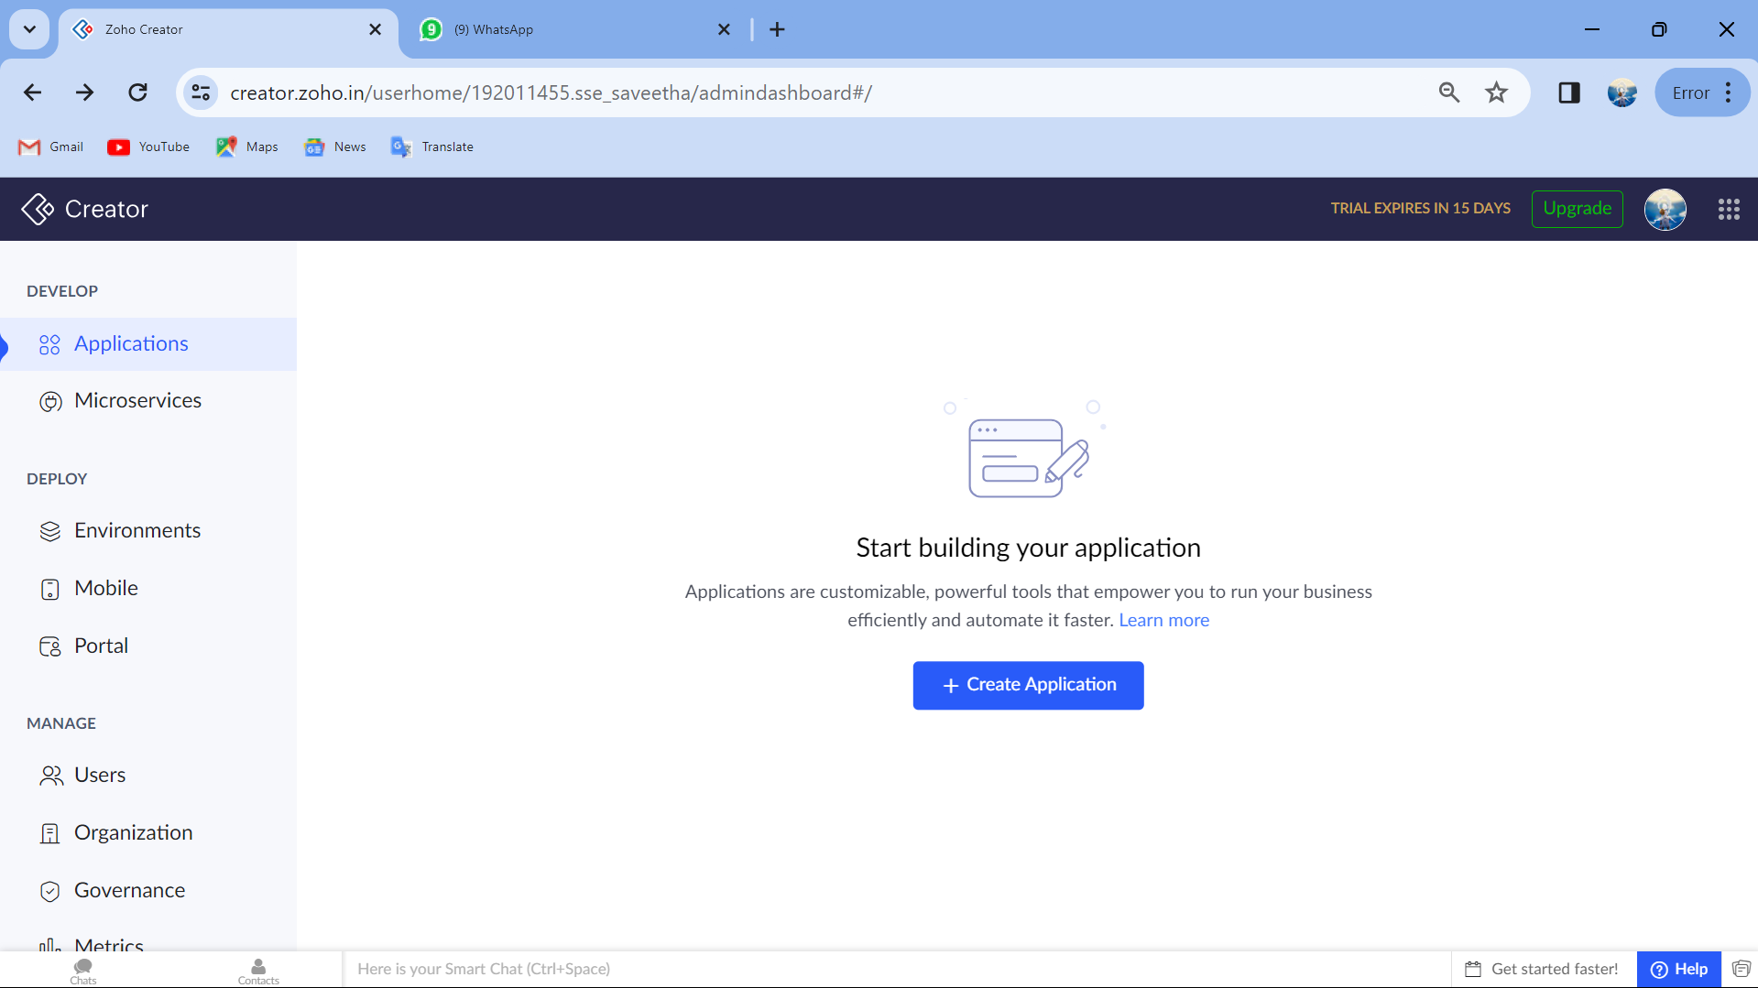

Step1:Open creator page in Zoho application

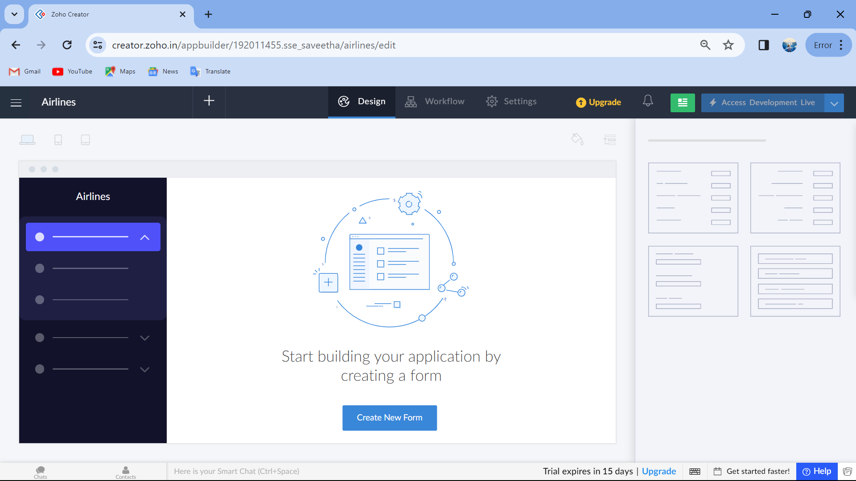

Step 2: Create a Application

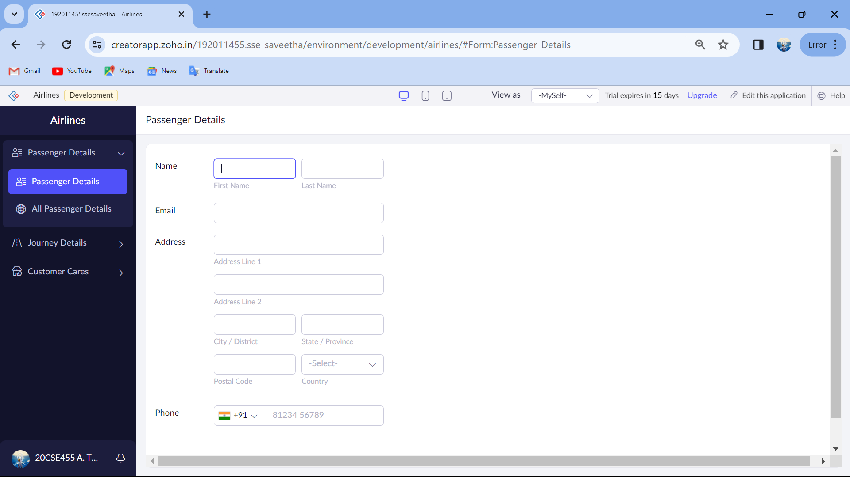

Step 3: Create the required forms

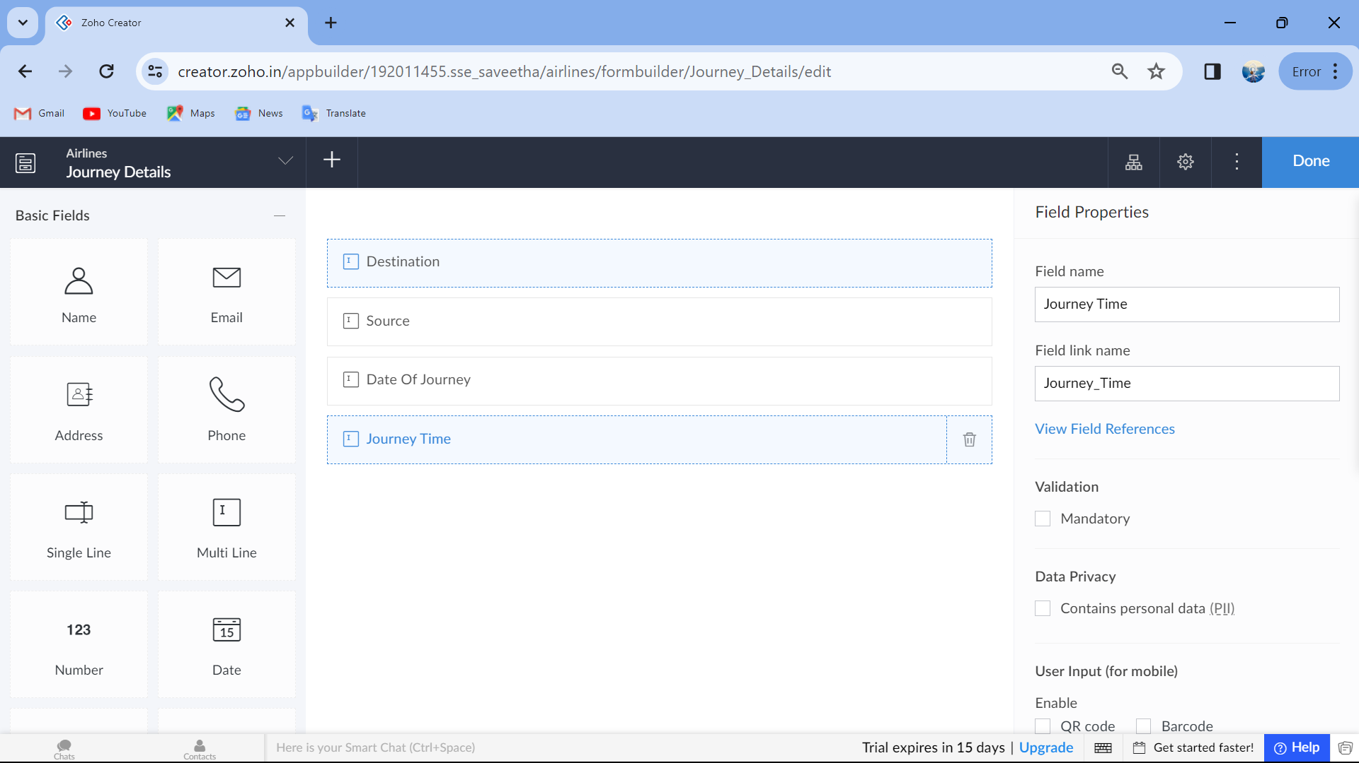

Step 4: Add the required details in the form

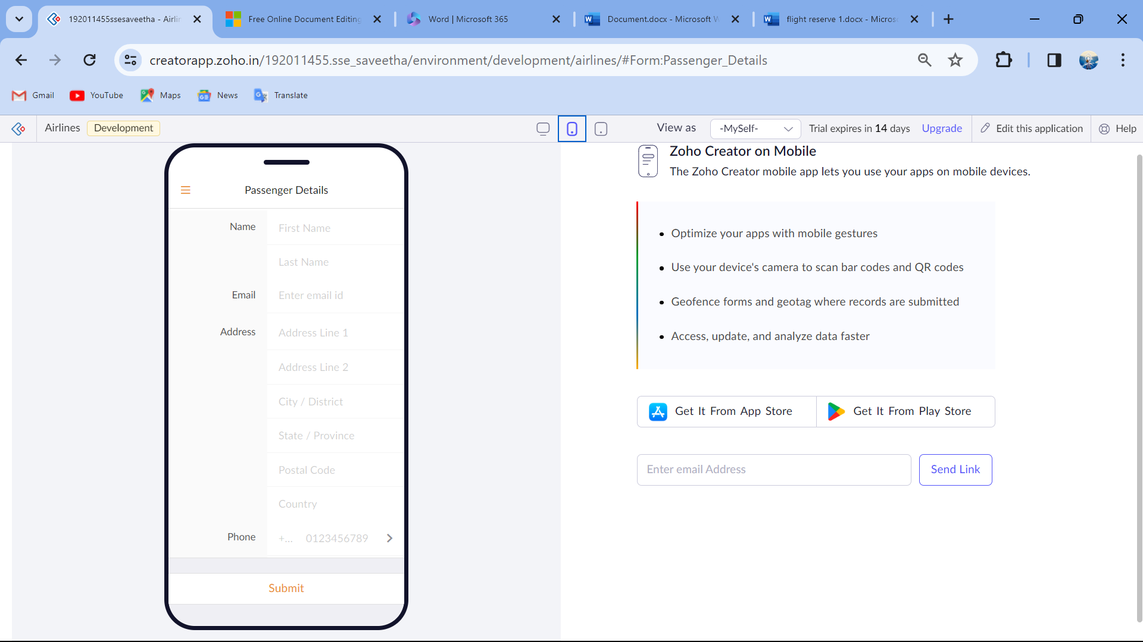

Step 5: This is the application UI for mobile.