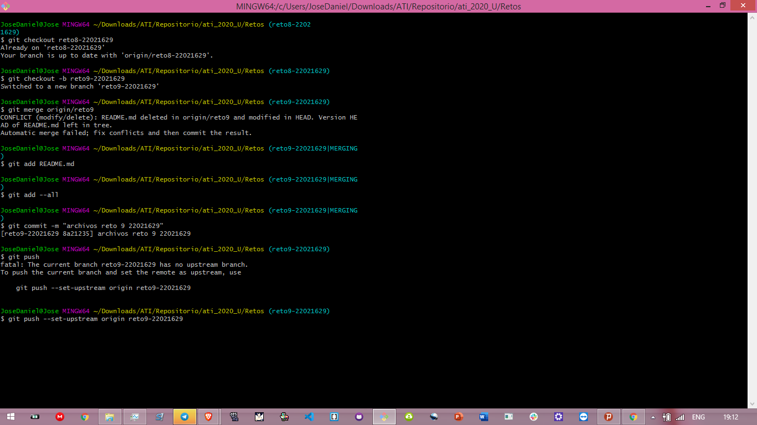

https://github.com/ATI1-UCV/ati_2020_U/tree/reto9-22021629