# ATK - Auto Trading Kit

This is a free software designed for traders. If you become wealthy thanks to it, that is our happiness.

## Description

Auto Trading Kit: its mean, this project can be used to build your own strategy, backtest to test and improve strategy. and can live trading by using your strategy.

A project for trader from trader. main features: draw tool, popular indicator like Tradingview; connect with many popular exchanges like binance, mexc… via api and secret key to live trade; build custom indicator, and clone famous custom indicator on MT4, MT5 and Tradingview; Build and test strategies.

* 🔹**Automate Your Trades** with cutting-edge algorithms.
* 🔹**Real-time Market Analysis** with advanced indicators.
* 🔹**Optimized for Performance** using Python & PySide6.

This project is built for traders who want to **enhance their strategy, reduce manual work, and execute trades efficiently** . Whether you’re a developer, trader, or enthusiast, your contributions can help improve this **open-source trading platform** !

* ⭐**Star this repo** to support the project!
* 🔄 **Fork it** to customize & contribute!.
* 💬 **Join the discussion** and share your insights!

Let’s build the future of algorithmic trading together! 🚀🔥

## ATK - Features

| **Features** | **All Plan** |
| --- | --- |
| **Number of Charts** | Unlimited (depends on user’s PC performance) |
| **Number of Indicators** | Unlimited |
| **Alerts** | Under Development |
| **Historical Data** | Unlimited |
| **Data Export** | Under Development |
| **Customer Support** | 24/7 |
| **Real-time Data** | Yes |
| **Auto Trade** | Under Development (using API key and Secret key) |
| **Backtesting** | Yes |
| **Basic and Advanced Drawing Tools** | Yes |
| **Support multiple tab** | Yes |
| **Support timeframe** | Yes (1m to 3D) |
| **buy/sell market, limit, trallingstop** | Under Development |
| **Crypto** | Yes |
| **Forex** | Under Development |
| **Stock** | Under Development |

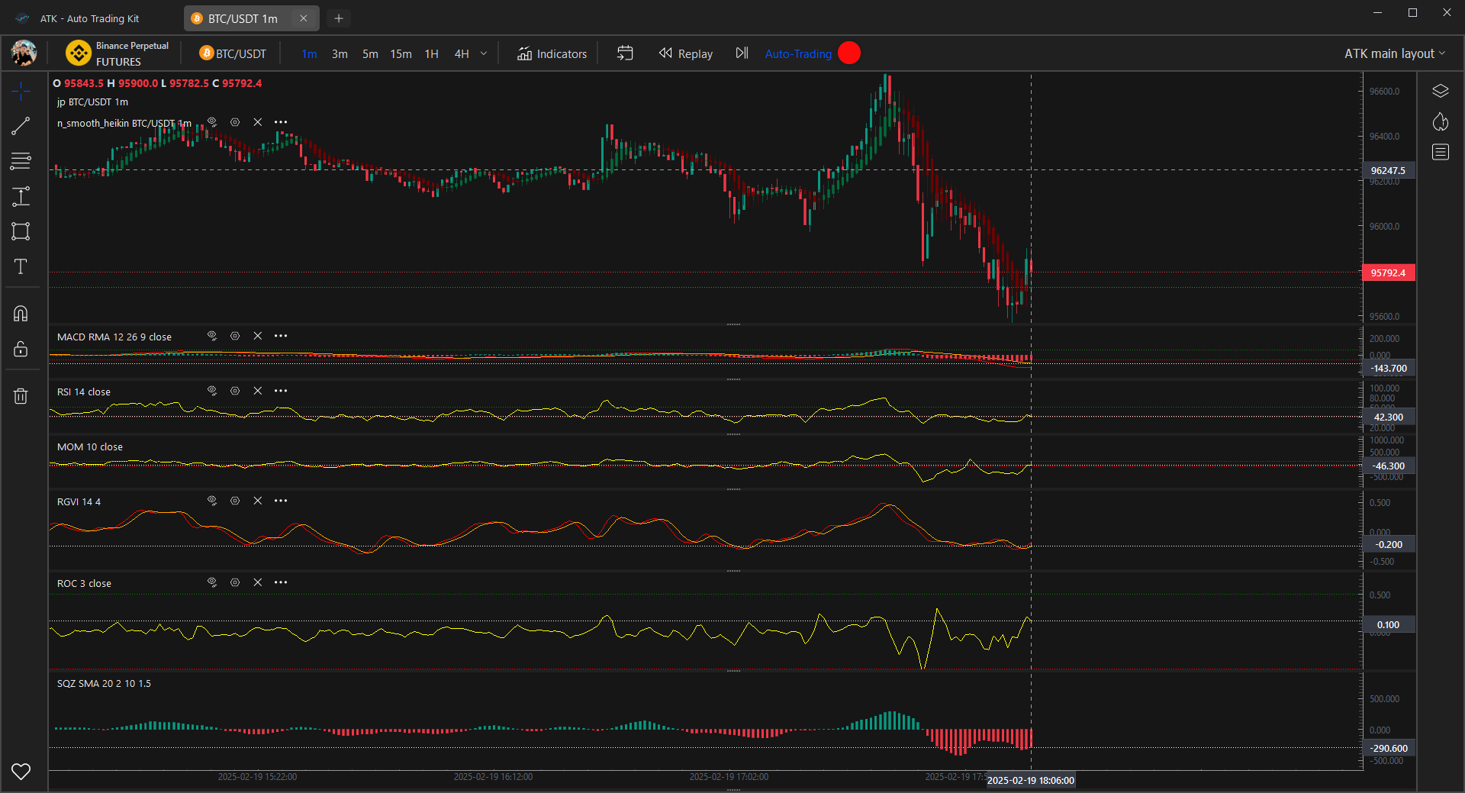

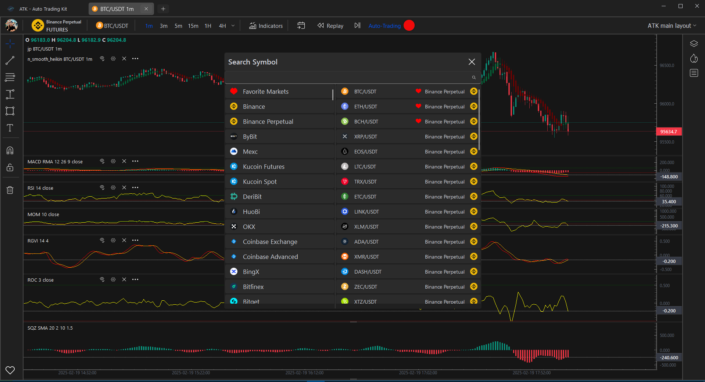

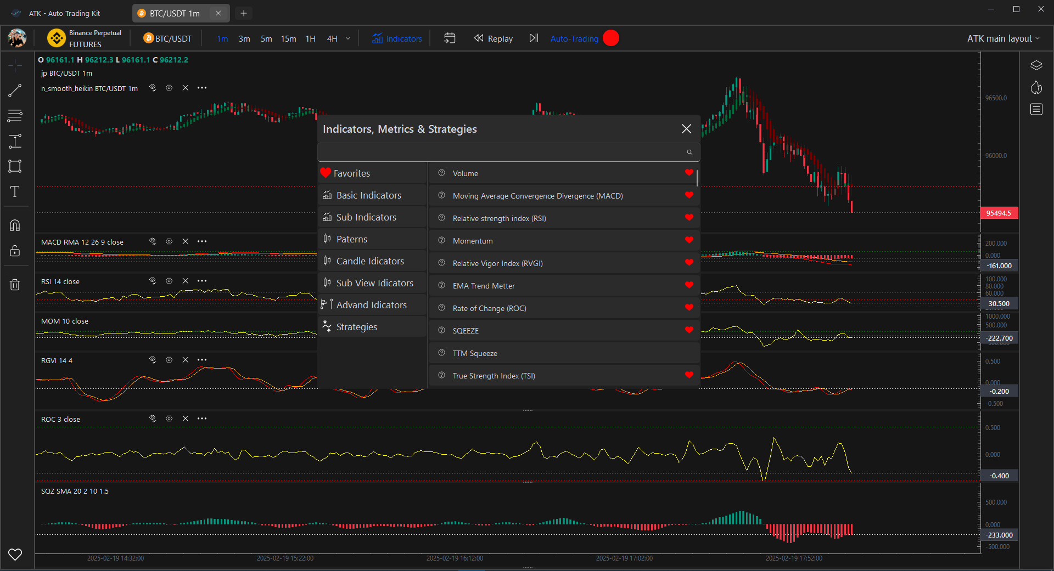

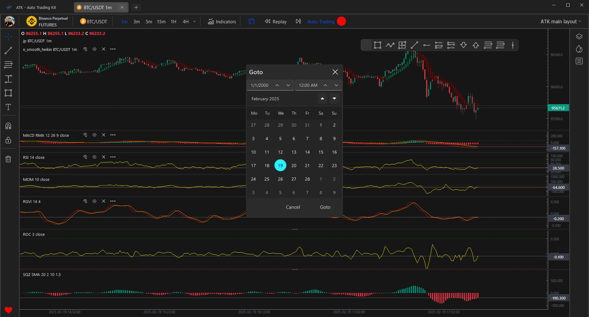

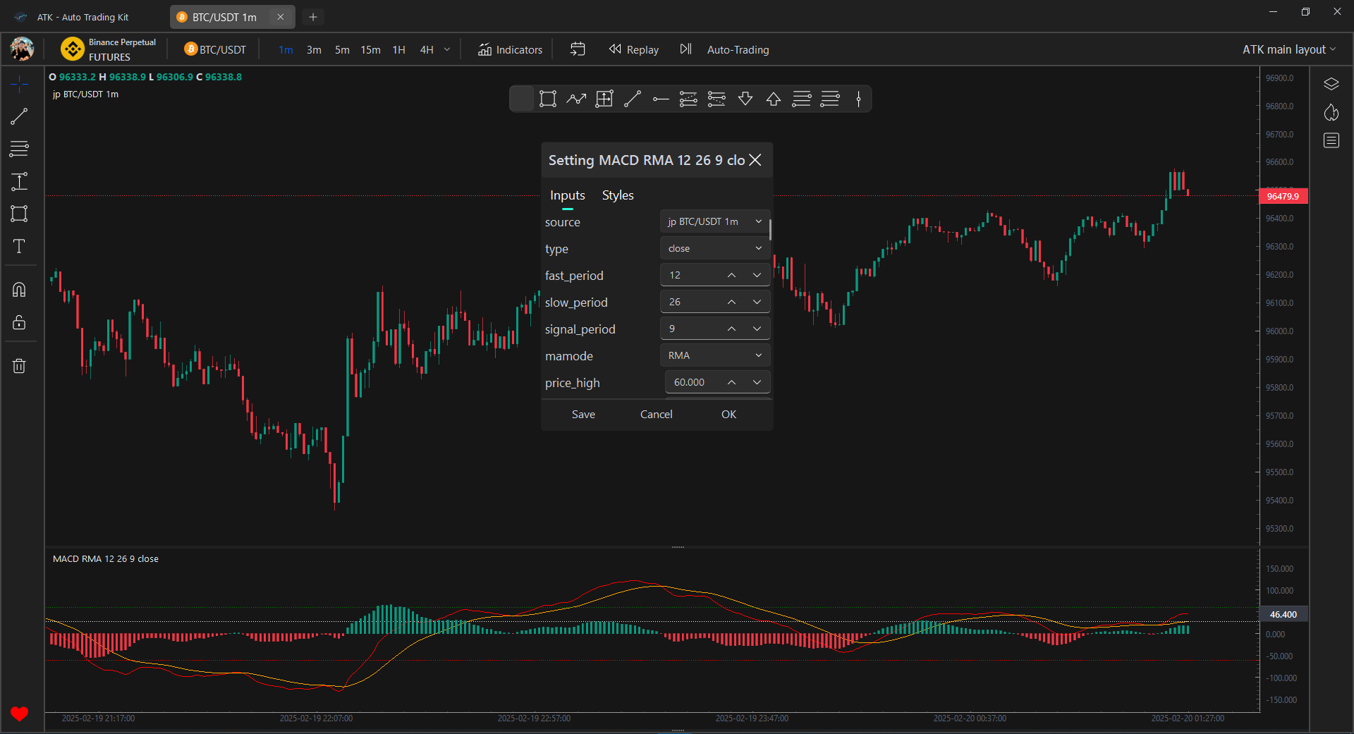

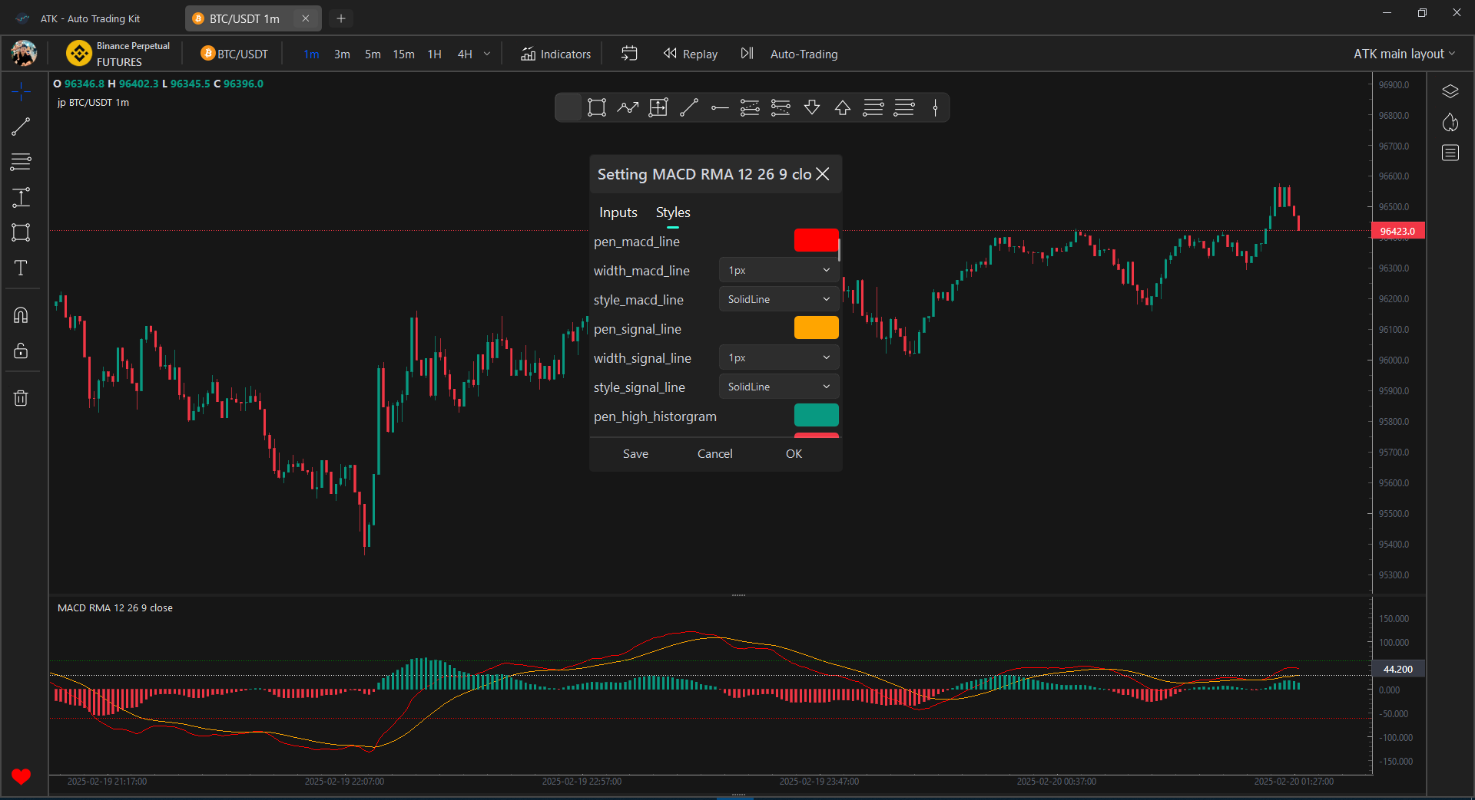

## Connect with ATK team

* Create an issue or request a new feature on this [Github repository](https://github.com/Khanhlinhdang/AutoTradingKit)
* If you want to update some personal feature, please sent an email to khanhlinhdangthditrach@gmail.com

## Many indicators, sourced from famous libraries such as [pandas-ta](https://github.com/twopirllc/pandas-ta/tree/main), ta-lib, and even indicators converted from TradingView,MT4,MT5

Currently provides below set of indicators. If your favourite indicator is missing, then create a ticket via GitHub Issues and there is a good chance that it will be included in the future version of ATK.

In the future, we will update more indicators, which are populars and famous on tradingview, MT4, MT5

* Accumulation/Distribution (ADL)
* Aroon
* Average Directional Index (ADX)
* Average True Range (ATR)
* Awesome Oscillator (AO)
* Balance of Power (BOP)
* Bollinger Bands (BB)
* Chaikin Oscillator
* Chande Kroll Stop
* Choppiness Index (CHOP)
* Coppock Curve
* Commodity Channel Index (CCI)
* Donchian Channel (DC)
* Detrended Price Oscillator (DPO)
* Ease of Movement (EMV)
* Force Index
* IBS
* Ichimoku Kinko Hyo
* Keltner Channel (KC)
* Klinger Volume Oscillator (KVO)
* Know Sure Thing (KST)
* Mass Index
* McGinley Dynamic
* Mean Deviation
* Moving Average (ALMA, DEMA, EMA, HMA, KAMA, SMA, SMMA, T3, TEMA, VWMA, WMA, ZLEMA)
* Moving Average Convergence Divergence (MACD)
* On-balance Volume (OBV), Smoothed On-balance Volume (SOBV)
* Parabolic SAR
* Pivots High/Low
* Rate of Change (ROC)
* Relative strength index (RSI)
* Schaff Trend Cycle (STC)
* SFX TOR
* Standard Deviation
* Stochastic Oscillator
* Stochastic RSI
* SuperTrend
* TRIX
* TTM Squeeze
* True Strength Index (TSI)
* Ultimate Oscillator (UO)
* Vortex Indicator (VTX)
* Volume Weighted Average Price (VWAP)
* ……

## Installation

clone from: https://github.com/Khanhlinhdang/AutoTradingKit.git

create python evironment: python -m venv venv

activate venv: venv/scripts/activate

install libs: pip install -r requirements.txt

* Have to install pdf2image if your os system is MacOS or Linux/Ubuntu: https://pypi.org/project/pdf2image/
* on MacOS: install : Brew https://brew.sh/ with cmd: /bin/bash -c “$(curl -fsSL https://raw.githubusercontent.com/Homebrew/install/HEAD/install.sh)” ,then install poppler: brew install poppler
* on Linux: conda install -c conda-forge poppler ,then install poppler: pip install pdf2image

run ATK.py to start app: python ATK.py or python3 ATK.py

## Build exe

* Convert py to pyd using cython
* Use pyinstaller to build

## Roadmap 2025

1. Update more indicator from MT4, MT5, Tradingview
2. Update Trading Strategies
3. Update set API-Key and Secret-Key for pupular exchanges like Binance, Mexc,…
4. Update Draw tool on left bar like Tradingview
5. Update Replay/Backtest function
6. Update save fovarite layouts
7. Update setting: change Light/Dark mode
8. Update change style of draw tool like color, width, size, font
9. Update Table Order and position of backtest and live trade
10. Update login and manage account
11. Build AI indicator
12. Build AI Strategy

## Restricted Open Source License

Copyright (c) 2025 @mr.BigD

This software is open source, and its source code is publicly available for review and learning purposes **only** . However, any form of usage, including commercial, personal, or academic purposes, requires explicit written permission from the author.

### License Terms:

1. **Public Source Code** : The source code is openly available but restricted in usage.
2. **Usage Requires Permission** : You **must** obtain written consent from the author before using this software.
3. **Paid License or Sponsorship**: If you get rich, please say thank to us by:

* Purchase a license from the author, or
* Provide sponsorship or financial support as agreed upon with the author.

1. **No Redistribution** : You are not allowed to share, resell, or distribute this code without explicit permission.
2. **No Unauthorized Modifications** : Modifying or creating derivative works from this software without approval is prohibited.
3. **No Warranty** : This software is provided “as is” without any warranties or guarantees.
4. **For any question**, please contact: **khanhlinhdangthditrach@gmail.com**

## Project status

The ATK is in an active development phase.

### **Support ATK Development and Help Us Grow!**

Dear ATK Users and Supporters,

ATK has been a valuable tool for many of you, helping to streamline workflows, solve problems, and improve productivity. However, maintaining and improving ATK requires significant resources, especially as we work to develop new features, fix bugs, and ensure the project remains sustainable for the long term.

To continue delivering the best experience for our users, we need your support. Your sponsorship will directly fund:

* **Development of new features** outlined in our Roadmap, ensuring ATK evolves to meet your needs.
* **Bug fixes and optimizations** to keep ATK stable, reliable, and efficient.
* **Support for our developers** , who work tirelessly to make ATK better every day.

**Why Sponsor ATK?**

* If ATK has helped you in your work or personal projects, your contribution ensures it can continue to do so for others.
* Your support allows us to prioritize features and improvements that matter most to the community.
* Sponsoring ATK is an investment in a tool you already rely on, ensuring its growth and sustainability.

**How You Can Help:**

* Click the link below to sponsor ATK via PayPal. Every contribution, no matter the size, makes a difference.
* You can sent to me a gift via my bank account (Vietnamese Bank), it is shown below
* Share this message with others who benefit from ATK. The more support we receive, the faster we can deliver new features and improvements.

**Thank You for Your Support!** Your generosity and belief in ATK mean the world to us. Together, we can make ATK even better and ensure it remains a powerful tool for everyone who depends on it.

With gratitude, mr.BigD - Creator/Developer of ATK

1. Bank account: MB Bank: 8699991689999 | Pham Cong Che | (Viet Nam Bank)
2. Paypal:

* [Paypal sponsor](https://www.paypal.com/cgi-bin/webscr?cmd=_s-xclick&hosted_button_id=XTHUBP3TB5H7J) (khanhlinhdangthditrach@gmail.com) (any value)
* [Sponsor via paypal](https://www.paypal.com/ncp/payment/363TPLRF4NAF4) 20$
* [Sponsor via Paypal](https://www.paypal.com/ncp/payment/G9R3YNN89KR8Y)10$
* [Premium Sponsor monthly via Subscribe paypal](https://www.paypal.com/webapps/billing/plans/subscribe?plan_id=P-0F53588022198101GM63BMVA)
* [Vip 1 Sponsor monthly via Subscribe paypal](https://www.paypal.com/webapps/billing/plans/subscribe?plan_id=P-06E5757414542143MM63BSGI)
* [Vip 2 Sponsor monthly via Subscribe paypal](https://www.paypal.com/webapps/billing/plans/subscribe?plan_id=P-00V92834XG336831FM63BTEQ)

1. Binance pay:

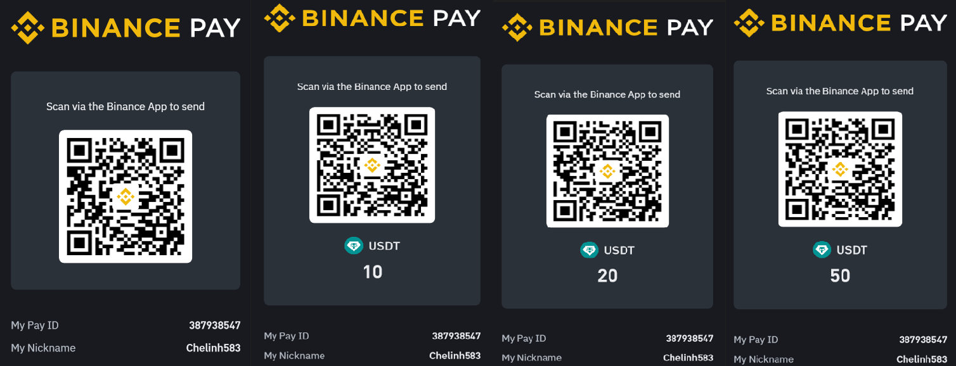

## Authors and acknowledgment

Pham Cong Che (nickname: BigD) - A trader, a freelancer and a developer from Viet Nam. The author of ATK.

Email: khanhlinhdangthditrach@gmail.com

Skype: khanhlinhdangthditrach@gmail.com

Zalo: 0343845888

Telegram: +79921849116 or username : @Chelinh0308

Phone number: +84343845888 (VN) or +79921849116 (RU)

Youtube Chanel: [AutoTradingKit](https://www.youtube.com/@AutoTradingKit)

Facebook: [Pham Cong Che](https://www.facebook.com/che.linh.9096/)

Discord: [AutoTradingKit](https://discord.gg/UNDh5MyR)

ATK Facebook Group: [Auto Trading Kit (ATK) - Facebook group](https://www.facebook.com/groups/748831980507126)