Name: Andrew Law

Professor: Dr. Smith

Course: CSCI 3038

Assignment: Project 4 Writeup

Part 1 – Design Explanation

This project presented a different kind of challenge compared to the previous projects, mainly, learning about and using an object-oriented approach in python. Generally, I enjoy OOP and have found python to be very friendly in terms of ease of use. The project programs themselves were not too difficult to implement. The project’s requirements split the project into classes and because of that I did not have to think too much about the overall structure of the final program. As such, I started by implementing the required elements of the three classes and built upon them from there. The hand and deck both use lists to store what cards they currently hold, I chose a list because they allow for insertion into any index. This implementation does mean however that duplicate cards are possible in both classes. This to me is not an inherently back thing, as it allows the programmer more flexibility when using the class, but it does mean that the programmer must be aware of the feature and implement measure to prevent duplicates from occurring if that is required for the application they are developing. I chose to implement the dunder len and getitem functions for the deck and hand classes to make them iterable, but beyond that I did not do too much else in terms of additional functionality. The blackjack program as well is quite simple. All it does is deal out cards to the two players (dealer and user) and then allows for the user to complete their turn (hit for more cards until they decided to stay). Next the dealer automatically draws cards until they reach a value greater than 17, and if the dealer goes over 21, they bust.

Part 2 – Challenges

I did not run into too many challenges with this project. The most difficult part was figuring out how to make my class iterable, however after referring to the python documentation I was able to figure out what dunder function to implement relatively quickly. Beyond that the only other issue I encountered was how to display the game in a pleasing and intuitive way, though game style design is somewhat beyond the scope of the course and not too important, so I kept it simple and just used text in the terminal with Unicode characters for the suits.

Part 3 – Screenshots of Game Examples

Example 1 – Player bust

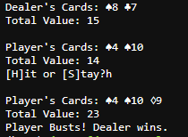

Example 2 – Dealer wins off points

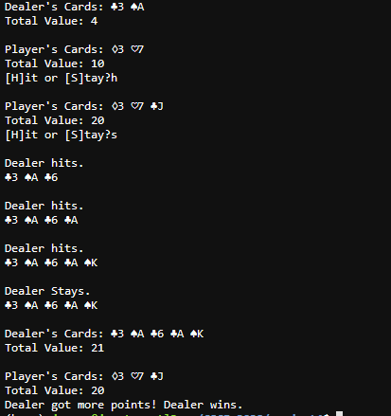

Example 3 – Dealer busts

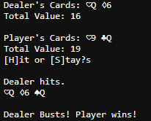

Note: it is also possible for the player to win off points, however for brevity I left that outcome out of the example screenshots.