**Lilly McNichols**

**Pseudocode**

**PC04 Gen Art**

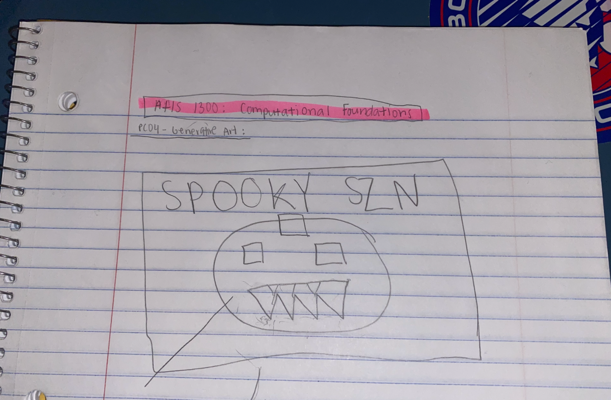

Import turtle and random to set libraries

Import screen from turtle to support random color text

Set background color to black

Name turtle pumpkin

Set coordinates of where to start circle

Set color to orange

Draw pumpkin circle

Fill in pumpkin

Name turtle square for first eye

Set color of eye to black

Set coordinates of left eye

For loop to make square in motion turning four times

Fill first eye square

For right eye set coordinates to right eye

Set heading to reset square drawing logic

For loop to make square in motion turning four times

Fill second eye square

Name turtle stump

Set stump color to brown

Set coordinates of where to start stump

Set heading to reset stump drawing logic

Make rectangle shape

Fill stump

Name turtle teeth

Speed up drawing

Set teeth color to black

Set coordinates of where to start triangles for teeth

Set tooth position

Draw each individual triangle in the innerloop and set the outerloop to draw how many triangles in the coordinates I want them to be in

Set screen

Set colormode

Name turtle text

Set text to “Spooky” and add random element somehow

Set text to “Szn!” and add random element somehow

Turtle done