ATM Simulation

Rishabh Barnwal

Meet Patel

1. CLASS DIAGRAM

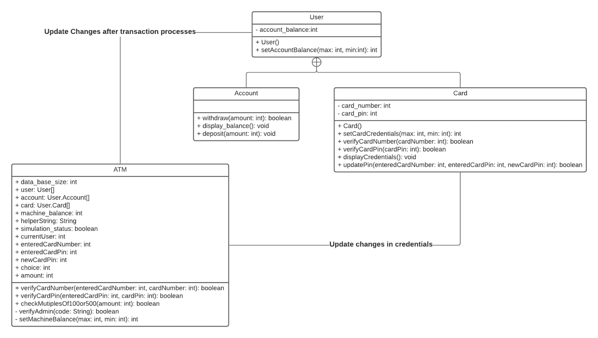

2. USECASE DIAGRAM

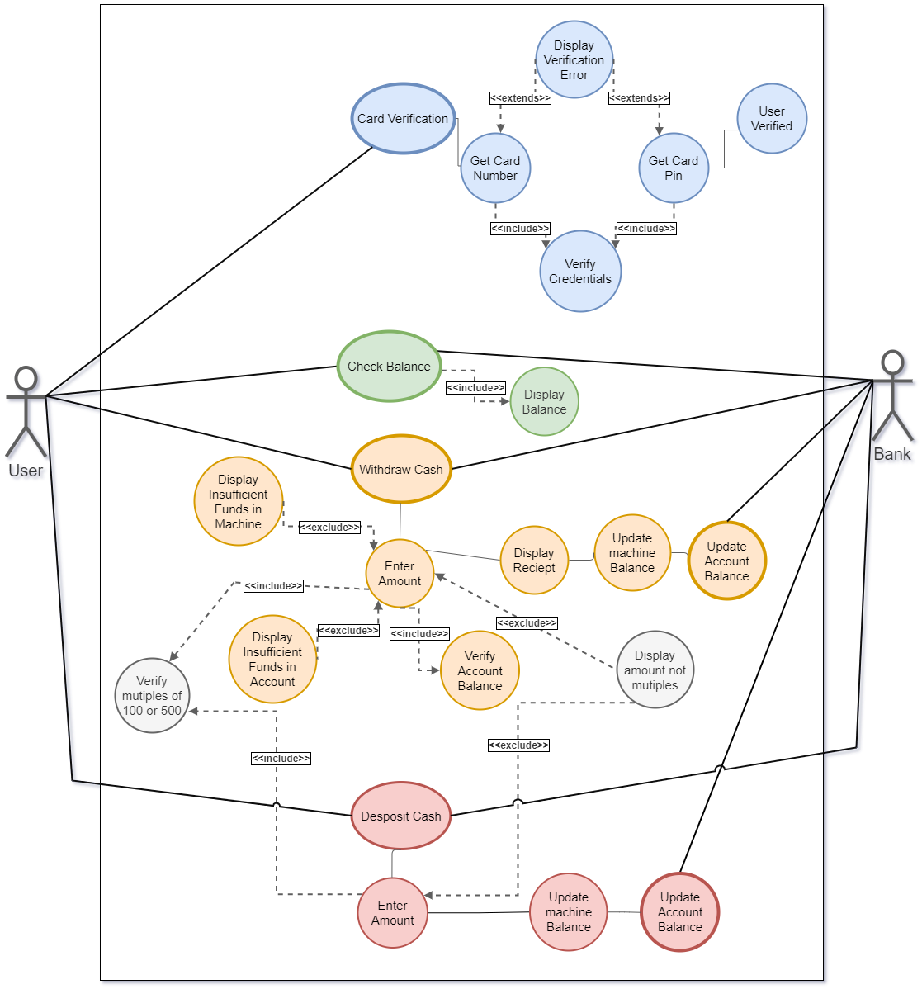

3. SEQUENCE DIAGRAM

