Sample of UML Diagrams for ATM System

For Data: Class diagram

**Class Diagram:-** Class diagrams describe the static structure of a system, or how it is structured rather than how it behaves.

These diagrams contain the following elements:

1. Classes , which represent entities with common characteristics or features. These features include

attributes, operations, and associations.

1. Associations , which represent relationships that relate two or more other classes where the relationships

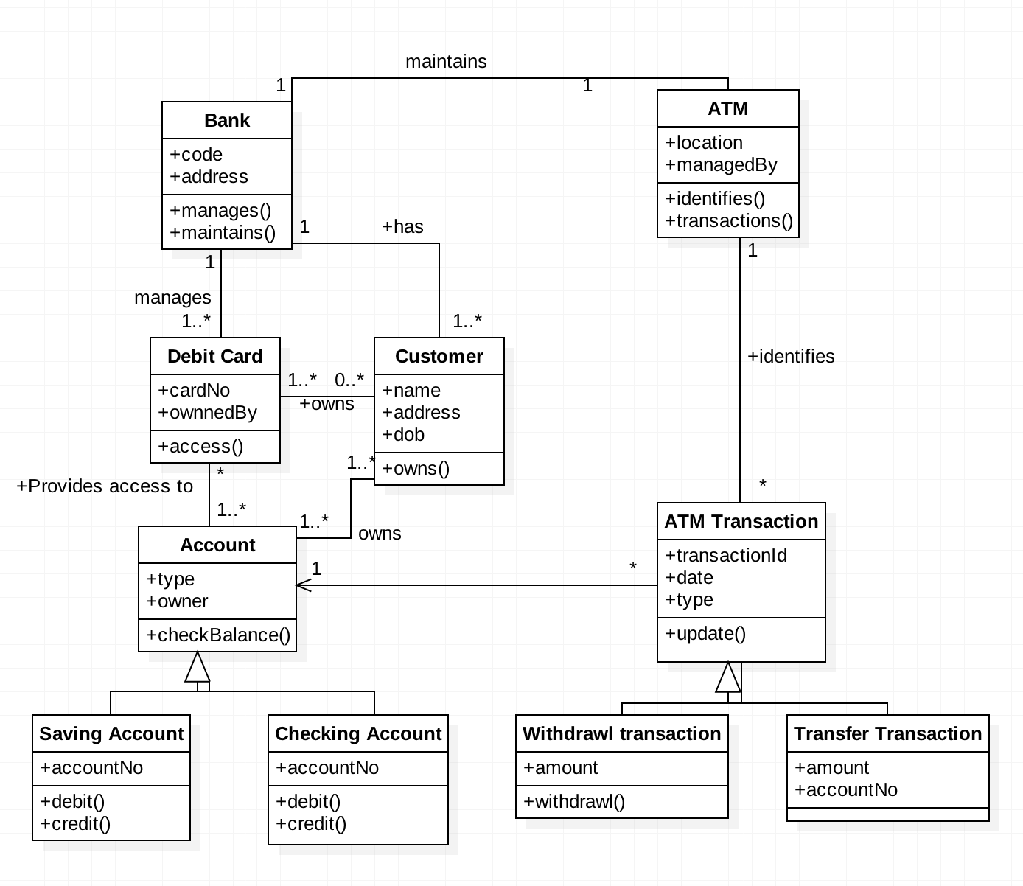have common characteristics or features. These features include attributes and operations.

For Function: Use case, Sequence, Collaboration/Communcation

**Use Case Diagram:** Use case diagrams describe the functionality of a system and users of the system. They contain the

following elements:

1. Actors , which represent users of a system, including human users and other systems
2. Use cases , which represent functionality or services provided by a system to users Here, is a use case diagram for the ATM System.

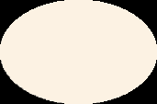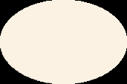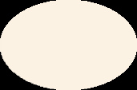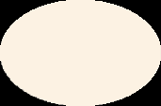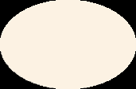

**Credit Card Login**

**Depit Card Login**

**Log in**

**Deposit Cash**

**Deposit a Check**

**Customer**

**Bank**

«extend»

**Log Out**

**Print Receipt**

**Check balance**

«include»

**Transfer Money**

**Withdraw Cash**

«include»

**Check Exceeding Balance**

**uc Use Case Model**

**Sequence Diagram:** Sequence diagrams typically show the flow of functionality through a use case, and consist of the following

components:

1. Actors , involved in the functionality
2. Objects , that a system needs to provide the functionality
3. Messages , which represent communication between objects

Here, is an example of Sequence diagram for withdrawing amount from ATM.

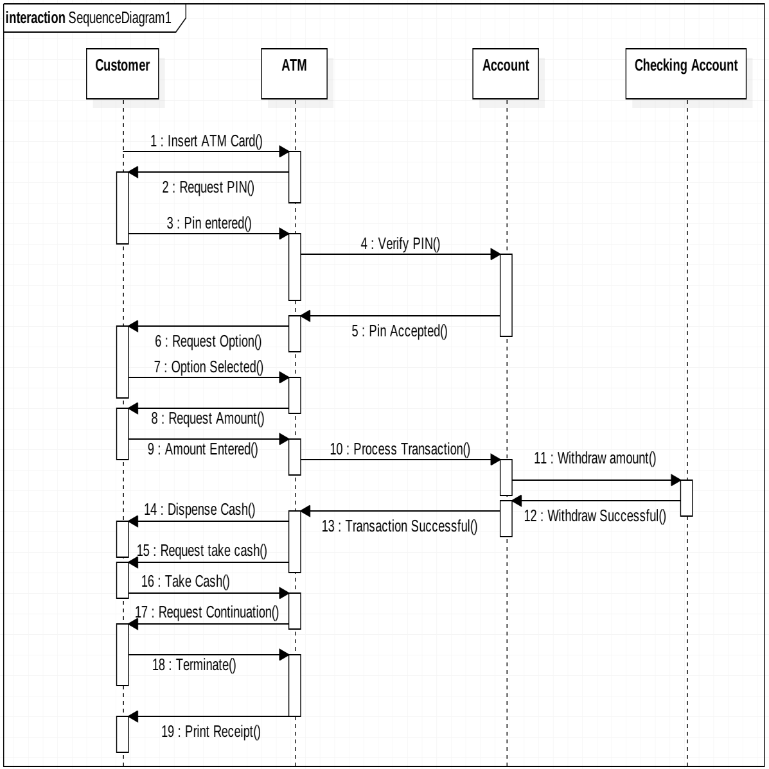

Communication/Collaboration Diagrams

A Communication or Collaboration diagram, as shown is a directed graph that uses objects and actors as graph nodes. The focus of the collaboration diagram is on the roles of the objects as they interact to realize a system function. Directional links are used to indicate communication between objects. These links are labeled using appropriate messages. Each message is prefixed with a sequence number indicating the time ordering needed to realize the system function.

Here is an example of the Check Balance communication diagram:

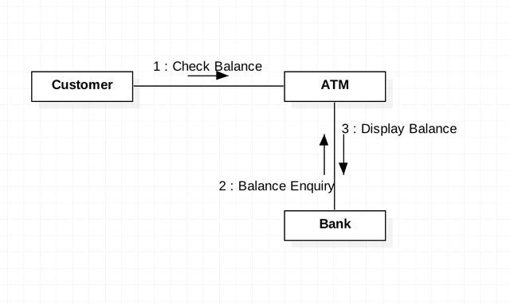

Here is an example of the Deposit Cash communication diagram:

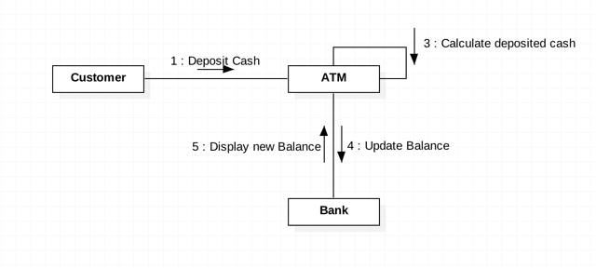

For behavior: State, Activity Diagram

State Diagram:- State transition diagrams provide a way to model the various states in which an object can exist. While the class diagram show a static picture of the classes and their relationships, state transition diagrams model the dynamic behavior of a systen in response to extermal events (stimuli). State transition diagrams consist of the following:

1. States , which show the possible situations in which an object can find itself
2. Transitions , which show the different events which cause a change in the state of an object.

Here, is an example of the state diagram for the session of ATM.

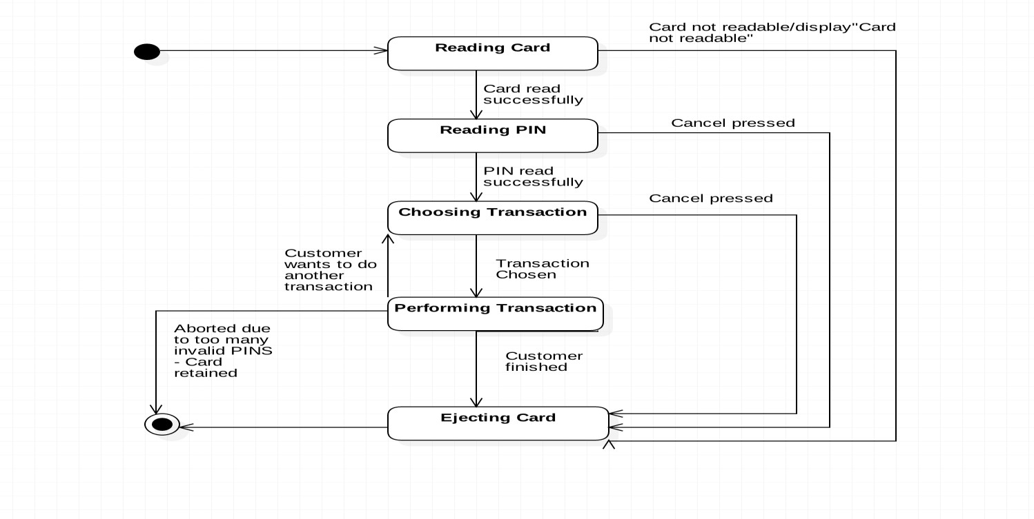

**Activity Diagram:-** Activity diagrams describe the activities of a class. They are similar to state transition diagrams and use similar conventions, but activity diagrams describe the behavior/states of a class in response to internal processing rather than external events. They contain the following elements:

1. Swimlanes , which delegate specific actions to objects within an overall activity
2. Action States , which represent uninterruptible actions of entities, or steps in the execution of an algorithm
3. Action Flows , which represent relationships between the different action states on an entity
4. Object Flows , which represent utilization of objects by action states, or influence of action states on objects.

Following are the examples of Login, Withdraw Activity Diagrams.

**act LogIn Activ ity Diagram**

**Customer**

**ATM**

**Bank**

ActivityInitial

**Insert Card**

**Authorize Card**

Ok?

[Yes]

[No]

**Display Error Msg**

Max Num Tries?

**Eject Card**

[No]

[No]

**Inser Pin**

ActivityFinal PIN is correct?

**Authorize PIN**

[Yes]

[Yes]

**Display Transactions List**



ActivityFinal

**Lock Card**

**Display Error**

ActivityFinal



ActivityFinal

**Display New Balance**

**Update Balance**

**Eject Money**

[Yes]

Ok?

[No]

**Display Balance**

**Amount <= Balance**

**Inser Amount**

ActivityInitial

**Bank**

**ATM**

**act Withdraw Cash Activ ity Diagram**

**Customer**