**Docker & Docker Hub**

Task 1:-Demonstrate minimum 15 basic docker command with explanation and screenshot.:-

Docker version:-

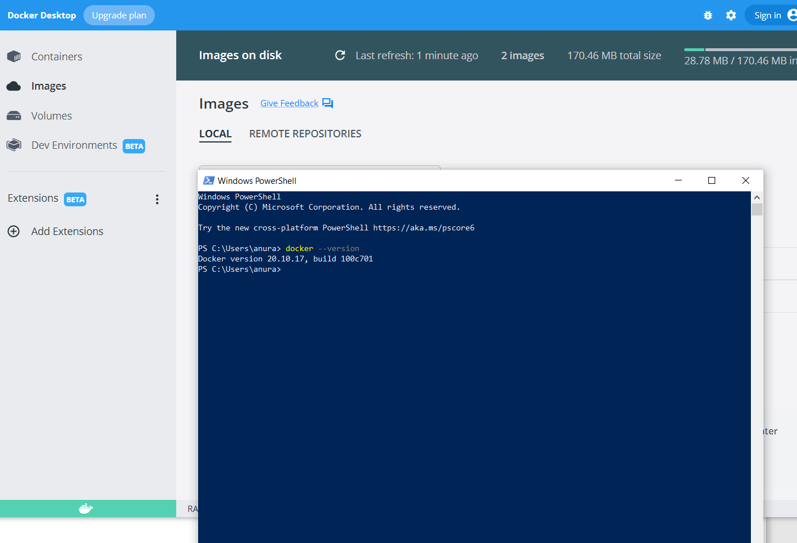

Docker ps:-

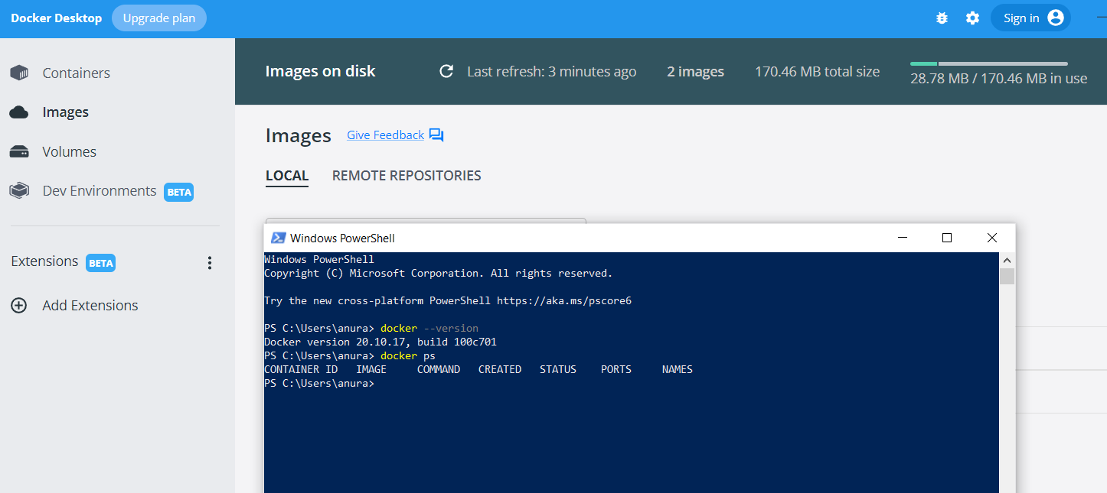

Docker ps-a

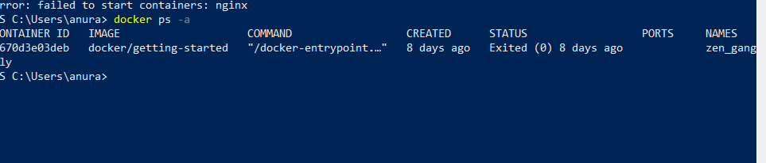

Imaeg-a:-

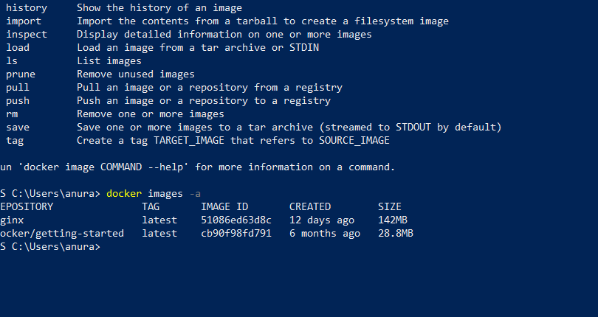

Remove image:-

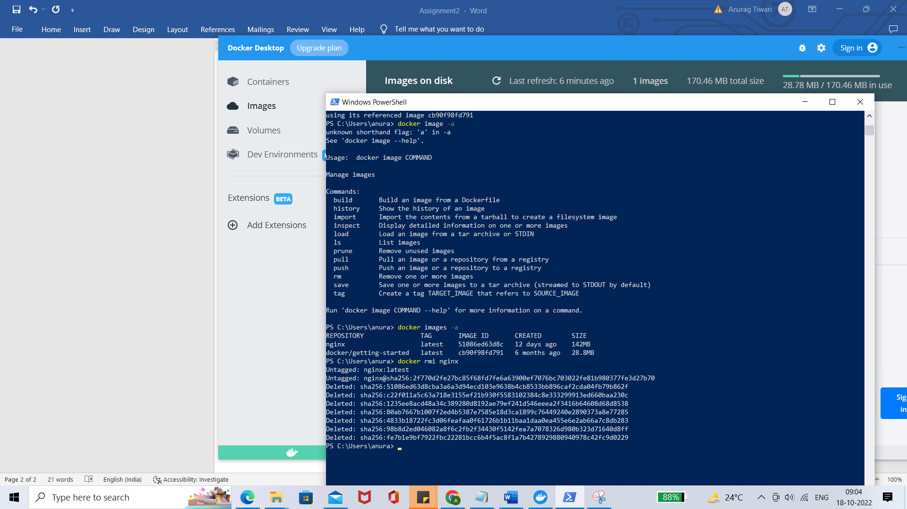

Create new image-

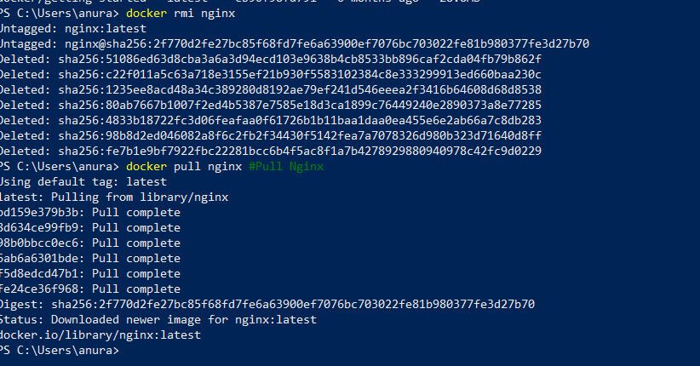

Stop container:-

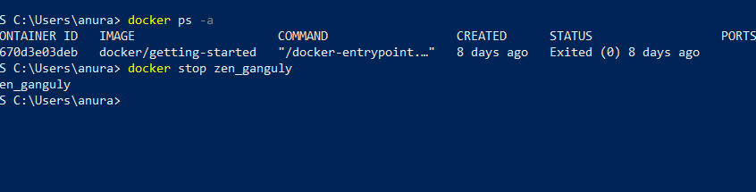

Check logs:-

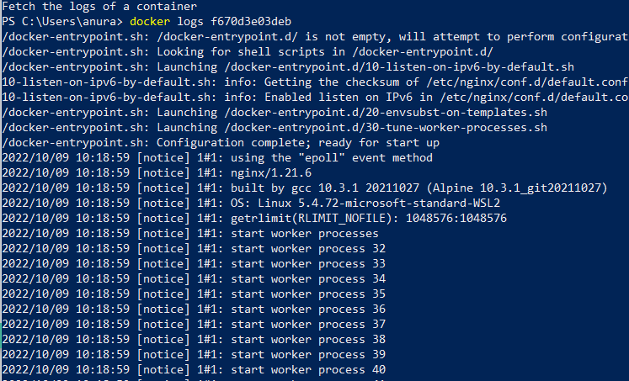

Stop container:-

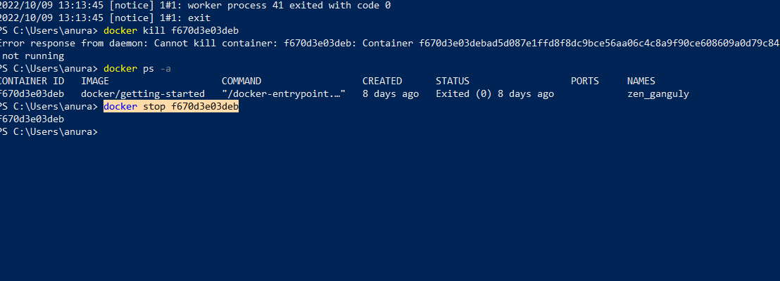

Run the image :-

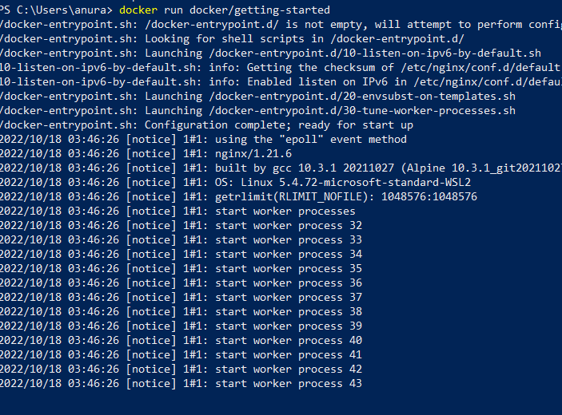

Kill a running container:

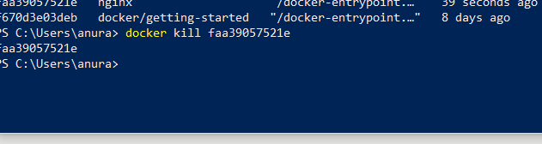

Remove container:-

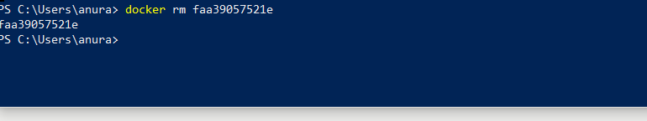

Remove unused

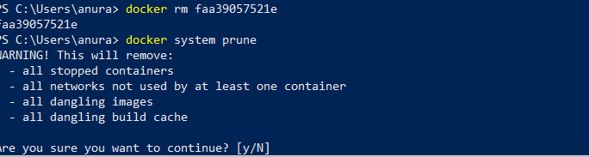

Remove network:-

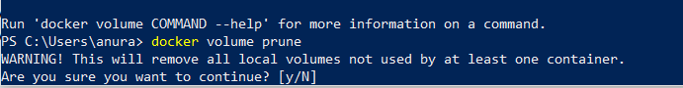

Delete specific image:-

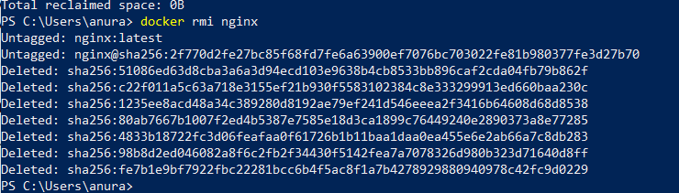

Task 2:- [Hello World Docker Image](https://hub.docker.com/_/hello-world) Run Hello World Docker Image Locally.

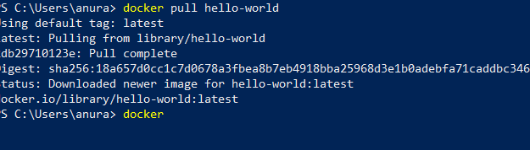

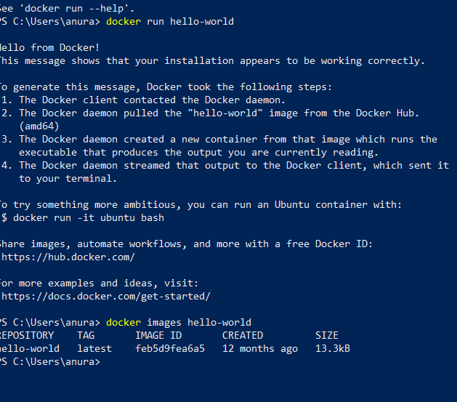

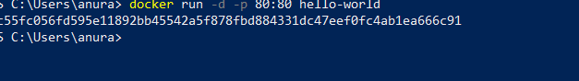

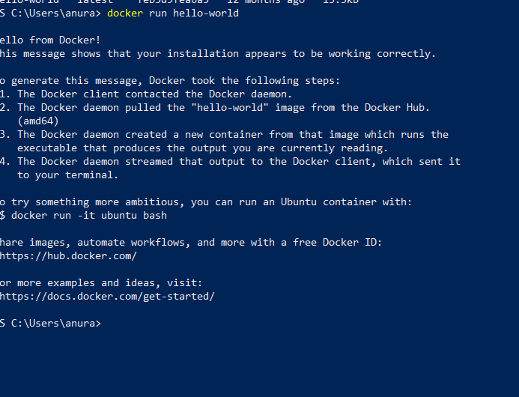

Task3 and 4:- Create a hello world fastapi application. Create a Dockerfile for your fastapi hello world application. Build Docker image using Docker file. Run docker image build in previous step. Push your Docker image to Docker Hub.

