readme

Gramophone
日本語
A sane music player built with media3 and the Material Design library that is following Android's standard strictly.

Features
- Light, stable, and minimalistic
- Up-to-date Material 3 design and theme
  - Dynamic player UI Monet color
  - Monet themed icon (Android 12+)
- Music library features
  - Search and browse for your favourite music
  - Uses MediaStore to quickly access on-device music
  - List and grid views
  - Browse songs by folder and filesystem
  - Natural sorting and various other sorting options
  - Read-only playlist support
- Synced lyrics
  - LRC, TTML, SRT
  - Supports word/syllable Karaoke lyrics synchronization
- Full support for ReplayGain 2.0
- Support for system/third-party Equalizer apps

Screenshots
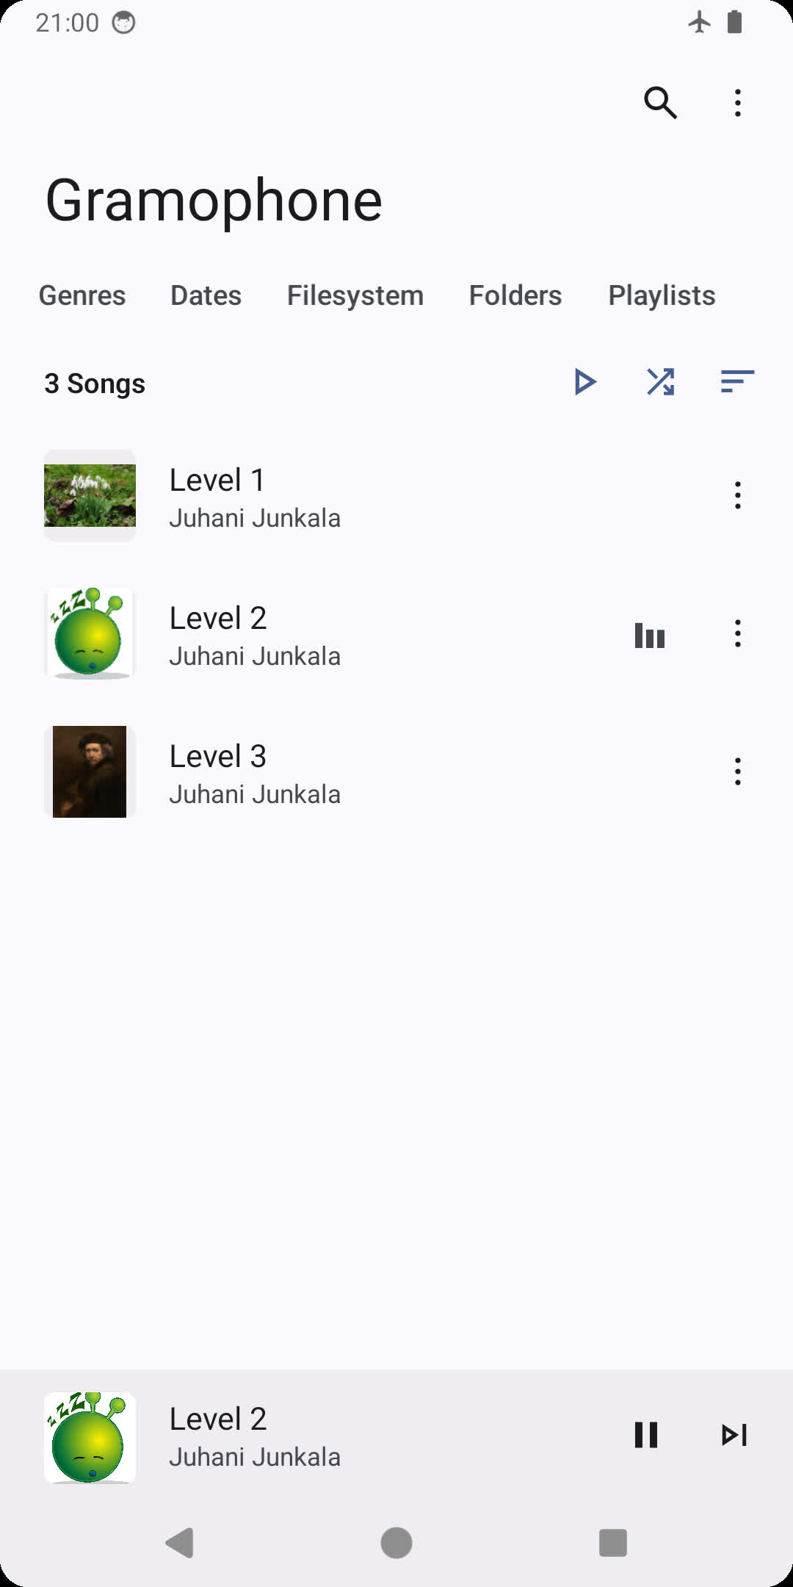 | 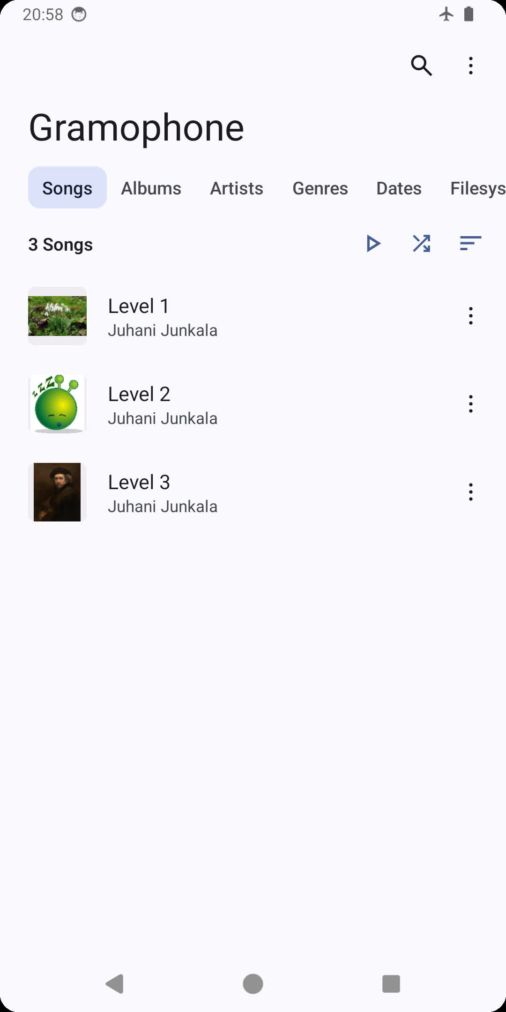 | 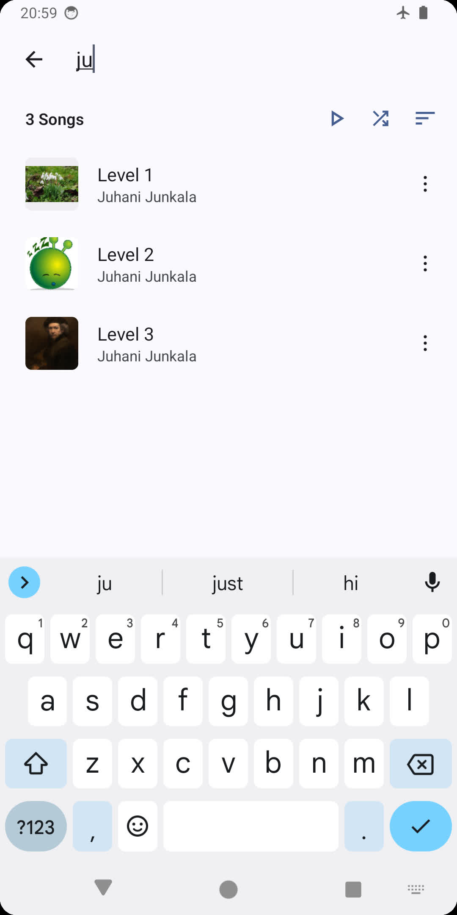
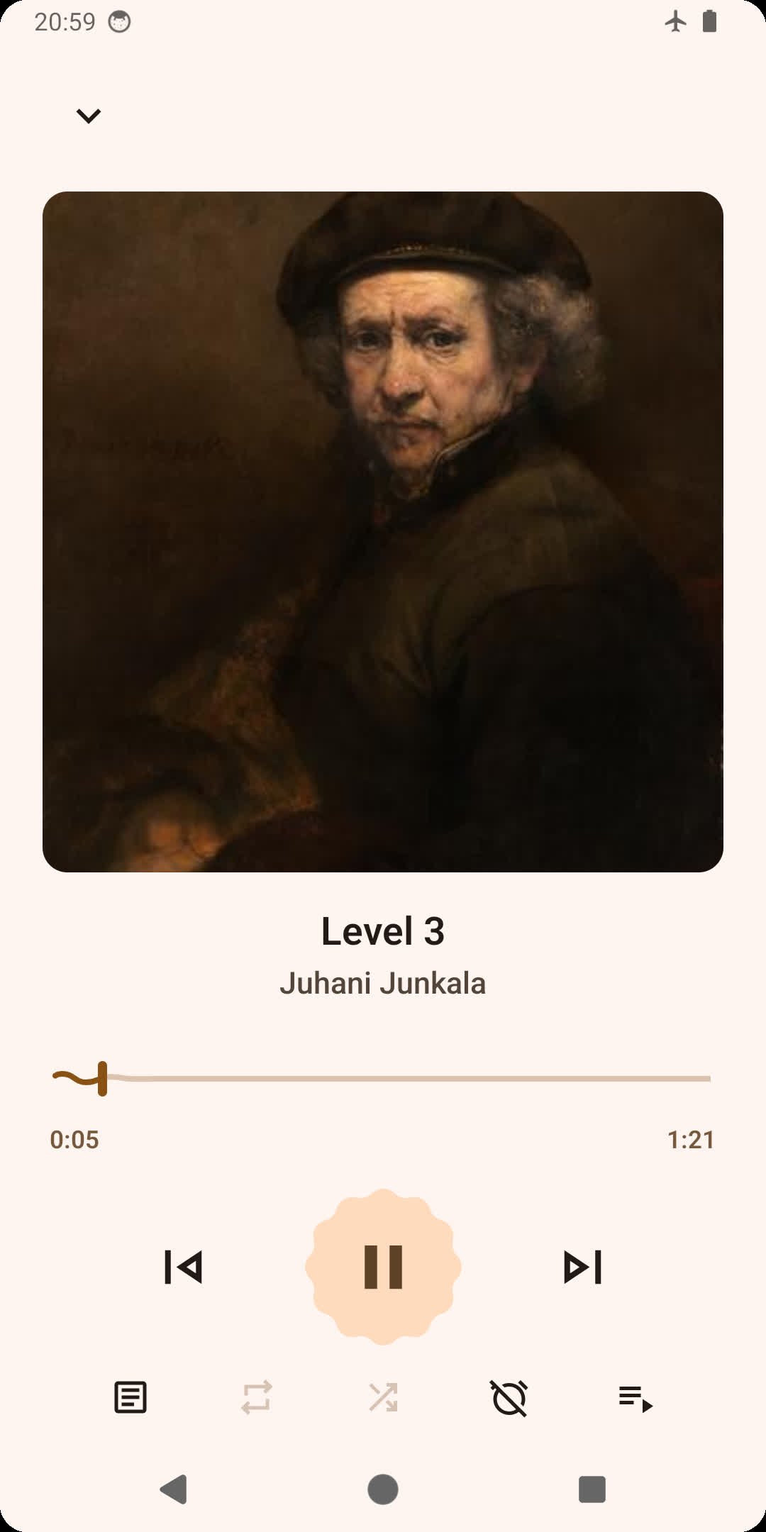 | 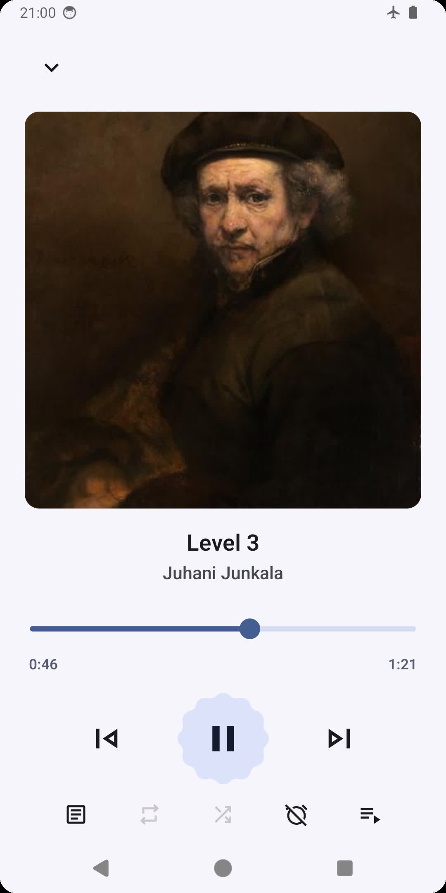 | 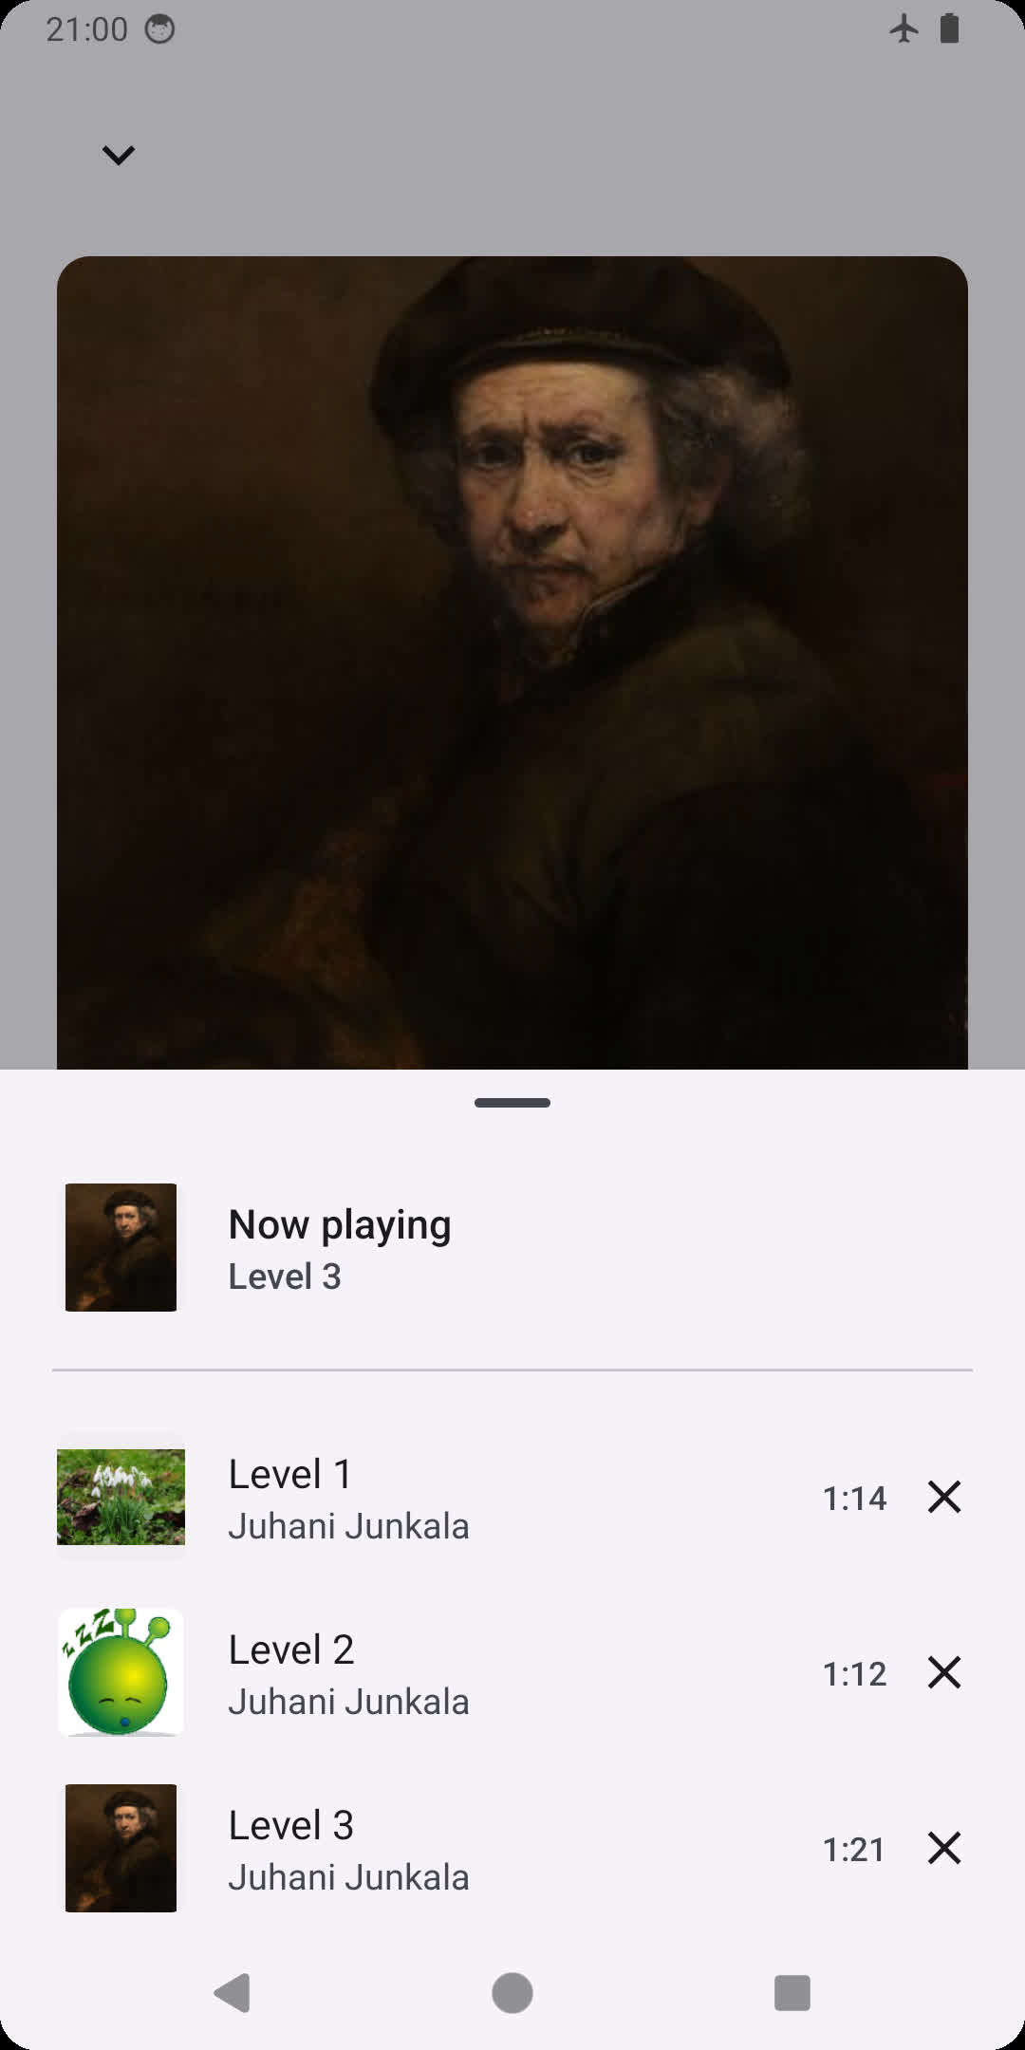
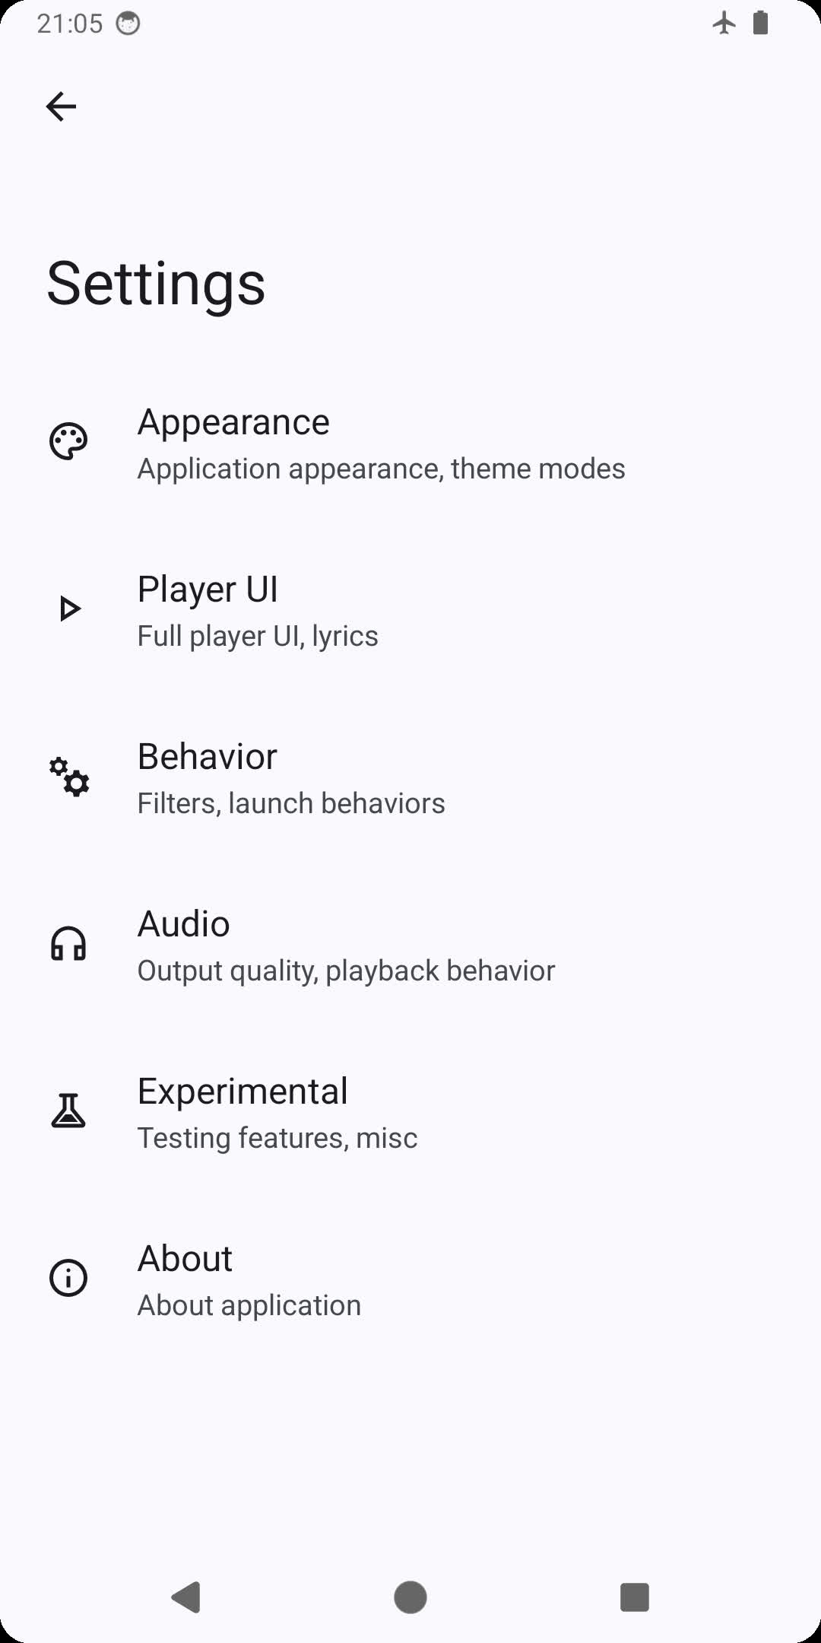 | 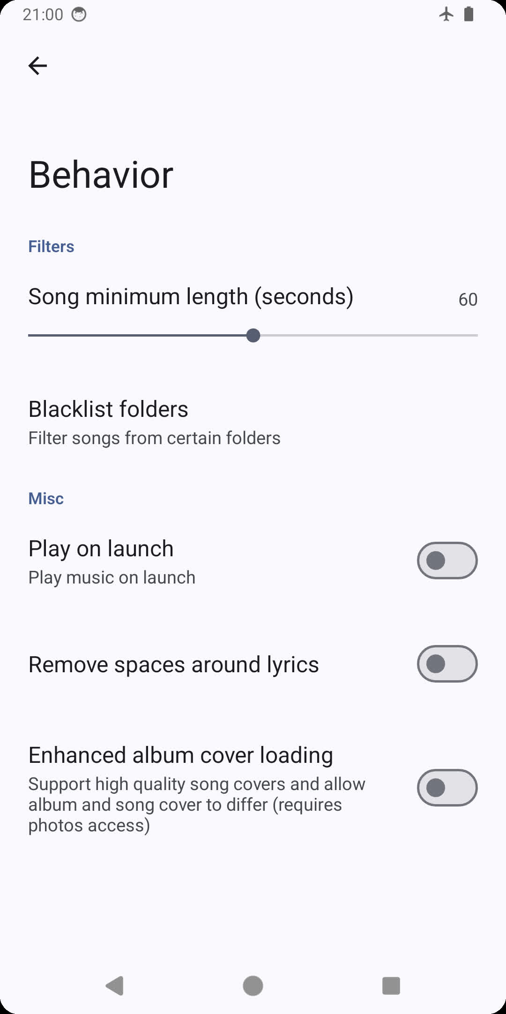 | 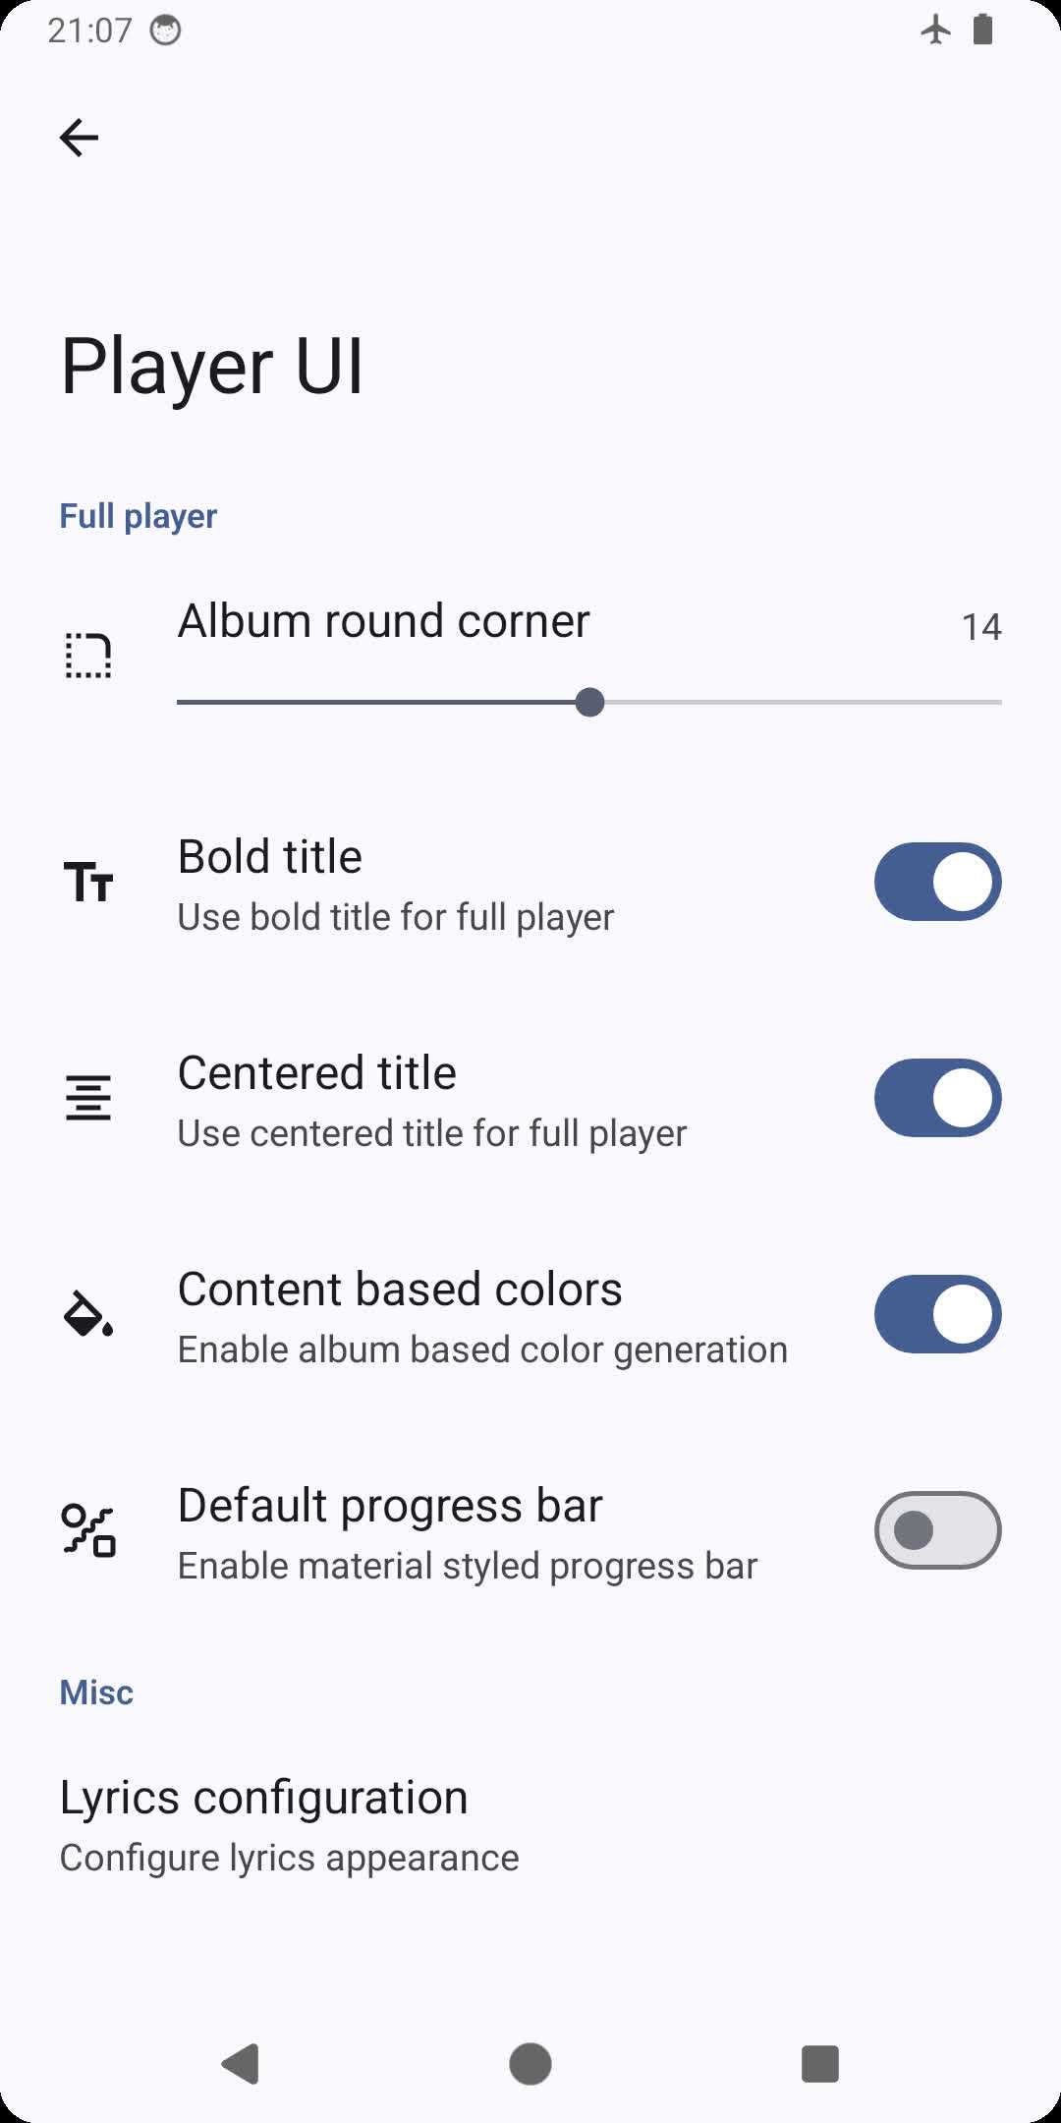

Installation
You can download the latest stable version of the app from either GitHub releases, F-Droid, or from IzzyOnDroid.
Beta versions and sneak peeks are available in the telegram channel or chat.

Building
To build this app, you will need the latest beta version of Android Studio and a fast network.

1. Submodules
Gramophone includes certain dependencies such as media3 as git submodule. Make sure you download git submodules by running git submodule update --init --recursive before trying to build Gramophone.

2. Set up package type
Gramophone has a package type that indicates the source of the application package. Package type string is extracted from an external file named package.properties.
Simply open your favorite text editor, type releaseType=SelfBuilt, and save it in the root folder of the repository as package.properties.

3. Start the build
Launch Android Studio and import your own app signing signature. You should be able to build Gramophone now.

License
This project is licensed under the GNU General Public License v3.0 - see the LICENSE file for details.

Translation

Notice
- Discussion chat: Telegram
- GitHub/F-Droid/IzzyOnDroid certificate SHA-256 digest: f451197ad7b80bd1bc981ba38a2c49d471856fb38bcc333676d6e8f8f3ce5d6e
- Play Store certificate SHA-256 digest: 178869b0f9130d145b53404df4d4e5e311095406cb3c51a3e7a4b03bb3e87786

FAQ
Why can't I see songs shorter than 60 seconds? Gramophone hides songs shorter than 60 seconds by default. You can change it in Three dots > Settings > Behaviour (set the setting to 0 to show all songs).
I changed the minimum song length setting, but some songs are still missing! Make sure you haven't excluded the folder in Behaviour > Folder blacklist. Then, try to reboot your phone, then wait a few minutes (this will rescan the system-wide media database Gramophone uses to find songs). If it's still not visible, your system version may not support scanning this file extension: this most commonly is observed for .opus, which will only be scanned since Android 10 (pro tip: rename your .opus file to .ogg, and it will be detected on Android 6 and later).
My song isn't playing! / My song is playing, but it's completely silent, yet the volume is turned up! Please note that Gramophone relies on system media codecs to make the app smaller. This means
- int32 (32-bit) FLAC files will only work on Android 14 or later
- FLAC files often do work even on versions prior to Android 8, but are only officially supported on Android 8 or later
- xHE-AAC files in general will only work on Android 9 or later
- Dolby Digital (AC-3) / Dolby Digital Plus (E-AC-3) / AC-4 requires a device that has licensed decoders for these formats
There is one exception: ALAC files can be played even without the system ALAC decoder as Gramophone includes an extremely lightweight Java ALAC decoder.

Friends
SongSync

