README

TorrServe
Download torrent files.

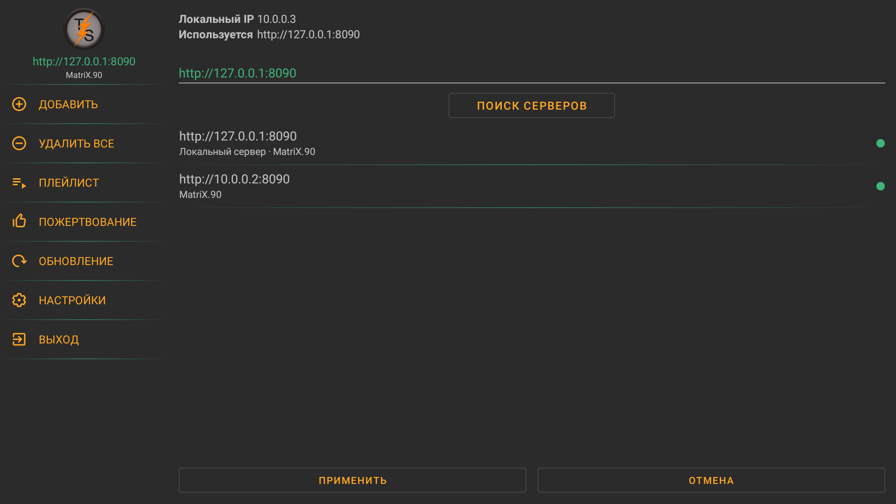
Application for downloading torrents as HTTP files. If your provider blocks torrents, be careful. The cache is stored in RAM, so the internal memory is not damaged. The application consists of two parts, a server and a client, this is a client for Android. Server source: https://github.com/YouROK/TorrServer
After first load, you need to download server from Updates -> Update server from network or choose any remote one.

