# Introduction

The Freedom Wing is an open-source assistive technology device that makes it possible for a user of a powerchair to utilize their power chair joystick as a joystick for gaming.

The FreedomWing 1.0 was designed by [ATMakers](http://atmakers.org/) in collaboration with [The AbleGamers Charity](http://ablegamers.org/) and [GRA-V Robotics](https://www.facebook.com/grav.robotics/). Makers Making Change updated the design of the PCB and created a basic set of documentation for FreedomWing 1.1.

# FreedomWing 1.0

## Design Overview

The FreedomWing 1.0 consists of a microcontroller attached to a custom printed circuit board (PCB) all mounted within a 3D printed enclosure. A DB9 connector on the PCB allows a user to connect a joystick with a matching connector.

## Hardware

### Circuitry

To interface with the wheelchair joystick, the signals from the joystick must be digitized. Voltage divider circuits are used to produce a suitable signal that can be read by a microcontroller.

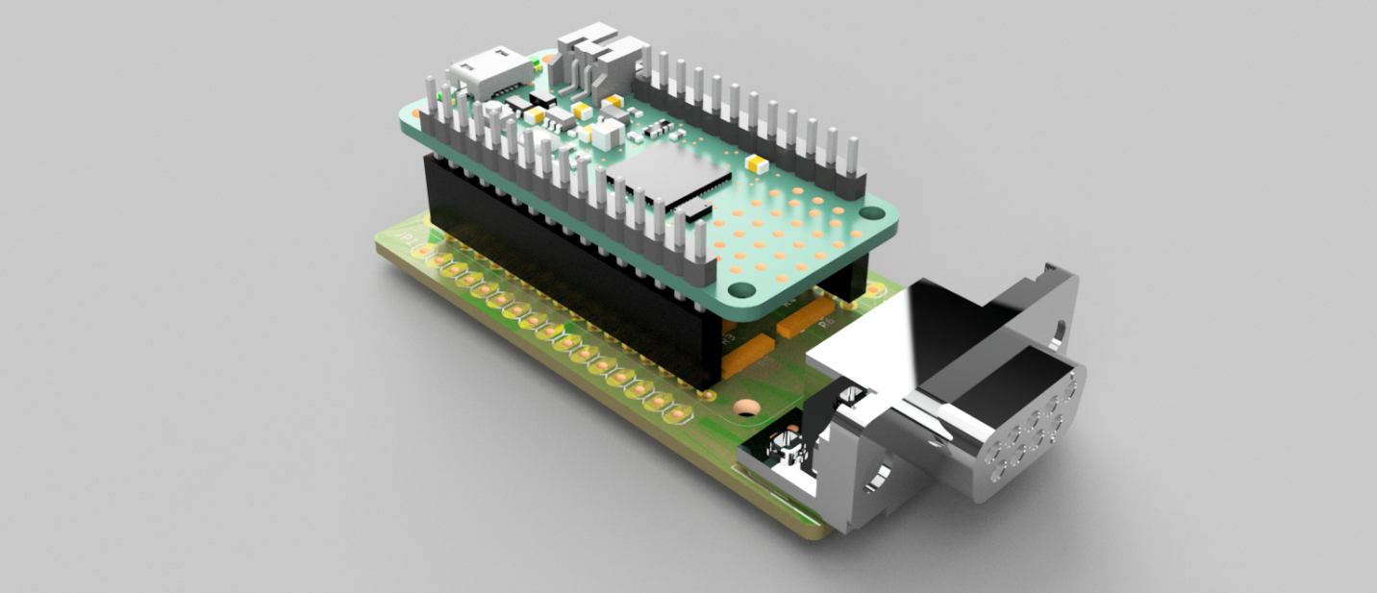

Figure 1: FreedomWing 1.0 Hardware

### Microcontroller

The PCB is designed to work with the range of Feather microcontrollers available from Adafruit. This provides the user with a different options depending on whether they want to connect to the host device via USB or Bluetooth.

Table : Adafruit Feather Microcontrollers

|  |  |  |  |  |  |
| --- | --- | --- | --- | --- | --- |
| Part Number | Description | QTY | Unit | Ext (USD) | Link |
| 4062 | Adafruit Feather nRF52840 Express (PREFFERED) | 1 | $24.95 | $24.95 | [Adafruit](https://www.adafruit.com/product/4062) [Digikey](https://www.digikey.com/short/zq2780) |
| 3857 | Adafruit Feather M4 Express | 1 | $22.95 | $22.95 | [Adafruit](https://www.adafruit.com/product/3857) [Digikey](https://www.digikey.com/short/zq27z7) |
| 4516 | Adafruit Feather nRF52840 Sense | 1 | $39.50 | $39.50 | [Adafruit](https://www.adafruit.com/product/4516) |
| 4242 | Adafruit PyGamer (w/Screen) | 1 | $39.95 | $37.95 | [Adafruit](https://www.adafruit.com/product/4242) |
| 4300 | Adafruit HalloWing M4 Express | 1 | $39.95 | $37.95 | [Adafruit](https://www.adafruit.com/product/4242) |

### Step-Up Regulator

The original design utilized a Pololu U3V12F12 booster module to step up the input voltage to the 12 V required by the joystick. Unfortunately, as of Summer 2022 this model has been discontinued and is difficult to source.

### Custom PCB

A custom printed circuit board (PCB) is used to mount the microcontroller, DB9 cable connector, and other cirtuitry.

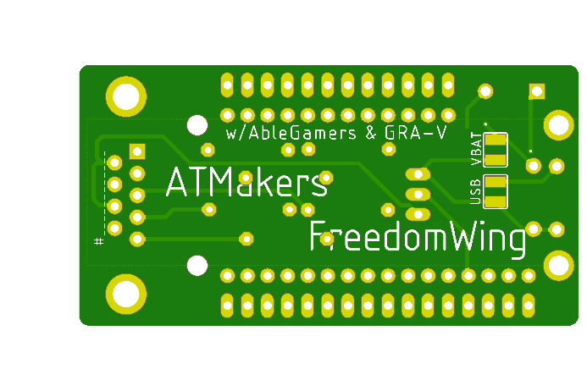

## Enclosure

The enclosure consists of two parts: the Case and the Lid. The Case holds the PCB, which is either held by two snap-fit tabs on the sides, or can be connected via screws through the bottom of the case. There Case has cutouts for the DB9 connector and the USB cable. The Lid connects to the case via a snap-fit. The Lid has an integrated flexure-based section to press the reset button.

The Case is adorned with the logos of ATMakers, AbleGamers, and GRA-V.

## Firmware

The basic firmware is used to emulate a USB HID Gamepad for use with adapted gaming but can be easily modified to suit different applications. The analog voltages from the joystick via the voltage divider circuit are digitized and mapped to the corresponding joystick axes.

## Documentation

<http://atmakers.org/freedomwing-build/>

### Design Files

The design files are hosted on GitHub: <https://github.com/ATMakersOrg/FreedomWing/>

* 3d printing files for the enclosure,
* CAD files for the enclosure (Fusion 360)
* PCB Files (Eagle)

### Bill of Materials

The electronic components and microcontrollers are listed at <http://atmakers.org/freedomwing-build/>

### Assembly

There is an assembly video that is available on YouTube: <https://www.youtube.com/watch?v=fD7QSvJnh4c>. This primarily covers soldering the PCB, and briefly shows one case option (that includes a number of switch input jacks). There are no instructions provided for programming the device.

### Programming

No instructions are available for programming the microcontroller.

### User Guide

No instructions are available for setting up the device.

## Opportunities for Improvement

1. Replace discontinued boost converter
2. Orient Lid STL file in intended print orientation.
3. Reduce the size of the cutout in the case for the DB9 Connector.
4. Replace multiple individual resistors with the same value with a Single Inline Package (SIP) resistor array.
5. Fix labels on PCB
6. Consider small / less expensive / alternate options for microcontroller.
7. Add more detailed documentation.
8. Improve PCB fastening method
9. Update firmware installation process.

# Freedom Wing 1.1

The primary goal of this version was to determine a suitable replacement for the discontinued boost converter to enable future builds of the device.

## Implemented Changes

### Replace discontinued boost converter

The Pololu U3V12F12 has been discontinued, so a replacement 12V buck booster was selected.

|  |  |  |  |  |  |  |
| --- | --- | --- | --- | --- | --- | --- |
| Option | Device | Operating Minimum Voltage | Dimension (mm x mm) | Input Current | Cost (US$) | Link |
| Original | Pololu U3V12F12 | 2.5V | 8.1x 13.1 | 1.4 A | 5.09 | <https://www.pololu.com/product/2117/specs> |
| 1 | **Pololu U3V40F12** | **1.3V** | **15.2×15.2** | **3.5A** | **9.95** | [**https://www.pololu.com/product/4016**](https://www.pololu.com/product/4016) |
| 2 | DFRobot 3.7-34V | 3.7V | 32x34 | 3A | 6.49 | <https://www.robotshop.com/en/dfrobot-dc-to-dc-step-up-voltage-regulator.html> |
| 3 | Valefod 6pack | 3V | 45x23 | NA | 10.99/6 | <https://www.amazon.com/Valefod-Efficiency-Voltage-Regulator-Converter/dp/B076H3XHXP/> |
| 4 | DAOKI 5PCS Mini | 2.5V | NA | NA | 5.99/5 | <https://www.amazon.com/DAOKI-Converter-Step-Up-Voltage-Regulator/dp/B08M19C7MM/> |

The replacement buck booster was selected using the following criteria:

* Availability
* Low cost
* Match the technical specifications of Pololu U3V12F12
* Footprint/Dimensions (i.e., does not require major updates to the PCB and the case)

The Pololu U3V40F12 was chosen.

* Updated the PCB to support the new 12V buck booster
* Added the pinouts for both old and new 12V buck boosters to the PCB

This would allow the users to be able to use old U3V12F12 buck booster with new PCBs.

* Updated the code to use a Flag in settings file to enable or disable debug information ( Serial prints )

This can improve the performance for longer usage time.

In addition to changing the footprint for the buck booster, the copper flood gap on non-grounded pins of the buck booster was increased This will assist makers during the soldering process, by minimizing the chance of soldering iron tip scraping away solder resist on the ground plane. Missing ground plane resist will cause shorts to ground if solder sticks between the ground plane and a solder joint. This can happen easily if the ground plane gap is small.

Figure Updated PCB Flood Gap.

### Fix labels on PCB

The labels for the analog pins were matched with their assigned functionality in the code

* Move the labels to improve readability
* Rotate DB9 connector label

Figure . Updated PCB Labels.

### Orient Lid STL file in intended print orientation.

All print files are saved in their intended print orientations to ease 3D printing setup.

### Reduce the size of the cutout in the case for the DB9 Connector.

The knockout / cutout for the DB9 connection was reduced in size to improve the appearance and reduce the likelihood of foreign material from entering the enclosure.

Figure 4: Modified DB9 Knockout

### Improve PCB fastening method

The original design used two methods for keeping the PCB fastened to the case, 4 holes and some snap fit elements on the side.

Installing machine screws from the bottom is challenging as small nuts need to be held in place inside the enclosure while the screws are inserted

Several alternative mounting option were considered:

|  |  |  |  |
| --- | --- | --- | --- |
| Option | Description | Pros | Cons |
| 0 | 4 Screws from bottom; nuts on top | No change required. | Hard to assemble |
| 1 | Female-Female standoff; Machine screw from bottom, machine screw from top | Reliable | Additional part count. |
| 2 | Male-Female standoff; Nut on bottom, machine screw from top |  |  |
| 3 | Lid snapfit + posts |  | Reliant on printing tolerances |
| 4 | 3D Printed Nut captures | Simple; cost-effective | Additional 3d printed parts; small |

The addition of 3D printed nut captures was selected. Two additional parts were designed to hold the hex nuts in place while the screws are inserted from the bottom.

#### PCB Changes to Accommodate Feather RP2040

Some modifications were made to the PCB to allow for newer Feather microcontroller models to be used. Other microcontroller options outside the Feather ecosystem were considered, but this was not pursued.

One of the newest and least expensive microcontrollers in the Feather line is the RP2040 (<https://www.adafruit.com/product/4884> ). Unfortunately, this model does not support analog pins A4 or A5. The FreedomWing 1.0 PCB utilizes A4 for the vertical joystick input.

The PCB schematic was modified to use A1, A2, and A3, rather than A2, A2, A4 (Table 2).

This change allows the more affordable Feather boards to be used as alternative option for the main microcontroller.

Table 2 PCB Pinout Change

|  |  |  |  |
| --- | --- | --- | --- |
| **DB9 Pin** | **Omni Pin (Analog)** | **Freedom Wing 1.0** | **Freedom Wing 1.1** |
| 1 | Speed | A4 (VER) | A3 (VER) |
| 2 | Direction | A3 (HOR) | A2 (HOR) |
| 3 | Reference | A2 (REF) | A1 (REF) |
| 4 | None | None | None |
| 5 | Detect | None | None |
| 6 | 5th Switch | None | None |
| 7 | 12V | 12V | 12V |
| 8 | GND | GND | GND |
| 9 | 12V | 12V | 12V |

#### Alternative Microcontrollers

If there was a desire to move away from the Feather ecosystem, the Seeduino Xiao would be a suitable replacement. It is available in a basic USB version, as well as versions with wireless capabilities.

### 

### Add more detailed documentation.

A comprehensive set of documentation was created covering the design, constructions, setup, and use of the FreedomWing.

### Update firmware installation process.

The XAC HID implementation was updated to use the new custom descriptor implementation through boot.py file instead of custom UF2 bootloader. ( CircuitPython 7 and up )

This will help to maintain the code and make it compatible with other versions of the Feather Board family.

## Non-Implemented Changes

### Replace multiple individual resistors with the same value with a Single Inline Package (SIP) resistor array.

This change was not implemented, as it was felt this would have minimal impact on the build success or BOM cost.