## Introduction

The FreedomWing Joystick Adapter provides a way to connect a powerchair joystick to a gaming system. This can enable someone to game with the same joystick they use to control their powerchair. This adapter is compatible with joysticks that attach to the powerchair via a DB9 connector.

## Features

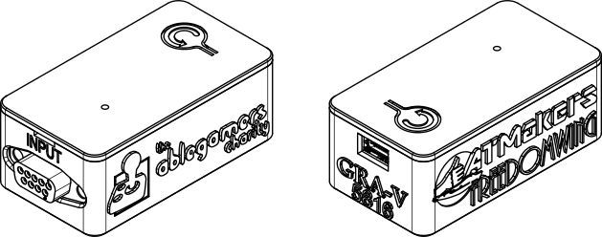

Joystick DB9 Input Connector

Reset Button

USB Connection

## Setup Instructions

1. Disable wheelchair motors.
2. Disconnect the joystick DB9 connector from wheelchair.
3. Connect the joystick DB9 connector to the FreedomWing Adapter Input.
4. Connect the FreedomWing Adapter USB cable to the host device. (Use a suitable adapter if necessary.)

For use with the Xbox Adaptive Controller, it is recommended that the XAC be connected to a power source.

## Compatibility

|  |  |  |
| --- | --- | --- |
| Wheelchair Manufacturer | Wheelchair Models | Required Interface |
| **Merits Health USA** | * Merits vector P323 | * R-Net OMNI interface * R-Net OMNI2 interface |
| **Permobil** | * F5 Corpus VS * F5 Corpus * F3 Corpus * M5 Corpus * M3 Corpus * M300 Corpus HD * M300 PS Jr. * K300 PS Jr. * Koola R-Net * K450 MX * F5 Corpus VS | * R-Net OMNI interface * R-Net OMNI2 interface |
| **Quickie** | * QM-710 * QM-720 * S636 * Q400 M * Q500 M | * R-Net OMNI interface * R-Net OMNI2 interface |

## Cleaning

The FreedomWing Adapter can be wiped with a damped cloth. Do not submerge the device.

## Warnings

The powerchair should be completely inoperable while you are gaming.