cateringpro Business Requirements | Version 4.0
Catering Management System
Business Requirements Specification
Source document: Catering Use Cases (RML Use Case Template), UC-01 to UC-10
Purpose: Requirements for a full company portal for a catering company, with role-based access, role dashboards, a food catalog and an order builder

10  Use Cases | 10  User Roles | 104  Functional Requirements | 35  Business Rules

What is new in this version
Version 4.0 is a review of version 3.0 before implementation. Rows shaded light amber are new or changed in this version; rows shaded light green were added in version 3.0. Version 4.0 fixes inconsistencies (order statuses, Order Manager visibility, the role list in NFR-01, and Must requirements that had no delivery phase), adds an executive summary, requirements FR-79 to FR-104 (order lifecycle and cancellation, notifications, customer self-service, food safety, invoicing, platform and delivery), business rules BR-27 to BR-35, non-functional requirements NFR-16 to NFR-24, and three new sections: order lifecycle and notifications (13), KPIs (14), and the proposed architecture and prototype scope (15). The full list is in Appendix D.

Executive Summary
CateringPro will replace phone and WhatsApp ordering with one web portal that runs the whole catering business. Customers order and track online, and every department (sales, kitchen, inventory, delivery, finance and management) works from the same order record, each through a dashboard built for its role.
What the portal delivers:
- One catalog for food items, packages, event menus and services, with a step-by-step Order Builder and automatic pricing.
- A controlled order lifecycle from Draft to Delivered, with a full history, cancellation rules and notifications at every step.
- Recipe-based stock reservation, so shortages are found before an order is promised to the customer.
- Delivery assignment with proof of delivery, and invoices and payments linked to each order.
- Ten role-based interfaces protected by server-side permission checks, and an executive dashboard measured by agreed KPIs.
How to read this document: Sections 1 and 2 describe the business and its roles. Sections 3 to 6 define what the system must do: 104 functional requirements, 35 business rules, 24 non-functional requirements and the data entities. Sections 7 to 9 list gaps, open questions and delivery phases. Sections 10 to 12 show the dashboards, use case diagrams and catalog design. Sections 13 to 15 (new) define the order lifecycle, the KPIs, and the proposed architecture and prototype.

1. Introduction

1.1 Purpose
This document lists the requirements extracted from the ten catering use cases. It is the starting point for designing and building a full company portal for the catering company, covering ordering, order tracking, delivery, management reporting, role-based access for every kind of user, and a food catalog with an order builder.

1.2 Business Problem
Customers currently place orders by phone calls or WhatsApp. This causes missed or misunderstood orders, many “where is my order?” calls, unclear responsibility for deliveries, and no reliable figures for the CEO. The portal must capture all orders in one system and give each role the information it needs, and only that information.

1.3 Business Goals
- Capture all orders in one system to reduce missed or misunderstood orders.
- Reduce status calls by letting customers track their orders.
- Give every delivery a clear owner and raise the on-time delivery rate.
- Give the CEO real-time visibility into sales, delays, stock, and unpaid orders.
- Give every person who logs in the dashboard and details that fit their job, and protect sensitive data (profits, customer data, payments) from people who do not need it.
- Let customers order in several ways (single items, packages, custom packages, event menus) from one catalog, so the kitchen, inventory, delivery and finance all work from the same order.
- Connect every order to ingredient stock and production, so the company knows early whether it can fulfil the order.
- Measure performance with agreed KPIs (Section 14), and keep order, invoice and stock records clean enough to connect to an ERP later.

1.4 In-Scope Use Cases
ID | Use Case | Main Actors | Frequency
UC-01 | Place Order | Customer, Order Manager | Many times per day
UC-02 | Track Order | Customer, Order Manager | Several times per order
UC-03 | Assign Delivery | Delivery Manager, Driver, Customer | Many times per day
UC-04 | View Performance Dashboard | CEO | Daily
UC-05 | Log In and Access Role Dashboard | All roles | Many times per day
UC-06 | Manage Users and Roles | CEO / Admin (Super Admin) | Occasionally
UC-07 | Manage Food Catalog | Catalog Manager, CEO / Admin | Occasionally
UC-08 | Build and Price Order (Order Builder) | Customer, Order Manager | Many times per day
UC-09 | Request and Approve Quotation | Customer, Order Manager, Event Coordinator | Several times per week
UC-10 | Reserve Inventory and Plan Production | Inventory Manager, Kitchen Staff | Many times per day

2. Actors and Roles
Each actor becomes a user role in the portal. The system is one web application; the role decides which interface, dashboard and data a person gets.
Actor | Responsibilities | Home Screen
Customer | Registers, places orders, saves drafts, approves changes, tracks own orders, views own invoices and payments, and rates the service. | Customer Portal
Order Manager | Reviews new orders, confirms them, edits price or time, approves quotations within their authority, and views and filters all orders allowed for the role. | Order Management
Kitchen Staff (implied) | Sees confirmed orders and production orders to prepare, updates preparation and quality status, and marks orders "Ready for Dispatch". Also called Kitchen Manager when responsible for production. | Kitchen Dashboard
Delivery Manager | Assigns and reassigns drivers, and reschedules failed deliveries. | Delivery Dashboard
Driver | Delivers assigned orders, marks them “Delivered”, and records proof of delivery or failure reasons. | Driver View
Inventory Manager | Tracks ingredient quantities and expiry, records goods in and out, reserves and releases stock for orders, and follows shortages, suppliers and purchase orders. | Inventory Dashboard
Accountant / Finance Staff | Follows invoices, payments and outstanding amounts, records payments, reviews refunds, and prepares financial reports. | Finance Dashboard
CEO / Admin | Views the performance dashboard, drills into figures, exports reports, and (as Super Admin) manages users, roles and system settings. | Executive Dashboard
Catalog Manager | Manages food items, packages, event menus, services and pricing rules; activates or deactivates offers. | Catalog Management
Event Coordinator | Coordinates guest counts, venue requirements, services and the event schedule; follows event preparation and service. | Event Planning
Payment Gateway (external system) | Takes online payments, if the company adds them. It is a system, not a person, and has no login. | None

Catalog Manager and Event Coordinator are new roles in this version. The Payment Gateway is an external system, not a user role. Inventory Manager and Accountant were added in version 2.0. The home screens are shown in Section 10.

2.1 Role-Based Access Control (RBAC)
Not everyone who logs in should see everything. In software engineering this is called Role-Based Access Control (RBAC): permissions are given by a person’s job in the company, not person by person. Two ideas must be kept apart:
- Authentication: who are you? This is the login and the check of the user’s identity.
- Authorization: what are you allowed to do? These are the permissions the user gets after logging in.
Example: when a customer logs in, the system knows the user is a Customer and opens the Customer Portal. When the CEO logs in, the system opens the Executive Dashboard.
Hiding buttons is not enough
The system itself must stop a user from reaching data or running actions outside their role, even if the user opens a direct link or sends a direct request to the API. Every request is checked on the server.

2.2 What Each Role Sees
Role | Can see and do | Cannot see | Interface
CEO / Super Admin | Full business overview: total orders, sales and profit; staff and department performance; stock, deliveries and delays; financial and management reports; system settings and permissions (Super Admin only). | Nothing is hidden, but system settings are limited to the Super Admin. | Executive Dashboard
Customer | Menu and prices; create, edit or cancel own orders (per policy); track own orders; own invoices and payments; edit own account; rate the service. | Other customers’ orders and the company’s internal financial data. | Customer Portal
Order Manager / Sales Staff | Orders assigned to them or that they may manage; review and confirm orders; approve quotations within their authority; delivery times and customer details; update order status within their permissions. | Full profit figures and user or system settings. | Order Management
Kitchen Staff / Chef | Confirmed orders to prepare; production orders with meals, quantities and essential dietary notes; recipes; update preparation and quality status; mark an order ready for dispatch. | Payment data and financial reports. | Kitchen Dashboard
Inventory Manager | Available ingredient quantities; update stock and track expiry; stock reservations and shortages for confirmed orders; record goods in and out; suppliers and purchase orders. | Order prices and customers’ financial data. | Inventory Dashboard
Delivery Manager | Orders ready for dispatch; available drivers; assign or reassign drivers; reschedule failed deliveries; track all deliveries. | Financial reports and user management. | Delivery Dashboard
Delivery Staff / Driver | Orders assigned to them; delivery address and the necessary contact number; update Out for Delivery or Delivered; record proof of delivery or failure reason. | All company orders and company accounts. | Driver View
Accountant / Finance Staff | Invoices, payments and outstanding amounts; record payments; review refunds (per permission); prepare financial reports. | Food preparation details and driver assignment. | Finance Dashboard
Catalog Manager | Food items, packages, event menus and services; pricing rules, effective dates and minimum quantities; activate or deactivate offers. | Customer data, payments and user settings. | Catalog Management
Event Coordinator | Event orders and quotations; guest counts, venue and setup details; services; event schedule and tasks; event progress. | Payment data, financial reports and user settings. | Event Planning

2.3 Permission Matrix
This is the starting matrix for analysis. The details of each permission must be confirmed with the company’s policy.
Feature | CEO / Admin | Cust. | Order Mgr | Kitchen | Deliv. Mgr | Driver | Inv. Mgr | Acct.
View orders | ✓ | Own | ✓ | To prepare | Ready / out | Assigned | — | Billing
Create order | ✓ | ✓ | ✓ | — | — | — | — | —
Update order status | ✓ | Own (policy) | ✓ | Preparation | Dispatch | Delivery | — | —
Manage menu & prices | ✓ | — | If granted | — | — | — | — | —
Manage inventory | ✓ | — | — | View | — | — | ✓ | —
Assign & track deliveries | ✓ | Own | Track | Ready flag | ✓ | Assigned | — | —
Manage drivers | ✓ | — | — | — | ✓ | — | — | —
Invoices & payments | View | Own | If granted | — | — | — | — | ✓
Financial reports | ✓ | — | If granted | — | — | — | — | ✓
CEO performance dashboard | ✓ | — | — | — | — | — | — | —
Manage users & roles | Super Admin only | Own account | — | — | — | — | — | —

✓ = full access to the function. Own = own records only. Assigned = records assigned to that user. View = read-only. Preparation / Dispatch / Delivery = may update only the status of their own stage. If granted = optional permission set by the administrator. — = no access. The CEO is not necessarily the technical Super Admin; the company may separate operational management from system administration. From version 3.0, menu and price management belongs to the Catalog Manager (see the second matrix); the Order Manager gets it only if granted.
Catalog and event features (new in this version). Same legend as above; Prepare = may prepare the quotation for approval; Within limit = only up to the approval limit set by the company; Events = may create orders on behalf of an event customer; Request = may request stock for production.
Feature | CEO / Admin | Cust. | Order Mgr | Catalog Mgr | Event Coord. | Kitchen | Inv. Mgr | Acct.
Browse catalog | ✓ | ✓ | ✓ | ✓ | ✓ | View | View | ---
Manage items, packages & menus | ✓ | --- | If granted | ✓ | --- | --- | --- | ---
Configure pricing rules | ✓ | --- | --- | ✓ | --- | --- | --- | ---
Build & submit order | ✓ | Own | ✓ | --- | Events | --- | --- | ---
Approve quotation | ✓ | Accept own | Within limit | --- | Prepare | --- | --- | ---
Manage event details | ✓ | Own | View | --- | ✓ | View | --- | ---
View production orders | ✓ | --- | View | --- | View | ✓ | View | ---
Manage recipes | ✓ | --- | --- | View | --- | ✓ | --- | ---
Reserve / release stock | ✓ | --- | --- | --- | --- | Request | ✓ | ---

2.4 One System, Different Interfaces
The best design is one system with different interfaces by role. There is no need for eight separate programs: they are parts of the same web application, and each person gets the screens and data that fit their role.
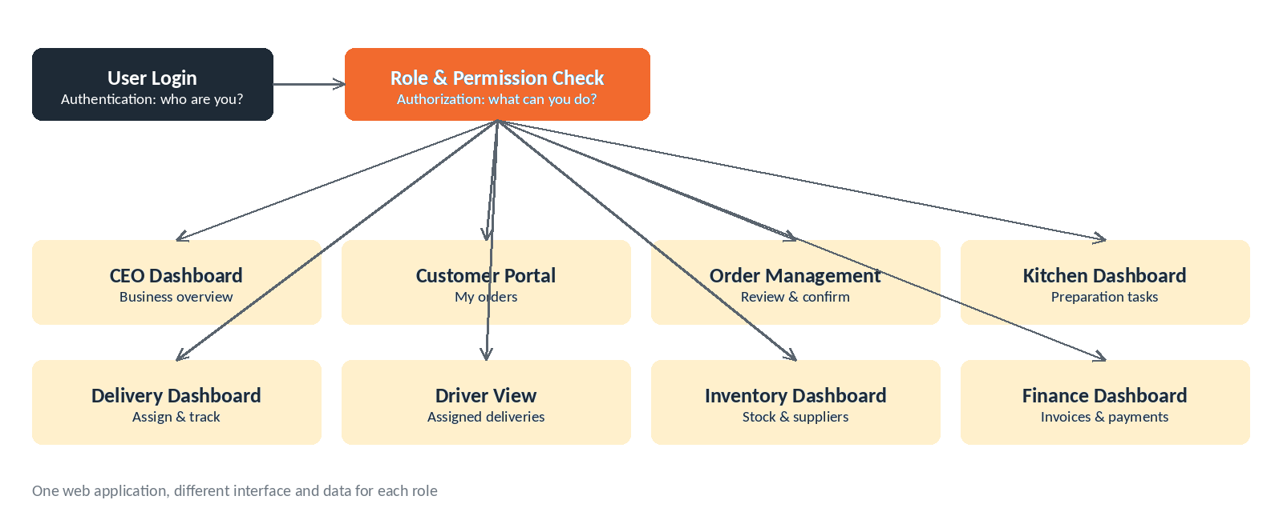
Figure 1: Login, role check and role interfaces

3. Functional Requirements
Priority uses MoSCoW (Must / Should / Could). Priorities are proposed by the analyst and should be confirmed with the stakeholders.

3.1 Account Management
ID | Requirement | Source | Priority
FR-01 | Customers can register, log in, and manage their account. | UC-01 (Assumptions) | Must

3.2 Menu and Order Placement
ID | Requirement | Source | Priority
FR-02 | Customers can browse the menu with item prices. | UC-01 | Must
FR-03 | Customers can select menu items and quantities. | UC-01 | Must
FR-04 | Customers can enter a delivery address, date, and time. | UC-01 | Must
FR-05 | The system calculates the total order price automatically. | UC-01 | Must
FR-06 | The system saves a submitted order with status “Pending” and generates a unique order number shown to the customer. | UC-01 | Must
FR-07 | Customers can save an order as a draft without submitting it. | UC-01 AC1 | Should
FR-08 | The system validates required fields and highlights any missing field before submission. | UC-01 EX1 | Must
FR-09 | The system checks the requested time slot and, if unavailable, suggests the nearest available time (the customer can pick another time or cancel). | UC-01 EX2 | Must
FR-10 | The system notifies the Order Manager when a new order is submitted. | UC-01 | Must
FR-11 | The Order Manager can edit an order’s price or time, and the customer must approve the change. | UC-01 AC2 | Should

3.3 Order Tracking
ID | Requirement | Source | Priority
FR-12 | Customers can view their orders under “My Orders” and open any order. | UC-02 | Must
FR-13 | The system supports these order statuses: Draft, Pending, Awaiting Customer Approval, Confirmed, Preparing, Ready for Dispatch, Out for Delivery, Delivered, Delivery Failed and Cancelled. Delayed is a flag that can be set on any active order (FR-17). The allowed transitions are listed in Section 13.1. | UC-02, UC-03 | Must
FR-14 | The system shows the current status and the last update time for each order. | UC-02 | Must
FR-15 | Customers can search for an order by order number; if not found, the system shows “Order not found”. | UC-02 AC1, EX1 | Should
FR-16 | The Order Manager can view all orders and filter them by status and date. | UC-02 AC2 | Must
FR-17 | The system flags a late order as "Delayed" (a flag on top of its current status, not a separate status) and shows the new expected time to the customer and the Order Manager. | UC-02 EX2 | Should
FR-18 | Kitchen and delivery staff can update the order status at each stage. | UC-02 (Assumptions) | Must

3.4 Delivery Management
ID | Requirement | Source | Priority
FR-19 | Drivers are registered in the system together with their availability status. | UC-03 (Assumptions) | Must
FR-20 | The Delivery Manager can see a list of orders with status “Ready for Dispatch”. | UC-03 | Must
FR-21 | The Delivery Manager can assign an available driver and a departure time to an order. | UC-03 | Must
FR-22 | On assignment, the system sets the status to “Out for Delivery” and notifies the customer. | UC-03 | Must
FR-23 | Drivers can mark an order “Delivered”, or record a failure reason, which sets the status to “Delivery Failed” and notifies the Delivery Manager to reschedule. | UC-03 | Must
FR-24 | The Delivery Manager can reassign an order to a different driver; the system notifies both drivers. | UC-03 AC1 | Should
FR-25 | If no driver is available, the system alerts the Delivery Manager and keeps the order as “Ready for Dispatch” until a driver is free. | UC-03 EX1 | Must

3.5 CEO Performance Dashboard
ID | Requirement | Source | Priority
FR-26 | The dashboard shows total orders, revenue, on-time delivery rate, low-stock items, and unpaid invoices. | UC-04 | Must
FR-27 | The CEO can select a period (today, week, or month) and the figures refresh for it. | UC-04 | Must
FR-28 | The CEO can click a figure (for example, delayed orders) to see the related orders. | UC-04 AC1 | Should
FR-29 | The CEO can export a report as PDF or Excel. | UC-04 AC2 | Should
FR-30 | The system shows “No data available” when a period has no data, and an error message with a retry option if the dashboard fails to load. | UC-04 EX1, EX2 | Must

3.6 Access Control and Roles
ID | Requirement | Source | Priority
FR-31 | Users log in with their own credentials; the system identifies who they are (authentication) and which role they hold. | UC-05 | Must
FR-32 | After login the system opens the interface and dashboard that belong to the user’s role. | UC-05 | Must
FR-33 | Each role sees only the data and functions allowed for it in the permission matrix (Section 2.3). Menu items the role cannot use are not shown. | UC-05, RBAC | Must
FR-34 | The system checks permission on the server for every request. A user who opens a direct link or sends a direct API request for data or an action outside their role is refused, not just hidden from the screen. | UC-05 AC1, RBAC | Must
FR-35 | Customers see only their own orders, invoices and payments; they can edit their account, change or cancel orders according to policy, and rate the service. | UC-02, RBAC | Must
FR-36 | Order Managers see the orders assigned to them or allowed for them; they review and confirm orders, follow delivery times and customer details, and update order status within their permissions. They do not see full profit figures or user settings. | UC-01, UC-02, RBAC | Must
FR-37 | Kitchen Staff see only confirmed orders to prepare, with meals, quantities and essential dietary notes. They update preparation and quality status and mark an order “Ready for Dispatch”. They do not see payment data or financial reports. | UC-02, RBAC | Must
FR-38 | Drivers see only the orders assigned to them, with the delivery address and necessary contact number. They update the status to “Out for Delivery” or “Delivered” and record proof of delivery or a failure reason. | UC-03, RBAC | Must
FR-39 | Inventory Managers see available ingredient quantities, update stock, track expiry dates, record goods in and out, and follow shortages, suppliers and purchase orders. They cannot change order prices or see customers’ financial data. | GAP-02, RBAC | Should
FR-40 | Accountants follow invoices, payments and outstanding amounts, record payments, review refunds according to their permission, and prepare financial reports. They cannot change food preparation or driver assignment. | GAP-03, RBAC | Should
FR-41 | The CEO / Admin sees the full business overview, including staff and department performance, stock, deliveries, delays and financial and management reports. | UC-04, RBAC | Must
FR-42 | An administrator can create user accounts, assign or change a user’s role, and enable or disable accounts. | UC-06 | Must
FR-43 | An administrator can edit the permissions of a role. Role, permission and account changes are recorded in an audit log. | UC-06 AC2 | Should

3.7 Dashboard and Interface Design
The design follows the reference dashboard supplied by the client (Flexcatering): a dark top bar, a blue sidebar, KPI tiles, shortcut cards and simple charts.
ID | Requirement | Priority
UI-01 | The portal is one web application with a different interface for each role, not separate programs. | Must
UI-02 | Every page uses the same layout: a dark top bar (logo, quick buttons such as New Order, user menu), a blue left sidebar for navigation, and a content area for the dashboard. | Must
UI-03 | Each dashboard starts with a row of KPI tiles (large number plus label) showing the key figures for that role, for example new orders, sales, on-time delivery, low stock and unpaid invoices. | Must
UI-04 | Dashboards use simple charts: orders by status, busiest days of the week, and sales over time, with a period filter (today, week, month, year). | Should
UI-05 | Dashboards include pipeline widgets (new orders, approved orders, invoiced orders, average orders per day) and shortcut cards to Orders, Customers, Products and the Kitchen Report. | Should
UI-06 | The sidebar and shortcut cards show only the sections the user’s role may open. | Must
UI-07 | Colour use is consistent: blue for navigation and actions, green for delivered or paid, orange for pending or warnings, red for delayed, failed or unpaid. | Should
UI-08 | The Order Builder guides the customer step by step: order type, method, quantity and schedule, customization, price review, submit. | Must
UI-09 | Before submitting, the customer sees the full price breakdown (items, extras, delivery, fees, tax, discount, total) and the availability result. | Must
UI-10 | The Catalog Manager and Event Coordinator have their own home screens in the same layout, colours and components as the other roles. | Should

3.8 Food Catalog (UC-07)
One catalog describes everything the company sells. The customer-facing offer is kept separate from its recipe and stock.
ID | Requirement | Source | Priority
FR-44 | The system keeps one catalog of everything the company sells, with four product types: individual food item, package, event menu, and catering service or add-on. | UC-07 | Must
FR-45 | Each food item has a name, SKU, category, unit of sale (portion, serving, bottle or piece), price, availability, dietary information, allergens, and a link to its recipe. | UC-07 | Must
FR-46 | A Catalog Manager can create, edit, activate and deactivate food items, packages, event menus and services. | UC-07 | Must
FR-47 | A package contains defined food items with quantities. It can be fixed, or it can allow controlled substitutions and paid add-ons. | UC-07 | Must
FR-48 | An event menu is organised in courses or sections that can contain food items, packages, drinks and services. It is priced per guest or by custom quotation. | UC-07 | Should
FR-49 | A catering service or add-on (waiter service, buffet setup, tableware rental, special delivery, event cleanup) has a service unit, a price rule and fulfilment needs, not a recipe. | UC-07 | Should
FR-50 | Customers can browse the catalog by type and category and open a detail page for any item, package or menu (contents, price, allergens). This extends FR-02. | UC-08 | Must

3.9 Order Builder (UC-08)
The Order Builder turns the customer's choices into a valid order. It has four ordering modes but one order record.
ID | Requirement | Source | Priority
FR-51 | One Order Builder supports four ordering modes from the same catalog: direct selection, package ordering, custom ordering and event ordering. All modes create the same kind of order. | UC-08 | Must
FR-52 | The customer chooses the order type (daily or event) and the ordering method, then enters quantity and schedule (portions, packages, guest count, date and time). | UC-08 | Must
FR-53 | In custom ordering the customer can change only the substitutions, extras and dietary options that the package allows. | UC-08 | Must
FR-54 | Before submission the system validates minimum quantities, availability for the required date, service area, lead time and any required approval. | UC-08 | Must
FR-55 | Each order line stores a snapshot of the selected offer, the quantity, the agreed unit price, discounts and the line total. Substitutions, extras and dietary choices are stored as line customizations. | UC-08 | Must
FR-56 | The customer reviews the full price breakdown and then submits the order, or requests a quotation, depending on the order type. | UC-08 | Must
FR-57 | After confirmation the system creates the operational records: production requirements, stock reservations, delivery tasks, and invoice or payment records. | UC-08, UC-10 | Must
FR-58 | One order can have more than one delivery or payment, where the business supports split delivery or instalments. | UC-08 | Could

3.10 Pricing (UC-08)
The price method depends on what is sold. The rules for tax, fees and discounts must follow company policy.
ID | Requirement | Source | Priority
FR-59 | Each offer type has its own price method: per unit or portion (item), per package, base package plus paid extras minus approved discounts (custom package), per guest, fixed fee or a mix (event menu), and per hour, person, event or fixed fee (service). | UC-08 | Must
FR-60 | The total is calculated as: subtotal (quantity × unit price) + delivery + service fees + tax − discount. Tax, discount and fee rules are configurable according to company policy. | UC-08 | Must
FR-61 | The Catalog Manager can configure pricing rules: customer-specific prices for corporate contracts, quantity-based discounts, effective dates (for example seasonal prices) and minimum quantities. | UC-07 | Should
FR-62 | Large or customized orders, and discounts above a set limit, need manager approval before confirmation. | UC-09 | Should
FR-63 | When an order is confirmed it keeps its own price and discount records. Later catalog changes do not change confirmed orders or past invoices. | UC-08 | Must

3.11 Inventory Integration and Production (UC-10)
A commercial order is translated into production and ingredient needs, so shortages are found before the order is promised.
ID | Requirement | Source | Priority
FR-64 | Each food item has a recipe (ingredients, quantities and units). The system turns a confirmed order into portions (package breakdown) and then into ingredient quantities (recipe explosion). | UC-10 | Must
FR-65 | For a customized package the system calculates the requirements from the customer's final selection, not from the default package. | UC-10 | Must
FR-66 | While the customer builds an order the system shows an availability estimate for the required date. It does not use up stock. | UC-10 | Should
FR-67 | When an order is confirmed the system reserves the stock needed for the fulfilment date, counting other confirmed orders. When an order is cancelled the reservations are released and any real losses are recorded separately. | UC-10 | Must
FR-68 | If an ingredient is not available, the system alerts the responsible manager and blocks or flags the confirmation according to the business rules. The manager can start replenishment or approve a substitution. | UC-10 | Must
FR-69 | When production begins the system issues the ingredients. When production ends, the actual usage, waste and variance are recorded. | UC-10 | Should
FR-70 | Ingredients are tracked by batch with lot number, expiry date and stock location. An expired batch cannot be allocated to production. | UC-10 | Should
FR-71 | The system uses consistent units and conversion rules (for example kilograms in a recipe and cases delivered by a supplier). | UC-10 | Should
FR-72 | After confirmation the system creates a production order for the kitchen with meals, quantities and dietary notes. | UC-10 | Must

3.12 Event Orders and Quotations (UC-09)
An event needs more than food: staff, equipment, venue access and a detailed schedule.
ID | Requirement | Source | Priority
FR-73 | An event order stores the event date, location, number of guests, setup time and the selected services. | UC-09 | Must
FR-74 | An event or customized order can be priced as a quotation with a validity date. The quotation goes to the Order Manager for approval when required, and the customer accepts it before the order is confirmed. Quotation statuses: Requested, Pending Approval, Sent, Accepted, Rejected, Expired. | UC-09 | Must
FR-75 | For event orders the system checks ingredients, production capacity, equipment and staffing before confirmation. | UC-09 | Should
FR-76 | The Event Coordinator manages guest counts, venue requirements, services and the event schedule, and receives the event tasks after confirmation. | UC-09 | Must
FR-77 | The system tracks event progress: preparation, dispatch, setup and final service completion. | UC-09 | Should
FR-78 | If the company adds online payment, customers pay through an external Payment Gateway. The portal does not store card details. | UC-09 | Could

3.13 Order Lifecycle and Cancellation (new)
Every order follows one controlled lifecycle (Section 13.1). This closes GAP-09, which had no cancellation flow.
ID | Requirement | Source | Priority
FR-79 | The system enforces the order lifecycle in Section 13.1: only the listed transitions are allowed, and only the listed role can perform each one. | UC-01 to UC-03 | Must
FR-80 | Every status change is stored in an order history (old status, new status, user, time, comment). Staff see the full timeline; customers see a simplified timeline. | UC-02, NFR-07 | Must
FR-81 | A customer can cancel an order free of charge until a configurable cut-off. After the cut-off, cancellation needs Order Manager approval and may carry a fee according to policy. | GAP-09 | Should
FR-82 | Cancelling an order releases its stock reservations, cancels production orders not yet started and open delivery tasks, and creates a refund or credit note request for any amount paid. | GAP-09, UC-10 | Must
FR-83 | Refunds are reviewed by the Accountant (within their limit), recorded against the original invoice, and the customer is notified. | GAP-09, GAP-15 | Should

3.14 Notifications (new)
ID | Requirement | Source | Priority
FR-84 | The system sends notifications for the events in the notification matrix (Section 13.2), for example order submitted, change awaiting approval, confirmed, delayed, out for delivery, delivered, failed, quotation sent and ingredient shortage. | GAP-08 | Must
FR-85 | Every user has an in-app notification centre with an unread count. Email, SMS or WhatsApp can be switched on per event by the administrator. | GAP-08, NFR-05 | Should
FR-86 | Customers can choose their notification preferences, except for mandatory messages (order confirmation and changes that need their approval). | GAP-08 | Could

3.15 Customer Self-Service and Corporate Accounts (new)
Daily corporate catering is repetitive. These features save corporate customers time and keep them ordering through the portal instead of by phone.
ID | Requirement | Source | Priority
FR-87 | Customers can reorder a previous order in one step. The system re-prices it with current catalog prices and re-checks availability before submission. | UC-01 | Should
FR-88 | Customers can set up a recurring order (for example lunch for 50 people every Sunday to Thursday) with an end date. The system creates each occurrence as a normal order for confirmation. | UC-01, UC-08 | Should
FR-89 | A corporate account can have several users under one company (company admin, requesters, approver), sharing addresses, contract prices and monthly invoicing. | GAP-14 | Could
FR-90 | Customers can save several delivery addresses and contact persons and pick one when ordering. | GAP-07 | Should
FR-91 | After delivery, the customer can rate the order from 1 to 5 for food quality, punctuality and service, with a comment. A rating of 2 or less alerts the Order Manager to follow up. | GAP-12 | Should
FR-92 | Customers can raise a complaint linked to an order. A complaint has an owner and a status (Open, In Progress, Resolved). | GAP-12 | Could

3.16 Food Safety and Kitchen Output (new)
ID | Requirement | Source | Priority
FR-93 | Allergens and dietary tags (for example vegetarian, vegan, gluten-free) are shown on every catalog item and on the order review. Allergy notes entered by the customer appear highlighted on the production order and packing labels. | UC-07, UC-10 | Must
FR-94 | The kitchen sees a daily production schedule (all confirmed orders for a date and time slot, totalled by dish) and can print packing lists or labels per order with customer, items, dietary and allergen notes. | GAP-04 | Should
FR-95 | Kitchen staff can record quality checks (for example final check and food temperature) before marking an order Ready for Dispatch. | GAP-04 | Could

3.17 Invoicing and Payments (new)
This closes GAP-03: the dashboard shows unpaid invoices, so the portal must create invoices and record payments.
ID | Requirement | Source | Priority
FR-96 | The system generates an invoice when an order is confirmed or delivered (as the company decides), with a unique invoice number, lines taken from the order's price snapshot, tax and total. | GAP-03, BR-20 | Must
FR-97 | The Accountant records payments (cash on delivery, bank transfer, or card through the gateway) with method, reference and date. Partial payments are allowed. Invoice status: Unpaid, Partially Paid, Paid, Overdue, Refunded. | GAP-03 | Must
FR-98 | Invoices past their due date are flagged Overdue and shown in an ageing report (0-30, 31-60, 61-90 and over 90 days). | GAP-03, UC-04 | Should

3.18 Platform, Administration and Delivery (new)
ID | Requirement | Source | Priority
FR-99 | The portal supports Arabic and English, with a right-to-left layout for Arabic. Users switch language from the user menu; catalog names and descriptions can be entered in both languages. | Open question 8.2 | Should
FR-100 | An administrator manages system settings: company profile, tax rates, delivery zones and fees, time slots and orders per slot, lead times, cancellation cut-off and approval limits. | NFR-12, FR-09 | Must
FR-101 | Staff screens offer a global search (order number, customer name, phone) and lists with filters, sorting, paging and export to Excel. | UC-02 AC2 | Should
FR-102 | Users can reset a forgotten password through an email link. An account is locked for a set time after repeated failed logins (for example 5 attempts, 15 minutes). | UC-05 | Must
FR-103 | Proof of delivery records the time, the recipient name, and a photo or signature; the location is recorded when the driver's device allows it. | UC-03 | Should
FR-104 | The Delivery Manager sees a daily delivery board grouped by time slot and driver, showing each driver's workload. | UC-03 | Should

4. Business Rules
ID | Rule | Source
BR-01 | An order is saved as “Pending” when submitted and receives a unique order number. | UC-01
BR-02 | A change to price or time made by the Order Manager takes effect only after the customer approves it. | UC-01
BR-03 | A driver can be assigned only when the order status is “Ready for Dispatch” and at least one driver is available. | UC-03
BR-04 | An order stays “Ready for Dispatch” until a driver becomes available. | UC-03
BR-05 | A failed delivery must have a recorded reason and must be rescheduled by the Delivery Manager. | UC-03
BR-06 | Customers can see only their own orders. The Order Manager sees the orders allowed by their scope (all orders, or only assigned orders, as decided by the company; see Section 8.2). This matches FR-36. | UC-02
BR-07 | Each status is updated by the staff who own that stage (kitchen, delivery, driver). | UC-02
BR-08 | Only users with admin permission can open the CEO dashboard. | UC-04
BR-09 | Every user account has a role, and the role decides what the user can see and do. | RBAC
BR-10 | Customers can never see other customers’ orders or the company’s internal financial data. | RBAC
BR-11 | Kitchen Staff see only confirmed orders and never see payment data. | RBAC
BR-12 | Drivers see only the orders assigned to them. | RBAC
BR-13 | Only the Accountant and the CEO / Admin can view financial reports; other roles may receive this permission only from the administrator. | RBAC
BR-14 | Only an administrator can create users, change roles or change permissions. | UC-06
BR-15 | Permissions are checked by the system on every request, not only by hiding buttons on the screen. | RBAC
BR-16 | The CEO is not necessarily the Super Admin. The company may separate operational management from system administration. | RBAC
BR-17 | A package is sold as one offer but is prepared from many ingredients. The customer-facing product is kept separate from its recipe and inventory components. | Catalog design
BR-18 | All ordering modes create the same order record. Kitchen, inventory, delivery and finance all work from that one record. | Catalog design
BR-19 | A customer can customize a package only within the substitutions and add-ons that the package allows. | UC-08
BR-20 | A confirmed order keeps its own agreed prices and discounts. Invoices are never recalculated with today's catalog price. | UC-08
BR-21 | Large or customized event orders need a quotation approved by a manager before they are confirmed. Approval limits are set by company policy. | UC-09
BR-22 | Minimum quantities, lead time and service area are checked before an order is accepted. Example values such as 30 packages or 100 event guests are illustrative and must be set by the company. | UC-08
BR-23 | Availability is checked for the required fulfilment date, counting the stock already reserved by other confirmed orders. | UC-10
BR-24 | Stock rules: while an order is being built stock is only estimated; on confirmation it is reserved; on cancellation it is released; when production begins it is issued; when production ends the actual usage is recorded. | UC-10
BR-25 | If an ingredient is unavailable, staff are alerted and the confirmation is blocked or flagged. An expired batch is never allocated to production. | UC-10
BR-26 | A production order is created after confirmation when food preparation is required. If the company confirms some orders automatically, the reservation follows that confirmation. | UC-10
BR-27 | An order status may change only along the allowed transitions in Section 13.1. Any other change needs the Order Manager or Admin and a recorded reason. | Lifecycle
BR-28 | A customer may cancel free of charge until the cancellation cut-off. After it, cancellation needs approval and may carry a fee. Cut-off values are set by the company. | GAP-09
BR-29 | A delivered order cannot be cancelled. Problems after delivery are handled as complaints or refunds. | GAP-09
BR-30 | A refund never exceeds the amount paid. The Accountant approves refunds up to a set limit; above it, the CEO / Admin approves. | GAP-15
BR-31 | An issued invoice is never deleted or edited. Corrections are made with a credit note. | GAP-03
BR-32 | An order with allergy notes cannot be marked Ready for Dispatch until the kitchen confirms the allergen check. | Food safety
BR-33 | Each occurrence of a recurring order is a separate order with its own price snapshot, status and invoice. | FR-88
BR-34 | A corporate user sees contract prices while a valid contract exists; otherwise the public catalog price applies. | GAP-14
BR-35 | A driver sees a customer's address and phone only for their own active deliveries; they are hidden once the delivery is closed. | RBAC

5. Non-Functional Requirements
Most of these are implied by the use cases and need to be confirmed with the client.
ID | Category | Requirement
NFR-01 | Security | All users must log in. Access is controlled by role (Customer, Order Manager, Kitchen Staff, Delivery Manager, Driver, Inventory Manager, Accountant, Catalog Manager, Event Coordinator, CEO/Admin). Each dashboard is available only to its own role; the Executive Dashboard only to the CEO/Admin.
NFR-02 | Performance | The dashboard shows up-to-date (real-time or near real-time) figures. Proposed target: loads in under 3 seconds. To be confirmed with the client.
NFR-03 | Availability | The system is used many times per day, so it must be available during business hours. Proposed target to be agreed with the client.
NFR-04 | Usability | The portal must work on mobile devices, especially for customers and drivers. Error and missing-field messages must be clear.
NFR-05 | Notifications | The system sends notifications to customers, staff and drivers according to the notification matrix in Section 13.2. In-app notifications are always available; email, SMS or WhatsApp are configurable per event.
NFR-06 | Reporting / Export | Reports can be exported in PDF and Excel formats.
NFR-07 | Data integrity | Every order, status change, and assignment is recorded with a timestamp so that figures on the dashboard are accurate.
NFR-08 | Security (authorization) | Permissions are enforced on the server for every page, action and API request. A user cannot reach data outside their role by typing a link or calling the API directly.
NFR-09 | Audit | Logins, failed access attempts, user creation, role changes and permission changes are recorded with user and time.
NFR-10 | Consistency | All role interfaces share the same layout, colours and components (UI-02, UI-07), so users who change role or device find their way easily.
NFR-11 | Maintainability | Role permissions are stored as data, so an administrator can change them without a new software release.
NFR-12 | Configurability | Prices, taxes, fees, discounts, minimum quantities, lead times and service areas are stored as configuration data, so the company can change them without a new software release.
NFR-13 | Price integrity | Confirmed orders keep their own price and discount records, so historical invoices stay correct when the catalog changes.
NFR-14 | Inventory accuracy | Every stock reservation, release, issue and receipt is recorded as a stock movement with user, time and unit, so stock figures can be audited.
NFR-15 | Integration | If online payment is added, the portal connects to an external payment gateway through a secure interface and does not store card data.
NFR-16 | Security (data) | All traffic uses HTTPS. Passwords are stored hashed (bcrypt or Argon2), never in plain text. Sessions expire after inactivity. The system is protected against the OWASP Top 10 risks (for example SQL injection, XSS, CSRF).
NFR-17 | Privacy | Personal data is handled under the data-protection law of the country where the company operates (for example Egypt's Law 151 of 2020 or Saudi Arabia's PDPL). Each role sees the minimum personal data it needs.
NFR-18 | Backup and recovery | The database is backed up automatically every day and backups are kept for at least 30 days. Proposed targets: at most 24 hours of data lost and service restored within 4 hours. To be confirmed.
NFR-19 | Localization | Arabic and English with right-to-left support; local date, time and currency formats; currency and time zone are configurable.
NFR-20 | Scalability | The first release handles at least 50 staff users at the same time and 500 orders per day without slowing down. Proposed figures, to be confirmed with the client.
NFR-21 | Accessibility | Screens meet WCAG 2.1 AA basics: enough colour contrast, keyboard navigation, and labels on all form fields. Status is never shown by colour alone.
NFR-22 | Devices and browsers | Works on the latest two versions of Chrome, Edge, Safari and Firefox, and on screens from 360 px phone width upwards. The driver view is designed for a phone.
NFR-23 | Monitoring | Application errors are logged centrally, the system has a health-check endpoint, and administrators are alerted when the system is down.
NFR-24 | Quality and testing | Pricing, permission and stock rules are covered by automated tests. The API is documented with OpenAPI so it can be tested and integrated.

6. Data Entities
Main information the portal must store.
Entity | Key information
User | Account with one role (customer, staff, driver, CEO), status (active or disabled), and contact details.
Order | Order number, customer, delivery address, date/time, total price, status, last update time.
Delivery | Order, assigned driver, departure time, outcome, failure reason, proof of delivery.
Driver | Driver details and availability.
Invoice / Payment | Order, amount, paid or unpaid status (needed for “unpaid invoices”).
Stock Item | Item, quantity on hand, low-stock threshold, expiry date, supplier. Ingredient batches and stock movements are described below.
Notification | Recipient, message, related order, time sent.
Role | Role name (for example Customer, Kitchen Staff) and its home interface.
Permission | A function a role may use (for example view all orders, manage menu) and the scope: all, own, or assigned.
Audit Log | User, action, time, and result for logins, access denials and permission changes.
Supplier / Purchase Order | Supplier details and orders placed for ingredients.
Catalog Product | The common identity of anything the company sells: name, description, product type, category, SKU, status.
Food Item | Unit of sale, portion size, price, dietary information, allergens, and a link to its recipe.
Package / Package Component | A package and the food items it contains, with quantities and optional or substitution rules.
Event Menu / Menu Section / Menu Entry | The courses or sections of an event menu and the items, packages or services in them; price per guest or by quotation.
Service Item | A service such as waiters, setup, tableware or cleanup, with service unit, duration, and staffing or setup needs.
Recipe / Recipe Ingredient | The ingredients and quantities needed to make a portion of a food item.
Ingredient / Inventory Batch / Stock Movement | Ingredients and units; batches with lot number, expiry date and location; every receipt, reservation, issue and use.
Order Line | The selected offer, quantity, agreed unit price, discount and line total (a price snapshot).
Order Line Customization | A substitution, extra or dietary choice for one order line.
Event Details | Event date, location, guest count, setup time, services and schedule.
Pricing Rule | Customer-specific price, quantity discount, effective dates, minimum quantity, tax, fee or approval limit.
Quotation | Quoted price for an event or customized order, its status (requested, sent, accepted, rejected) and the approver.
Production Order | Meals and quantities to prepare for a confirmed order, ingredient needs and preparation status.
Order Status History | Order, old status, new status, user, time and comment, for every change (FR-80).
Cancellation / Refund / Credit Note | Order, reason, fee, refund amount, approver, status, and the credit note linked to the original invoice.
Customer Address | Saved delivery addresses and contact persons for a customer, with delivery zone.
Corporate Account | A company customer with its users, roles in the company (admin, requester, approver), contract and billing terms.
Recurring Order Schedule | Template order, days of the week, delivery time, start and end date, and the orders generated from it.
Rating / Complaint | Order, scores for food, punctuality and service, comment; complaints with owner and status.
Delivery Zone / Time Slot | Service areas with delivery fee and minimum order; time slots with the number of orders allowed per slot.
System Setting | Configurable values: tax rates, cut-offs, lead times, approval limits, notification channels.

6.1 Key Relationships
- A Catalog Product belongs to a category and has a product type.
- A Package contains many food items through Package Component. One food item can appear in many packages.
- An Event Menu contains menu entries. Each entry can point to a food item, a package or a service.
- A Food Item has a recipe made of many ingredients. One ingredient can be used in many recipes.
- An Order has one or more Order Lines. Each line points to the selected catalog offer and keeps the agreed price.
- An Order can have one or more Deliveries and Payments if the business supports split delivery or instalments.
- An Order has many Status History entries, and may have one Cancellation and one or more Refunds or Credit Notes.
- A Corporate Account has many users and may have a contract that gives customer-specific prices.
Modeling rule
Keep the customer-facing product separate from its recipe and inventory components. A package is sold as one offer but can need many different ingredients to prepare.

7. Gaps and Proposed Additional Modules
The use cases do not cover everything a full company portal needs. The items below are referenced by the use cases but are not described, and should be added as new use cases.
ID | Proposed Use Case | Why it is needed | Main Actor
GAP-01 | Manage Menu and Prices | UC-01 assumes a menu already exists, but no use case creates or updates it. Status: covered by UC-07 since version 3.0. | Admin / Order Manager
GAP-02 | Manage Inventory / Stock | The dashboard shows low-stock items, but nothing records or updates stock. | Inventory Manager / Admin
GAP-03 | Manage Payments and Invoices | The dashboard shows unpaid invoices, but no use case creates invoices or records payments. Status: now specified by FR-96 to FR-98. | Customer / Accountant
GAP-04 | Kitchen Order View | Kitchen staff update status (UC-02) but have no defined screen or flow for preparing orders. Status: now specified by FR-37, FR-94 and FR-95. | Kitchen Staff
GAP-05 | Manage Users and Roles | Now covered by UC-05 and UC-06 (RBAC). Detailed permissions per role still need to be confirmed. | Admin
GAP-06 | Manage Drivers | UC-03 assumes drivers are registered with availability, but no use case covers it. | Delivery Manager
GAP-07 | Customer Registration and Profile | UC-01 says the customer “can register” but this is not specified. Status: partly specified by FR-90 and FR-102. | Customer
GAP-08 | Notifications Center | Notifications appear in all use cases but their rules and channels are not defined. Status: now specified by FR-84 to FR-86 and Section 13.2. | All
GAP-09 | Cancel Order / Refunds | Cancellation is mentioned only in an exception (UC-01 EX2); there is no cancellation flow or policy. Status: now specified by FR-81 to FR-83 and BR-28 to BR-30. | Customer / Order Manager
GAP-10 | Reports and Analytics | Only a CEO dashboard exists; managers may need detailed operational reports. Status: KPIs defined in Section 14. | Managers / CEO
GAP-11 | Suppliers and Purchase Orders | The Inventory Manager follows suppliers and purchase orders, but no use case describes them. | Inventory Manager
GAP-12 | Service Rating and Feedback | Customers can rate the service, but no use case describes how. Status: now specified by FR-91 and FR-92. | Customer
GAP-13 | Production Capacity and Staffing | Event orders need checks of kitchen capacity, equipment and staff, but no use case plans them. | Event Coordinator / Kitchen
GAP-14 | Corporate Contracts and Customer Prices | Customer-specific prices are in the pricing design, but there is no way to manage contracts. Status: partly specified by FR-89 and BR-34. | Catalog Manager / CEO
GAP-15 | Online Payment and Refunds | The payment gateway is optional. Supported methods, instalments and refunds are not defined. | Accountant / Customer

8. Assumptions and Open Questions

8.1 Assumptions from the Source Document
- A menu with prices is already set up in the system.
- Customers have an account or can register.
- Kitchen and delivery staff update the order status at each stage.
- Drivers are registered in the system with their availability.
- Orders, stock, deliveries, and payments are recorded in the system by their owners.
- Every user has one role that decides what they can see and do.
- The CEO is not necessarily the Super Admin; the company decides who administers the system.
- The company sells four kinds of things: food items, packages, event menus and services.
- Each food item has an approved recipe with ingredient quantities, so ingredient needs can be calculated.
- Prices, quantities and other numbers in the examples are illustrative, not actual company figures.
- Kitchen, inventory, delivery and finance staff all work from the same order record the customer created.
- The first release serves one central kitchen; more branches can be added later.
- Prices are in one currency (EGP in the examples) and tax rates are configurable.
- A responsive web portal is enough for the first release; native mobile apps are not required.

8.2 Open Questions for the Stakeholders
- Which notification channels are required (in-app, email, SMS, WhatsApp)?
- How is payment made (cash on delivery, online, invoice later)? Does the portal need an online payment gateway?
- How is time-slot availability defined (kitchen capacity, number of orders per slot)?
- Is there a minimum order value or lead time (for example, orders must be placed 24 hours ahead)?
- Can customers cancel or edit an order after submission, and until which status?
- Should the portal support Arabic, English, or both languages?
- What are the target performance and availability numbers for the dashboard and the system?
- Is a mobile app required, or is a responsive web portal enough?
- Can one person hold more than one role (for example Order Manager and Accountant)?
- Does an Order Manager see all orders or only the orders assigned to them?
- Who is the Super Admin: the CEO, or a separate system administrator?
- Which optional permissions (menu management, financial reports) may an Order Manager receive?
- Can a corporate customer have several users under one company account?
- What share of the business is daily catering and what share is event catering?
- What are the approval rules and limits (which orders and discounts need manager approval)?
- When is stock reserved: at confirmation, or only after approval? Which orders are confirmed automatically?
- What are the minimum quantities, lead times and service areas?
- Which pricing policies apply (tax rates, discount limits, contract prices, seasonal prices)?
- Which ingredients need batch and expiry tracking?
- What do events need in staff, equipment and venue access?
- Are split deliveries or payment by instalments needed?
- Which country's tax and data-protection rules apply (for example 14% VAT in Egypt or 15% VAT in Saudi Arabia), and where must the data be hosted?
- What are the cancellation cut-offs and fees for daily orders and for event orders?
- Does the company have more than one kitchen or branch?
- Is an invoice issued at confirmation, at delivery, or monthly for corporate customers?
- Which ERP or accounting system, if any, must the portal exchange data with?

9. Suggested Delivery Phases
Phase | Scope | Requirements
Phase 1 | Core ordering: accounts, login and roles, catalog (items and packages), Order Builder (direct, package and custom), pricing, order placement, lifecycle and tracking, in-app notifications | FR-01 to FR-18, FR-31 to FR-36, FR-42, FR-44 to FR-47, FR-50 to FR-56, FR-59, FR-60, FR-63, FR-79, FR-80, FR-84, FR-90, FR-100, FR-102, UI-01 to UI-03, UI-06, UI-08, UI-09
Phase 2 | Fulfilment: operational records, kitchen and production, recipe-based stock reservation, inventory, delivery management, food safety | FR-19 to FR-25, FR-37 to FR-39, FR-57, FR-64 to FR-72, FR-93 to FR-95, FR-103, FR-104, GAP-06, GAP-11
Phase 3 | Finance and management: invoices and payments, CEO dashboard, KPIs | FR-26 to FR-30, FR-40, FR-41, FR-96 to FR-98, UI-04, UI-05, Section 14
Phase 4 | Service quality: cancellations and refunds, notification channels, reorder and recurring orders, ratings and complaints, permission editing, bilingual interface, search and exports | FR-43, FR-81 to FR-83, FR-85 to FR-88, FR-91, FR-92, FR-99, FR-101, UI-07
Phase 5 | Events and advanced operations: event menus, services, quotations, contract pricing, corporate accounts, event fulfilment, split delivery, online payment | FR-48, FR-49, FR-58, FR-61, FR-62, FR-73 to FR-78, FR-89, UI-10, GAP-13 to GAP-15
Version 4.0 rebuilds the phases so that every requirement belongs to exactly one phase. In version 3.0, the Must requirements FR-44 to FR-47, FR-50 to FR-57, FR-59, FR-60, FR-63 to FR-72, UI-08 and UI-09 had no phase. Phase 1 now contains the catalog and Order Builder core, because customers cannot order without them. The prototype in Section 15.3 covers Phase 1 and a thin slice of Phases 2 and 3.

10. Role Dashboard Designs
The screens below are mock-ups in the style of the reference dashboard (blue sidebar, dark top bar, KPI tiles, charts). They show the home screen of each role. The figures are sample data. Notice that the sidebar and the content change with the role.

10.1 CEO / Admin: Executive Dashboard
KPI tiles for total orders, revenue, on-time delivery rate, low-stock items and unpaid invoices; period filter; charts for orders by status and sales; drill-down on delayed orders; export to PDF or Excel.
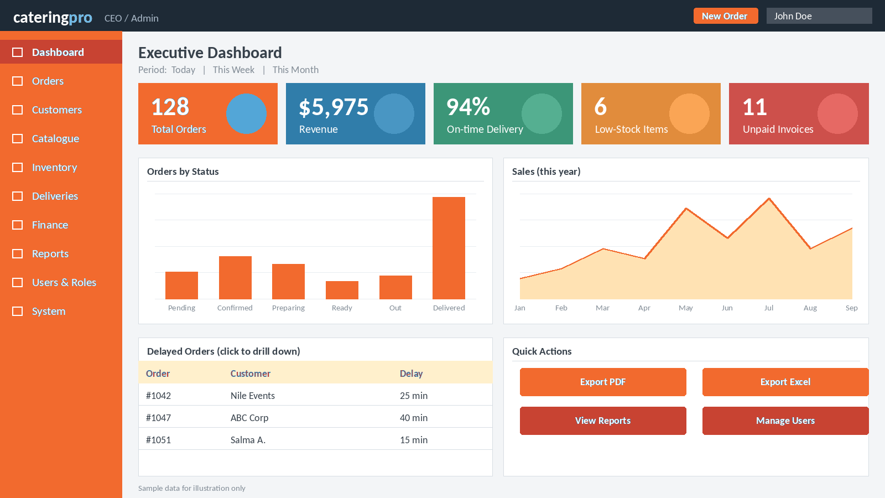
Figure 2: CEO / Admin: Executive Dashboard

10.2 Customer: Customer Portal
Own active orders, delivered orders, changes waiting for approval and unpaid amounts; status timeline of the latest order; list of own orders only.
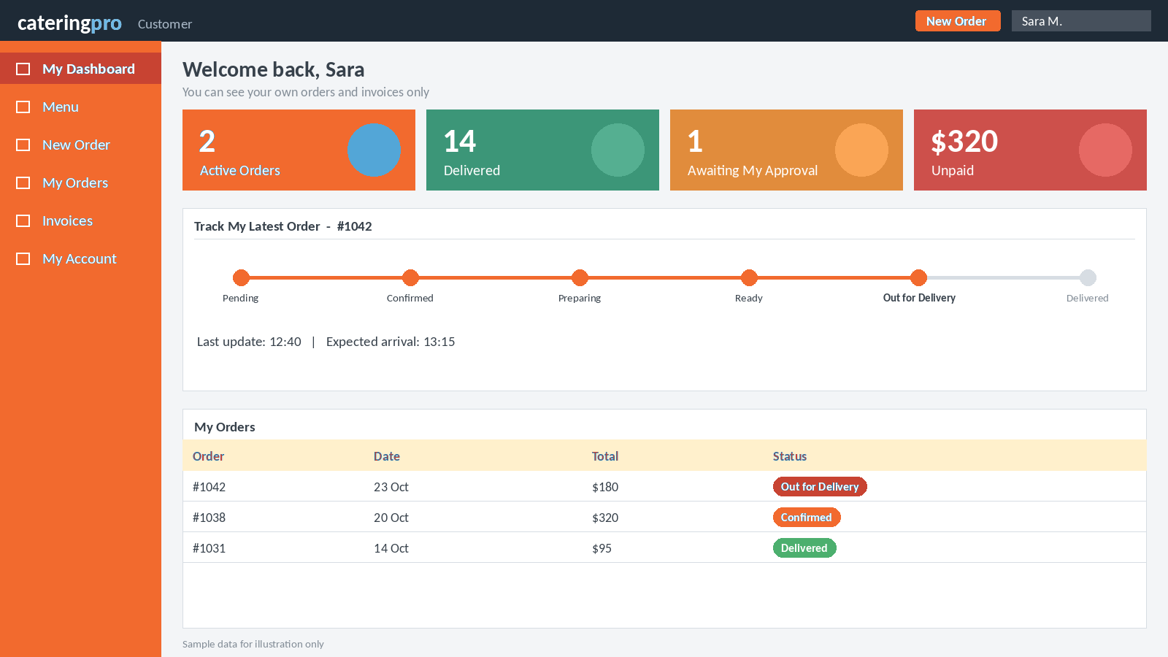
Figure 3: Customer: Customer Portal

10.3 Order Manager: Order Management
New orders, orders to confirm, delayed orders and today’s deliveries; list of all permitted orders with review and edit actions.
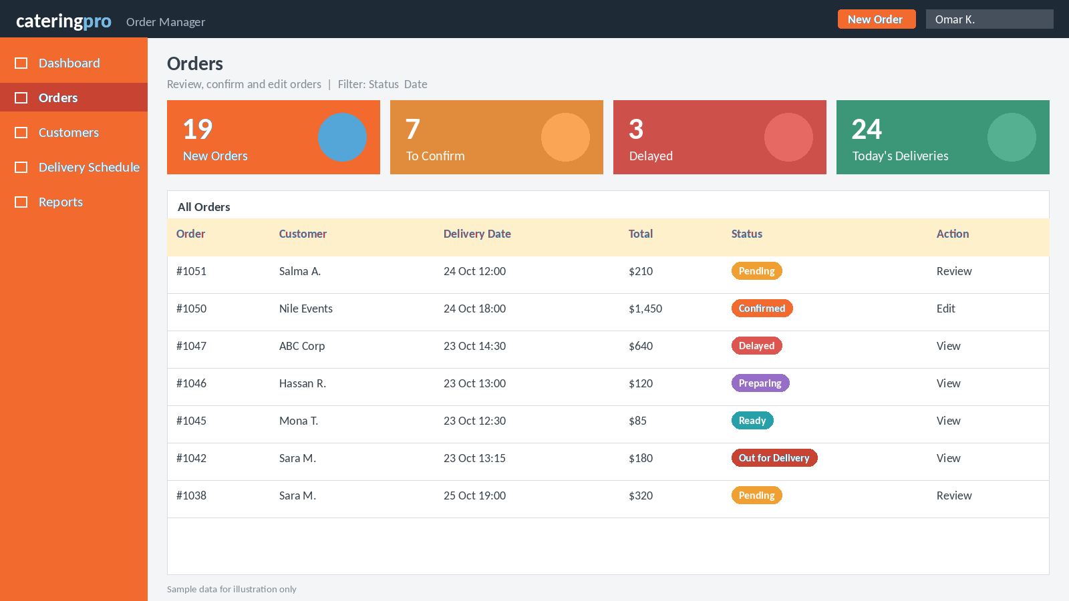
Figure 4: Order Manager: Order Management

10.4 Kitchen Staff: Kitchen Dashboard
Orders to prepare with meals, quantities and dietary notes; buttons to mark Preparing and Ready for Dispatch. No payment or financial data.
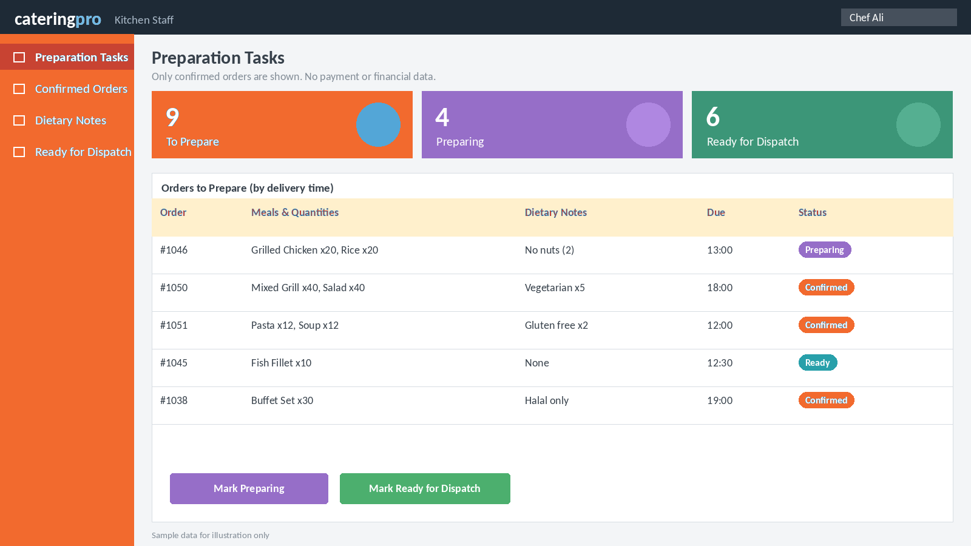
Figure 5: Kitchen Staff: Kitchen Dashboard

10.5 Delivery Manager: Assign Delivery
Orders ready for dispatch, available drivers, and the assignment form with departure time; reassign action.
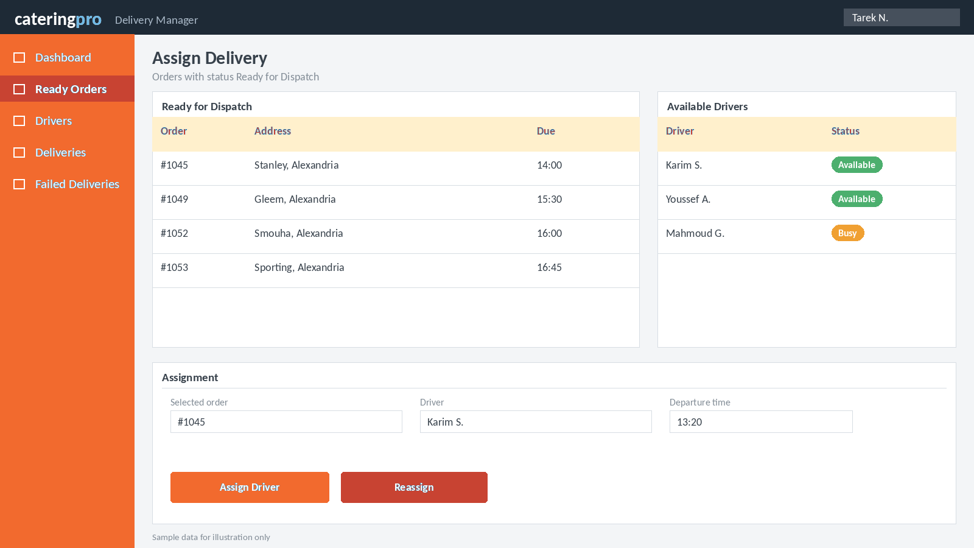
Figure 6: Delivery Manager: Assign Delivery

10.6 Driver: Driver View
Only the deliveries assigned to the driver, with address and contact; buttons for Delivered, Delivery Failed with reason, and proof of delivery.
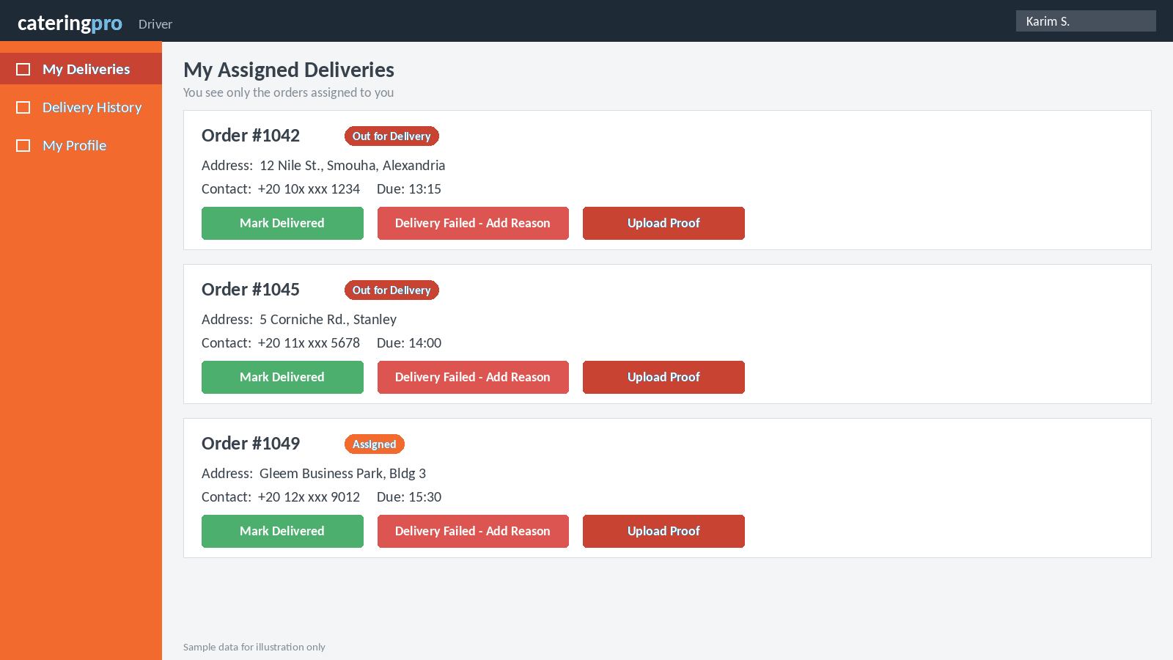
Figure 7: Driver: Driver View

10.7 Inventory Manager: Stock Levels
Stock items, low-stock and expiring items, suppliers and open purchase orders; add stock and record goods in and out.
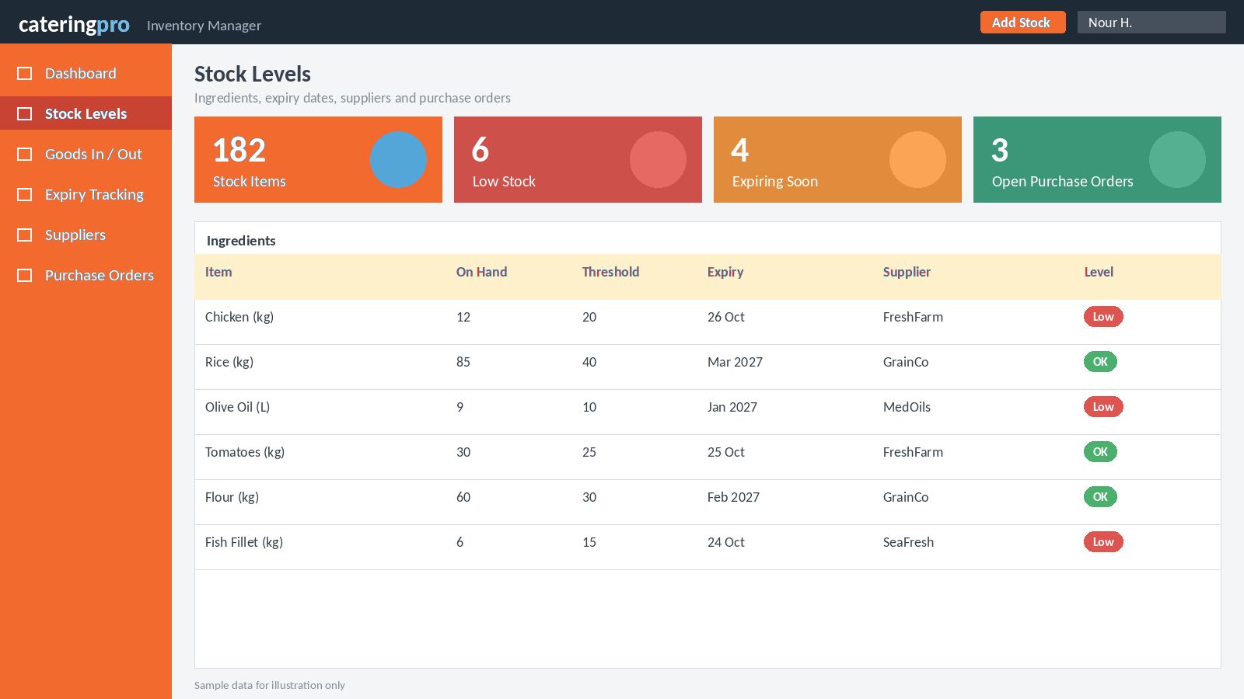
Figure 8: Inventory Manager: Stock Levels

10.8 Accountant: Invoices and Payments
Invoiced, paid and outstanding amounts; invoice list with paid or unpaid status; monthly collections; pending refunds.
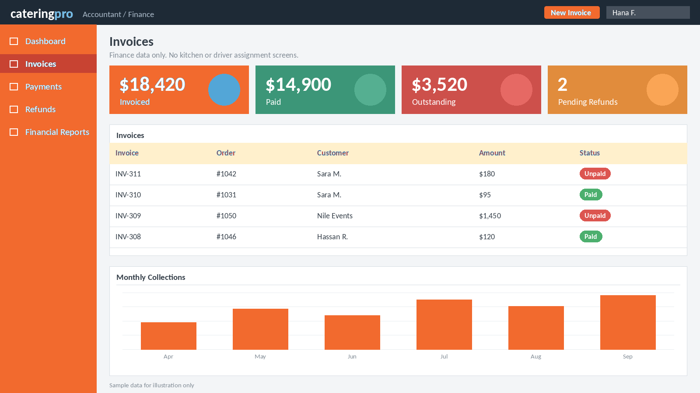
Figure 9: Accountant: Invoices and Payments

10.9 Customer: Order Builder
Step-by-step ordering: order type, method, quantity and schedule, customization, price review, submit. Availability for the date is shown before submit.
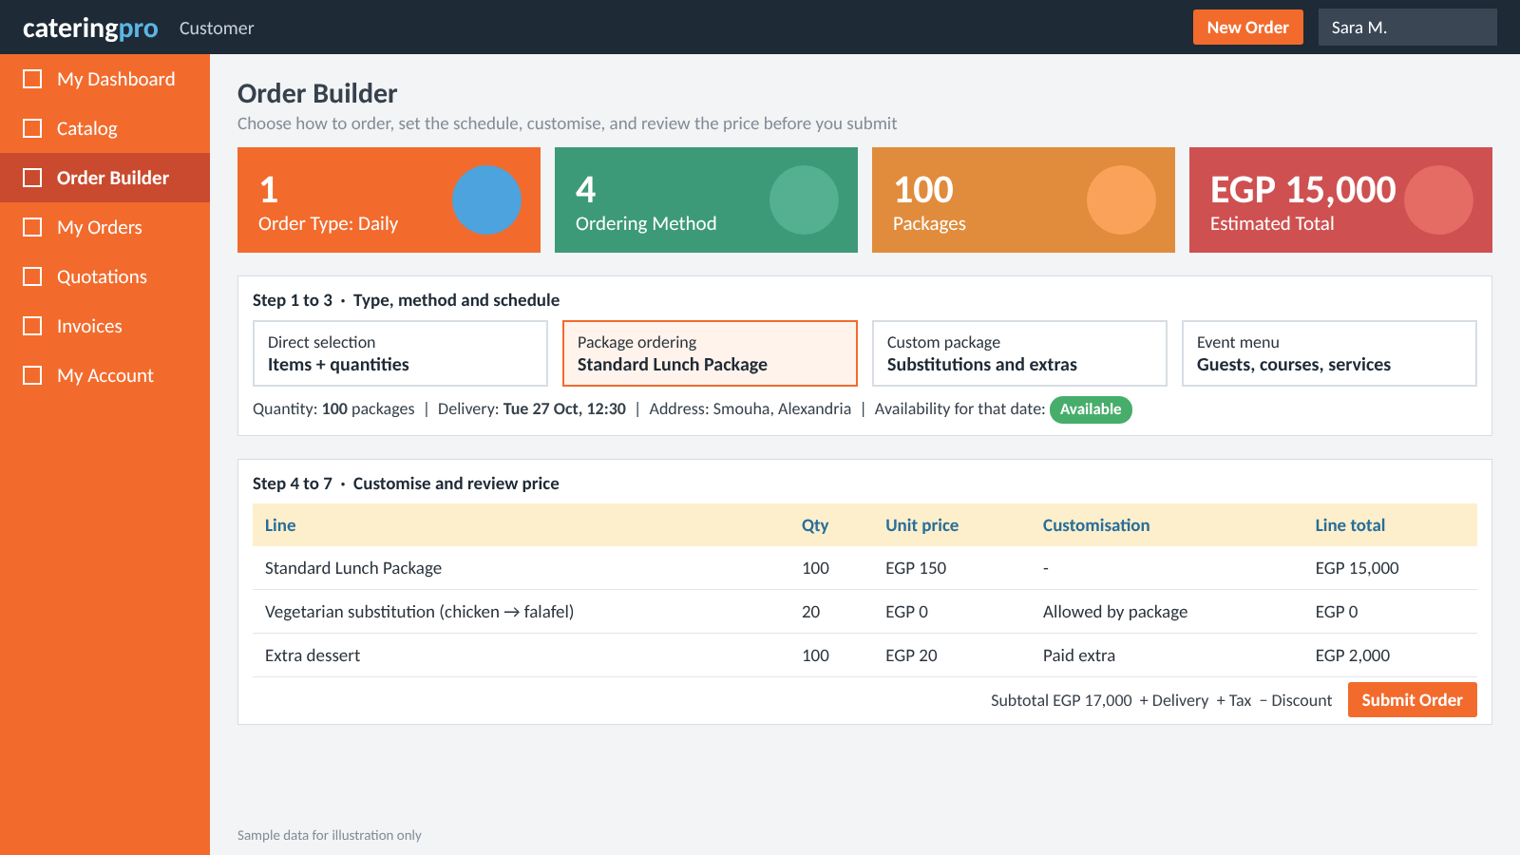
Figure 10: Customer: Order Builder

10.10 Catalog Manager: Catalog Management
Food items, packages, event menus, services and pricing rules; activate or deactivate offers; minimum quantities and effective dates.
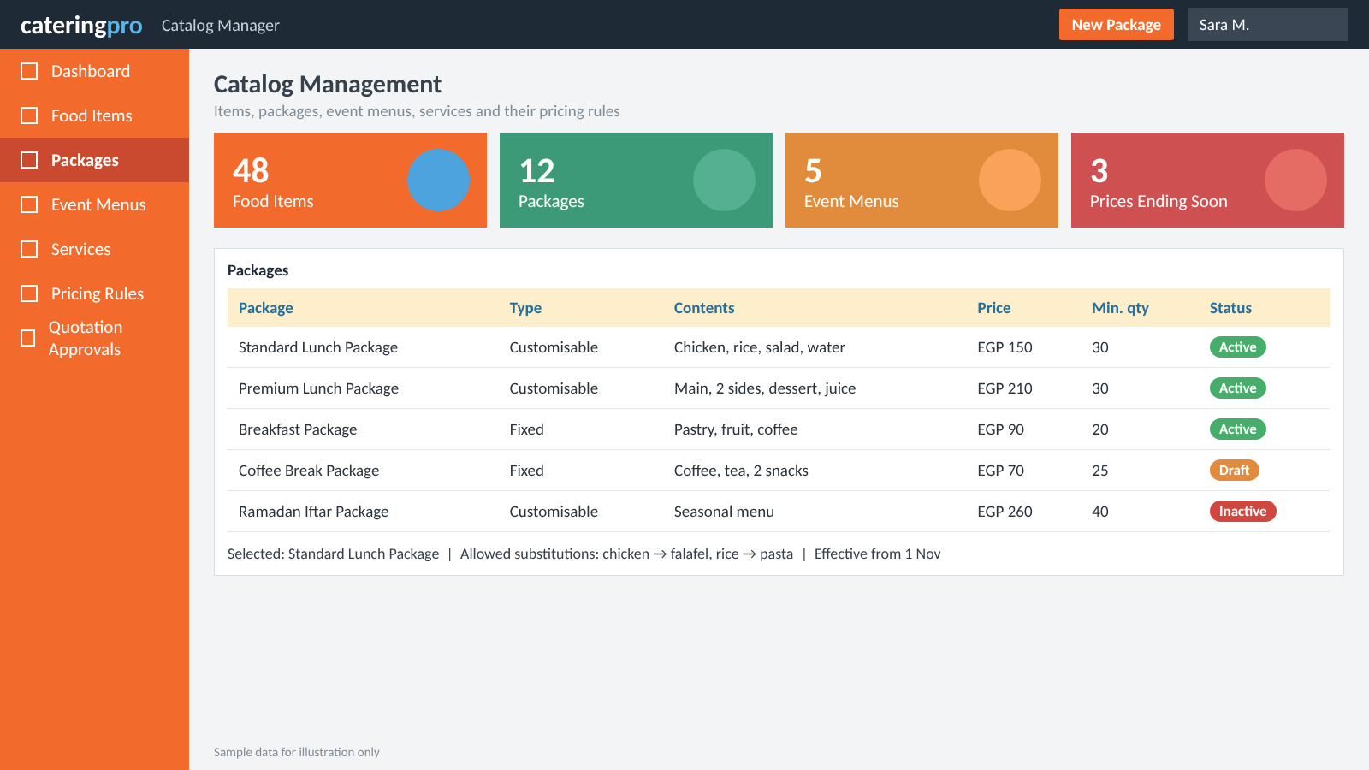
Figure 11: Catalog Manager: Catalog Management

10.11 Event Coordinator: Event Planning
Upcoming events with guest counts, services and status; quotations waiting; staffing gaps; event progress.
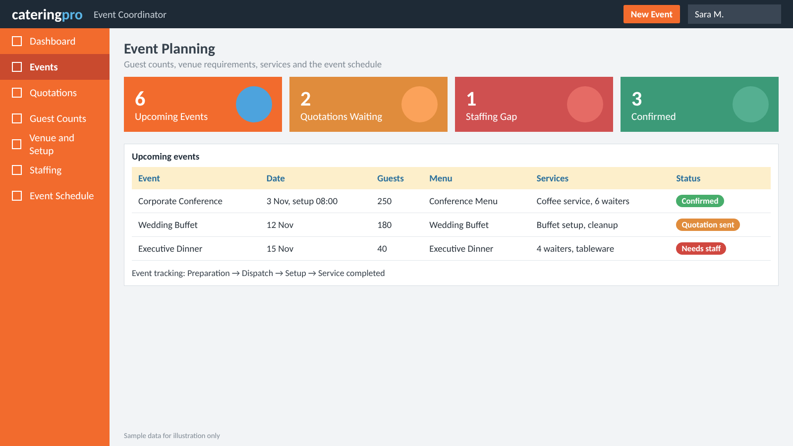
Figure 12: Event Coordinator: Event Planning

11. Use Case Diagram Plan
Every role becomes an actor in the use case diagrams, connected to the use cases it can run. To keep the drawings readable, split them into six diagrams instead of one crowded diagram.
# | Diagram | Scope | Actors
1 | System Overview | All actors and the main functions of the system. | All ten roles and the Payment Gateway
2 | Order Management | Create, confirm, edit and cancel orders; order tracking. | Customer, Order Manager, CEO
3 | Kitchen and Inventory | Order preparation, stock, expiry, suppliers and purchase orders. | Kitchen Staff, Inventory Manager
4 | Delivery and Tracking | Assign driver, deliver, failed delivery, tracking. | Delivery Manager, Driver, Customer
5 | Finance and Administration | Invoices, payments, reports, users and permissions. | Accountant, CEO / Admin
6 | Food Catalog and Order Builder | Browse, select, customize, build event menu, price, availability, submit order or quotation, approve, reserve, production order. | Customer, Order Manager, Catalog Manager, Inventory Manager, Kitchen Staff

Use <<include>> and <<extend>> only when a real relationship exists between use cases, never just to show permissions. Possible examples: Save Draft extends Place Order; Record Failed Delivery extends Assign Delivery; Export Report extends View Performance Dashboard. For diagram 6: Customize Package extends Select Package; Build Event Menu and Submit Order include Enter Order Details; Submit Order includes Calculate Price and Check Availability; Review / Approve Order includes Reserve Inventory and Generate Production Order.
Diagram 6 is drawn below as a starting point. The PlantUML source is in Appendix C.
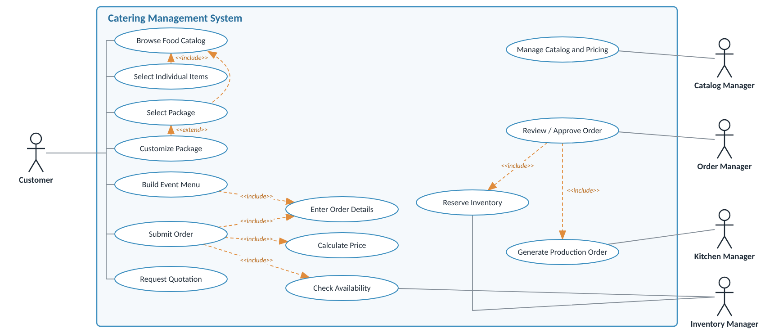
Figure 13: Use case diagram 6: Food Catalog and Order Builder

12. Food Catalog and Order Builder Design
This section explains the design behind requirements FR-44 to FR-78. The key idea: the customer has several ways to order, but the kitchen, inventory, delivery and finance departments all work from the same order data. It covers daily corporate catering and event catering.

12.1 Overall Structure
The catalog describes what the company sells. The Order Builder records what the customer actually requests. The order then drives the operational departments.
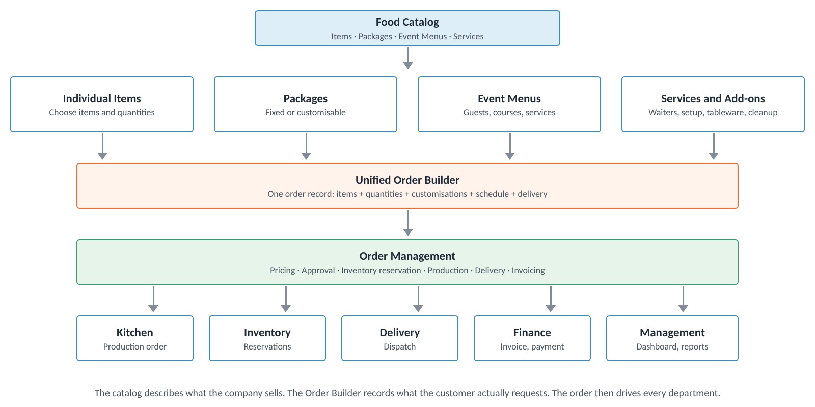
Figure 14: Food catalog, Order Builder and order management

12.2 What the Company Sells
The food itself is kept separate from the commercial offer shown to the customer. There are four kinds of offer.
Type | What it is | Examples | Key information
Individual Food Item | A single sellable item. | Grilled chicken per portion; rice; salad; water per bottle; dessert per piece. | SKU, category, unit, price, dietary information, recipe
Package | A bundle of items with defined quantities. Fixed, or with controlled substitutions and add-ons. | Standard Lunch, Premium Lunch, Breakfast, Coffee Break. | Included items, quantities, customization rules
Event Menu | An event offer with courses, items, packages, drinks and services. Priced per guest or by quotation. | Corporate Conference Menu, Wedding Buffet, Executive Dinner. | Courses, guest count, service needs
Service / Add-on | Not food. Needs service pricing and fulfilment rules, not a recipe. | Waiter service, buffet setup, tableware rental, special delivery, event cleanup. | Service unit, duration, staffing or setup needs

12.3 How Customers Order
The system supports four ordering modes using the same catalog. They are different ways to create an order, not four separate order-management systems.
Mode | Customer action | Example
Direct selection | Chooses individual items and quantities. | 100 salads + 100 juices
Package ordering | Selects a predefined package. | 200 Standard Lunch Packages
Custom ordering | Selects a package and changes the allowed choices. | 100 lunch packages with vegetarian substitutions
Event ordering | Chooses a menu and gives the event details. | Buffet for 250 guests, with waiters and setup

12.4 Pricing Model
Selling a single meal is not the same as quoting a wedding buffet, so each offer has its own price method. All values are illustrative, not actual company prices.
Offer | Price method | Example
Individual food item | Price per unit or portion | EGP 85 per meal
Fixed package | Price per package | EGP 150 per lunch box
Custom package | Base package price + paid extras − approved discounts | EGP 150 + EGP 20 extra
Event menu | Price per guest, fixed event fee, or a combination | 250 guests × EGP 400
Catering service | Per hour, person, event or fixed fee | 4 waiters × 6 hours
Total calculation: Subtotal = Σ (Quantity × Unit Price); Total = Subtotal + Delivery + Service Fees + Tax − Discount. The tax, discount and fee rules must be configurable. For events the calculation can also include venue, staffing, equipment rental and setup charges.
Pricing rules worth implementing:
- Customer-specific prices: negotiated prices for corporate contracts.
- Quantity-based pricing: discounts for large orders, if approved by policy.
- Effective dates: prices that change by season or date.
- Minimum quantities: for example a minimum of 30 packages or 100 event guests.
- Quotation approval: large or customized event orders need manager approval.
- Price snapshots: once an order is confirmed, keep the agreed prices even if the catalog changes later.
Never use today's price for an old invoice
The confirmed order keeps its own price and discount records. Historical invoices are never calculated from the current catalog.

12.5 Inventory Integration
This is what makes the design stronger than a simple food-ordering website. A Standard Lunch Package contains 1 chicken portion, 1 rice portion, 1 salad and 1 bottle of water. If a customer orders 100 packages, the system must turn that commercial order into production and ingredient needs.
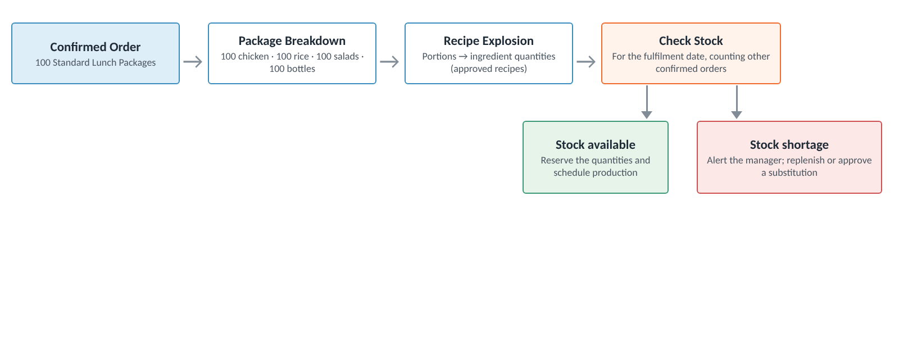
Figure 15: From confirmed order to stock reservation or shortage alert
Event | System behaviour
Customer is still building an order | Calculate an availability estimate. Do not consume stock.
Order is confirmed | Reserve the required stock according to the company's reservation policy.
Order is cancelled | Release the reservations. Record any actual losses separately.
Production begins | Issue the ingredients according to the production process.
Production is completed | Record actual usage and any waste or variance.
Ingredient is unavailable | Alert staff and block or flag the confirmation according to the business rules.
Expired batch is found | Prevent its allocation to production.
Units must be consistent and have conversion rules: a recipe may need kilograms of chicken while the supplier delivers cases. Batches and expiry dates are tracked where food safety needs it. For customized packages the requirements come from the customer's final choices. Availability must also consider the fulfilment date: having 100 portions today does not mean they are free for an event next week if other confirmed orders already need them.

12.6 Order Builder Workflow
Step | Name | What happens
1 | Choose order type | Daily catering or event catering.
2 | Choose ordering method | Individual items, fixed package, customized package or event menu.
3 | Enter quantity and schedule | Portions, number of packages, guest count, delivery date and time.
4 | Customize the selection | Allowed alternatives, extras, dietary requirements and service options.
5 | Validate the order | Minimum quantities, availability, service area, lead time and required approvals.
6 | Calculate the quote | Prices, discounts, taxes and service or delivery fees.
7 | Review and submit | Show the full breakdown. Confirm the order or request a quotation, depending on the order type.
8 | Create operational records | Production requirements, stock reservations, delivery tasks, and payment or invoice records.
Example: event ordering. A customer wants catering for 250 conference attendees. The customer selects an event menu, chooses vegetarian alternatives for 30 guests, adds coffee service and asks for setup at 8:00 AM. The system should:
- Save the event date, location, attendance and setup time.
- Apply the chosen menu's pricing and calculate the custom quotation.
- Check ingredients, production capacity, equipment and staffing.
- Send the quotation for approval if required.
- After confirmation, create the production and event-fulfilment tasks.
- Track preparation, dispatch, setup and final service completion.

12.7 Proposed Business-Analysis Deliverables
This is the package of work that can be presented to the CEO.
Deliverable | Purpose
Business process overview | Explain how daily catering and events work.
Food catalog data model | Show how items, packages, menus and services relate.
Pricing rules | Explain fixed, custom and event-based pricing.
Order lifecycle diagram | Show how an order moves through the departments.
Role-permission matrix | Define what each employee and customer can access.
UML use case diagrams | Show actors and system functions.
Detailed use case specifications | Document normal flows, exceptions and business rules.
Dashboard wireframes | Show what the customer, staff and CEO will see.
KPI proposal | Define how operational performance is measured.

13. Order Lifecycle and Notifications (new)
Version 3.0 listed the order statuses but not how an order moves between them or who may move it. This section defines both, and who is told at each step. It is the basis for FR-79, FR-84 and BR-27.

13.1 Order Status Lifecycle
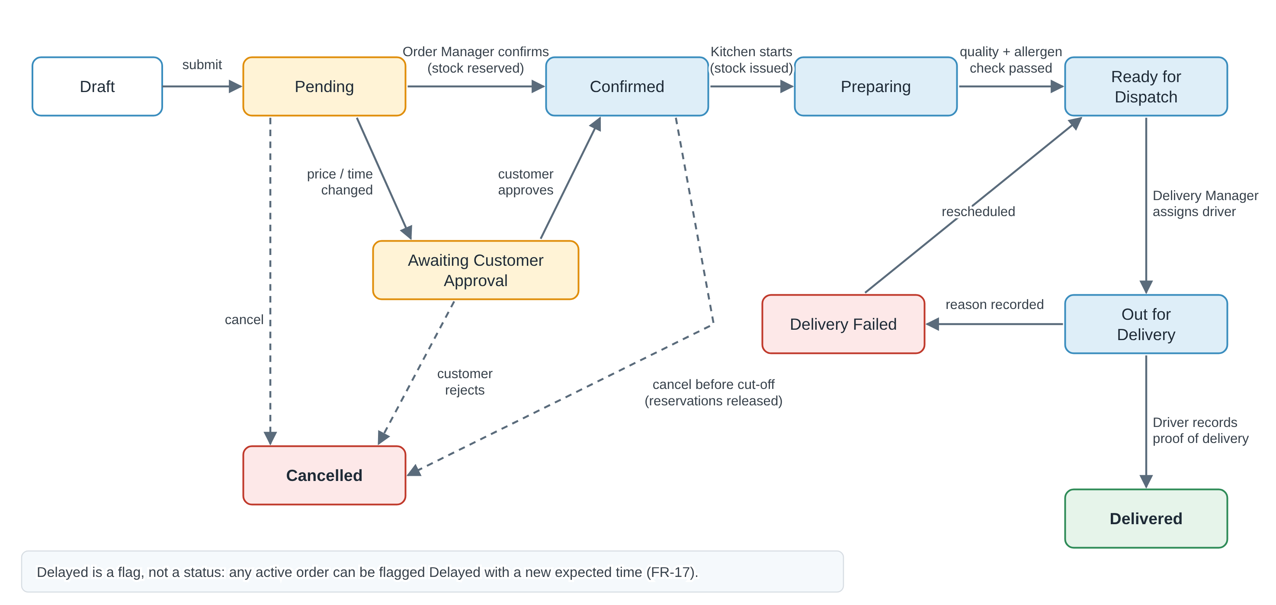
Figure 16: Order status lifecycle
From | To | Performed by | Condition and system action
Draft | Pending | Customer, Order Manager | Required fields valid (FR-08); order number generated (FR-06); Order Manager notified.
Pending | Awaiting Customer Approval | Order Manager | Price or time changed (FR-11); customer notified to approve.
Awaiting Customer Approval | Confirmed | Customer | Customer approves the change (BR-02).
Awaiting Customer Approval | Cancelled | Customer | Customer rejects the change.
Pending | Confirmed | Order Manager (or automatic, if allowed) | Availability checked, approval or quotation accepted; stock reserved and production order created (FR-57, FR-67).
Pending or Confirmed | Cancelled | Customer (before cut-off), Order Manager | Reservations released, refund requested if paid (FR-81, FR-82).
Confirmed | Preparing | Kitchen Staff | Production starts; ingredients issued (FR-69).
Preparing | Ready for Dispatch | Kitchen Staff | Quality and allergen checks done (FR-95, BR-32).
Ready for Dispatch | Out for Delivery | Delivery Manager | Available driver assigned (BR-03); customer notified (FR-22).
Out for Delivery | Delivered | Driver | Proof of delivery recorded (FR-103); invoice issued if policy is on delivery.
Out for Delivery | Delivery Failed | Driver | Failure reason recorded (BR-05); Delivery Manager notified.
Delivery Failed | Ready for Dispatch | Delivery Manager | Delivery rescheduled with a new time.

Why Delayed is a flag, not a status
An order can be late while it is still being prepared or while it is on the road. If Delayed were a status, the system would lose the real stage of the order. As a flag with a new expected time, both facts are kept, and the on-time delivery KPI stays accurate.

13.2 Notification Matrix
Event | Who is notified | Channel (proposed) | Req.
Order submitted | Order Manager; customer (confirmation with order number) | In-app, email | FR-10
Price or time changed | Customer (action needed) | In-app, email, SMS | FR-11
Order confirmed | Customer; kitchen (production order) | In-app, email | FR-57
Order delayed | Customer; Order Manager | In-app, SMS | FR-17
Out for delivery | Customer; assigned driver | In-app, SMS | FR-22
Delivered or delivery failed | Customer; Delivery Manager (if failed) | In-app, email | FR-23
Driver reassigned | Both drivers | In-app | FR-24
Quotation sent or about to expire | Customer; Event Coordinator | Email, in-app | FR-74
Shortage, low stock or batch expiring | Inventory Manager; Kitchen Manager | In-app, email | FR-68
Invoice issued or overdue | Customer; Accountant | Email | FR-96, FR-98
Low rating or new complaint | Order Manager | In-app | FR-91
Account created or password reset | The user | Email | FR-42, FR-102

14. Key Performance Indicators (new)
Section 12.7 lists a KPI proposal as a deliverable; this is that proposal. Each KPI is calculated from data the portal already records. The targets are starting suggestions for discussion with the CEO, not commitments.
KPI | How it is calculated | Owner | Proposed target
On-time delivery rate | Orders delivered within the promised time ÷ all delivered orders | Delivery Manager | 95% or more
Failed delivery rate | Delivery Failed events ÷ delivery attempts | Delivery Manager | 2% or less
Order confirmation time | Average time from Pending to Confirmed | Order Manager | 30 minutes or less in business hours
Order accuracy | Delivered orders with no complaint ÷ delivered orders | Order Manager, Kitchen | 98% or more
Customer satisfaction | Average rating (1 to 5) of rated orders | CEO | 4.5 or more
Quotation conversion rate | Accepted quotations ÷ quotations sent | Event Coordinator | Set after the first quarter
Revenue and average order value | Total of confirmed orders; revenue ÷ number of orders, per period | CEO, Accountant | Growth over the previous period
Food cost percentage | Cost of ingredients issued ÷ food revenue | CEO, Inventory Manager | Set by company policy
Waste rate | Recorded waste ÷ quantity issued (FR-69) | Kitchen Manager | Falling trend
Stock-out incidents | Confirmations blocked or flagged for shortage per month (FR-68) | Inventory Manager | Falling trend
Outstanding receivables | Unpaid and overdue amounts by age band (FR-98) | Accountant | No invoice older than 60 days
Repeat customer rate | Customers with 2 or more orders in the period ÷ active customers | CEO | Rising trend

15. Proposed Solution Architecture and Prototype (new)

15.1 Architecture
The portal is one web application (UI-01). A single-page frontend talks to a REST API. The API checks authentication and role permissions on every request, then passes the work to business modules that match the departments. All modules share one database, so every department works from the same order record (BR-18). Scheduled work, such as sending notifications, creating recurring orders and flagging delays, runs as background jobs.
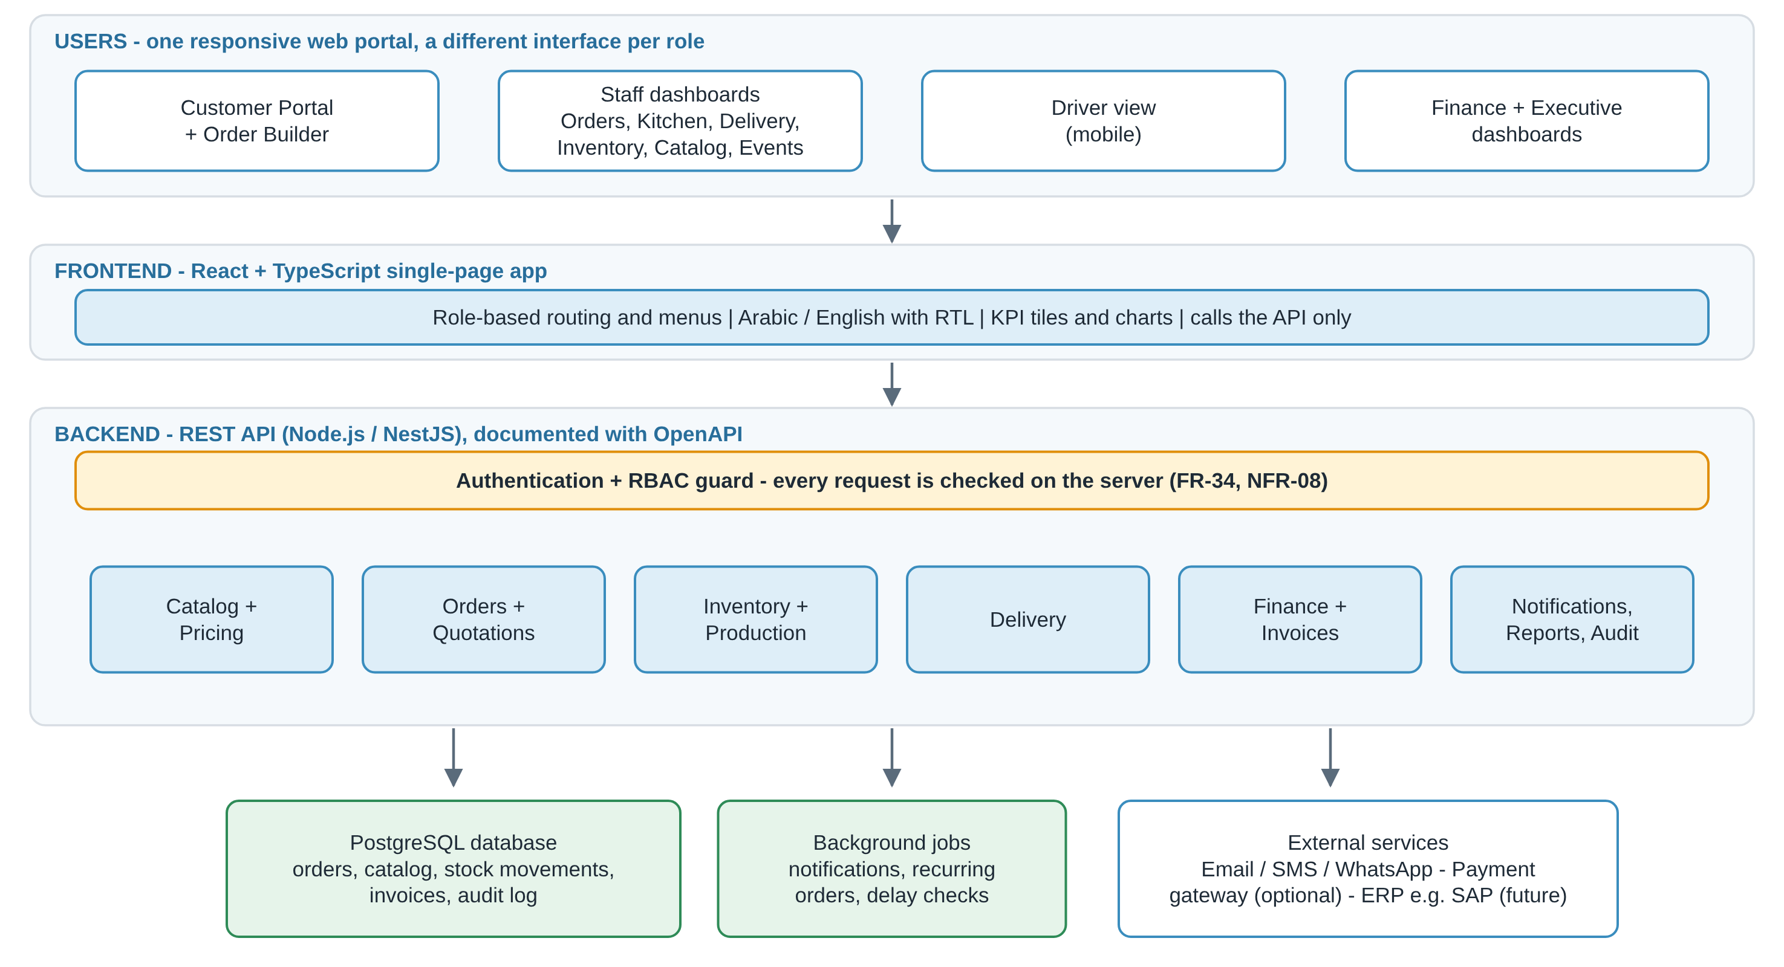
Figure 17: Proposed solution architecture
Ready for ERP integration
Orders, invoices, payments and stock movements are stored as clean, timestamped records with their own IDs. This keeps the way open to posting them later to an ERP such as SAP (sales orders, billing, goods movements) through an integration layer, without redesigning the portal.

15.2 Proposed Technology Stack
Layer | Proposed choice | Why
Frontend | React, TypeScript, Vite, Tailwind CSS | Reusable components for ten role dashboards; type safety; fast builds.
Frontend libraries | React Router, TanStack Query, Recharts, i18next | Role-based routes, server data caching, dashboard charts, Arabic and English with RTL.
Backend | Node.js with NestJS (TypeScript) | Modules map to departments; built-in guards for RBAC; same language as the frontend.
API | REST with OpenAPI (Swagger) documentation | A clear contract between frontend and backend; easy to test and to integrate later (NFR-24).
Database | PostgreSQL with Drizzle ORM | Relational data (orders, lines, recipes, stock) with transactions for safe stock reservation. Pure TypeScript, no engine binaries to install.
Authentication | JWT access and refresh tokens; bcrypt password hashing | Stateless API and secure password storage (NFR-16).
Files and jobs | S3-compatible file storage; a job queue for scheduled work | Proof-of-delivery photos and exports; notifications and recurring orders.
Quality | Unit tests, Playwright end-to-end tests, ESLint | Automatic checks for pricing, permission and stock rules.
Deployment | Docker and a CI pipeline (for example GitHub Actions) | The same environment everywhere; every change is built and tested automatically.

The stack is a proposal. It can be replaced (for example .NET or Java Spring for the backend) without changing any requirement in this document.

15.3 Prototype Scope for the Presentation
To show the design working end to end, the first build is a working prototype with sample data and one demo account per role (ten accounts). It implements Phase 1 and a thin slice of Phases 2 and 3, so that one complete order can be followed through every department. The demo script below is the acceptance test for the prototype.
Step | Role | Action | What it proves
1 | Customer | Logs in, browses the catalog and builds an order of 50 Standard Lunch packages with 10 vegetarian substitutions. | Catalog, Order Builder and customization rules (FR-50 to FR-53)
2 | Customer | Reviews the price breakdown and availability, then submits. | Pricing, validation, order number (FR-54 to FR-56, FR-06)
3 | Order Manager | Opens a seeded pending order and changes its delivery time; the customer approves, which confirms that order. | Notifications and approval loop (FR-10, FR-11, BR-02)
4 | Order Manager | Confirms the customer’s new order from step 2. | Stock reserved, production order and invoice created (FR-57, FR-67, FR-72, FR-96)
5 | Kitchen Staff | Opens the production order with allergen notes and moves it to Preparing, then Ready for Dispatch. | Kitchen view and allergen check (FR-37, FR-93, BR-32)
6 | Delivery Manager | Assigns an available driver. | Assignment rules (FR-21, BR-03)
7 | Driver | Marks the order Delivered with proof, on a phone-size screen. | Mobile driver view (FR-38, FR-103)
8 | Customer | Sees the full timeline and rates the order. | Tracking, history and rating (FR-80, FR-91)
9 | Accountant | Sees the invoice and records the payment. | Invoice from the price snapshot (FR-96, FR-97)
10 | CEO | Sees the KPI tiles update and drills into the orders. | Executive dashboard (FR-26 to FR-28)
11 | Driver | Types the address of a finance page directly into the browser. | Server refuses access and logs the attempt (FR-34, NFR-09)

Appendix A. Summary of Changes in Version 2.0
Section | Change
Cover, 1.3, 1.4 | Six use cases, new business goal about role-based access, UC-05 and UC-06 added.
2. Actors and Roles | Inventory Manager and Accountant added; RBAC explanation, role views, permission matrix and interface structure added.
3.6, 3.7 | New requirements FR-31 to FR-43 and UI-01 to UI-07.
4. Business Rules | BR-09 to BR-16 added.
5. Non-Functional Requirements | NFR-08 to NFR-11 added (server-side authorization, audit, consistency, maintainability).
6. Data Entities | Role, Permission, Audit Log, Supplier / Purchase Order added; User and Delivery updated.
7. Gaps | GAP-05 updated; GAP-11 and GAP-12 added.
8. Assumptions and Questions | Role-related assumptions and open questions added.
9. Phases | Phases updated to include the new requirements.
10, 11 | New: role dashboard designs and use case diagram plan.

Appendix B. Summary of Changes in Version 3.0
Section | Change
Cover, 1.1, 1.3, 1.4 | Ten use cases; two new business goals; UC-07 to UC-10 added.
2. Actors and Roles | Catalog Manager and Event Coordinator added; Payment Gateway added as an external system; Kitchen, Order Manager and Inventory rows updated; new permission matrix for catalog and event features.
3.8 to 3.12 | New requirements FR-44 to FR-78: catalog, Order Builder, pricing, inventory integration and production, events and quotations.
3.7 UI | UI-08 to UI-10 added.
4. Business Rules | BR-17 to BR-26 added.
5. Non-Functional | NFR-12 to NFR-15 added (configurability, price integrity, inventory accuracy, integration).
6. Data Entities | Catalog, recipe, batch, order line, pricing, quotation, event and production entities added; Menu Item and Order Item replaced; 6.1 relationships added.
7. Gaps | GAP-01 and GAP-02 updated; GAP-13 to GAP-15 added.
8. Assumptions and Questions | New assumptions and open questions on catalog, pricing, approval and inventory.
9. Phases | Phases updated; Phase 5 added.
10, 11 | New mock-ups (Order Builder, Catalog Manager, Event Coordinator); diagram 6 and its use case diagram.
12 | New: Food Catalog and Order Builder design.
Appendix C | PlantUML source for use case diagram 6.

Appendix C. PlantUML Source for Use Case Diagram 6
Render this code with PlantUML to redraw diagram 6. Check the include and extend relationships against the final business rules before you use it.
@startuml
left to right direction
actor Customer
actor "Order Manager" as OM
actor "Catalog Manager" as CM
actor "Inventory Manager" as IM
actor "Kitchen Manager" as KM
rectangle "Catering Management System" {
usecase "Browse Food Catalog" as UC1
usecase "Select Individual Items" as UC2
usecase "Select Package" as UC3
usecase "Customize Package" as UC4
usecase "Build Event Menu" as UC5
usecase "Enter Order Details" as UC6
usecase "Calculate Price" as UC7
usecase "Check Availability" as UC8
usecase "Submit Order" as UC9
usecase "Request Quotation" as UC10
usecase "Manage Catalog and Pricing" as UC11
usecase "Review / Approve Order" as UC12
usecase "Reserve Inventory" as UC13
usecase "Generate Production Order" as UC14
}
Customer --> UC1
Customer --> UC2
Customer --> UC3
Customer --> UC4
Customer --> UC5
Customer --> UC9
Customer --> UC10
UC2 ..> UC1 : <<include>>
UC3 ..> UC1 : <<include>>
UC4 ..> UC3 : <<extend>>
UC5 ..> UC6 : <<include>>
UC9 ..> UC6 : <<include>>
UC9 ..> UC7 : <<include>>
UC9 ..> UC8 : <<include>>
OM --> UC12
CM --> UC11
IM --> UC8
IM --> UC13
KM --> UC14
UC12 ..> UC13 : <<include>>
UC12 ..> UC14 : <<include>>
@enduml
Modeling note: the diagram assumes that approval is required before inventory is reserved and a production order is generated. If the company confirms some orders automatically, or a quotation needs a separate customer-acceptance step, adjust the flows. <<include>> means a required behaviour; <<extend>> means an optional or conditional one.

Appendix D. Summary of Changes in Version 4.0
Section | Change
Cover, What is new | Version 4.0; counts updated (104 functional requirements, 35 business rules).
Executive Summary | New: one-page summary for presenting the document.
1.3 | New goal on KPIs and ERP readiness.
2.3 | Legend clarifies that the Catalog Manager owns menu and prices.
3.3 | FR-13 status list completed (Draft, Awaiting Customer Approval, Cancelled); FR-17 defines Delayed as a flag.
3.12 | FR-74 quotation statuses completed (Pending Approval, Expired) with a validity date.
3.13 to 3.18 | New FR-79 to FR-104: lifecycle and cancellation, notifications, self-service and corporate accounts, food safety, invoicing and payments, platform, administration and delivery.
4. Business Rules | BR-06 aligned with FR-36; BR-27 to BR-35 added.
5. Non-Functional | NFR-01 lists all ten roles; NFR-05 points to the notification matrix; NFR-16 to NFR-24 added (security, privacy, backup, localization, scalability, accessibility, devices, monitoring, testing).
6. Data Entities | Superseded Menu Item and Order Item rows removed; eight entities added; two relationships added.
7. Gaps | Each gap now shows whether it is covered and by which requirements.
8. Assumptions and Questions | Three assumptions and five open questions added (tax and hosting country, cancellation cut-offs, branches, invoice timing, ERP).
9. Phases | Rebuilt so every requirement has exactly one phase; Must requirements that had no phase in version 3.0 are now placed.
13, 14, 15 | New: order lifecycle and notification matrix, KPI proposal, solution architecture, technology stack and prototype demo script.
15.2, 15.3 | Updated after building the prototype: Drizzle ORM replaces Prisma (no engine binaries); demo steps 3 and 4 match the real approval flow.

